Using random seed 1 for all the experiments

|  |  |  |  |
| --- | --- | --- | --- |
|  | **Average accuracy** | **Average sensitivity** | **Average specificity** |
| **Cumulative_cases** | 0.80 | 0.81 | 0.80 |
| **Cumulative_cases, new_cases_today** | 0.82 | 0.81 | 0.83 |
| **Cumulative_cases, new_cases_today,**  **age34_or_less** | 0.84 | 0.84 | 0.85 |
| **Cumulative_cases, new_cases_today,**  **non_white** | 0.81 | 0.78 | 0.84 |
| **Cumulative_cases, new_cases_today,**  **high_school_or_less** | 0.83 | 0.83 | 0.83 |
| **Cumulative_cases, new_cases_today,**  **age34_or_less,**  **non_white** | 0.81 | 0.77 | 0.85 |
| **Cumulative_cases, new_cases_today,**  **age34_or_less,**  **high_school_or_less** | 0.81 | 0.81 | 0.81 |
| **Cumulative_cases, new_cases_today,**  **age34_or_less,**  **high_school_or_less,**  **non_white** | 0.78 | 0.75 | 0.82 |

**Variables: cumulative_cases**

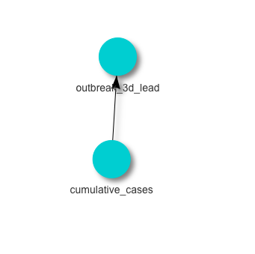

[1] "Cross validation on fold 1"

[1] "The accuracy of the fold is 0.732394366197183"

[1] "The sensitivity of the fold is 0.526315789473684"

[1] "The specificity of the fold is 0.96969696969697"

[1] "-----------------"

[1] "Cross validation on fold 2"

[1] "The accuracy of the fold is 0.8"

[1] "The sensitivity of the fold is 1"

[1] "The specificity of the fold is 0.611111111111111"

[1] "-----------------"

[1] "Cross validation on fold 3"

[1] "The accuracy of the fold is 0.859154929577465"

[1] "The sensitivity of the fold is 0.911764705882353"

[1] "The specificity of the fold is 0.810810810810811"

[1] "Average accuracy across folds 0.797183098591549"

[1] "Average sensitivity across folds 0.812693498452012"

[1] "Average specificity across folds 0.797206297206297"

**Variables: cumulative_cases, new_cases_today**

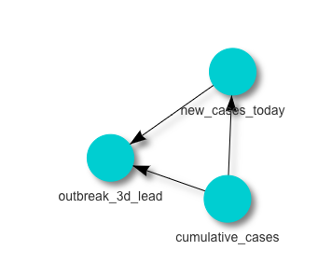

[1] "Cross validation on fold 1"

[1] "The accuracy of the fold is 0.732394366197183"

[1] "The sensitivity of the fold is 0.578947368421053"

[1] "The specificity of the fold is 0.909090909090909"

[1] "-----------------"

[1] "Cross validation on fold 2"

[1] "The accuracy of the fold is 0.842857142857143"

[1] "The sensitivity of the fold is 0.941176470588235"

[1] "The specificity of the fold is 0.75"

[1] "-----------------"

[1] "Cross validation on fold 3"

[1] "The accuracy of the fold is 0.873239436619718"

[1] "The sensitivity of the fold is 0.911764705882353"

[1] "The specificity of the fold is 0.837837837837838"

[1] "Average accuracy across folds 0.816163648558015"

[1] "Average sensitivity across folds 0.81062951496388"

[1] "Average specificity across folds 0.832309582309582"

**Variables: cumulative_cases, new_cases_today, age34_less**

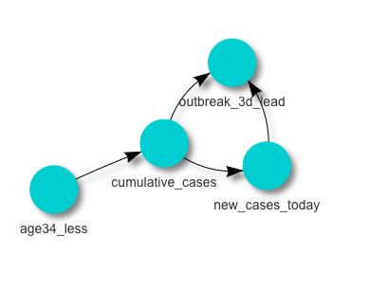

[1] "Cross validation on fold 1"

[1] "The accuracy of the fold is 0.816901408450704"

[1] "The sensitivity of the fold is 0.684210526315789"

[1] "The specificity of the fold is 0.96969696969697"

[1] "-----------------"

[1] "Cross validation on fold 2"

[1] "The accuracy of the fold is 0.842857142857143"

[1] "The sensitivity of the fold is 0.941176470588235"

[1] "The specificity of the fold is 0.75"

[1] "-----------------"

[1] "Cross validation on fold 3"

[1] "The accuracy of the fold is 0.859154929577465"

[1] "The sensitivity of the fold is 0.882352941176471"

[1] "The specificity of the fold is 0.837837837837838"

[1] "Average accuracy across folds 0.839637826961771"

[1] "Average sensitivity across folds 0.835913312693498"

[1] "Average specificity across folds 0.852511602511603"

**Variables: cumulative_cases, new_cases_today, age34_less, high_school_orless**

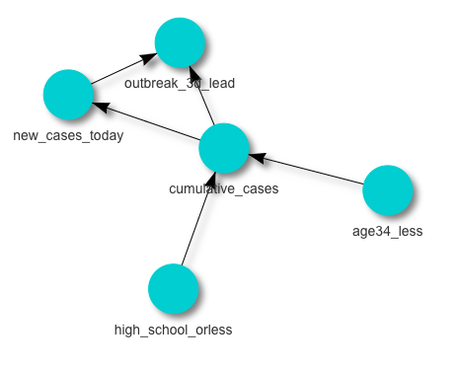

[1] "Cross validation on fold 1"

[1] "The accuracy of the fold is 0.746478873239437"

[1] "The sensitivity of the fold is 0.578947368421053"

[1] "The specificity of the fold is 0.939393939393939"

[1] "-----------------"

[1] "Cross validation on fold 2"

[1] "The accuracy of the fold is 0.814285714285714"

[1] "The sensitivity of the fold is 0.970588235294118"

[1] "The specificity of the fold is 0.666666666666667"

[1] "-----------------"

[1] "Cross validation on fold 3"

[1] "The accuracy of the fold is 0.859154929577465"

[1] "The sensitivity of the fold is 0.882352941176471"

[1] "The specificity of the fold is 0.837837837837838"

[1] "Average accuracy across folds 0.806639839034205"

[1] "Average sensitivity across folds 0.81062951496388"

[1] "Average specificity across folds 0.814632814632815"

**Variables: cumulative_cases, new_cases_today, age34_less, non_white**

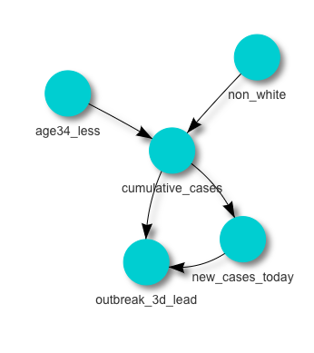

[1] "Cross validation on fold 1"

[1] "The accuracy of the fold is 0.788732394366197"

[1] "The sensitivity of the fold is 0.631578947368421"

[1] "The specificity of the fold is 0.96969696969697"

[1] "-----------------"

[1] "Cross validation on fold 2"

[1] "The accuracy of the fold is 0.828571428571429"

[1] "The sensitivity of the fold is 0.911764705882353"

[1] "The specificity of the fold is 0.75"

[1] "-----------------"

[1] "Cross validation on fold 3"

[1] "The accuracy of the fold is 0.802816901408451"

[1] "The sensitivity of the fold is 0.764705882352941"

[1] "The specificity of the fold is 0.837837837837838"

[1] "Average accuracy across folds 0.806706908115359"

[1] "Average sensitivity across folds 0.769349845201238"

[1] "Average specificity across folds 0.852511602511603"

**Variables: cumulative_cases, new_cases_today, age34_less, high_school_orless, non_white**

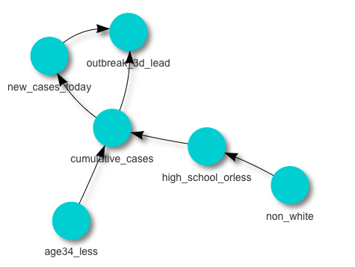

[1] "Cross validation on fold 1"

[1] "The accuracy of the fold is 0.71830985915493"

[1] "The sensitivity of the fold is 0.526315789473684"

[1] "The specificity of the fold is 0.939393939393939"

[1] "-----------------"

[1] "Cross validation on fold 2"

[1] "The accuracy of the fold is 0.8"

[1] "The sensitivity of the fold is 0.911764705882353"

[1] "The specificity of the fold is 0.694444444444444"

[1] "-----------------"

[1] "Cross validation on fold 3"

[1] "The accuracy of the fold is 0.830985915492958"

[1] "The sensitivity of the fold is 0.823529411764706"

[1] "The specificity of the fold is 0.837837837837838"

[1] "Average accuracy across folds 0.783098591549296"

[1] "Average sensitivity across folds 0.753869969040248"

[1] "Average specificity across folds 0.823892073892074"

**Check class imbalance in each fold**

In training and testing sets of each fold, the outbreak YES and NO classes are evenly distributed.

(no, yes) in each testing set of the fold: (33, 38), (36, 34), (37, 34)