**Objective: To create a smart home automation based on a sensor using Arduino as the master controller.**

**SPECIFICATION (Major Components):**

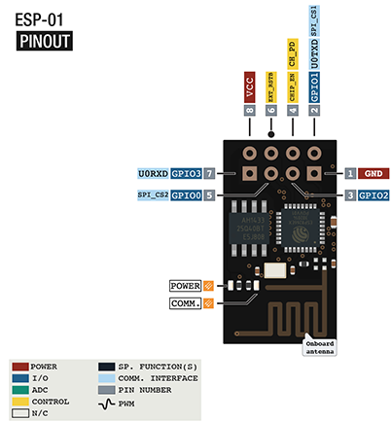

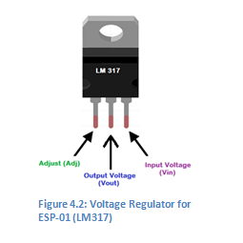

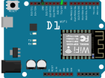Figure 4.1: Pin Specification for ESP8266 ESP-01

Figure 4.4 WeMos D1 R2 as Console 3 for data broadcast over web

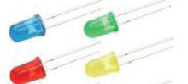

Figure 4.3: LEDs

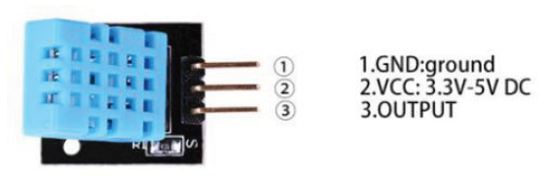

Figure 4.5: Temperature and Humidity Sensor

**HARDWIRE REQUIRED:**

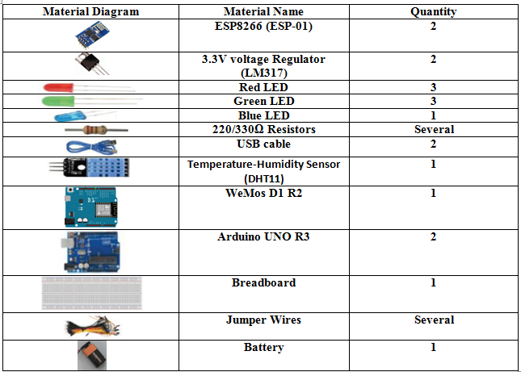

Table 4.: Material Required

**CONNECTION**

**Schematic**

**Serial Communication between Console 1 & Console 2 : The connection includes ESP - 01** **and DHT11 Temperature & Humidity Sensor**

**along with Arduino UNO Boards 🡪**

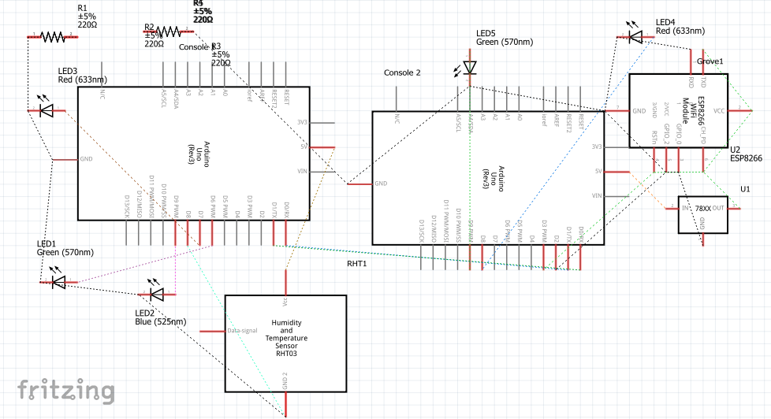

**Console 3 : The connection includes ESP -01 connected with WeMos D1 R2** **that communicates wirelessly with Console 2 (Arduino UNO) 🡪**

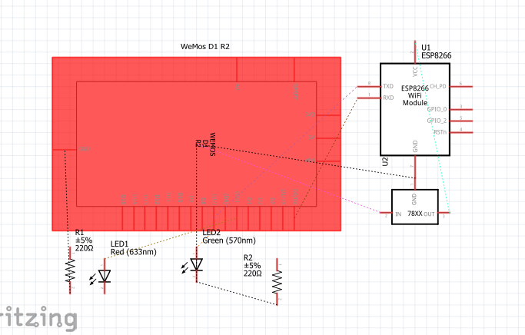

**Connection Diagram:**

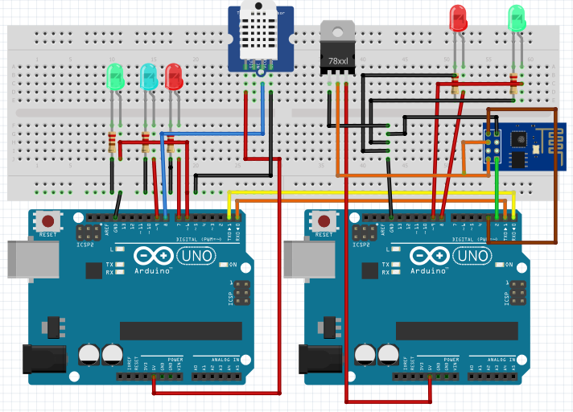

Figure 4.6 : Console 1 - Console 2 Connected Serially

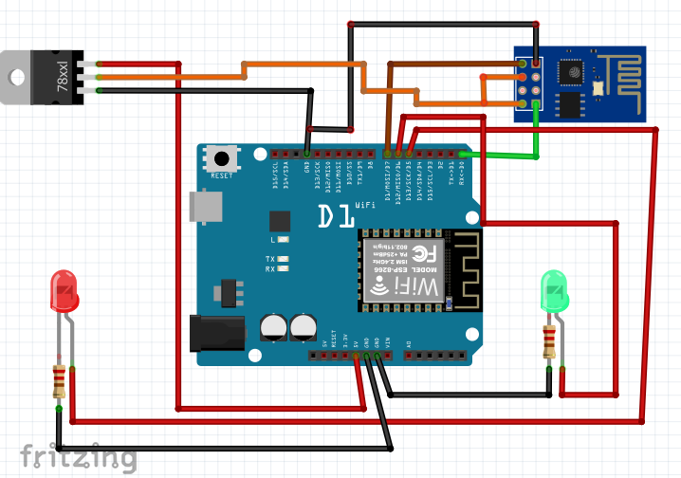

**Sample Code:**

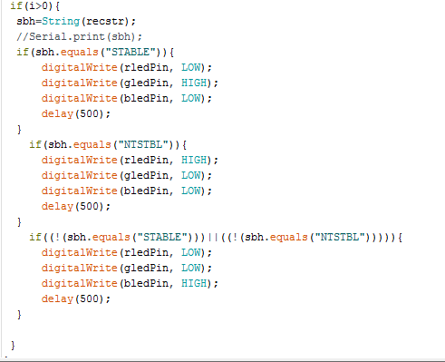

Code Sample 4.1: Console 1 code of concept for acknowledging data sent from Console 2

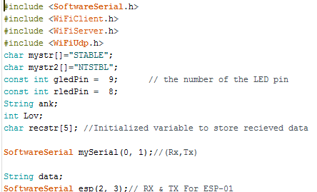

Code Sample 4.2: Console 2 concept of receiving data from Console 1 through serial ports and then broadcasting it to Console 3 wirelessly using ESp8266

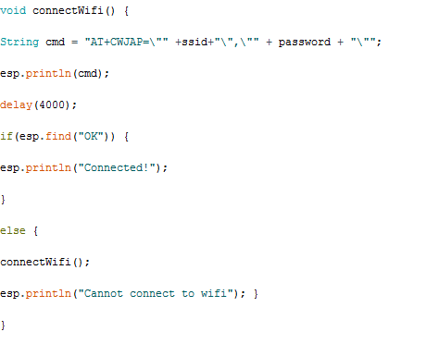

Code Sample 4.3: Console 2 concept of connecting to WiFi of home router using ESP8266

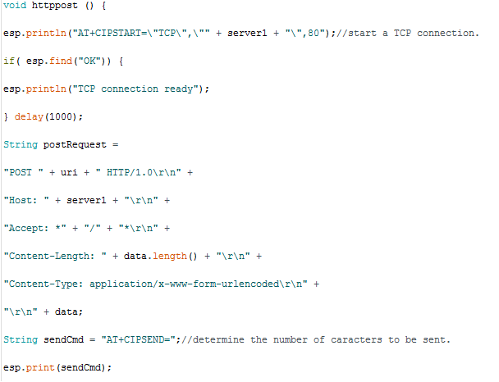

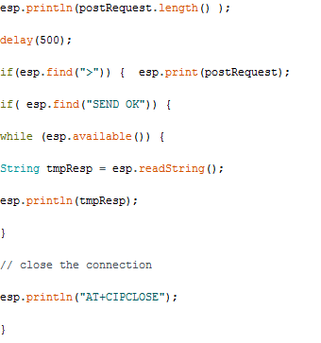

Code Sample 4.4: Console 2 concept of broadcasting Console 1 data received at its end to the static server created by WiFi of home router using ESP8266

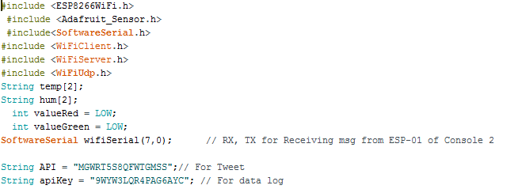

Code Sample 4.5: Console 3 concept of broadcasting data received from console 2 to the static and Web server including Twitter by using WiFi of home router

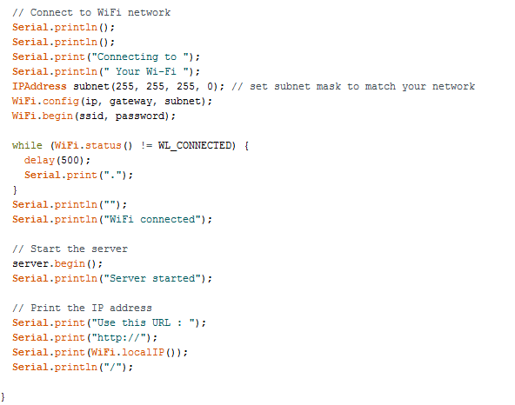

Code Sample 4.6: Console 3 concept of creating a static local server

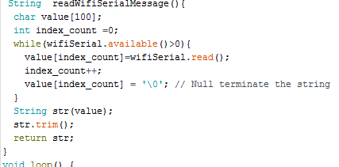

Code Sample 4.7: Console 3 concept of reading the data sent from Console 2 wirelessly using ESP-01

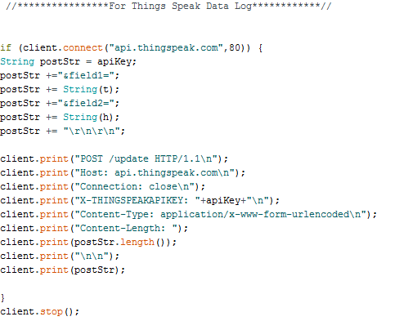

Code Sample 4.8: Console 3 concept of posting the data on ThingSpeak.com

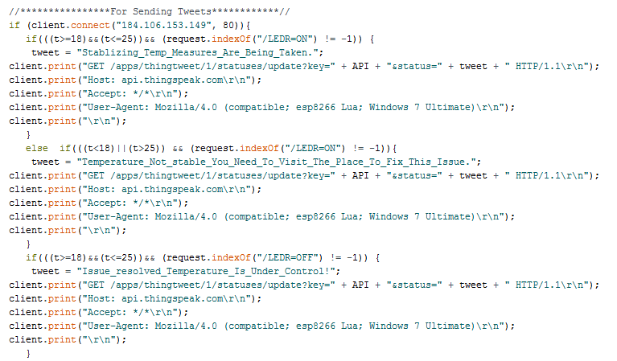

Code Sample 4.9: Console 3 concept of posting tweets using API key of Twitter

**Example Picture:**

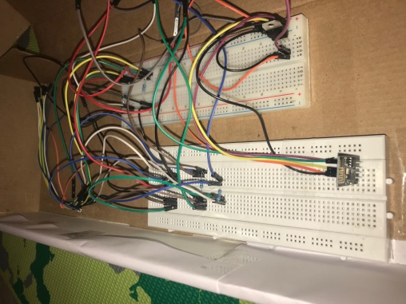 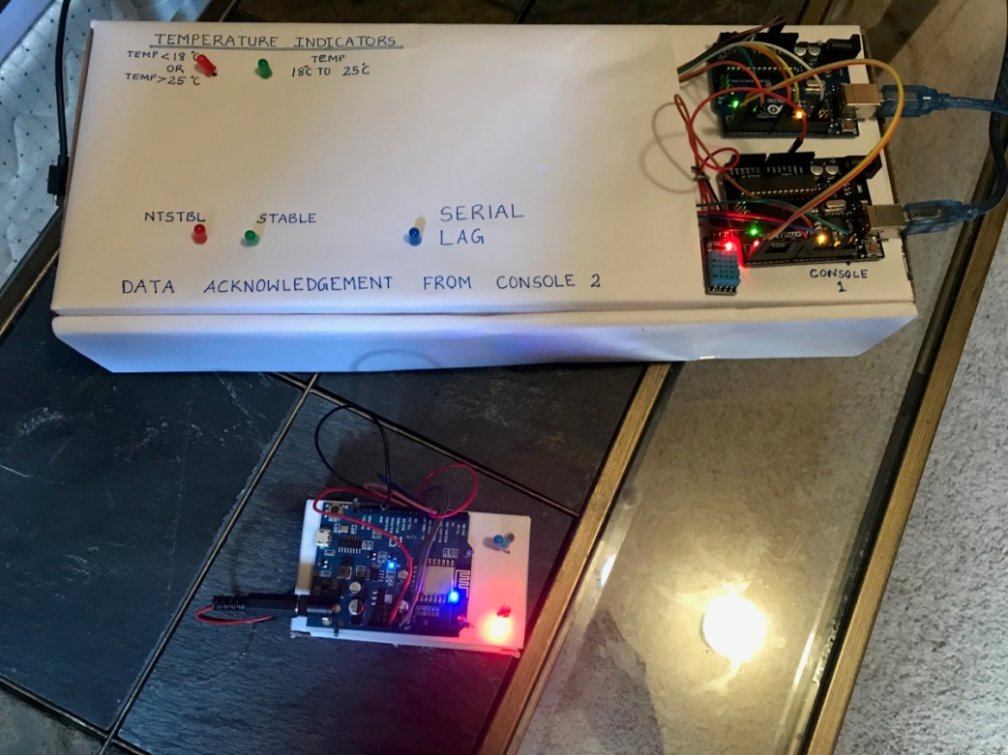

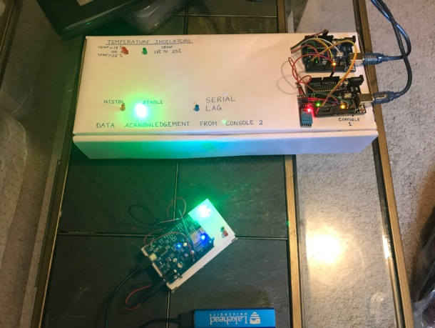 Experiment_Figure 4.1: Box 1 (Inside) Experiment_Figure 4.2: Box 1 - Console 1 and Console 2

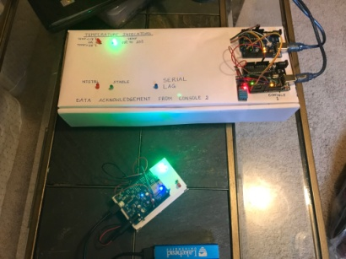

Experiment_Figure 4.4: Console 1 acknowledging the message from Console 2  
& Console 3 acknowledging the data sent from Console 2 simultaneously

Experiment_Figure 4.3: When Temperature is stable  
and is acknowledged by Console 2 and Console 3 simultaneously

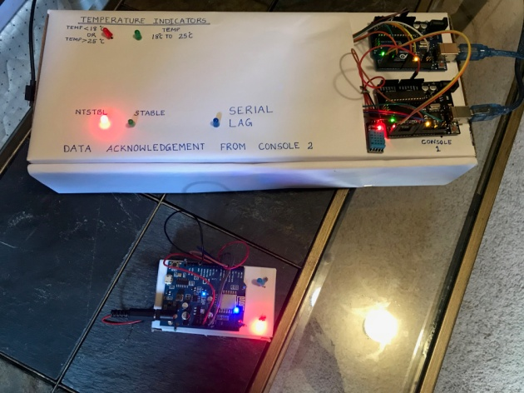 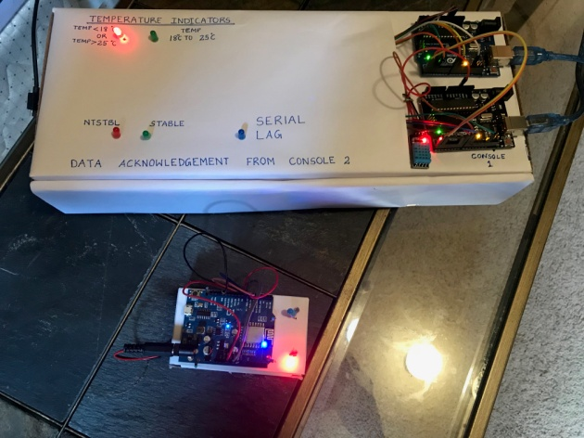

Experiment_Figure 4.5: When Temperature is greater than room temperature (25 degrees)

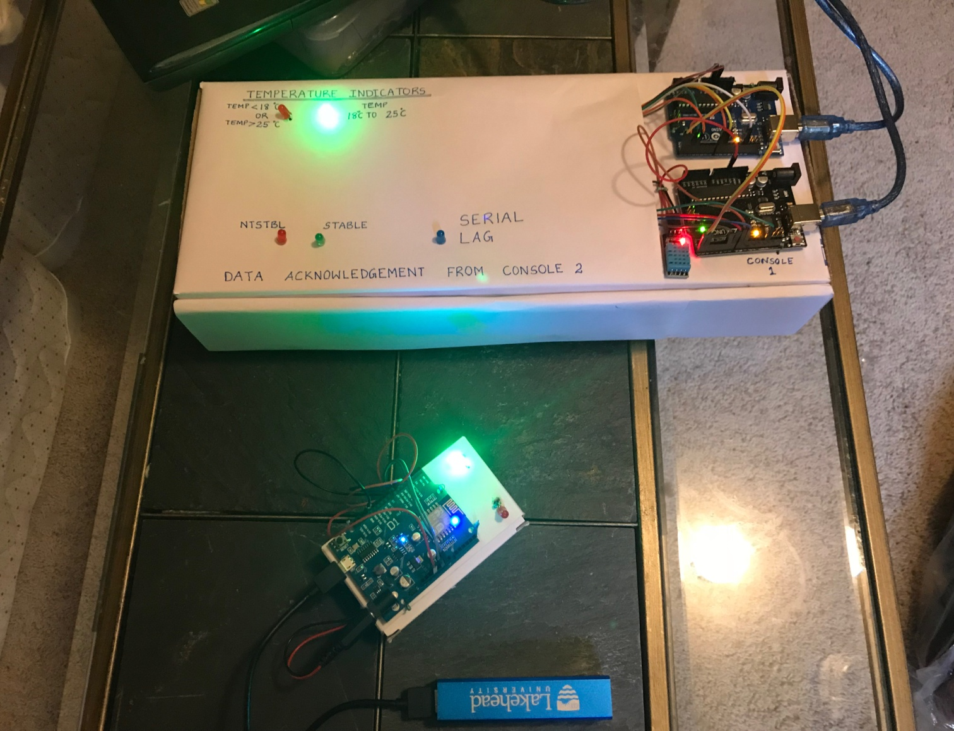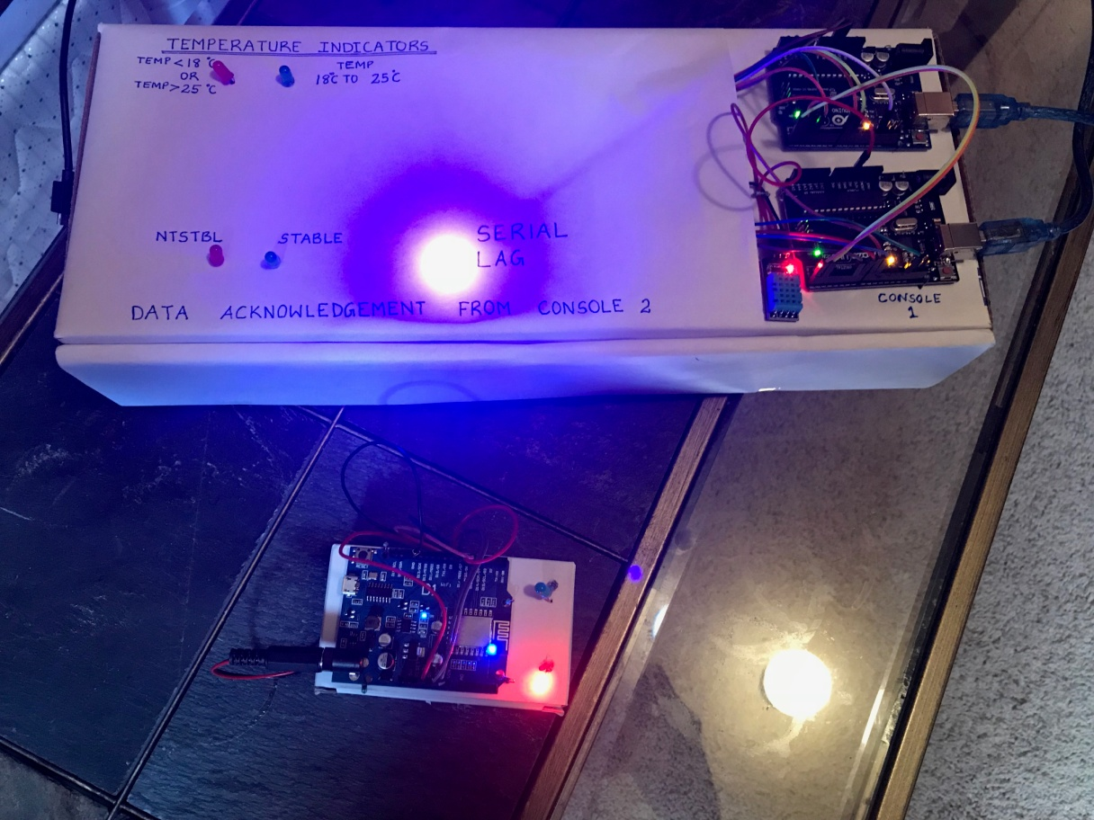

Experiment_Figure 4.6: Different modes of Console 3

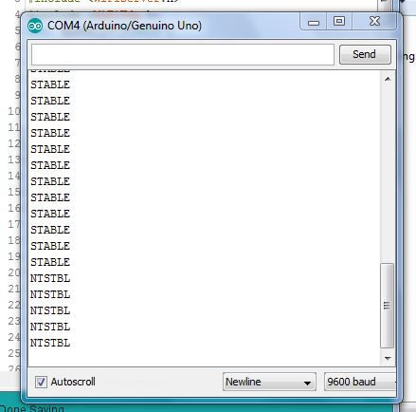

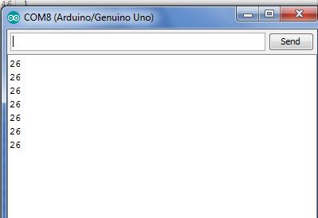

Experiment_Figure 4.7: Temperature data sent from Console 1

Experiment_Figure 4.8: Not Stable Temperature being acknowledged by Console 2

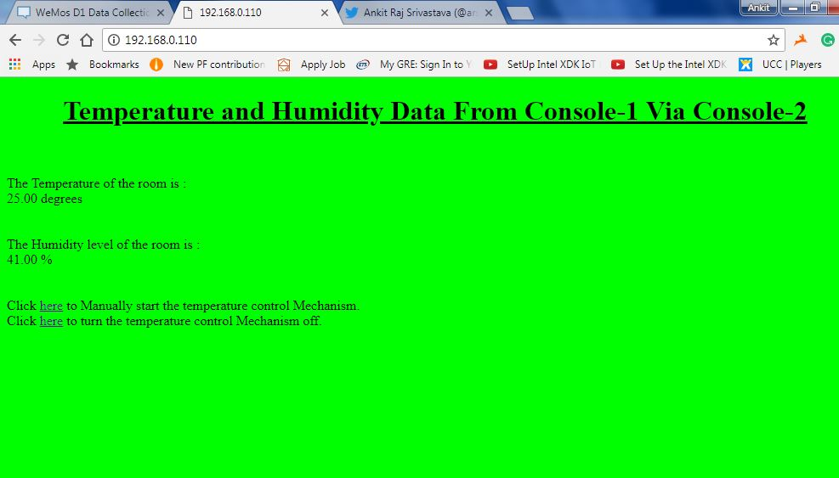

Experiment_Figure 4.9: Static Server (Local)

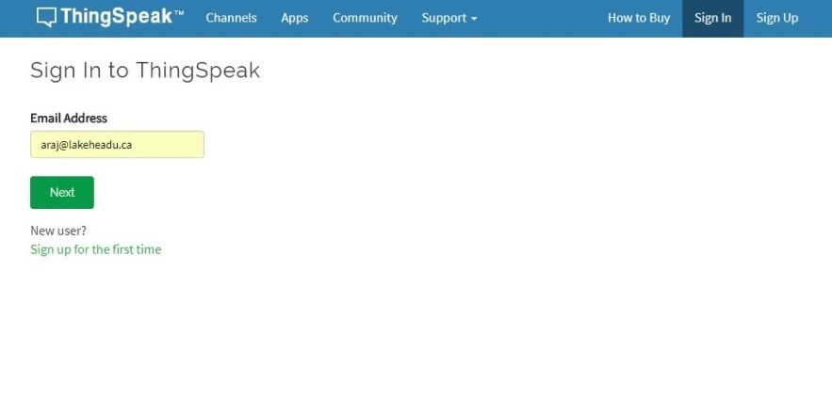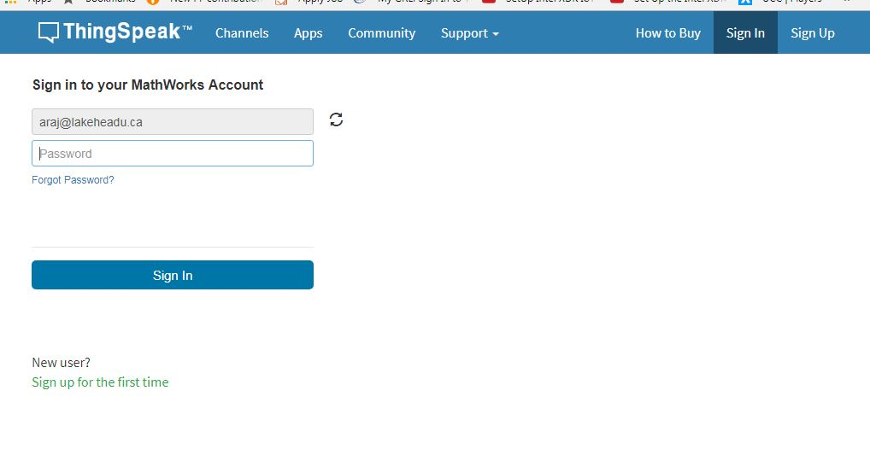

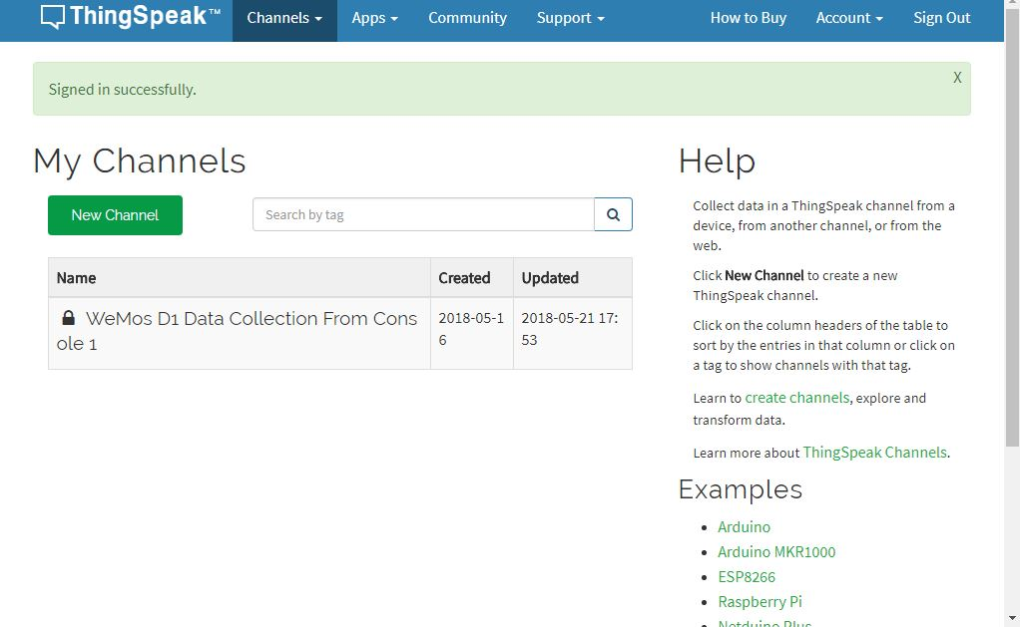

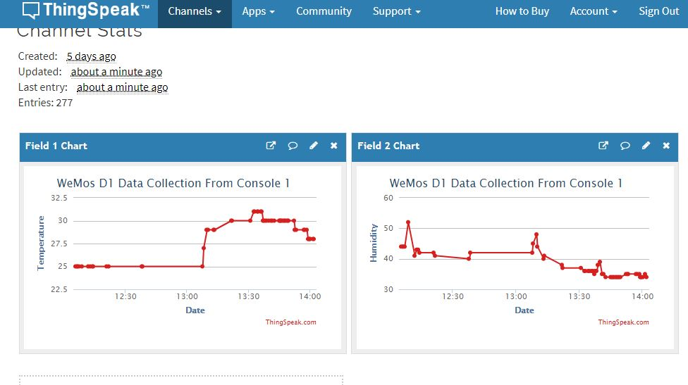

Experiment_Figure 4.0: Data Posted on Web Server of Thingspeak.com

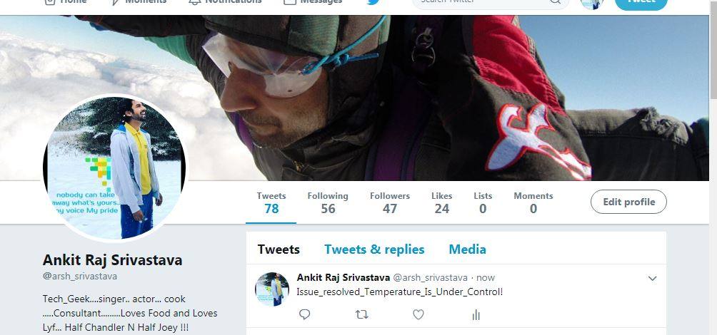

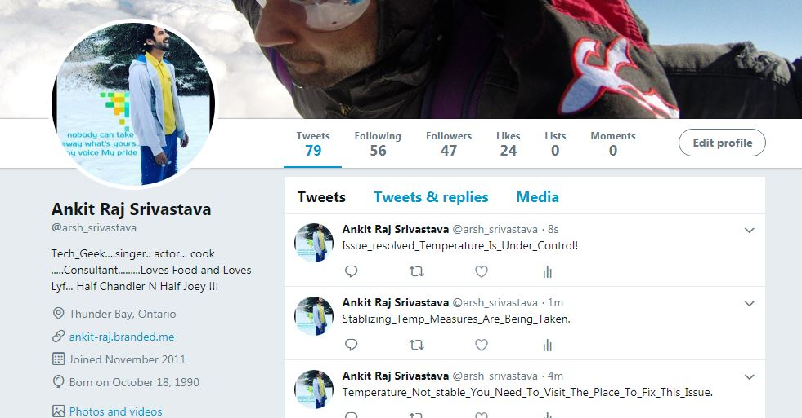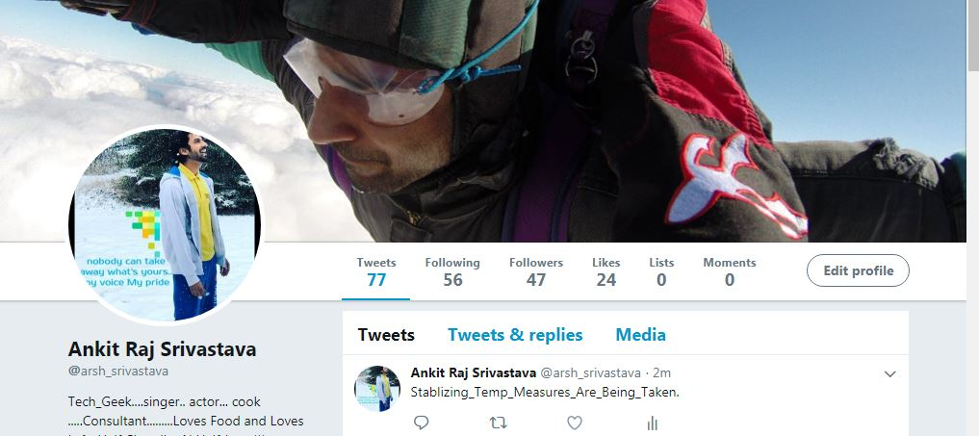

Experiment_Figure4.11: Several Tweets posted based on the interaction with Sensor

**Application effect**

With this application one can create a home automation system keeping Arduino UNO as master controller. In this application temperature sensor note the subsequent data (temperature & humidity) and post it on a server (local and Wed both) using UNO with ESP-01 module and WeMos D1 R2.

**Link for Demo Video:**

<https://www.amazon.ca/clouddrive/share/TXrYbbBl81tV0iJ70ObOyscMNDcglLl46a11lWWxKIz>

**Reference:**

<http://fritzing.org/learning/>