**INTERNATIONAL SCHOOL FOR STUDENTS AND YOUNG SCIENTISTS**

**“EXOPLANETS IN THE BINARY STELLAR SYSTEMS”**

Institute of Astronomy, Russian Academy of Sciences

Pyatnitskaya st., 48, Moscow, Russia

May 30 - June 1, 2016



**Institute of Astronomy,**

**Russian Academy of Sciences**

** Russian Science Foundation**

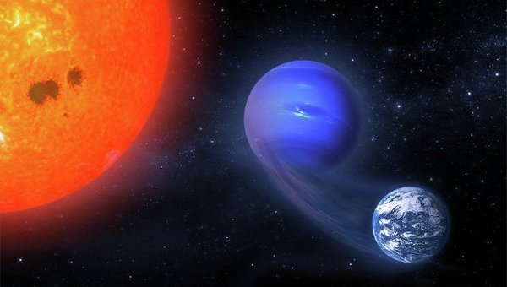

**INASAN, Moscow, 2016**

**The school is organized by**

− Institute of Astronomy, Russian Academy of Sciences

− Russian Science Foundation

**Organizing Committee**

− Shematovich V.I. (Chair, Institute of Astronomy)

− Bisikalo D. V. (Institute of Astronomy)

− Kaygorodov P. V. (Institute of Astronomy)

− Fateeva A.M. (Scientific secretary, Institute of Astronomy)

− Arakcheev A.S. (Institute of Astronomy)

− Cherenkov A.A. (Institute of Astronomy)

The school is organized as a course of invited lectures given by leading

Russian and foreign scientists working in exoplanet sciences, astrophysics of binary stellar systems, kinetic theory of gases, computational fluid dynamics.

**Contact information**

E-Mail: school_exo_2016@inasan.ru

Web-page: http://www.inasan.ru/school-exo-2016

Fateeva Anna +7(9xx)xxxxxxxx (Moscow)

Arakcheev Artem +7(9xx)xxxxxxxx (Moscow)



**Institute of Astronomy,**

**Russian Academy of Sciences**

** Russian Science Foundation**

**INTERNATIONAL SCHOOL FOR STUDENTS AND YOUNG SCIENTISTS**

**“EXOPLANETS IN THE BINARY STELLAR SYSTEMS”**

Institute of Astronomy, Russian Academy of Sciences

Pyatnitskaya st., 48, Moscow, Russia

May 30 - June 1, 2016

**First announcement**

We are pleased to announce that the International School for students and young scientists “Exoplanets in the Binary Stellar Systems” will be held in Moscow on May 30 - June 01, 2015.

**The school is organized by**

− Institute of Astronomy, Russian Academy of Sciences

− Russian Science Foundation

**Organizing Committee**

− Shematovich V.I. (Chair, Institute of Astronomy)

− Bisikalo D. V. (Institute of Astronomy)

− Kaygorodov P. V. (Institute of Astronomy)

− Fateeva A.M. (Scientific secretary, Institute of Astronomy)

− Arakcheev A.S. (Institute of Astronomy)

− Cherenkov A.A. (Institute of Astronomy)

**Preliminary Program**

The school is organized as a course of invited lectures given by leading

Russian and foreign scientists working in exoplanet sciences, astrophysics of binary stellar systems, kinetic theory of gases, computational fluid dynamics.

* **Luca Fossati** - Space Research Institute AAS, Austria

A comprehensive overview of results obtained from multi-wavelength exoplanet transit observations

* **Helmut Lammer** - Space Research Institute AAS, Austria

Exoplanets and their systems: a general view

* **Herbert Lichtenegger** - Space Research Institute AAS, Austria

Non-thermal escape from planetary atmospheres

* **Elke Pilat-Lohinger** - Department of Astrophysics, University of Vienna, Austria

Binary star exoplanets

* **Colin Johnstone** - Department of Astrophysics, University of Vienna, Austria

Mass loss evolution studies...

* **Kristina Kislyakova** - Space Research Institute AAS, Austria

Stellar wind interaction with exoplanets

* **Dmitry V. Bisikalo** - Institute of Astronomy RAS, Moscow, Russia

MHD-modeling of the flows in binaries and planets neighborhoods

* **Andrey G. Zhilkin** - Institute of Astronomy RAS, Moscow, Russia

Numerical simulation of close binary systems with magnetic field

* **Pavel V. Kaygorodov** - Institute of Astronomy RAS, Moscow, Russia

Shock waves in protoplanetary disks of binaries

* **Eugeny P. Kurbatov** - Institute of Astronomy RAS, Moscow, Russia

Turbulence in accretion flows

* **Valery I. Shematovich** - Institute of Astronomy RAS, Moscow, Russia

Dissipation of the planetary atmospheres in the Solar and extrasolar planetary systems

* **Ildar F. Shaikislamov -** Institute of Laser Physics SB RAS, Novosibirsk, Russia

MHD simulation of plasma environment of Hot Jupiter HD 209458b

* **Alexander Cherenkov** - Institute of Astronomy RAS, Moscow, Russia

The Influence of Coronal Mass Ejections on the Gas Dynamics of the Exoplanet Atmosphere

* **Igor I. Alexeev** **and Elena S. Belenkaya** - Skobeltsyn Institute of Nuclear Physics, Lomonosov Moscow State University

Role of the equatorial magnetodisc in the exoplanet magnetosphere dynamics

* **Yaroslav N. Pavluchenkov -** Institute of Astronomy, Russian Academy of Sciences, Moscow

Protoplanetary disks: observations and basic models

* **Igor S. Savanov -** Institute of Astronomy, Russian Academy of Sciences, Moscow

Stellar superflares

Working languages of the school are **English** and **Russian**.

**Contact information**

E-Mail: school_exo_2016@inasan.ru

Web-page: http://www.inasan.ru/school-exo-2016

Fateeva Anna +7(9xx)xxxxxxxx (Moscow)

Arakcheev Artem +7(9xx)xxxxxxxx (Moscow)