**SAMPLE FORMS**

**Super Admin Panel**

**7.1 Admin Login**

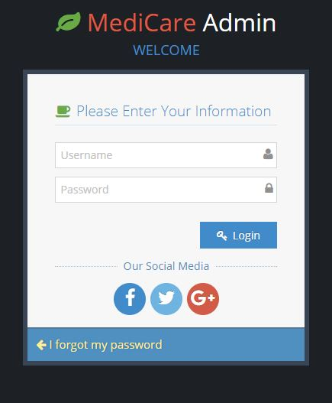

**7.2 Admin Home Page**

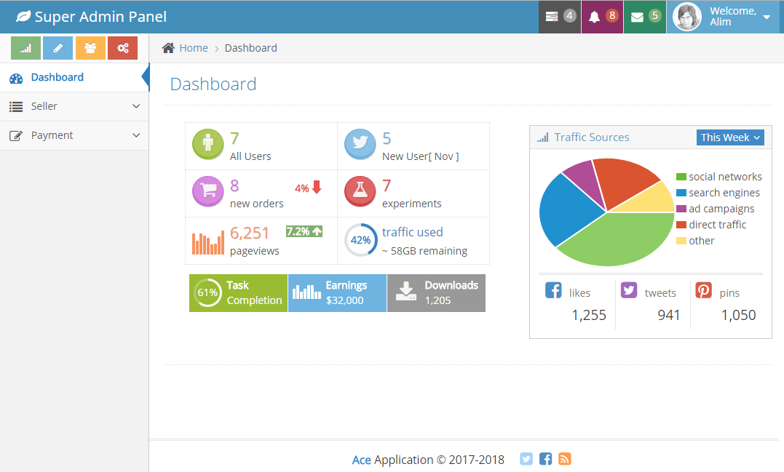

**7.3 View Seller Details**

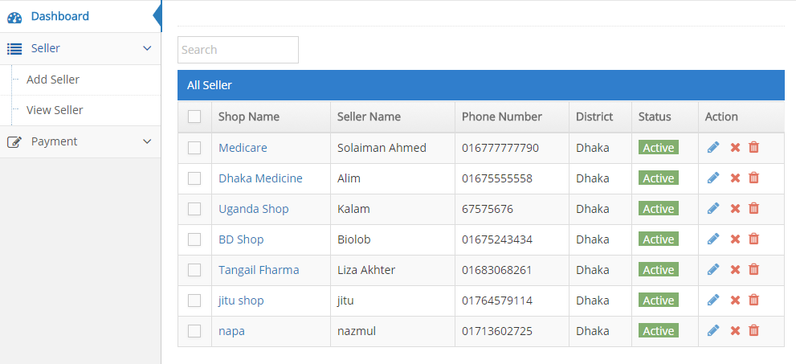

**7.4 Seller Suspended**

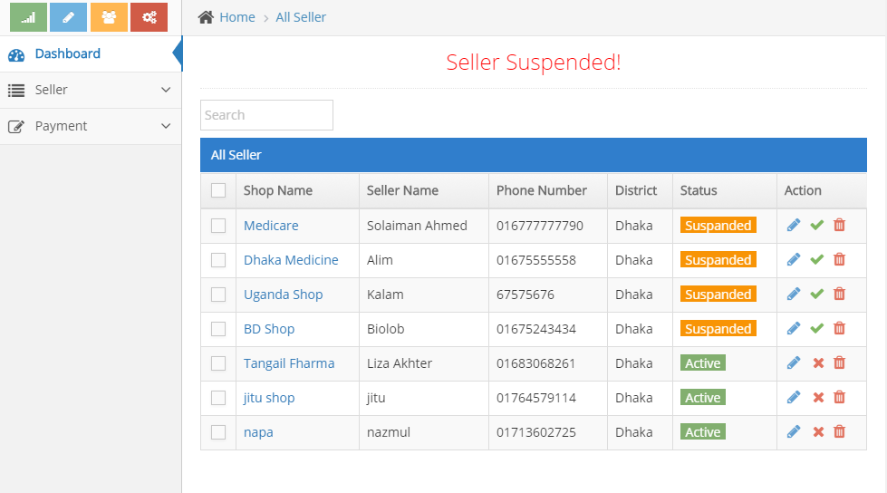

**7.5 Seller Active**

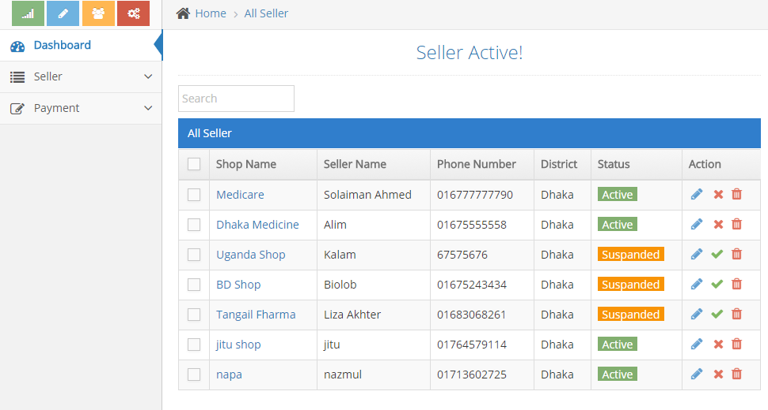

**7.6Add Seller**

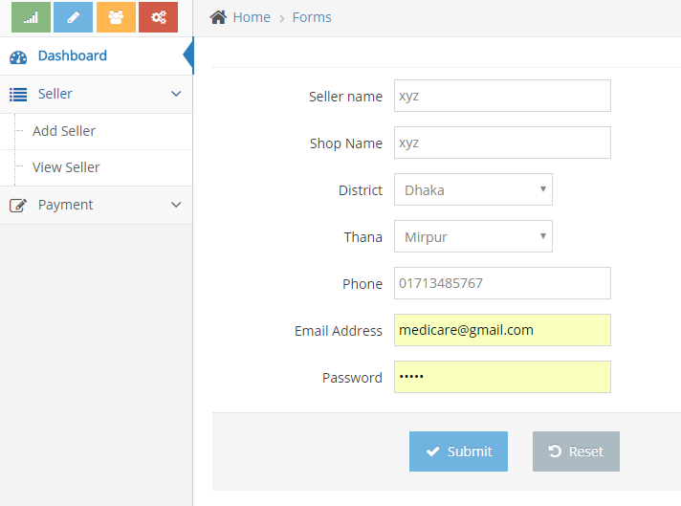

**7.7 Seller Added**

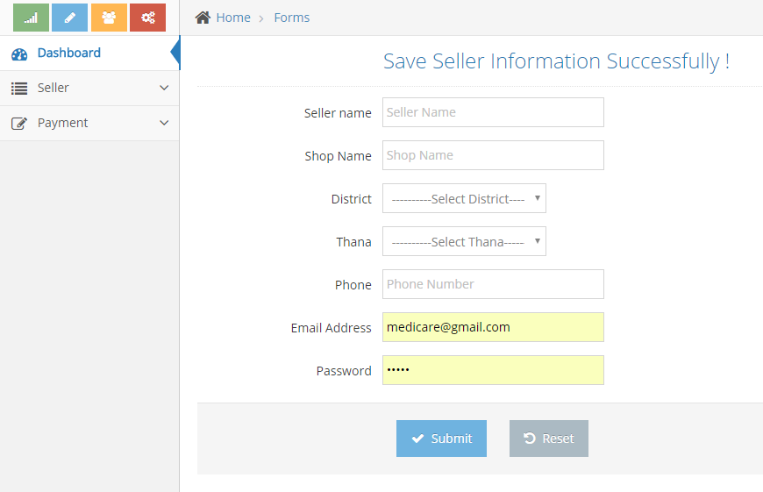

**7.8 Update Seller Data**

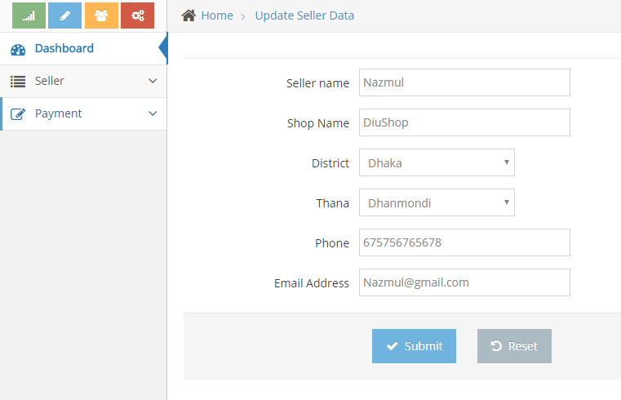

**7.9 Seller Data Successfully Updated**

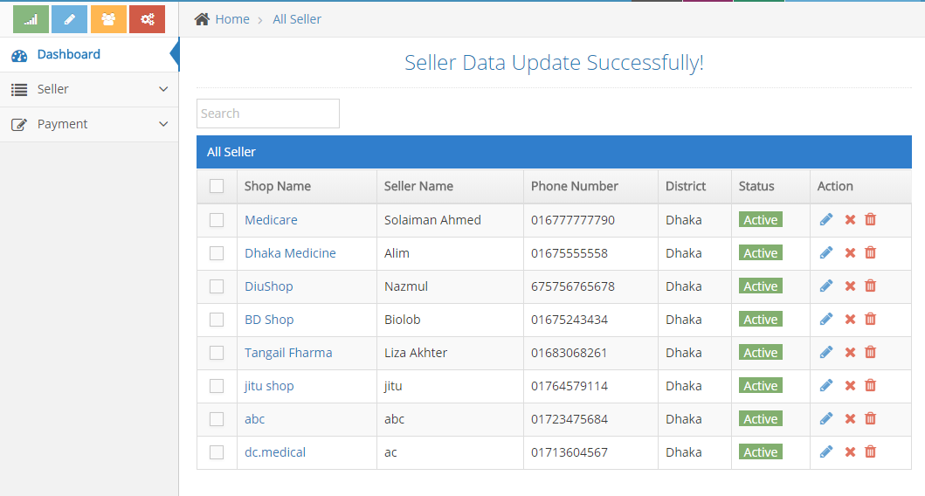

**7.10 Monthly Bill Payment**

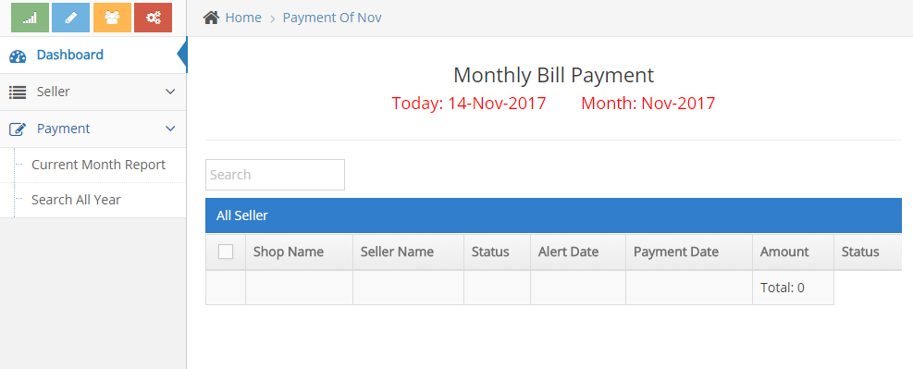

**7.11 Month Wise Payment Report**

