Now the MATLAB side: display info store, D line, exchange option, params.Now compile-checking both sketches with stubs (including fake LCD/Wire libraries).The LCD version is a separate sketch, firmware_node/mg_node_lcd/, and mg_node is untouched. It uses the same node logic files, so its replies to MATLAB are identical. Without an LCD it still runs normally; it just skips the display.
Wiring. I could put both I2C pins on the LED side of the board after all:
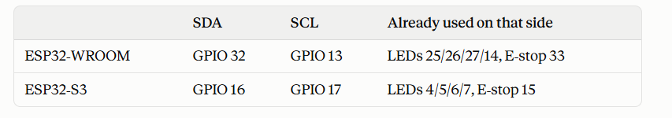
Connect the LCD backpack's VCC to 5 V and GND to GND. The LCD address (0x27 or 0x3F) is detected automatically.
⚠️ Safety: most I2C backpacks pull SDA and SCL up to their supply, which is 5 V, but ESP32 pins are 3.3 V. Use a level shifter, or remove the backpack's two pull-up resistors and fit 4.7 kΩ to 3.3 V instead. Don't use GPIO 12, because the board fails to boot if it's pulled high.
What each LCD shows. It follows your doc. Line 1 is the parameter, line 2 the value and unit, and the pages rotate every 2.5 s. This is from a PC test of the sketch:
- 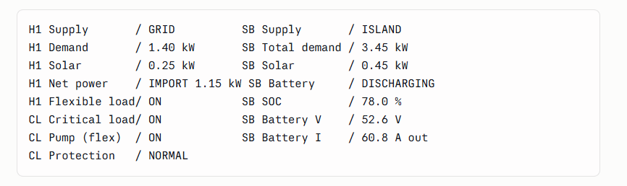Supply shows GRID, ISLAND, ISLAND (SYNC) or OFF. OFF means no voltage at that node, or its critical circuit is open.
- If the main controller goes silent, the Supply page shows "NO MAIN CTRL".
- If the E-stop is pressed, every page shows "E-STOP PRESSED".
How to use it:
- Install the "LiquidCrystal I2C" library by Frank de Brabander from the Arduino Library Manager.
- Flash mg_node_lcd only onto boards that have an LCD.
- In run_hil_nodes.m or run_live_pi.m, list those boards in LCD_NODES, e.g. LCD_NODES = {'H1','SB'};.
The display needs the operating mode and total demand, which aren't in the node's normal messages. So MATLAB sends a small extra "D" line before each tick, only to boards listed in LCD_NODES. Never list a board that runs the plain mg_node: it would reject the D line and the run would stop.
The battery voltage and current are display-only values. The power model doesn't include a DC battery, so I assumed a 51.2 V LiFePO4 pack, with V = 51.2 × (0.95 + 0.10 × SOC) and I = P / V. The assumption is labelled in the params file. If a judge asks, say these are estimated from charge level and power.
Tests so far:
- Both sketches compile with no warnings when built on the PC.
- The LCD sketch printed the pages above for sample H1, CL and SB inputs.
- The node firmware still matches MATLAB on all 835,600 test replies.
- Unit tests 13/13, and scenarios S11–S13 pass.
Not tested: a real LCD on an ESP32. Things to check on the bench: the text contrast (the blue potentiometer on the backpack), the address, and that the LCD library accepts our custom SDA/SCL pins.

