* Most asteroids in between Mars and Jupiter some classes cannot be detectable there
* Near earth asteroids are from 1 – 1.5 AU (0.149 to 0.224 billion kilometers)

A Type

* Minimum near 1um
* Olivine and metal or pure olivine
* Scaled to 1 at 0.55um, 52 colour survey  
  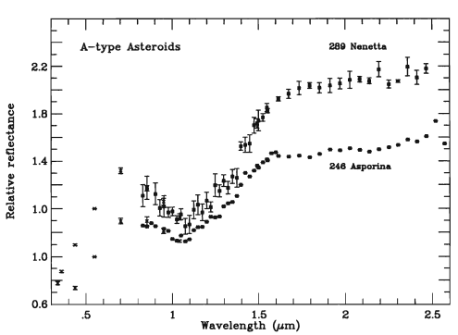

B, C, F, G Type

* Flat and featureless spectra
* G type may aluminium based components on them
* C, B, G type shown to have hydrated phyllosilicates on them
* C type have different 3 um ranges based on the composition

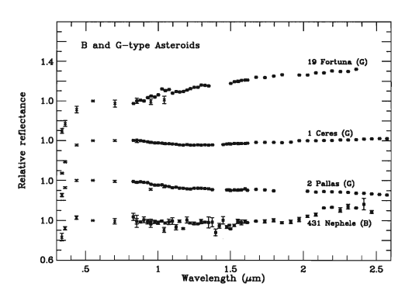

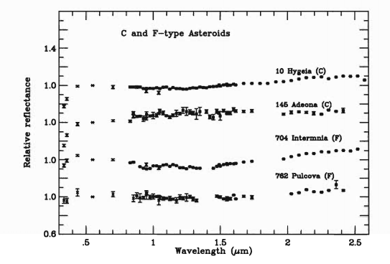

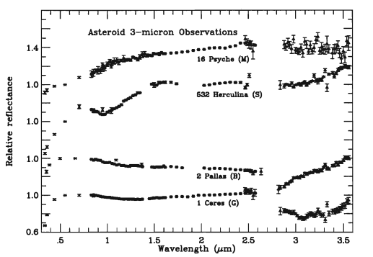

D, P, T, E Type

* Spectra properties not yet known
* Features in 3um range
* E Type has higher albedos

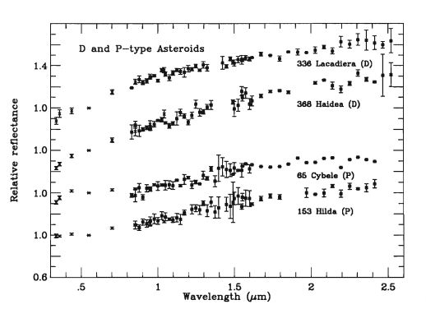

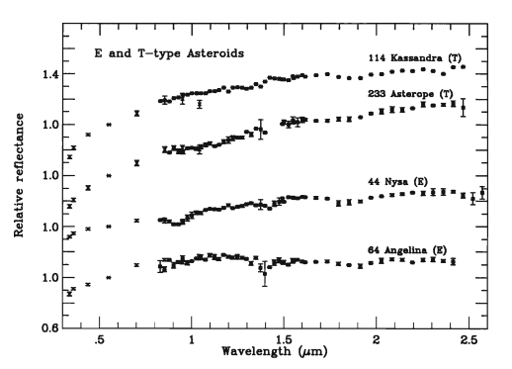

M Type

* Spectral features on 3um absorption features
* Water, iron, silicate components

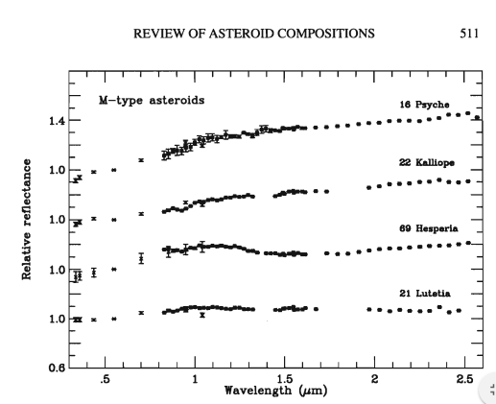

Q Type

* Absorption features at 1um
* Olivine, pyroxene present
* Near earth

R Type

* Absorption features at 1um and 2 um
* Olivine, pyroxene

V Type

* Spectrum absorption at 1um, 1.25um and 2um
* Olivine and pyroxene

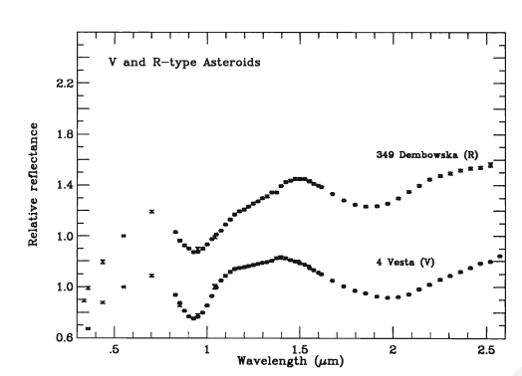

S Type

* Absorption features in 1um and 2 um
* Olivine and pyroxene
* Inner main belt

