1. Attachment feature does not work properly

* When a picture is uploaded... it does not show that it is uploaded
* You do not know it is uploaded unless you press enter

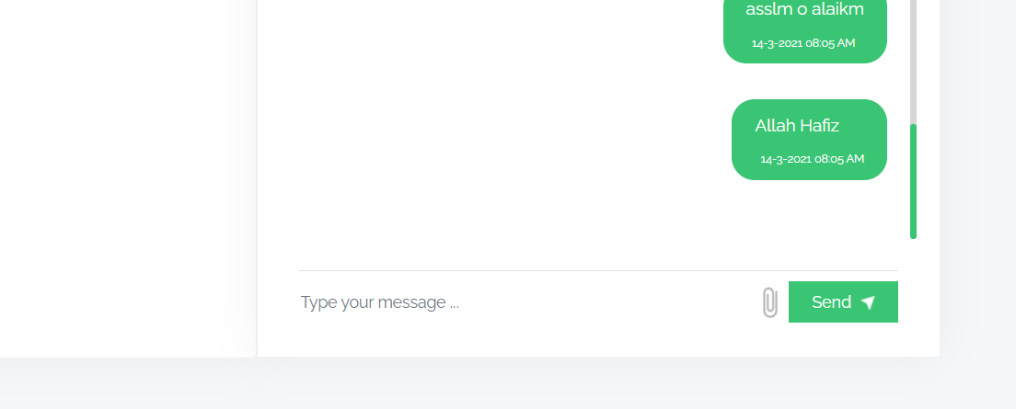

1. Please add an emoji option next to the attachment

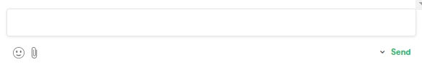

1. Need option to add spaces to the message

* By pressing Shift and Enter
* Let me know if you have any questions on what I mean about this.

1. Update Format from 2days to: 2 days

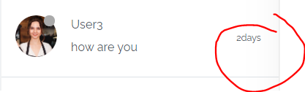

1. Update wording and spacing from ALL CONVERSATION(2) to: ALL CONVERSATIONS (2)

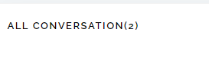

1. Add: Last Seen 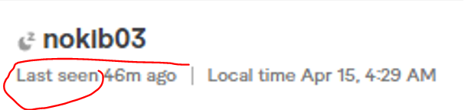
2. Need to add Date and Local time to this as well

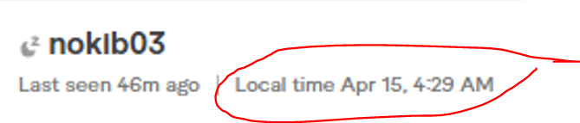

1. Date is incorrect

* Currently showing March

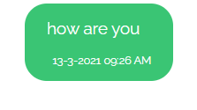

1. Update the date format to: month date year

4-14-2021

1. Remove the 0 from the time

* For example, if it is 9 o’clock – it I’ll be 9:26 AM or 9:26 PM

1. Update inside the search to: search messages...

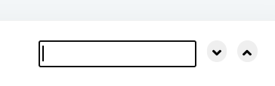

1. Please update the flow to look more like this..

* Where you can see the profile picture, time and date.
* And remove the green and blue bubbles for conversation.

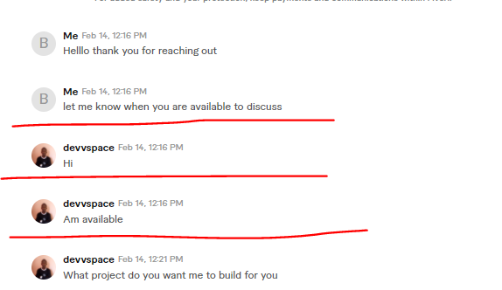

1. When this is updated, this should reflect current reviews and languages.

