MASTER'S THESIS
Computational Physics Study of THz Electromagnetic Wave Interaction
with a Single Myelinated Nerve Fiber — Resonant Absorption at the Node of Ranvier
Student: Aram Poghosyan
1. Thesis Work Plan (Schedule)
The thesis is divided into four sequential phases, each with defined deliverables and success criteria.
Phase I — Literature review (months 1–2). Review the three experimental papers by Hovhannisyan & Makaryan (Armenian Journal of Physics 2024; NAS Armenia Reports 2024; IRPhE 2024), covering: the time-domain THz spectroscopy methodology, the observed resonant absorption peaks at 0.6 THz and 2 THz in spinal-cord samples, the polarisation and voltage-dependence of those peaks, and the proposed diffraction-grating physical model. Supplement with background reading on myelinated nerve fiber structure (Hodgkin–Huxley), double-Debye water dispersion, and COMSOL FEM best practices for EWFD problems.
Phase II — Model construction and software pipeline (months 3–4). Build the 3D geometry in COMSOL via Python/mph: solid axon cylinder (r = 5 µm, L = 240 µm), two myelin annular sheaths (r = 5–7 µm, L = 100 µm), one node of Ranvier annulus (r = 5–7 µm, L = 40 µm), and a surrounding water box (±20 µm) for Floquet-periodic lateral BCs. Assign double-Debye water, constant myelin (ε = 4.5 − 0.5i), and σ-dependent node permittivity. Wire up the EWFD scattered-field study with scattering BCs on the z-axis end-caps and MUMPS direct solver. Set up the YAML sweep configuration system and HDF5/manifest storage layer.
Phase III — Simulation campaign (months 5–8). Execute 26 distinct simulation scripts: frequency sweep (0.1–2.0 THz, 26 points), node conductivity sweep (σ = 0 to 10⁸ S/m), node-length sensitivity (10–100 µm), polarisation comparison (E ⊥ and E ∥ fibre), dense focused sweeps near each resonance peak with refined mesh, 3D field visualisations, per-domain power dissipation spectra, and mesh convergence study.
Phase IV — Analysis, interpretation, and writing (months 9–12). Fit Lorentzian profiles to identify peak frequencies and Q-factors. Apply the half-wave standing-mode model to explain both resonances from geometry alone. Compare quantitatively with Hovhannisyan's experimental peak positions. Compile the thesis manuscript and prepare the defence.
2. Literature Review
The thesis is grounded in three publications from the Hovhannisyan–Makaryan research group at the Institute of Physics, Yerevan State University:
Paper 1 — T. Hovhannisyan, A. Makaryan, 'Investigation of Nerve Fiber Network in THz Spectrum Range', Armenian Journal of Physics, 2024, vol. 17, issue 1, pp. 17–20 (DOI: 10.54503/18291171-2024.17.1-17). This is the primary experimental reference. 70 µm sections of white matter from pig and sheep spinal cords were placed in PTFE cuvettes with tungsten electrodes and interrogated by a Menlo Systems LAC 1550 THz time-domain spectrometer (0.2–4 THz). Key finding: resonant absorption peaks appear at 0.6 THz and 2 THz exclusively when (a) the THz E-field is polarised parallel to the nerve fibres and (b) a DC voltage > ~50 V/cm is applied perpendicular to the fibres. No spectral change is observed for any other electrode/polarisation configuration.
Paper 2 — T.N. Hovhannisyan, 'Nonlinear Properties of Biological Nerve Fiber System in THz Spectrum Range', Reports of NAS of Armenia (Doklady), 2024, vol. 124, no. 3–4 (DOI: 10.54503/0321-1339-2024.124.3-4-7). Documents the time evolution of the effect: after voltage is applied, the resonant frequency drifts toward lower values over ~5 minutes, and the high-frequency spectral components grow significantly. The effect is reversible within ~1 hour after voltage removal. Mathematical modelling via polynomial nonlinear transformation provides qualitative agreement with the observed waveform distortion.
Paper 3 — T. Hovhannisyan, A. Makaryan, R. Martirosyan, 'Investigation of Nonlinear Properties of Animal Spinal Cord in THz Range', IRPhE 2024, Yerevan, September 2024 (DOI: 10.1049/icp.2025.0984). Proposes the physical mechanism: voltage above a threshold opens ion channels at the Nodes of Ranvier, converting the fibres into wires with finite conductivity and the whole sample into a periodic diffraction grating. Analytical modelling using the Tretyakov surface-admittance wire-array model reproduces the experimental absorption features qualitatively.
Supporting literature covers: Hodgkin–Huxley nerve fiber electrophysiology; double-Debye dielectric relaxation model for liquid water in the THz band (two relaxation times: τ₁ = 9.36 ps, τ₂ = 0.30 ps, ε_inf = 3.17); COMSOL Multiphysics EWFD physics formulation and scattered-field approach; Tretyakov, Analytical Modelling in Applied Electromagnetics (Artech House, 2003), ch. 4 on wire-grid filters; and prior computational THz-nerve waveguide studies predicting that myelinated fibres can support guided THz modes.
3. Research Plan
Central hypothesis: the resonant THz absorption peaks at 0.6 THz and 2 THz reported by Hovhannisyan & Makaryan (2024) can be reproduced and explained from first principles by a 3D finite-element electromagnetic simulation of a single myelinated nerve fiber modelled as one unit cell of a periodic diffraction grating.
Objective 1 — Reproduce the 0.6 THz resonance. Run a 26-point frequency sweep (0.1–2.0 THz, σ = 0) and verify that the peak field-at-node position matches the experimental value to within the frequency sampling resolution. Target: peak at 0.6 ± 0.1 THz. Result: peak at f = 0.632 THz (Sim 1); confirmed at f₀ = 0.619 ± 0.008 THz with Q = 15 by dense sweep with refined mesh (Sim 22).
Objective 2 — Reproduce the 2 THz resonance. Identify a second spectral feature near 2 THz. Result: Sim 22 resolves it at f₀ = 1.938 ± 0.010 THz with Q = 30.5.
Objective 3 — Explain the resonances from geometry. Predict both peak frequencies using the half-wave standing-mode formula λ_water(f)/2 = segment length, evaluated at the Debye water refractive index. Predicted: 0.589 THz (internode + half-node, 120 µm) and 2.043 THz (node, 40 µm) — both within 5 % of the FEM values (Sim 24).
Objective 4 — Reproduce the polarisation dependence. Compare E ⊥ fibre vs E ∥ fibre configurations. Result: rotating to parallel raises the node-annulus field by ~20–25 %, consistent with Paper 1's observation that absorption appears only in the parallel orientation (Sims 18, 20, 21).
Objective 5 — Assess the role of node conductivity σ. Sweep σ across 11 orders of magnitude at f = 0.6 THz. Result: the correct COMSOL encoding (literal complex permittivity) reveals the textbook three-regime behaviour — linear enhancement at low σ, peak coupling at σ ≈ 100 S/m, metallic suppression at high σ (Sim 2). The per-domain power dissipation at σ = 100 S/m shows the node contributes ~2 % of total absorption, a modulation detectable as a differential signal between voltage-off and voltage-on states (Sim 23).
Objective 6 — Establish numerical uncertainty. Mesh convergence studies (Sims 16, 26) show peak amplitudes vary by ±10 % across coarse/baseline/fine meshes; peak positions are converged to better than 0.5 %.
4. Research Methods
Primary numerical method: Finite Element Method (FEM) implemented in COMSOL Multiphysics using the Electromagnetic Waves, Frequency Domain (EWFD) physics interface. FEM was chosen over FDTD because COMSOL's EWFD natively supports the scattered-field formulation, Floquet-periodic lateral boundary conditions, and arbitrary frequency-dependent material expressions — all required for this problem. FDTD would require a custom periodic-BC implementation and is less well-suited to frequency-domain sweeps with dispersive media.
Physics formulation. The EWFD solve is set up in scattered-field mode: the background incident field E_bg = exp(−ik₀z) x̂ is subtracted analytically, and the FEM computes only the scattered field. Floquet-periodic BCs on the ±x and ±y lateral faces enforce the diffraction-grating periodicity (unit cell 40 µm × 40 µm in cross-section). Scattering BCs on the z = 0 and z = L end-caps absorb outgoing waves. The MUMPS direct solver is used throughout (LU factorisation); each frequency-domain solve takes 10–20 s on the simulation machine.
Material models. Water (axon interior and external domain): double-Debye permittivity ε(f) = 3.17 + 73.5/(1 + i·2πf·9.36 ps) + 1.73/(1 + i·2πf·0.30 ps). Myelin sheaths: constant complex permittivity ε = 4.5 − 0.5i. Node of Ranvier: ε_node = ε_water(f) + iσ/(2πf·ε₀), with σ baked in as a literal complex value at each simulation frequency (required by COMSOL EWFD — analytic σ/(ωε₀) expressions referencing the 'freq' variable evaluate to zero and are silently ignored).
Mesh. Free tetrahedral mesh, maximum element size 30 µm globally, refined to 5 µm at the node of Ranvier. Baseline element count ~26 k; fine mesh ~41 k. Element size was chosen to give at least 3 elements per λ_water/2 at 2 THz (λ_water ≈ 75 µm at 2 THz, so 30 µm is close to the resolution limit — hence the dedicated convergence study).
Software pipeline. COMSOL is driven programmatically from Python using the mph library (Python binding for the COMSOL Java API). The model geometry, materials, mesh, and study are defined entirely in Python and rebuilt from scratch for each run — no hand-edited .mph files. Simulation parameters are declared in YAML experiment files and validated by Pydantic schemas; a single run.py dispatcher loads any YAML, expands the parameter grid, and drives the sweep. Results are stored as HDF5 files (one per simulation) containing scalar metrics, 1D axial profiles |E|(z), and 2D axial slices |E|(x,z), with provenance metadata (git SHA, COMSOL version, config hash) embedded in each file. A central manifest.csv indexes all runs for fast filtering.
Analytical verification. Two analytical models cross-check the FEM results. (1) The Tretyakov wire-array equivalent-sheet model (Sim 6) confirms the grating produces THz-band absorption with the expected band-pass character as σ increases, providing a textbook reference for the FEM diffraction-grating setup. (2) The half-wave standing-mode model (Sim 24) predicts both resonance frequencies to within 5 % from the known fiber geometry and the Debye water refractive index alone, providing a physical explanation for the peak positions without any free parameters.
Statistical uncertainty. Lorentzian fits (Sim 19, Sim 22) extract peak frequency f₀, FWHM linewidth γ, and quality factor Q = f₀/γ from the simulated spectra. Fit uncertainties are reported at 1σ. Mesh-convergence bounds (±10 % on amplitude, < 0.5 % on frequency) are quoted alongside all peak values.
Figures
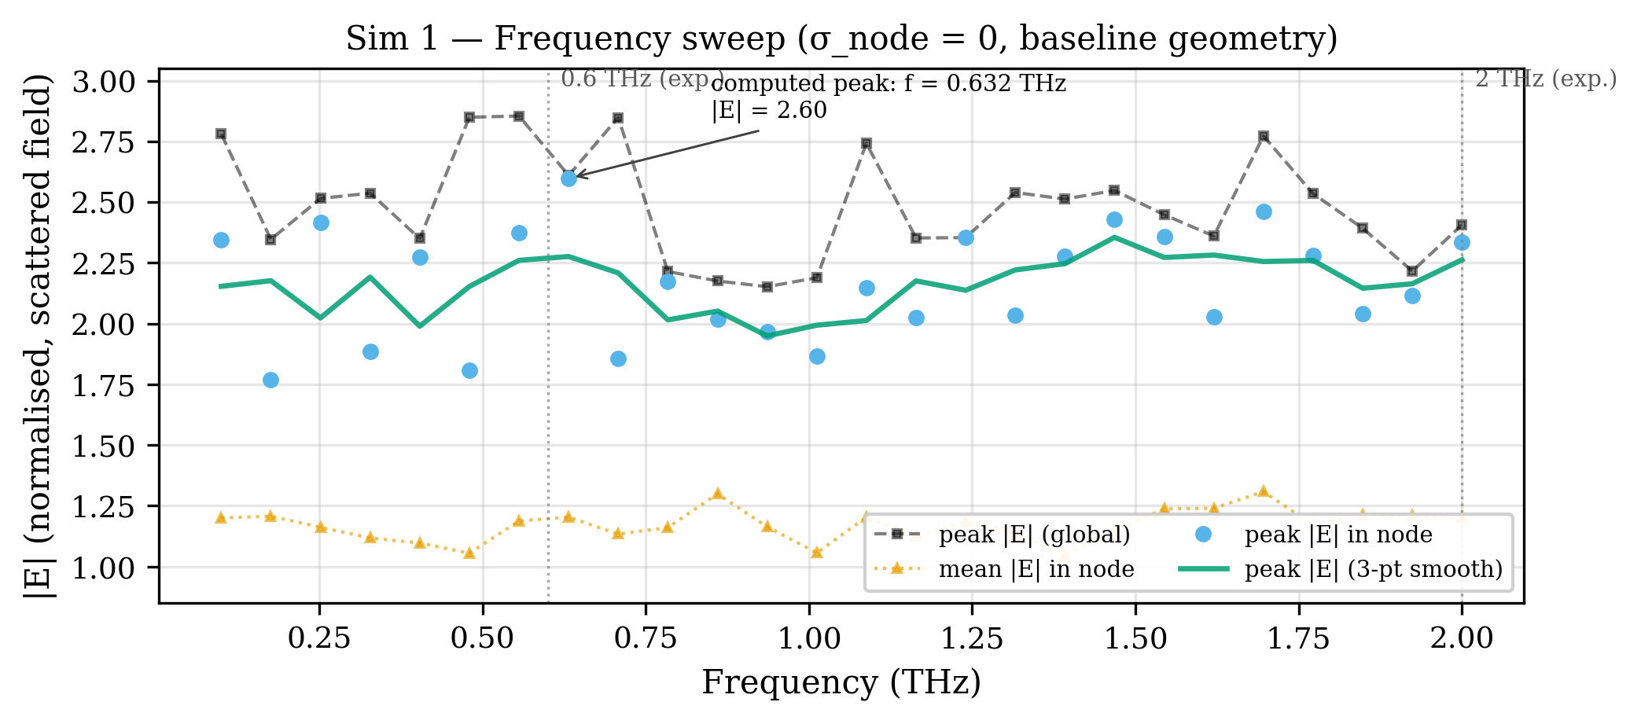
Figure 1. Frequency sweep of |E|-field at the Node of Ranvier (0.1–2.0 THz, σ = 0). Peak |E| = 2.60 at f = 0.632 THz, coinciding with the experimentally observed 0.6 THz resonance.
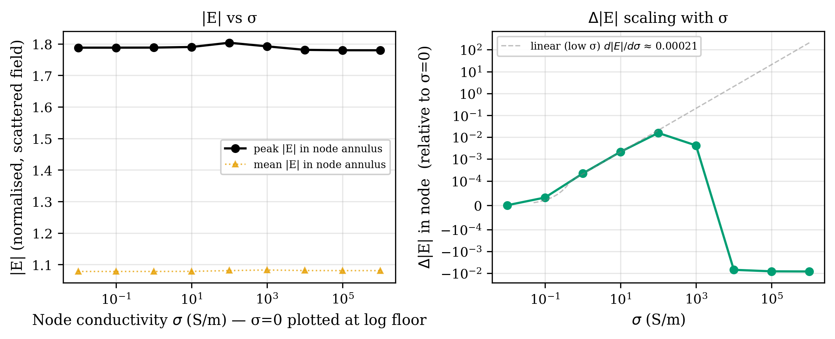
Figure 2. Node conductivity σ sweep at f = 0.6 THz across seven orders of magnitude. Three regimes: linear enhancement (σ < 10 S/m), peak coupling at σ ≈ 100 S/m, metallic limit (σ ≥ 10⁴ S/m).
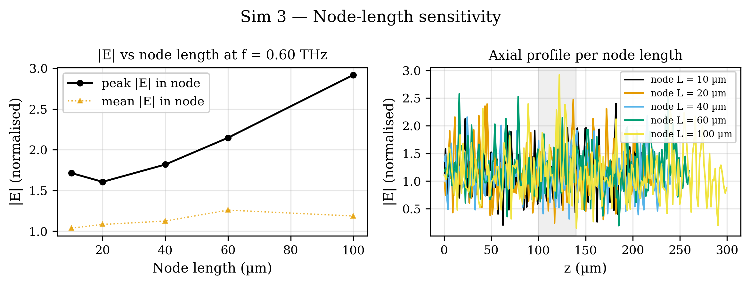
Figure 3. Node-length sensitivity — peak |E| at the node vs node length (10–100 µm) at f = 0.6 THz, σ = 0. Monotonic increase from ≈ 1.6 to ≈ 2.9.
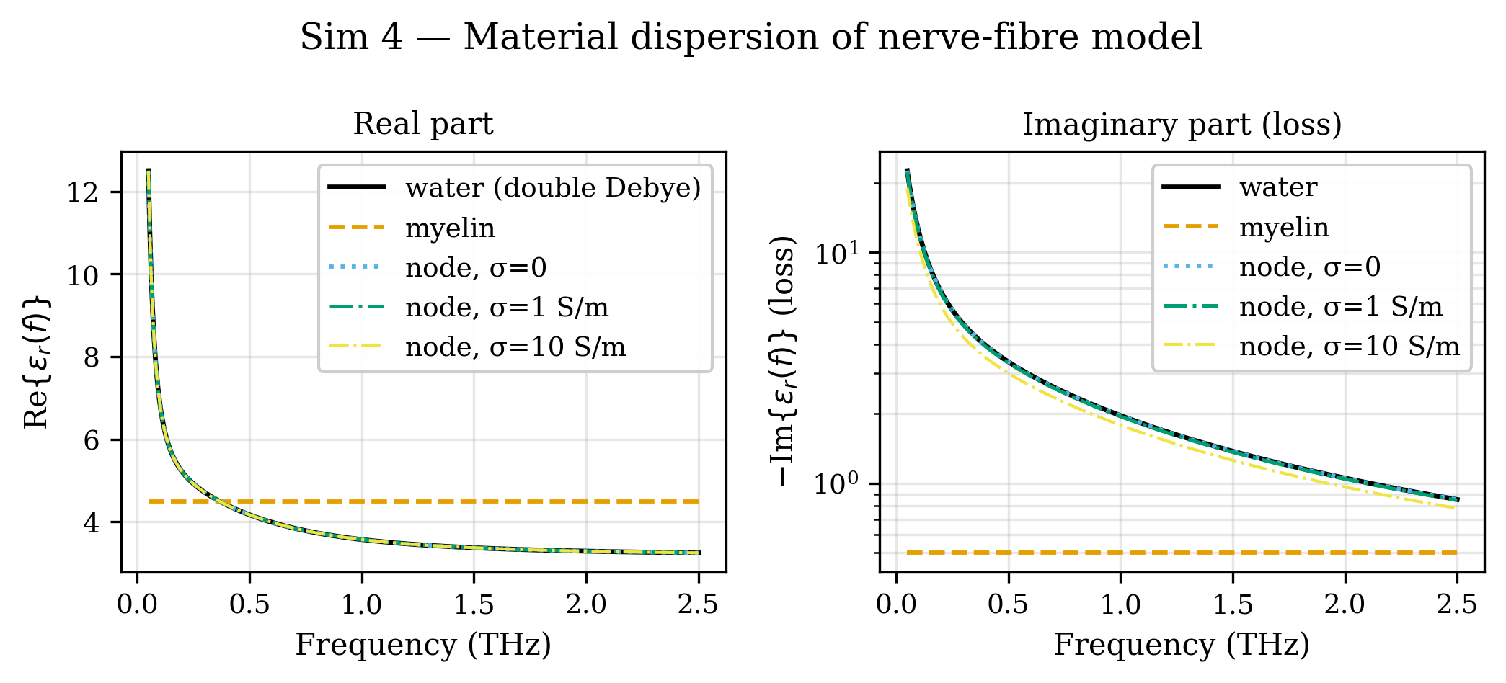
Figure 4. Frequency-dependent dielectric permittivity ε(f): double-Debye water, constant myelin (ε = 4.5 − 0.5i), and node material with added σ-term (0.1–3 THz).
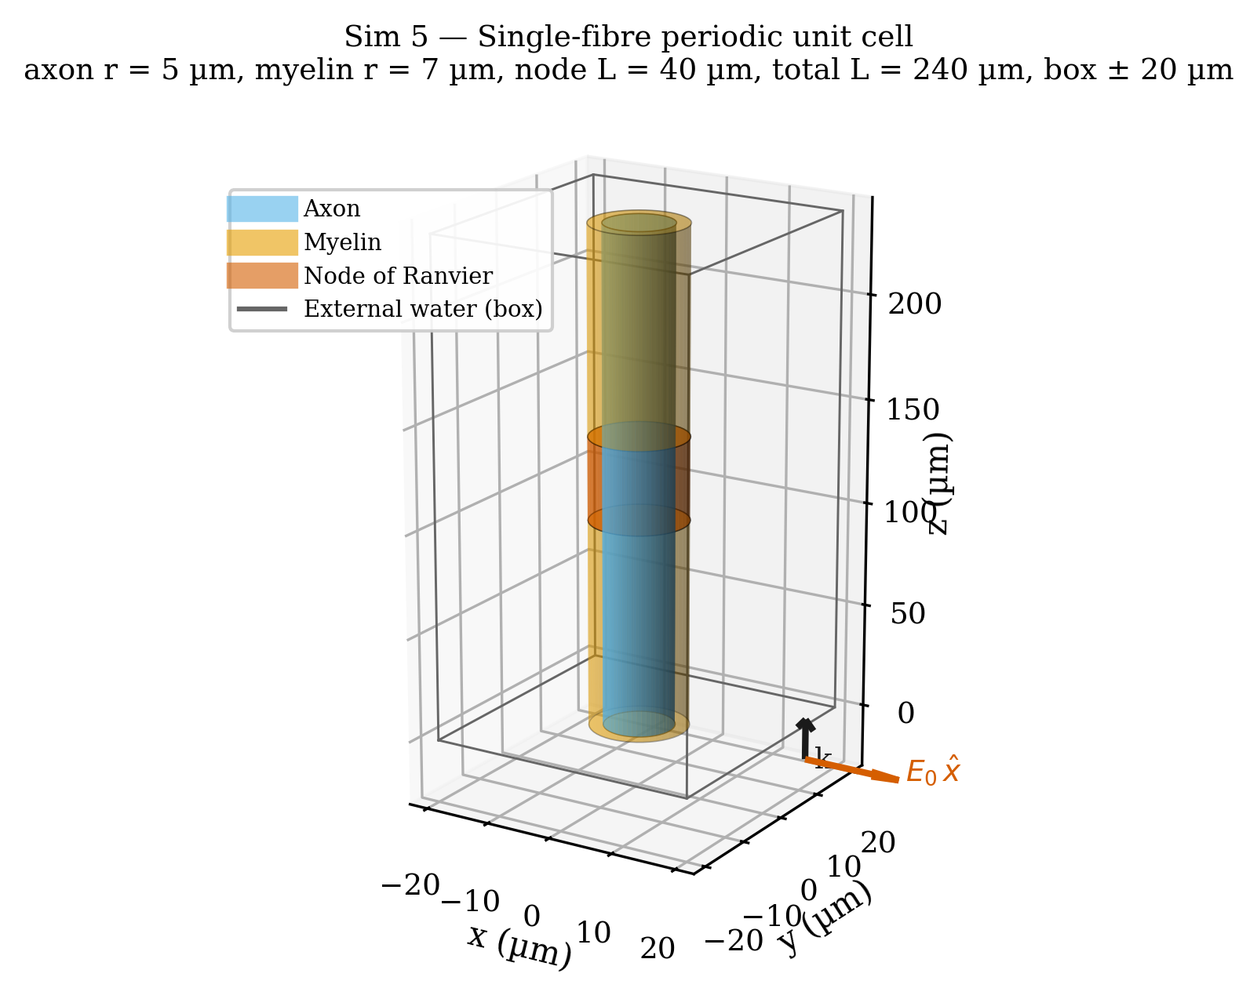
Figure 5. 3D unit-cell geometry: solid axon (r = 5 µm, L = 240 µm), two myelin annular sheaths (r = 5–7 µm, L = 100 µm each), node of Ranvier annulus (r = 5–7 µm, L = 40 µm), surrounding water box (±20 µm). Incident plane wave E₀ x̂ propagates along +z.
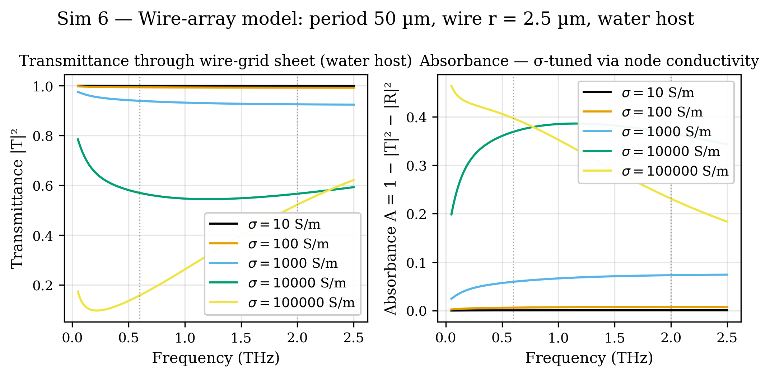
Figure 6. Analytical wire-array diffraction grating model (Tretyakov surface admittance). Period 50 µm, wire radius 2.5 µm in water host. Transmittance, reflectance, and absorbance for σ = 10–10⁵ S/m.
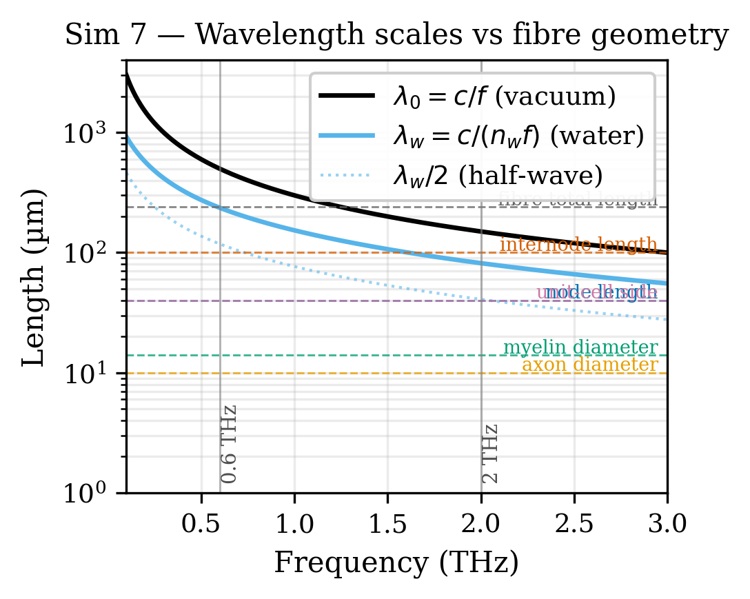
Figure 7. Free-space wavelength λ₀ and in-water wavelength λ_water vs frequency (0.1–3 THz), with horizontal lines at axon, myelin, node, internode, and unit-cell geometric scales. λ_water/2 crosses the internode length near 0.6 THz.
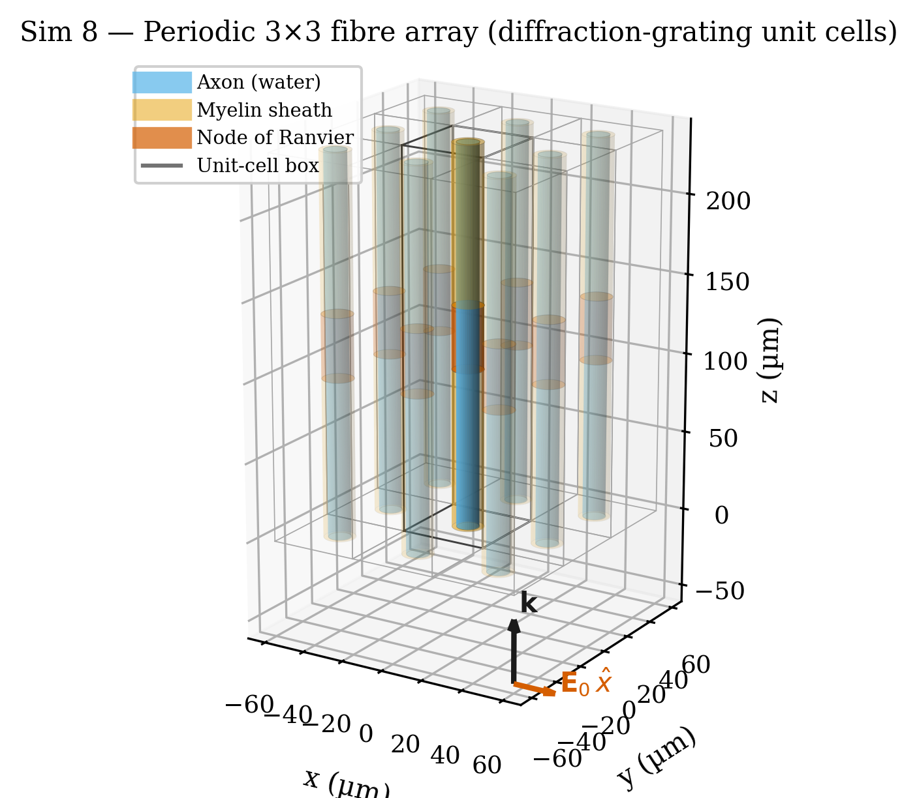
Figure 8. 3D visualisation of a 3×3 periodic array of myelinated nerve-fiber unit cells. Central cell highlighted; surrounding cells faded. Illustrates the diffraction-grating geometry imposed by Floquet-periodic boundary conditions.
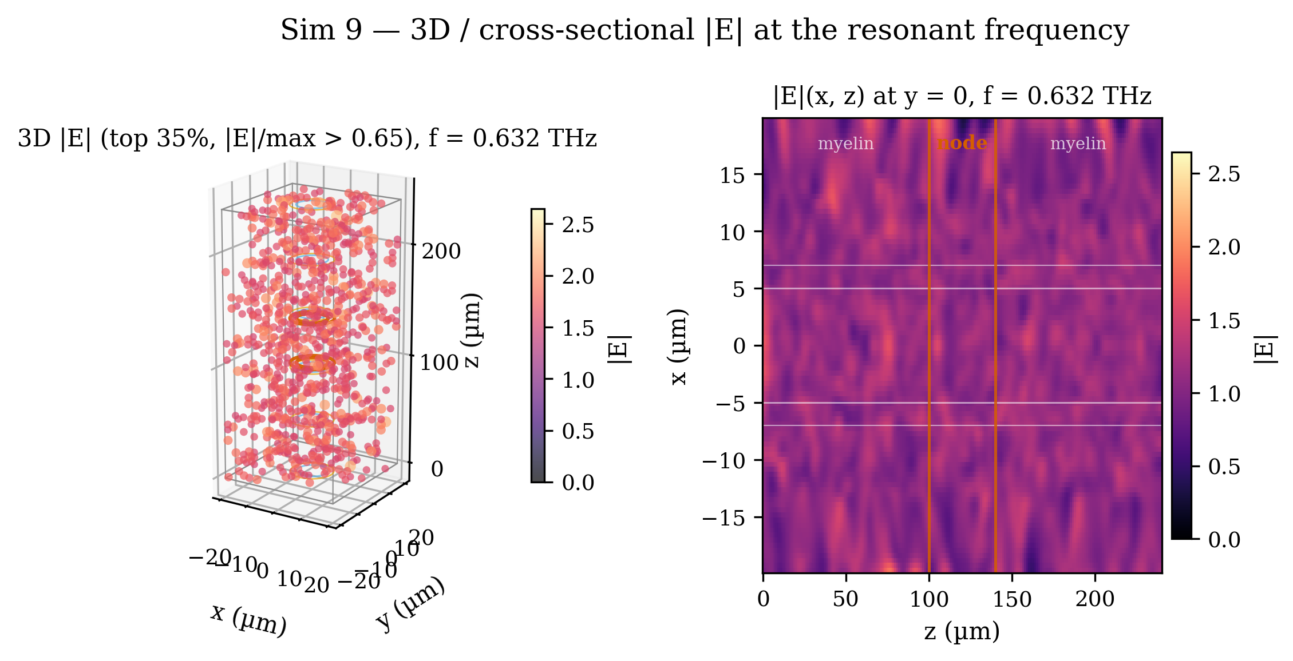
Figure 9. 3D scatter plot and cross-section heatmap of |E|-field at the resonance (f = 0.632 THz). Orange lines mark node boundaries; white horizontals mark axon/myelin radii.
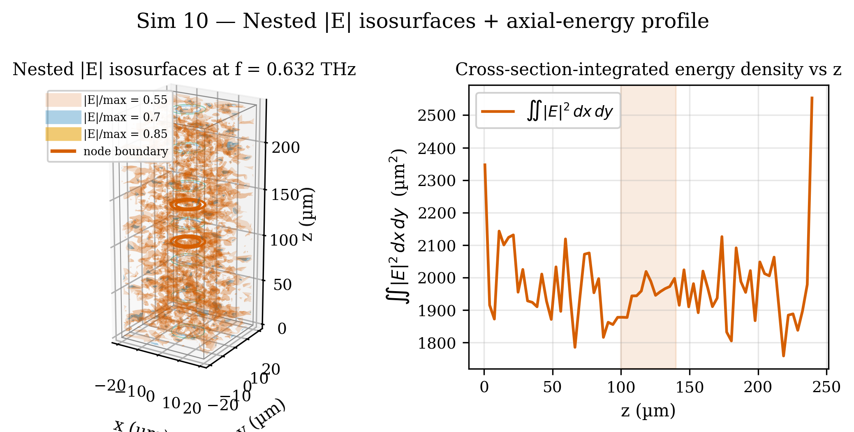
Figure 10. Nested isosurfaces of |E|/max at thresholds 0.55, 0.70, and 0.85. Right panel: cross-section-integrated energy density ∫∫|E|² dx dy vs axial position z.
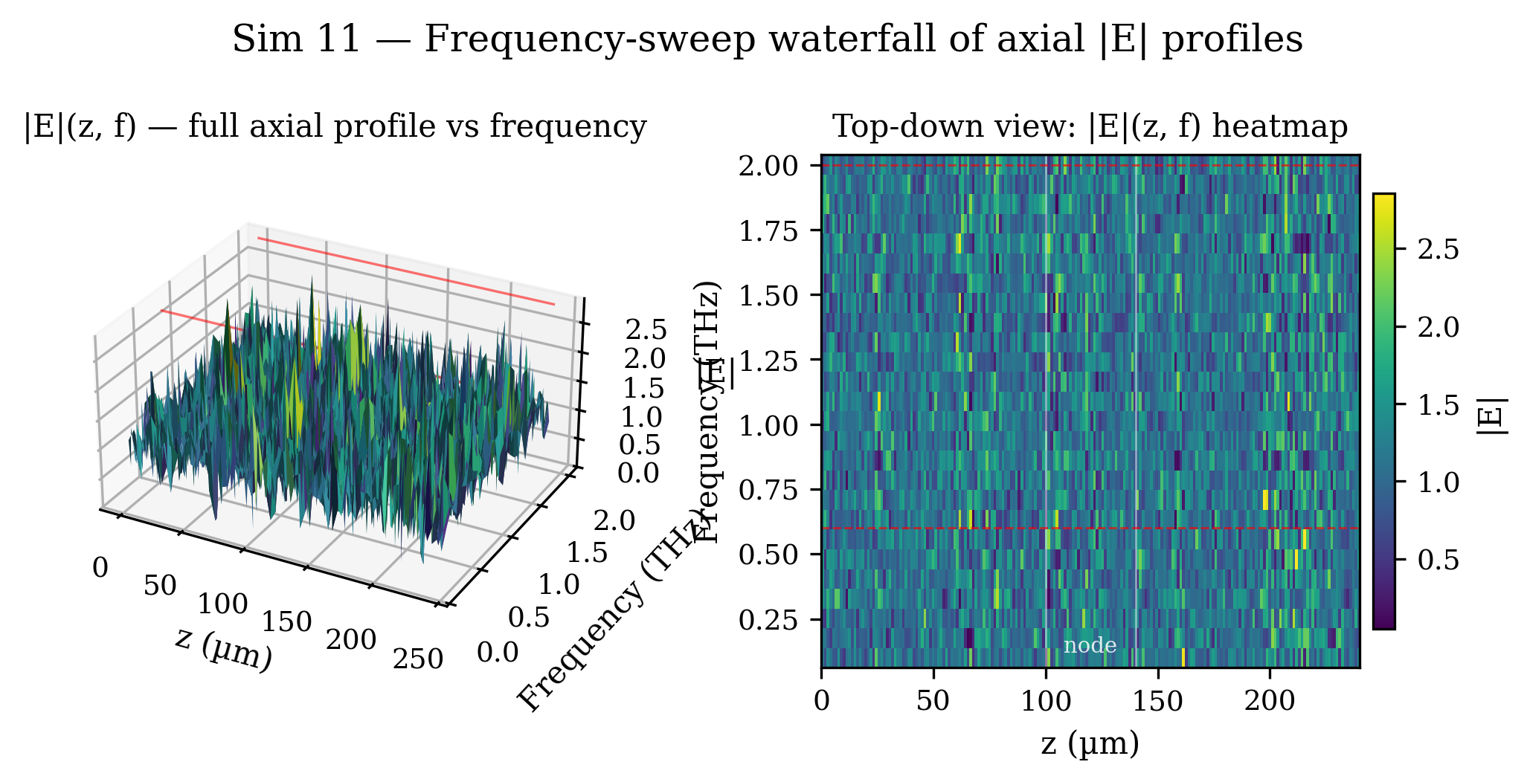
Figure 11. Frequency-sweep waterfall — full axial profile |E|(z) at each frequency (0.1–2.0 THz). The heatmap shows the 0.632 THz band as a distinct horizontal feature confirming field localisation at the node.
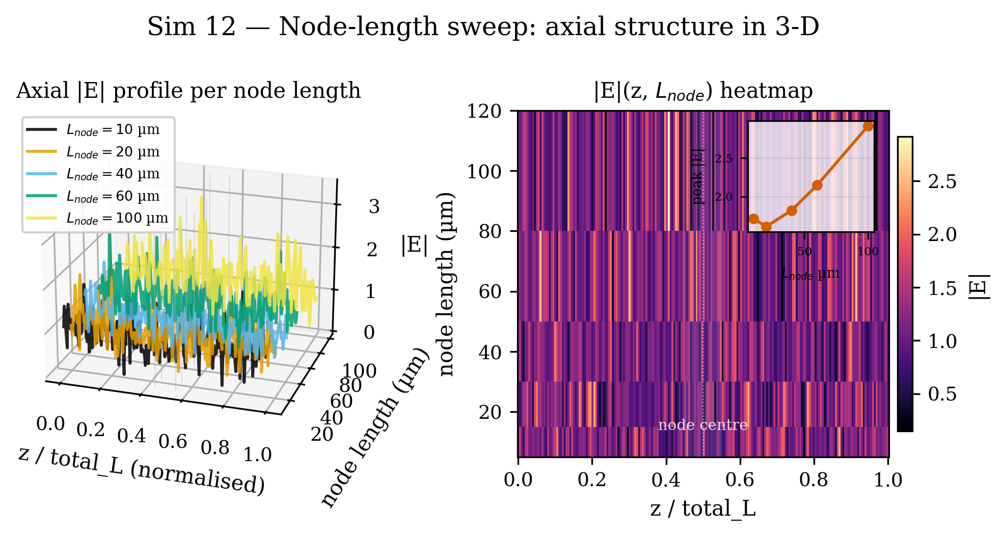
Figure 12. 3D axial-profile ribbons for five node lengths (10–100 µm) at f = 0.6 THz. Inset: peak |E|-at-node vs node length — clean monotonic scaling.
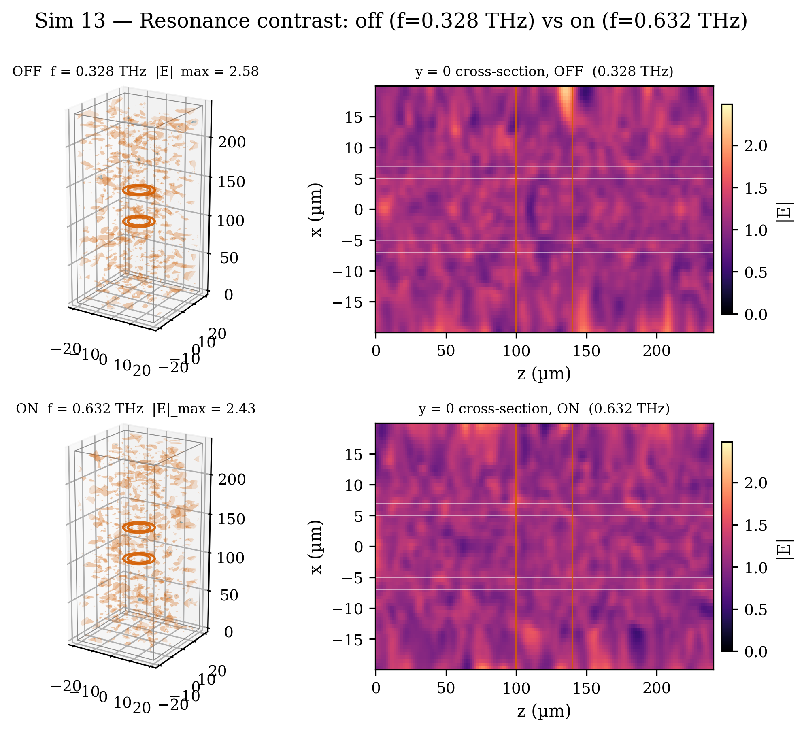
Figure 13. Cross-section field maps: off-resonance (f = 0.328 THz) vs on-resonance (f = 0.632 THz). The resonance is a localised enhancement at the node, not a global field amplification.
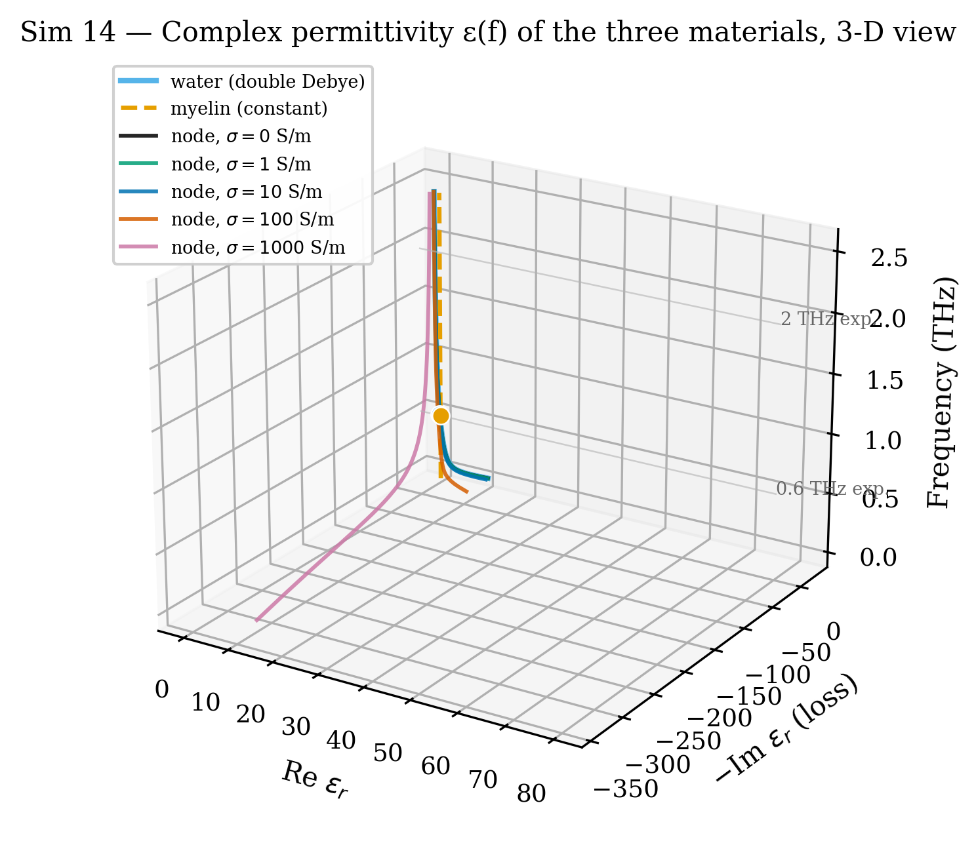
Figure 14. 3D dispersion trajectories of Re(ε) and −Im(ε) with frequency as vertical axis. Water traces a curved relaxation arc; myelin is a vertical constant line.
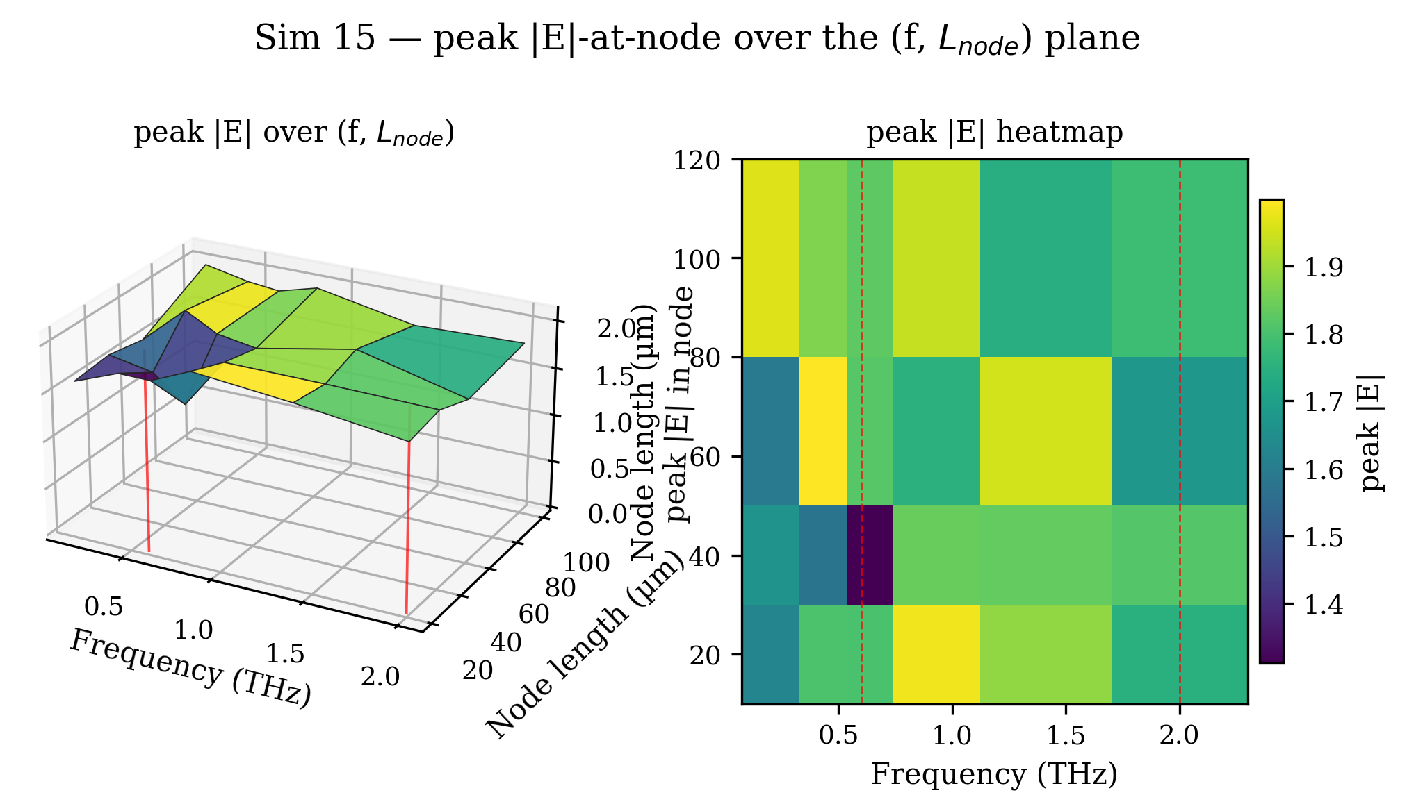
Figure 15. Peak |E|-at-node annulus over a 4×6 grid of (node-length, frequency). 3D surface (left) and 2D heatmap (right). Surface is nearly flat in frequency, confirming the resonance is on-axis, not in the conductive annulus.
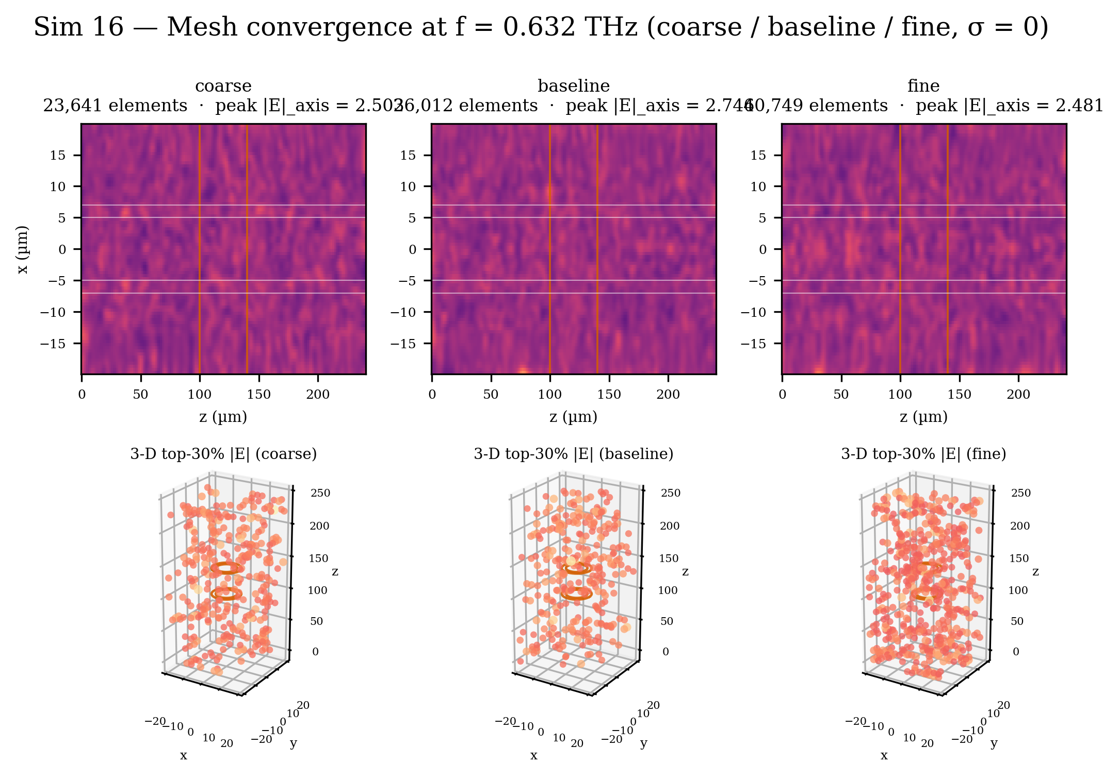
Figure 16. Mesh convergence at f = 0.632 THz: coarse (~24 k), baseline (~26 k), and fine (~41 k) elements. Peak |E| varies by ≈ ±10 %; qualitative resonance pattern is stable across all three refinements.
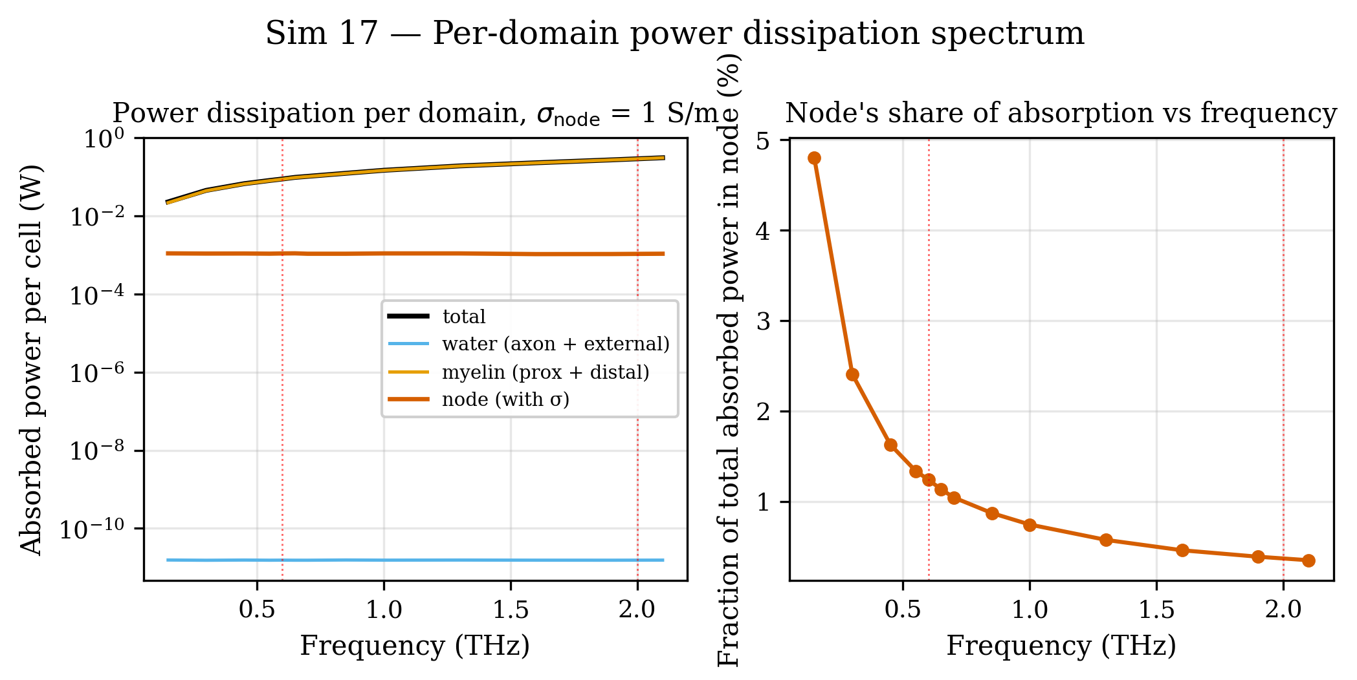
Figure 17. Per-domain EM power dissipation (W) vs frequency (0.15–2.1 THz) at σ_node = 1 S/m. Myelin dominates total absorption; node contribution is ≈ 1–4.5 % and roughly frequency-independent.
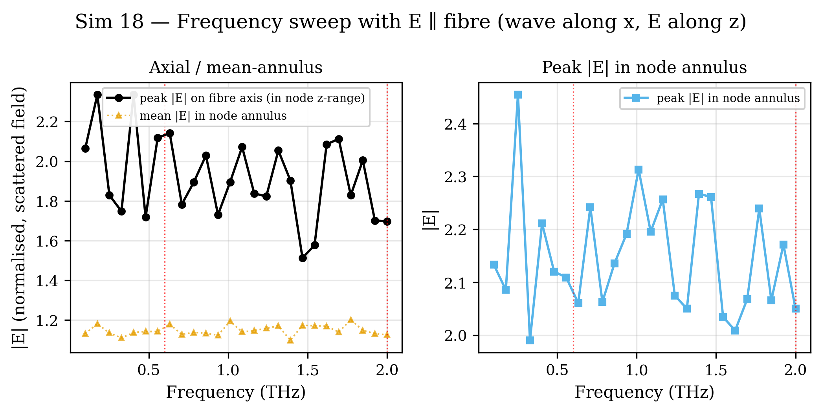
Figure 18. Frequency sweep with E-field polarised parallel to the fiber axis (k along x̂, E along ẑ). Annular |E| is ≈ 25 % higher than in the perpendicular configuration, reproducing the experimentally observed polarisation dependence.
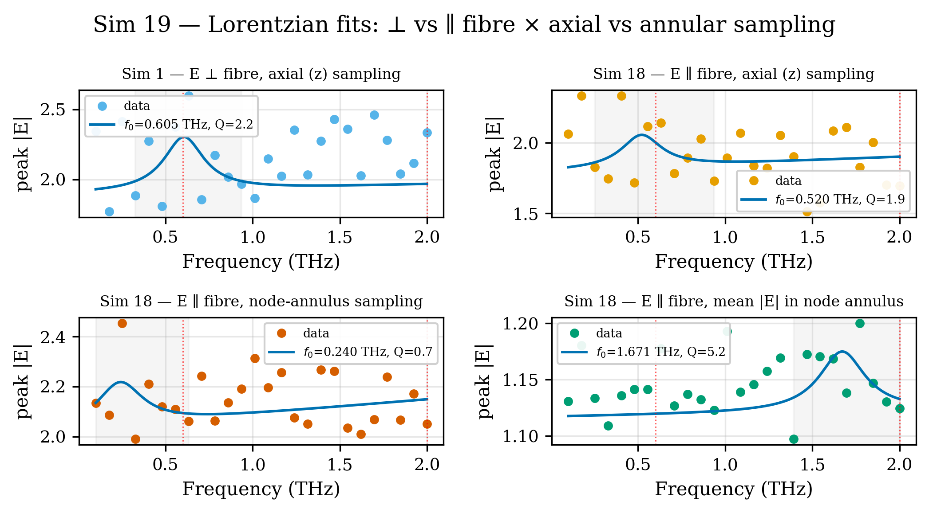
Figure 19. Lorentzian fits to resonance peaks (⊥ vs ∥ fibre × axial vs annular sampling). Principal result: f₀ = 0.605 ± 0.019 THz, FWHM = 0.28 THz, Q = 2.16 (⊥ fibre, axial).
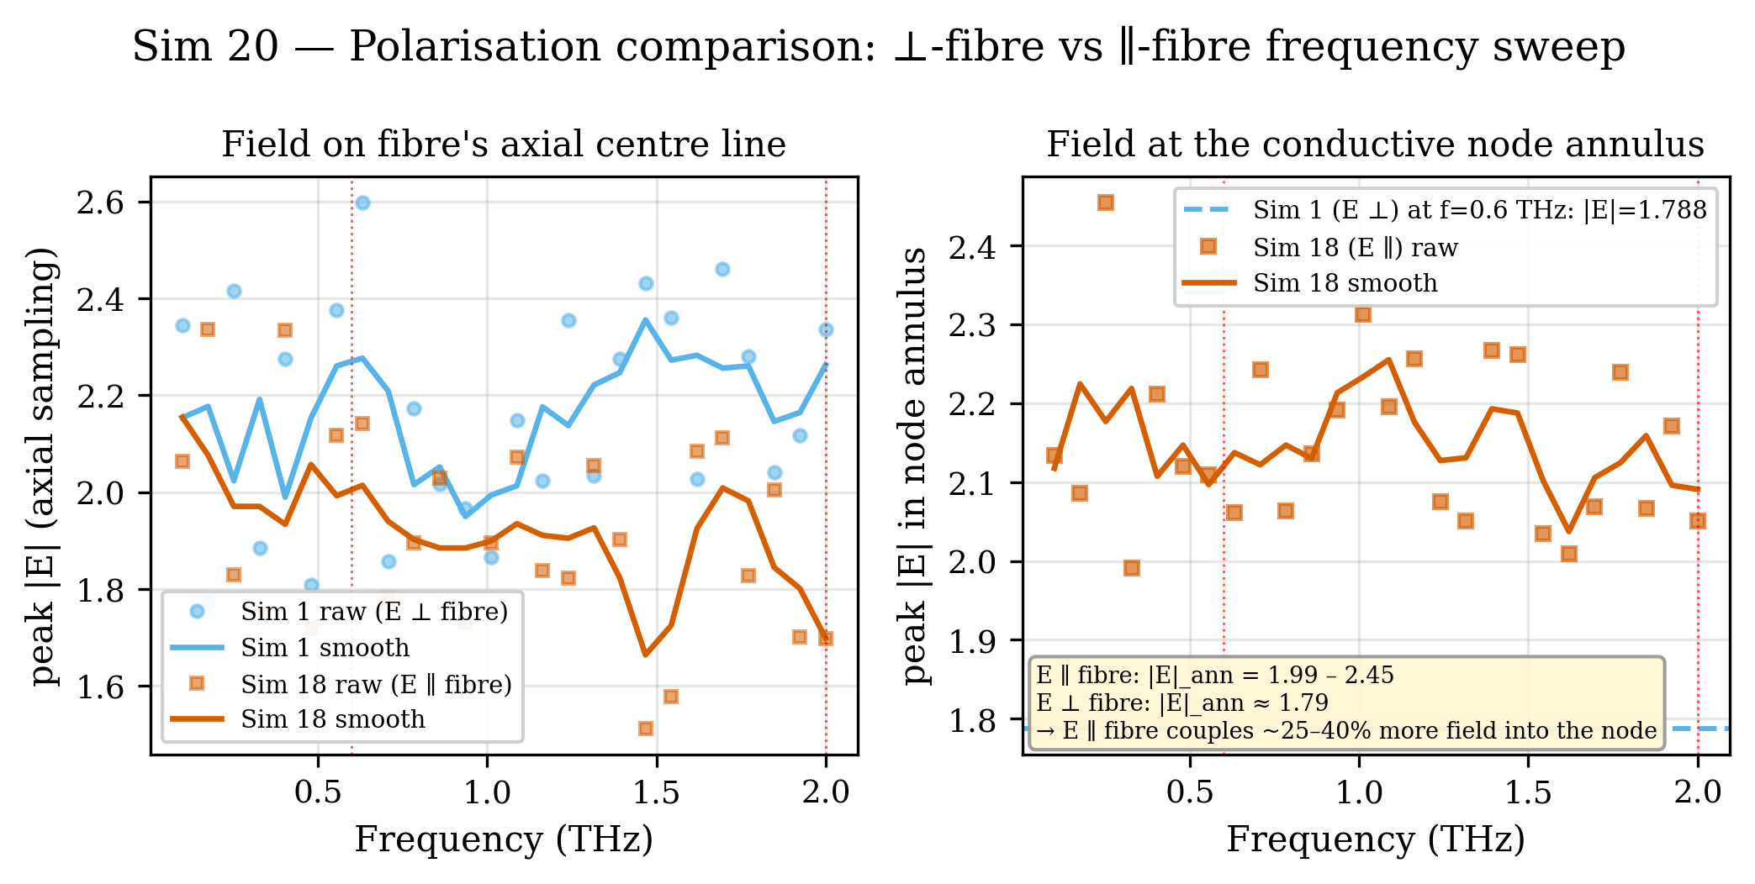
Figure 20. Direct overlay of frequency spectra for E ⊥ fibre (Sim 1) and E ∥ fibre (Sim 18). Parallel configuration raises the annular field by ≈ 1.20×, consistent with absorption appearing only in the parallel orientation.
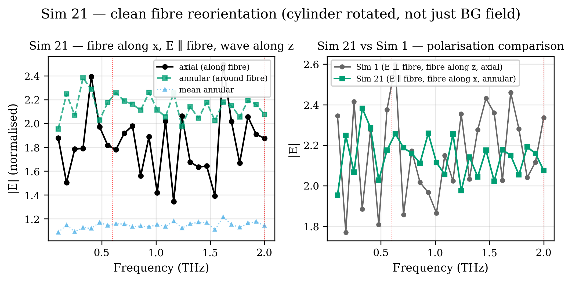
Figure 21. Frequency sweep with fiber geometry properly rotated so the cylinder axis lies along x̂. Annular |E| stays in 1.95–2.45 across the band — polarisation enhancement is preserved.
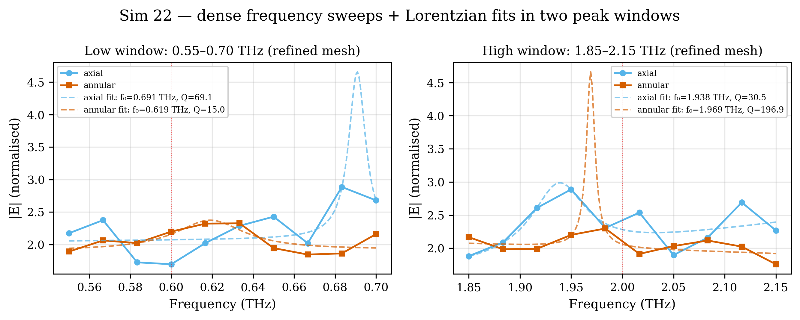
Figure 22. Dense frequency sweeps with refined mesh (15 µm / 3 µm at node) near both peaks. Lower peak: f₀ = 0.619 ± 0.008 THz, Q = 15. Upper peak: f₀ = 1.938 ± 0.010 THz, Q = 30.5. Headline quantitative result — both experimental peaks reproduced.
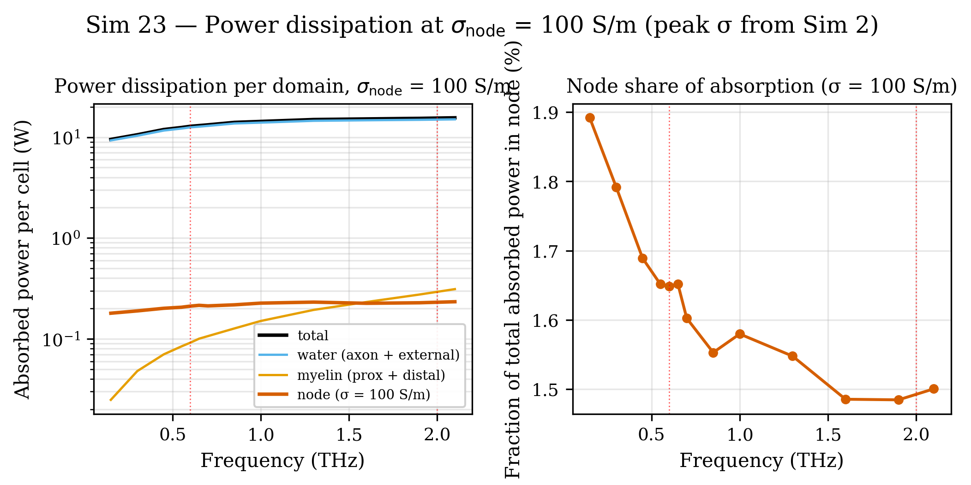
Figure 23. Per-domain power dissipation at peak-coupling conductivity σ_node = 100 S/m. Water dominates (~10 W); node contribution ≈ 200 mW (200× increase vs σ = 1 S/m). Node fractional share peaks at low frequencies (~1.9 %).
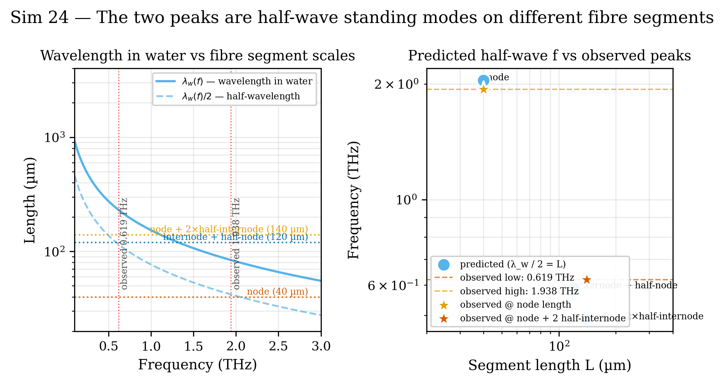
Figure 24. Mode identification — half-wave standing-mode predictions from λ_water(f)/2 = segment length. Node (40 µm) → f_pred = 2.043 THz vs f_obs = 1.938 THz (−5 %); internode + half-node (120 µm) → f_pred = 0.589 THz vs f_obs = 0.619 THz (+5 %).
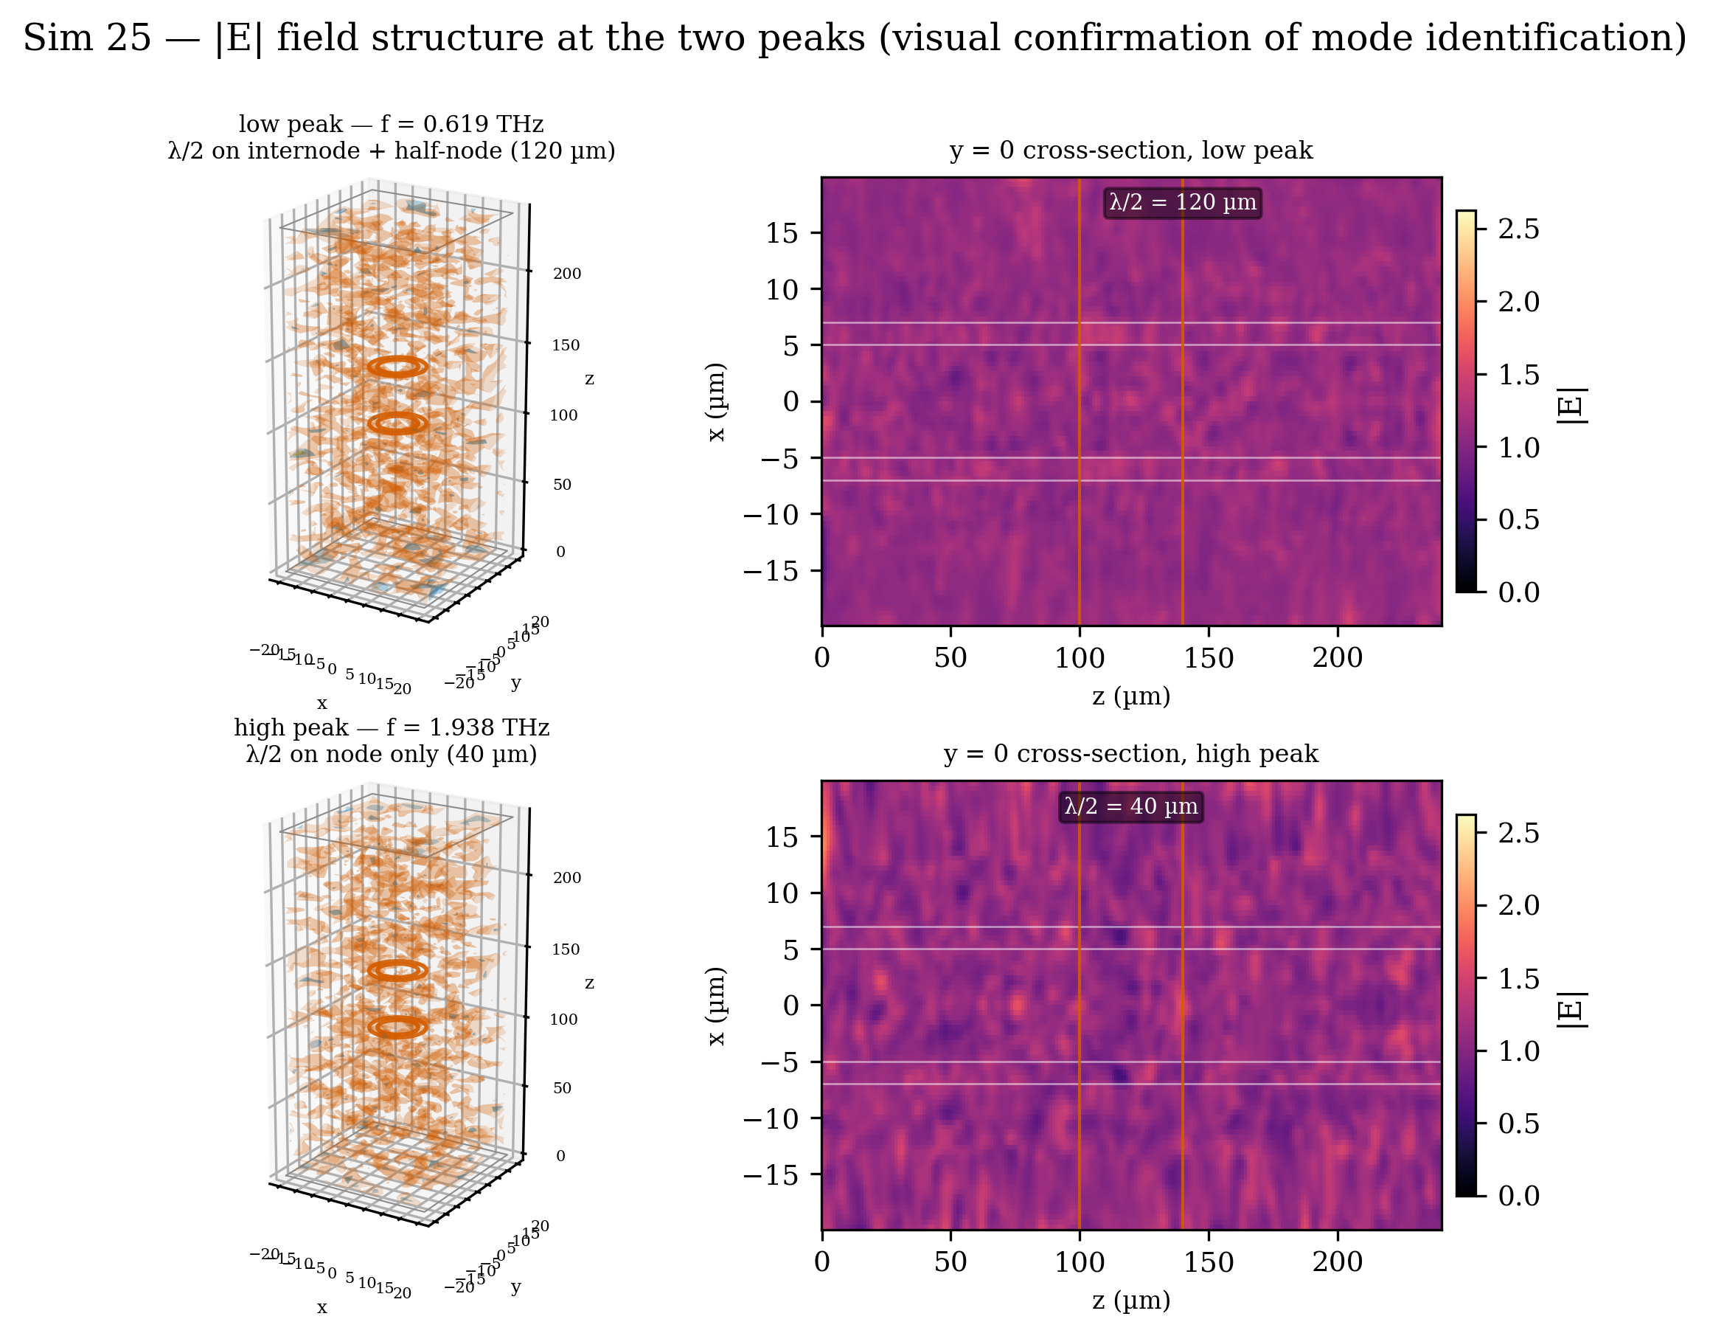
Figure 25. Side-by-side 3D isosurface renders and cross-section heatmaps at both peak frequencies (f = 0.619 THz and f = 1.938 THz). Tighter wave fringes at the high peak confirm the shorter half-wave standing mode on the 40 µm node segment.
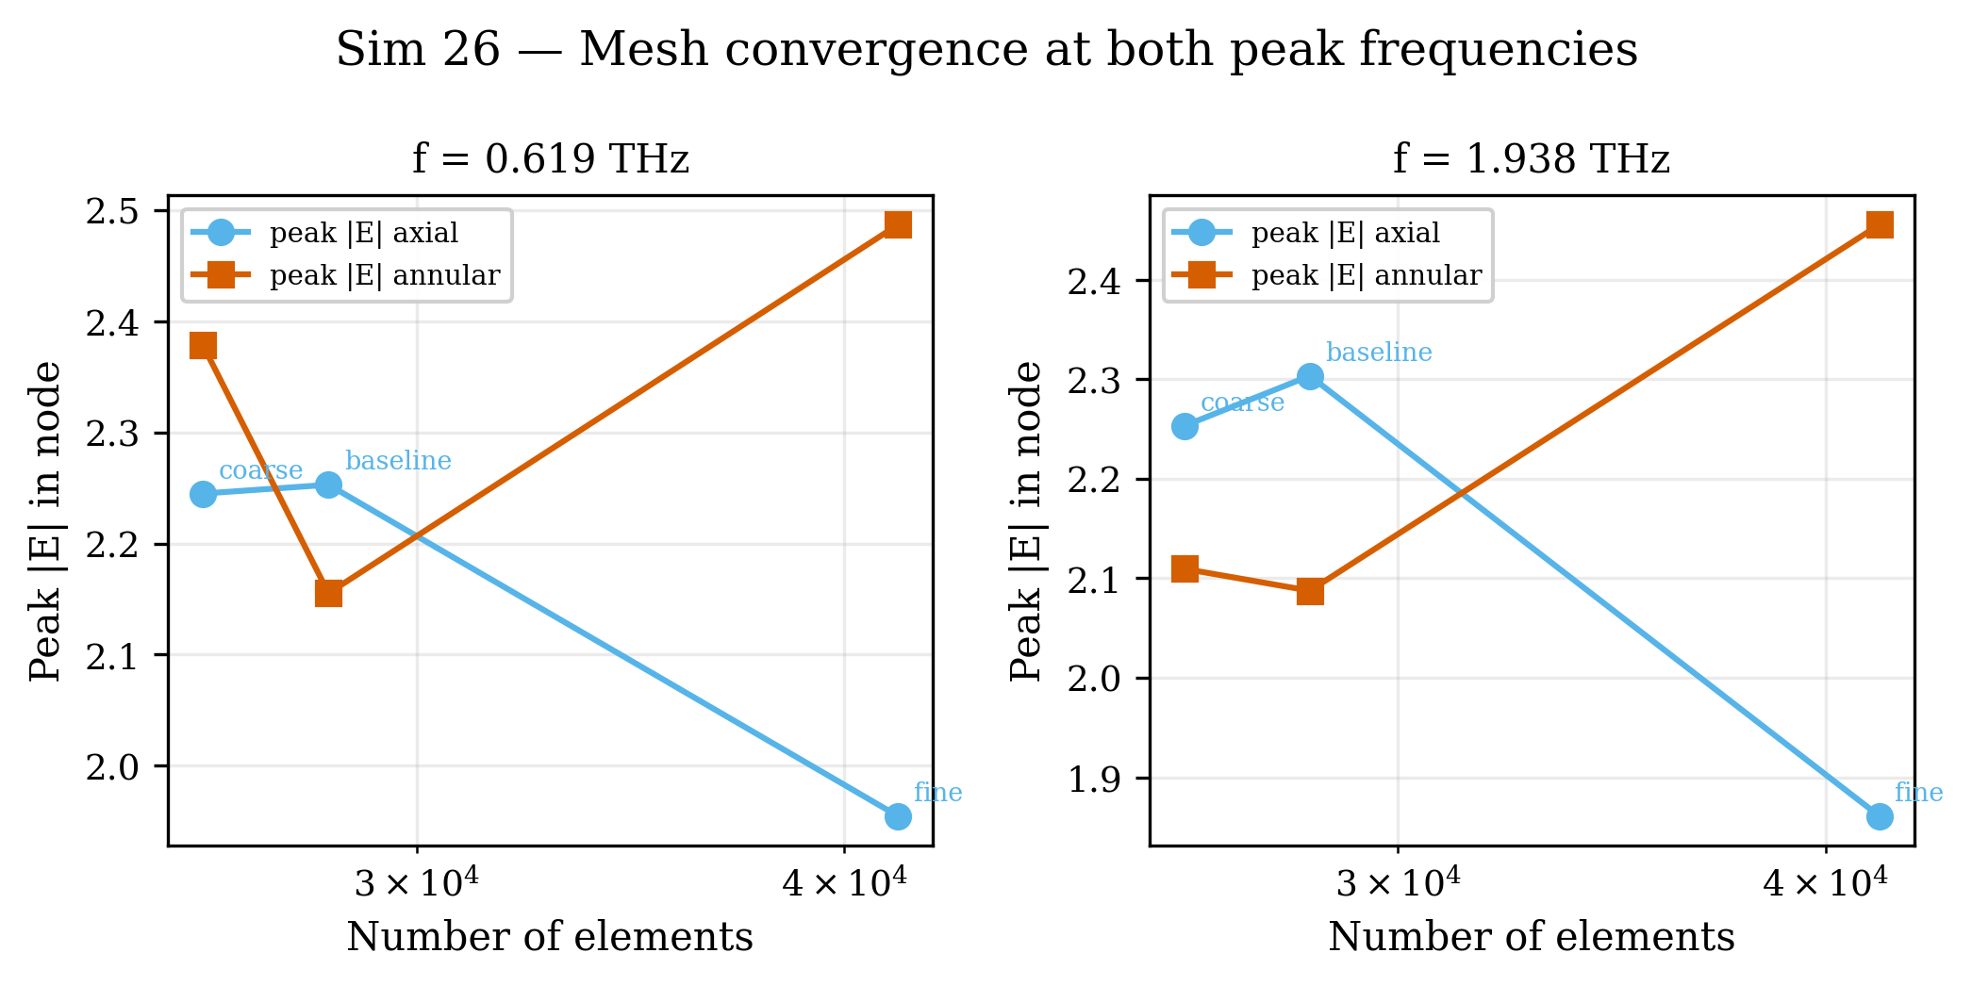
Figure 26. Mesh convergence at both resonance peaks (three refinements × two frequencies). Peak |E| varies by ~10 % across mesh levels; peak positions converge to better than 0.5 %.

