Xplrss
A minimalistic RSS reader

By: Andreas Johansson

Description
What I wanted in a RSS reader was a lightweight, portable, cross-platform compatible RSS reader. There was no RSS reader available that did everything the way I wanted it to. Using a self-built XML parser and Swing I managed to make everything happen to the best of my ability.
This was a difficult project and it took me all day every single day for the last few weeks to code, and it was a lot of late nights. But it was amazingly fun, and I'm really happy with the result.
The program starts with a very empty user interface with a single category in the left area labeled 'Feeds'. This category needs to be selected to be able to add categories and feeds into the tree.
Main class is called Reader.

Controls
- Select a tree-node and click Insert to add a Feed or Category
- Select a tree-node and click Delete to remove a Feed or Category
- Left-clicking a category will draw a list of all entries in the feed under that category
- Left-clicking a feed will draw a list of its entries in the main area to the right
- Left-clicking an entry will mark it as read and select it
- Left-clicking a selected entry will open the article

Features
- Updates feeds once every minute
- Entries that were updated in the online feed will overwrite the local entry
- Caches all the information to the harddrive
- Clears out html code in entries
- Renaming of feeds and categories by clicking a selected node
(Note: Remove the unread count when renaming)
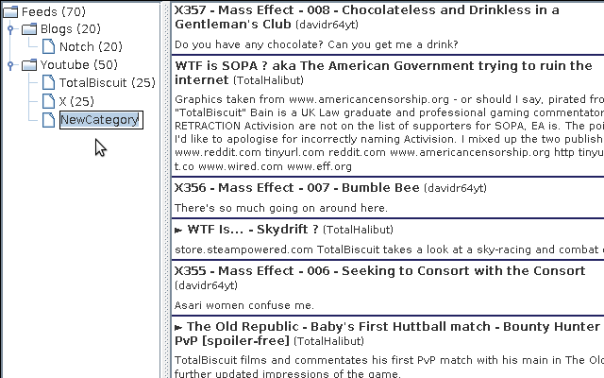
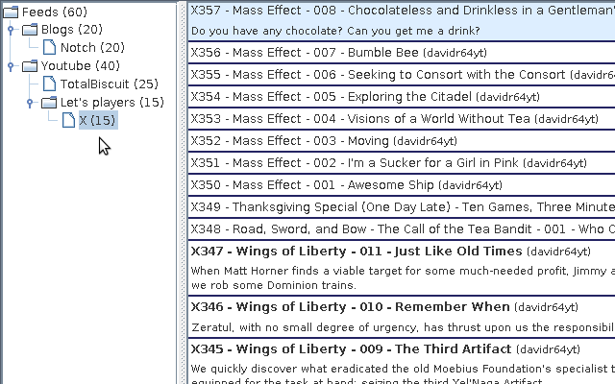
- Reorganizing feeds in the tree using drag and drop

- Using categories to view several feeds at once

Features I planned to add
Ideas that were scrapped due to lack of time.
- Rendering HTML in entries
- Settings to control the program features and feed properties
- Visual feedback for when feeds are updating
- More controls, such as:
  - Unread entry
  - Minimize/Maximize entries
  - Read/Unread feed and category
  - Force reload feed and category

