TABLE OF CONTENTS
1. Rationale 1
1.1 Problem Description 1
1.2 Background 1
1.3 Community Impact 1
1.4 Proposed Solution 1
1.5 Computational Thinking Process 1
1.6 Algorithm Design (Summary) 1
1.7 SDG Alignment 1
1.8 Open Source Justification 1
1.9 Digital Public Goods Justification 1
2. Algorithm Design 1
2.1 Main Algorithm 1
2.2 Algorithm for Module 1: registerFarmer() 1
2.3 Algorithm for Module 2: getCropAdvice() 1
2.4 Algorithm for Module 3: showBestMarket() and getBestNetPrice() 1
2.5 Algorithm for Module 4: sellOrStore() 1
3. Pseudocode 1
3.1 Main Algorithm and Constants 1
3.2 Data Loading (Variables and Data Types) 1
3.3 Module 1: Registration 1
3.4 Module 2: Crop Advice 1
3.5 Module 3: Best Market and Core Function 1
3.6 Module 4: Sell or Store 1
3.7 Helper Functions 1
4. Flowcharts 1
5. Functional Modules 1
5.1 Functions 1
5.2 Variables, Constants and Data Types 1
6. Expected Outputs 1
6.1 Sample Data Tables 1
6.2 Scenario Results 1
6.3 Trace of the Repetition in getBestNetPrice() (Scenario S7) 1
6.4 Sample Phone Screens (USSD/SMS) 1
7. GitHub Evidence 1
8. References 1

1. Rationale

1.1 Problem Description
Smallholder farmers in Sierra Leone make three costly decisions every season: when to plant, where to sell, and whether to store or sell immediately. Most make them with little reliable and timely information. They often plant by habit rather than by a recommended calendar, sell to the first buyer who visits the farm gate, and have no way of comparing prices between markets. The core problem is therefore an information gap, not a lack of effort or land.

1.2 Background
Agriculture is the main livelihood for most Sierra Leoneans, and the sector is dominated by small family farms growing rice, cassava, groundnut and maize. Rice is the staple food, yet the country still relies on imports to meet part of its demand, which shows how much room there is to raise local productivity and incomes. Government agricultural extension officers serve very large areas, so many farmers see an adviser only rarely. Mobile network coverage in rural areas is uneven, and smartphones and mobile data are expensive, whereas basic phones that can send SMS or use USSD menus are far more common. A solution for farmers must therefore work on a basic phone, in plain language, at very low cost.

1.3 Community Impact
Who is affected: smallholder farmers (including the many women farmers), farmer-based organisations and cooperatives, extension officers, and urban consumers who pay for the resulting high and unstable food prices. Why the problem exists: weak information systems, long distances between farms and markets, poor storage, limited extension coverage, and strong bargaining power of buyers who know prices that farmers do not. Expected impact: farmers plant within the recommended window, choose the market that gives the best price after transport costs, and avoid selling perishable crops late or storing crops that will not gain value. The expected results are higher net income, lower post-harvest loss and better household food security. Long-term sustainability: the system uses open data files that extension officers can update, runs on cheap infrastructure, and can be hosted by a government agency, NGO or telecom partner.

1.4 Proposed Solution
AgriLink SL is a text-based decision-support system accessed by SMS or a USSD menu on any mobile phone. A farmer dials a short code and chooses from a menu: (1) register, (2) get crop advice, (3) find the best market, (4) get a sell-or-store recommendation, or (5) exit. The system compares the farmer's crop, district and the current month with open data tables (crop calendars, market prices, distances) and replies with a short, clear recommendation. This directly addresses the information gap: the farmer receives the same kind of advice an extension officer would give, instantly and at the point of need.

1.5 Computational Thinking Process
- Decomposition: the problem is broken into four modules (registration, crop advice, best market, sell-or-store), one core function (getBestNetPrice) and several small helper functions.
- Pattern recognition: every crop follows the same pattern (a planting window, a harvest window, a price in each market, perishable or not). One algorithm can therefore serve all crops by reading values from tables instead of writing separate logic for each crop.
- Abstraction: weather detail, soil type and exact road conditions are ignored. Only the facts needed for a decision are kept: month, crop, district, price, distance, perishability and storage.
- Algorithm design: the steps for each module are written as a numbered algorithm, then as pseudocode and finally as flowcharts. The design is tested by tracing the sample scenarios in Section 7.

1.6 Algorithm Design (Summary)
The system follows an Input, Processing, Output pattern. Input: menu choice, phone number, crop, district, quantity and storage availability. Processing: validation, table search using loops, month comparison, net-price calculation (price minus transport cost) and rule-based decisions using Boolean logic. Output: a short advice message. The full step-by-step algorithm is in Section 2, the pseudocode in Section 3 and the flowcharts in Section 4.

1.7 SDG Alignment
- SDG 2 Zero Hunger (primary): Target 2.3 aims to raise the productivity and incomes of small-scale food producers. AgriLink SL supports this through better planting timing and better selling decisions.
- SDG 1 No Poverty: higher net farm income reduces rural poverty.
- SDG 12 Responsible Consumption and Production: Target 12.3 includes reducing food losses along production and supply chains, including post-harvest losses. The sell-or-store rule helps farmers avoid spoilage.
- SDG 9 Industry, Innovation and Infrastructure: Target 9.c promotes access to information and communications technology. The system works on basic phones.

1.8 Open Source Justification
The solution should be Open Source because agricultural advice is a public interest service and should not depend on one company's licence or pricing. Open code can be inspected and trusted, hosted locally, and adopted free of charge by the Ministry of Agriculture and Food Security, NGOs and cooperatives. Benefits for Sierra Leone: no licence fees, local ownership of data and skills, and no vendor lock-in. Potential community contributions: students and local developers can add new crops and districts; extension officers can improve crop calendars and price data; translators can add Krio, Mende and Temne; and other countries can adapt the design. A permissive licence such as Apache-2.0 for the code, and CC BY 4.0 for the open data, is proposed.

1.9 Digital Public Goods Justification
AgriLink SL could qualify as a Digital Public Good by meeting the Digital Public Goods Standard: it supports the SDGs, uses an open licence for software and open data, is documented, allows data to be exported (platform independence), protects farmers' phone numbers and personal data, and is designed to do no harm. Accessibility: it works on any phone without internet. Openness: its logic and data tables are public and reusable. Public benefit: it is free to farmers, with running costs shared by the government, development partners and telecom operators.

2. Algorithm Design

2.1 Main Algorithm
- START. Load the crop calendar, market, price and district tables.
- Display the main menu (1 Register, 2 Crop Advice, 3 Best Market, 4 Sell or Store, 5 Exit).
- Read the user's choice.
- If the choice is not between 1 and 5, display an error message and go back to Step 2.
- If the choice is 1, run registerFarmer(). If 2, run getCropAdvice(). If 3, run showBestMarket(). If 4, run sellOrStore().
- If the choice is 5, display a goodbye message and STOP. Otherwise, go back to Step 2.

2.2 Algorithm for Module 1: registerFarmer()
- Set attempts to 0.
- Read the phone number. If it has 8 digits and contains only digits, go to Step 4.
- Add 1 to attempts. If attempts is 3 or more, display 'Too many invalid attempts' and STOP. Otherwise go back to Step 2.
- If the phone number is already registered, display 'Welcome back' and STOP.
- Read the farmer's name and district. If the district is not one of the 16 districts, display an error and read the district again.
- Display the list of crops, read the main crop, save the farmer record and display 'Registration successful'.

2.3 Algorithm for Module 2: getCropAdvice()
- Read the crop name. Search the crop table from the first crop to the last using a loop.
- If the crop is not found, display 'Crop not supported' and STOP.
- Get the current month (1 to 12).
- If the month is inside the planting window, display 'PLANT NOW'. Otherwise, if the month is before the window, display how many months remain. Otherwise, display 'Planting window closed'.
- If the month is inside the harvest window, display a harvest and drying tip. STOP.

2.4 Algorithm for Module 3: showBestMarket() and getBestNetPrice()
- Read the crop name and the farmer's district.
- Set bestNet to 0 and the best market to empty. Repeat for every market in the list: read the crop's price; if the price is greater than 0, calculate net price = price − (distance × transport rate); if the net price is greater than bestNet, save it as the new best.
- After the loop, if no market was saved, display 'No price data available'. Otherwise, display the best market and its net price per bag. STOP.

2.5 Algorithm for Module 4: sellOrStore()
- Read the crop, district, number of bags and whether storage is available.
- Calculate the current best net price using getBestNetPrice(). Get the expected price for next month.
- If the crop is perishable, advise 'SELL NOW'. Otherwise, if storage is available AND expected price ≥ current net price × 1.10, advise 'STORE'. Otherwise, advise 'SELL NOW at best market'.
- If the number of bags is 20 or more, add the tip 'Join a cooperative to sell in bulk'.
- Display the advice, best market and prices. STOP.

3. Pseudocode
Notation: ← means assignment, = means comparison, text after // is a comment. Constants are written in capitals. Indentation shows structure.

3.1 Main Algorithm and Constants
ALGORITHM AgriLinkSL_Main
// ----- Constants (values that never change) -----
CONSTANT PHONE_LENGTH ← 8
CONSTANT MAX_ATTEMPTS ← 3
CONSTANT TRANSPORT_RATE ← 0.40 // Leones per bag per km
CONSTANT PRICE_MARGIN ← 0.10 // minimum 10% gain to justify storing
CONSTANT BULK_THRESHOLD ← 20 // bags
CONSTANT MENU_EXIT ← 5
// ----- Variables -----
DECLARE choice AS Integer
DECLARE running AS Boolean ← TRUE
DECLARE lastBestMarket AS String ← "" // shared result of getBestNetPrice()
CALL loadData()
WHILE running = TRUE DO
DISPLAY "1 Register 2 Crop Advice 3 Best Market 4 Sell or Store 5 Exit"
INPUT choice
IF choice < 1 OR choice > MENU_EXIT THEN
DISPLAY "Invalid choice, try again"
ELSE IF choice = 1 THEN
CALL registerFarmer()
ELSE IF choice = 2 THEN
CALL getCropAdvice()
ELSE IF choice = 3 THEN
CALL showBestMarket()
ELSE IF choice = 4 THEN
CALL sellOrStore()
ELSE
running ← FALSE
END IF
END WHILE
DISPLAY "Thank you for using AgriLink SL"
END ALGORITHM

3.2 Data Loading (Variables and Data Types)
FUNCTION loadData()
// Data tables are stored in open files so extension officers can update them
DECLARE CROP_NAME AS Array OF String // Rice, Cassava, Groundnut, Maize
DECLARE PLANT_START, PLANT_END AS Array OF Integer // month numbers 1-12
DECLARE HARVEST_START, HARVEST_END AS Array OF Integer
DECLARE PERISHABLE AS Array OF Boolean
DECLARE EXPECTED_PRICE AS Array OF Real // expected price next month (Le per bag)
DECLARE MARKET_NAME AS Array OF String // Bo, Kenema, Freetown ...
DECLARE PRICE AS 2D Array OF Real // PRICE[crop][market], 0 = no data
DECLARE DISTRICT_LIST AS Array OF String // the 16 districts of Sierra Leone
READ all tables from the data files
SET totalCrops, totalMarkets
END FUNCTION

3.3 Module 1: Registration
MODULE registerFarmer()
DECLARE phoneNumber, farmerName, district AS String
DECLARE mainCrop, attempts, i AS Integer
DECLARE phoneOK AS Boolean ← FALSE
attempts ← 0
WHILE phoneOK = FALSE AND attempts < MAX_ATTEMPTS DO
INPUT phoneNumber
IF isValidPhone(phoneNumber) THEN
phoneOK ← TRUE
ELSE
attempts ← attempts + 1
DISPLAY "Invalid phone number"
END IF
END WHILE
IF phoneOK = FALSE THEN
DISPLAY "Too many invalid attempts. Try later."
RETURN
END IF
IF farmerExists(phoneNumber) THEN
DISPLAY "Welcome back, " + getFarmerName(phoneNumber)
RETURN
END IF
INPUT farmerName
REPEAT
INPUT district
IF NOT inList(district, DISTRICT_LIST) THEN
DISPLAY "Unknown district"
END IF
UNTIL inList(district, DISTRICT_LIST)
FOR i ← 1 TO totalCrops DO
DISPLAY i + ". " + CROP_NAME[i]
END FOR
INPUT mainCrop
saveFarmer(phoneNumber, farmerName, district, mainCrop)
DISPLAY "Registration successful"
END MODULE

FUNCTION isValidPhone(phone) RETURNS Boolean
IF LENGTH(phone) = PHONE_LENGTH AND isAllDigits(phone) THEN
RETURN TRUE
ELSE
RETURN FALSE
END IF
END FUNCTION

3.4 Module 2: Crop Advice
MODULE getCropAdvice()
DECLARE cropName AS String
DECLARE i, index, currentMonth AS Integer
DECLARE found AS Boolean ← FALSE
INPUT cropName
i ← 1
WHILE i ≤ totalCrops AND found = FALSE DO
IF CROP_NAME[i] = cropName THEN
found ← TRUE
index ← i
ELSE
i ← i + 1
END IF
END WHILE
IF found = FALSE THEN
DISPLAY "Crop not supported"
RETURN
END IF
currentMonth ← getCurrentMonth()
IF currentMonth ≥ PLANT_START[index] AND currentMonth ≤ PLANT_END[index] THEN
DISPLAY "PLANT NOW: " + cropName
ELSE IF currentMonth < PLANT_START[index] THEN
DISPLAY "Prepare land. Plant in " + (PLANT_START[index] − currentMonth) + " month(s)"
ELSE
DISPLAY "Planting window closed. Focus on weeding and crop care"
END IF
IF currentMonth ≥ HARVEST_START[index] AND currentMonth ≤ HARVEST_END[index] THEN
DISPLAY "Harvest period: dry the crop well before storage"
END IF
END MODULE

3.5 Module 3: Best Market and Core Function
FUNCTION getBestNetPrice(cropName, district) RETURNS Real
DECLARE i AS Integer
DECLARE price, distance, netPrice, bestNet AS Real
bestNet ← 0
lastBestMarket ← ""
FOR i ← 1 TO totalMarkets DO
price ← PRICE[cropIndex(cropName)][i]
IF price > 0 THEN
distance ← getDistance(district, MARKET_NAME[i])
netPrice ← price − (distance × TRANSPORT_RATE)
IF netPrice > bestNet THEN
bestNet ← netPrice
lastBestMarket ← MARKET_NAME[i]
END IF
END IF
END FOR
RETURN bestNet
END FUNCTION

MODULE showBestMarket()
DECLARE cropName, district AS String
DECLARE bestNet AS Real
INPUT cropName, district
bestNet ← getBestNetPrice(cropName, district)
IF lastBestMarket = "" THEN
DISPLAY "No price data available"
ELSE
DISPLAY "Best market: " + lastBestMarket
DISPLAY "Net price: Le " + bestNet + " per bag"
END IF
END MODULE

3.6 Module 4: Sell or Store
MODULE sellOrStore()
DECLARE cropName, district, advice AS String
DECLARE quantityBags AS Integer
DECLARE hasStorage AS Boolean
DECLARE currentNet, expectedPrice AS Real
INPUT cropName, district, quantityBags, hasStorage
currentNet ← getBestNetPrice(cropName, district)
expectedPrice ← getExpectedPrice(cropName)
IF isPerishable(cropName) THEN
advice ← "SELL NOW (crop spoils quickly)"
ELSE IF hasStorage = TRUE AND expectedPrice ≥ currentNet × (1 + PRICE_MARGIN) THEN
advice ← "STORE and sell next month"
ELSE
advice ← "SELL NOW at best market"
END IF
IF quantityBags ≥ BULK_THRESHOLD THEN
advice ← advice + ". Tip: join a cooperative to sell in bulk"
END IF
DISPLAY advice, lastBestMarket, currentNet, expectedPrice
END MODULE

3.7 Helper Functions
FUNCTION getDistance(district, market) RETURNS Real // looks up km in the distance table
FUNCTION getCurrentMonth() RETURNS Integer // returns 1 to 12 from the system date
FUNCTION getExpectedPrice(cropName) RETURNS Real // returns EXPECTED_PRICE[cropIndex(cropName)]
FUNCTION isPerishable(cropName) RETURNS Boolean // returns PERISHABLE[cropIndex(cropName)]
FUNCTION cropIndex(cropName) RETURNS Integer // linear search of CROP_NAME
FUNCTION inList(item, list) RETURNS Boolean // linear search of a list
FUNCTION farmerExists(phone) RETURNS Boolean // checks the farmer file

4. Flowcharts
Symbols used: rounded box = Start/End; rectangle = process; parallelogram = input/output; diamond = decision; double-bordered rectangle = call to another module; circle = connector. The flowcharts were drawn with Graphviz and the Mermaid source files are included in the GitHub repository (flowcharts folder).
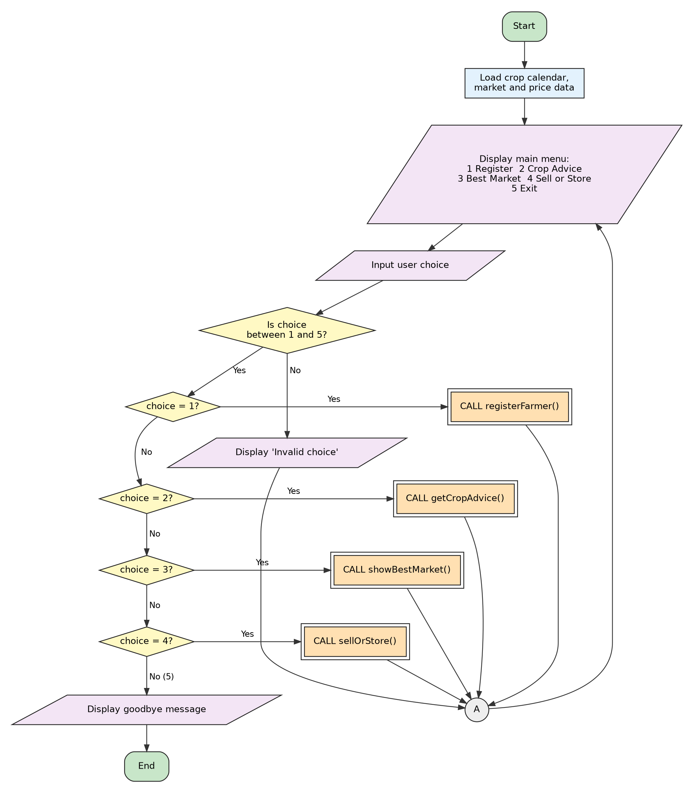
Figure 1: Main System Flowchart (menu controller)

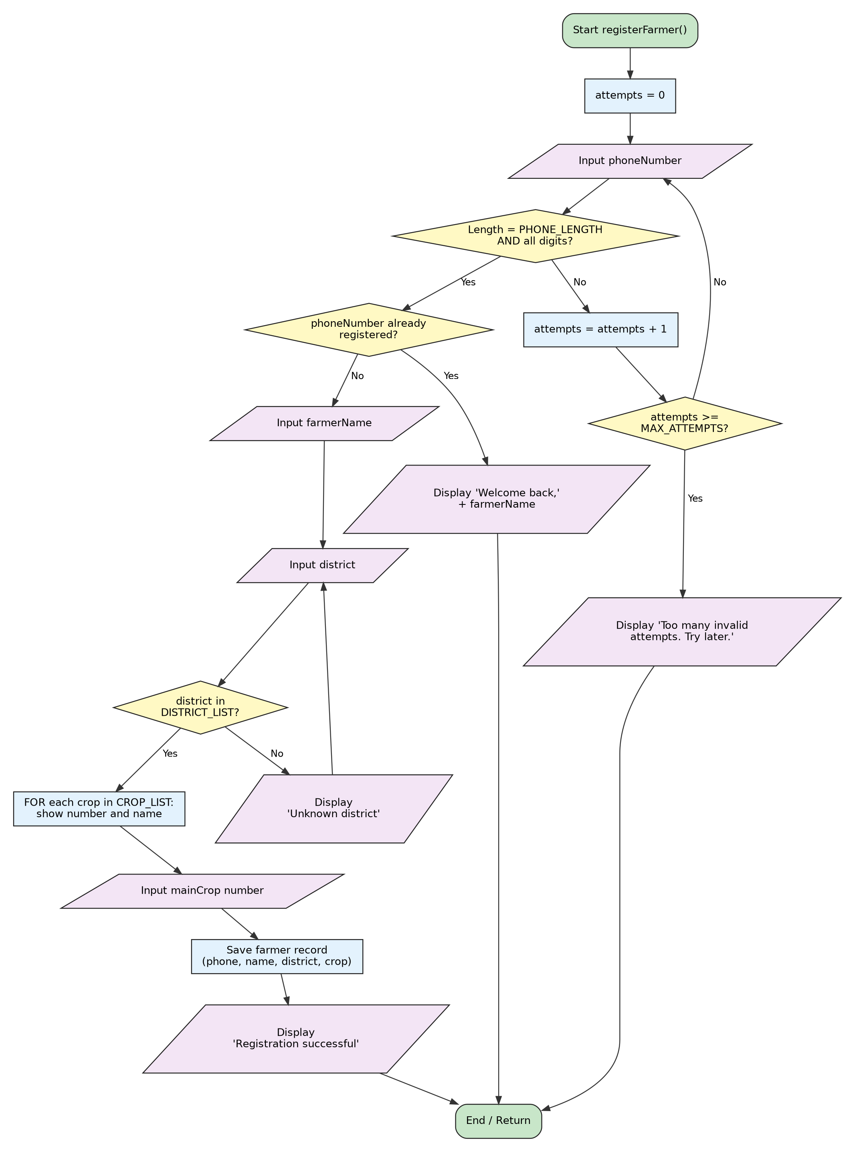
Figure 2: Module 1 - registerFarmer()

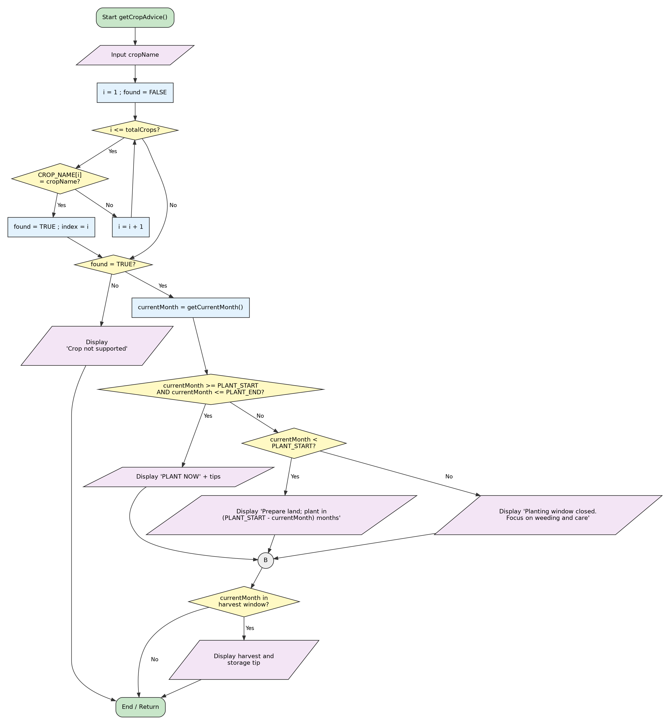
Figure 3: Module 2 - getCropAdvice()

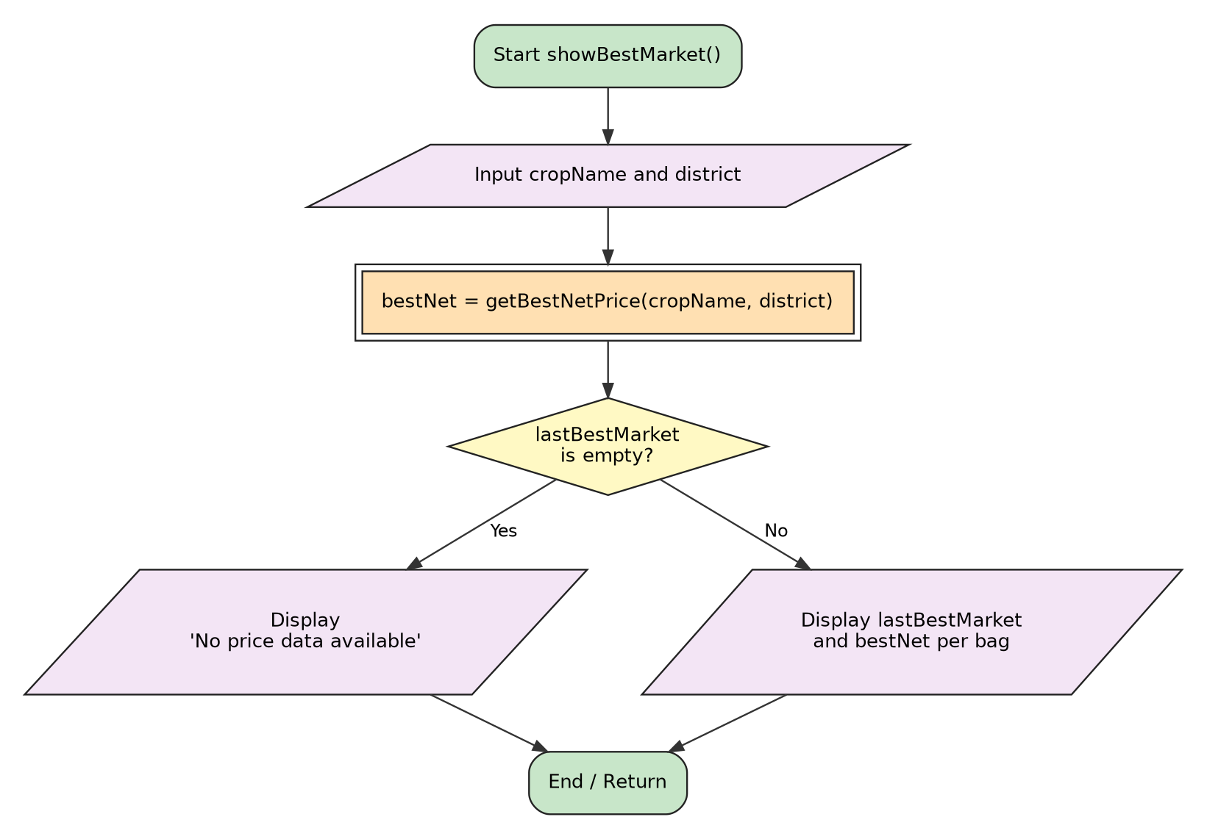
Figure 4: Module 3 - showBestMarket()

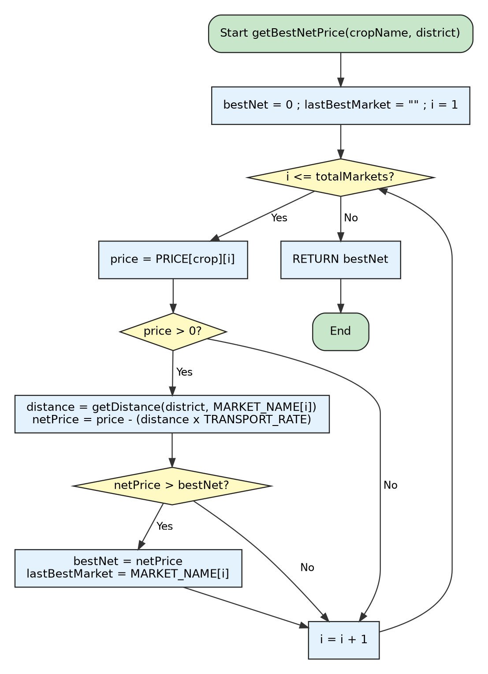
Figure 5: Core function - getBestNetPrice(cropName, district), used by Modules 3 and 4

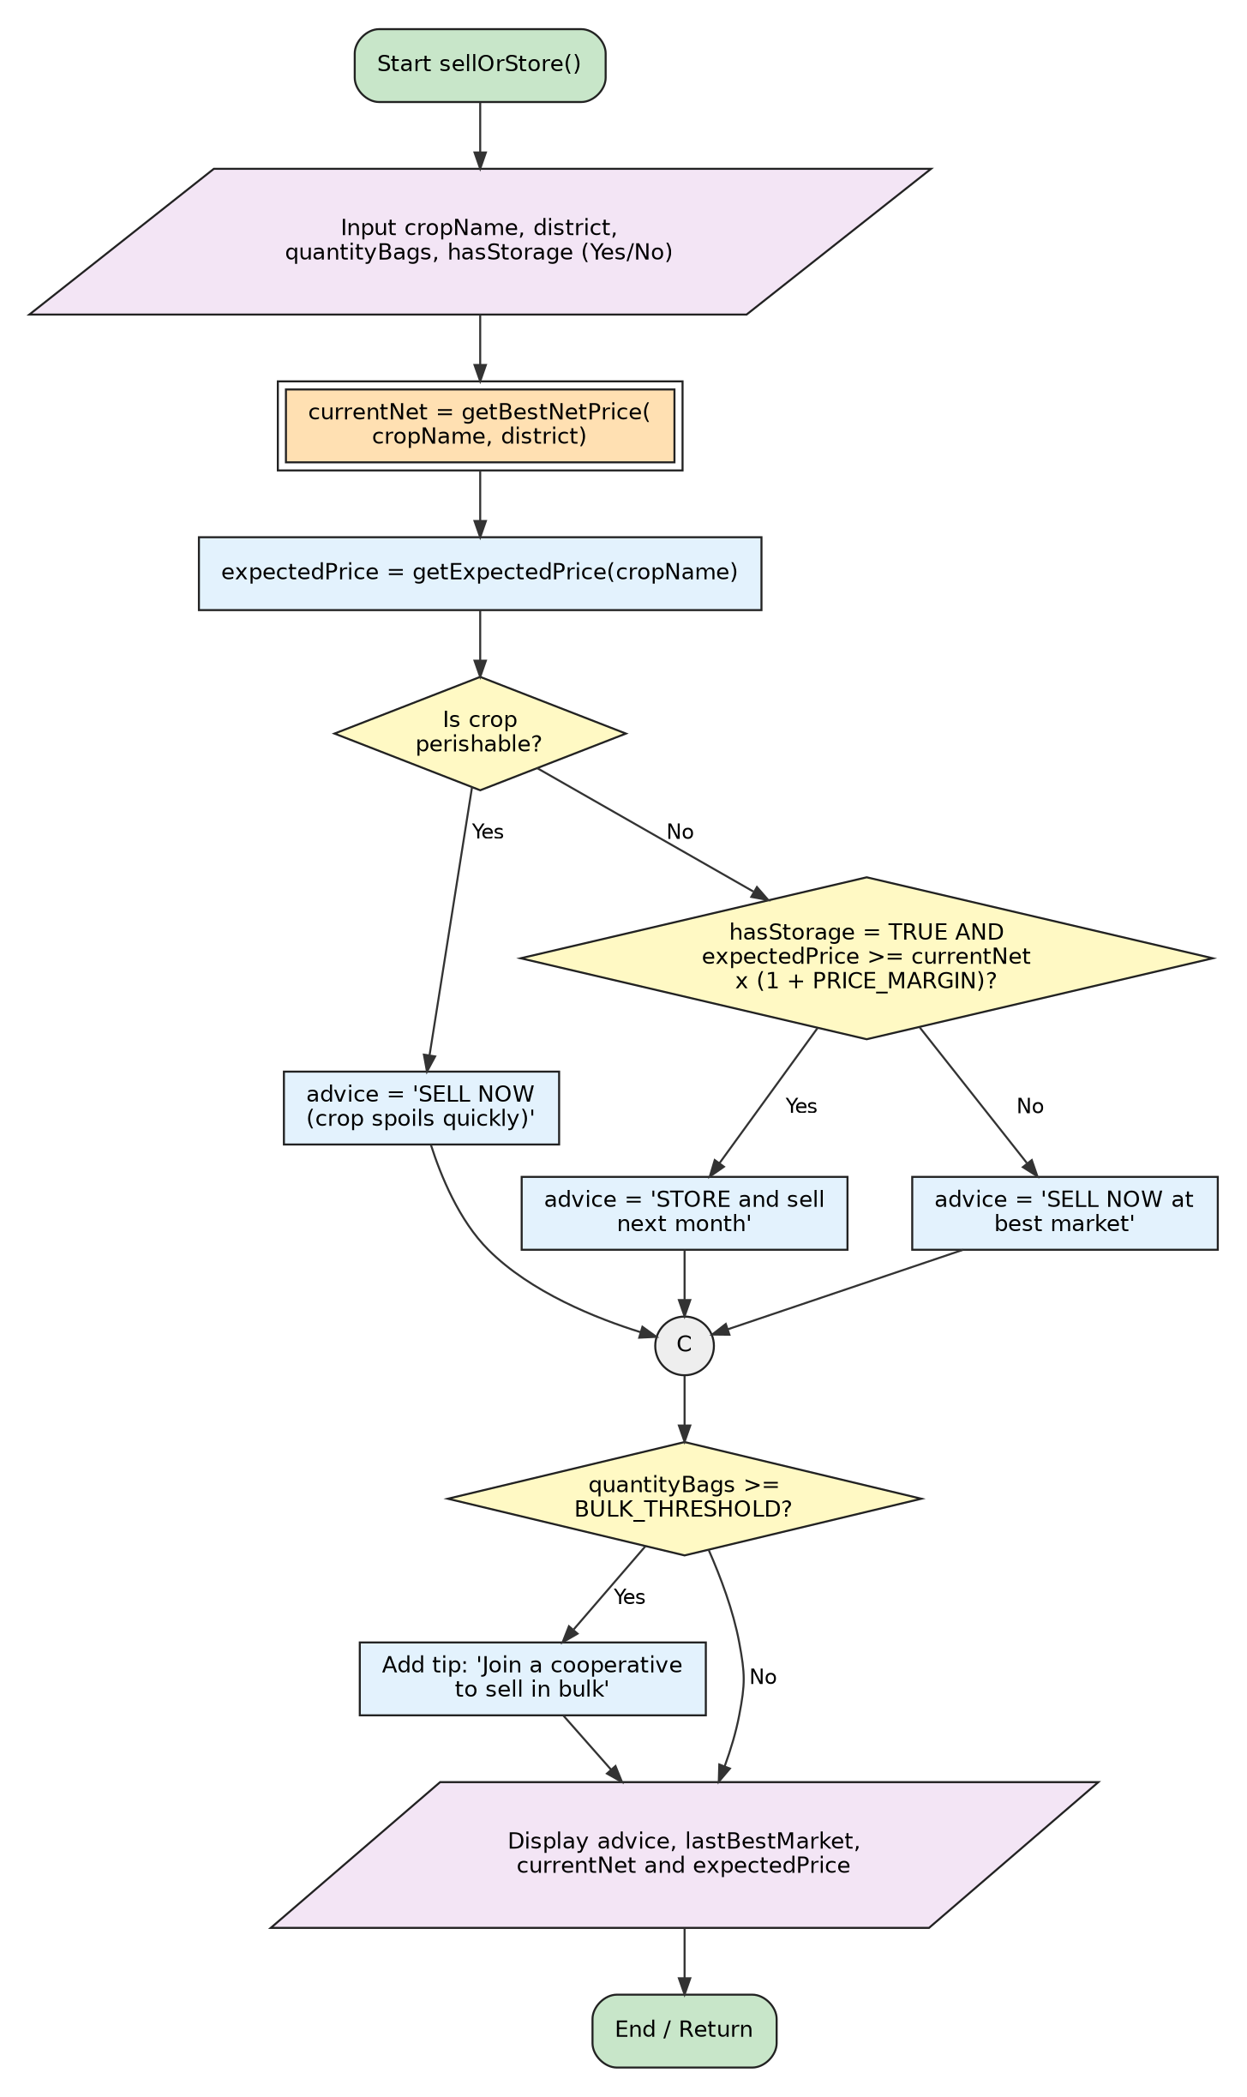
Figure 6: Module 4 - sellOrStore()

5. Functional Modules
The system is decomposed into modules that each do one job. Modules communicate only through parameters, return values and the shared data tables.
Module | Inputs | Outputs | Logic structures used
Main menu controller | Menu choice | Calls a module or exits | Repetition (WHILE), decision (IF / ELSE IF), constants
1. registerFarmer() | Phone, name, district, main crop | Saved record, success or error message | Repetition (WHILE, REPEAT UNTIL, FOR), Boolean logic (AND, NOT), validation
2. getCropAdvice() | Crop name, current month | PLANT NOW, wait time or closed message, harvest tip | Repetition (linear search), nested decisions, range check using AND
3. showBestMarket() | Crop, district | Best market and net price | Calls getBestNetPrice(), decision
4. sellOrStore() | Crop, district, bags, storage | SELL NOW or STORE, bulk tip | Decisions with AND, arithmetic, function calls
Core: getBestNetPrice() | Crop, district | Best net price (and market name) | Repetition (FOR), nested decisions, arithmetic

5.1 Functions
Function | Returns | Purpose
isValidPhone(phone) | Boolean | Checks that the number has PHONE_LENGTH digits and contains only digits
getDistance(district, market) | Real | Looks up the road distance in km
getCurrentMonth() | Integer (1 to 12) | Reads the month from the system date
getExpectedPrice(crop) | Real | Gets next month's expected price from the table
isPerishable(crop) | Boolean | TRUE for crops that spoil quickly, such as cassava
cropIndex(crop) | Integer | Finds the crop's position in the crop table
inList(item, list) | Boolean | Checks whether a value is in a list (used for districts)
farmerExists(phone) | Boolean | Checks whether the phone number is already registered

5.2 Variables, Constants and Data Types
Name | Type | Use
PHONE_LENGTH, MAX_ATTEMPTS, MENU_EXIT, BULK_THRESHOLD | Constant (Integer) | Fixed rules: 8 digits, 3 attempts, option 5, 20 bags
TRANSPORT_RATE, PRICE_MARGIN | Constant (Real) | Le 0.40 per bag per km; 10% margin for storing
phoneNumber, farmerName, district, cropName | Variable (String) | User input
choice, attempts, i, currentMonth, quantityBags | Variable (Integer) | Counters, menu choice, month, bags
price, distance, netPrice, bestNet, expectedPrice | Variable (Real) | Money and distance calculations
running, phoneOK, found, hasStorage | Variable (Boolean) | Loop and decision flags
CROP_NAME, MARKET_NAME, DISTRICT_LIST, PRICE | Array / 2D Array | Lookup tables loaded from open data files

6. Expected Outputs
Note on data: the planting windows, prices and distances below are illustrative values for testing the logic. Before real use they must be replaced with verified data from the Ministry of Agriculture and Food Security (MAFFS), the Sierra Leone Agricultural Research Institute (SLARI) and market surveys.

6.1 Sample Data Tables
Crop | Plant window (month) | Harvest window (month) | Perishable | Expected price next month (Le/bag) | Note
Rice | 5 to 7 | 9 to 11 | No | 640 | Staple
Cassava | 4 to 6 | 1 to 4 | Yes | n/a | Spoils fast
Groundnut | 5 to 7 | 9 to 10 | No | n/a | Keeps well if dry
Maize | 4 to 6 | 8 to 9 | No | n/a | Keeps well if dry

Market | Distance from Bo (km) | Rice price (Le/bag) | Net price = price − (km × 0.40)
Bo | 0 | 560 | 560.00
Kenema | 100 | 610 | 610 − 40.00 = 570.00
Freetown | 250 | 650 | 650 − 100.00 = 550.00

6.2 Scenario Results
Scenario | Input | Expected output
S1 Valid registration | Phone 76123456, name Mariatu Sesay, district Bo, crop 1 | 'Registration successful'
S2 Invalid phone | 1234, then 12ab, then 99 (3 failures) | 'Invalid phone number' twice, then 'Too many invalid attempts. Try later.'
S3 Crop advice, month 6 | Rice | 'PLANT NOW: Rice'
S4 Crop advice, month 1 | Rice | 'Prepare land. Plant in 4 month(s)'
S5 Crop advice, month 10 | Rice | 'Planting window closed. Focus on weeding and crop care' + 'Harvest period: dry the crop well before storage'
S6 Unknown crop | Yam | 'Crop not supported'
S7 Best market | Rice, district Bo | 'Best market: Kenema. Net price: Le 570.00 per bag'
S8 Store | Rice, Bo, 30 bags, storage Yes. Threshold: 570 × 1.10 = 627; expected 640 ≥ 627 | 'STORE and sell next month. Tip: join a cooperative to sell in bulk'
S9 Perishable | Cassava, 12 bags, storage Yes | 'SELL NOW (crop spoils quickly)'
S10 No storage | Rice, Bo, 8 bags, storage No | 'SELL NOW at best market' (no bulk tip)

6.3 Trace of the Repetition in getBestNetPrice() (Scenario S7)
i | Market | Price | Distance | Net price | Net > bestNet? | bestNet after
1 | Bo | 560 | 0 | 560.00 | Yes | 560.00 (Bo)
2 | Kenema | 610 | 100 | 570.00 | Yes | 570.00 (Kenema)
3 | Freetown | 650 | 250 | 550.00 | No | 570.00 (Kenema)
After i = 3 the condition i ≤ totalMarkets (3) becomes false, the loop ends and the function returns 570.00 with lastBestMarket = Kenema.

6.4 Sample Phone Screens (USSD/SMS)
AgriLink SL
1 Register
2 Crop Advice
3 Best Market
4 Sell or Store
5 Exit
> 2
Enter crop: Rice
PLANT NOW: Rice. Sow in the next few weeks.

AgriLink SL
> 4
Crop: Rice | District: Bo | Bags: 30 | Storage: Yes
STORE and sell next month.
Best market now: Kenema (Le 570.00/bag).
Expected next month: Le 640.00/bag.
Tip: join a cooperative to sell in bulk.

7. GitHub Evidence
The repository follows the required naming convention and contains the report, flowcharts, pseudocode and README.md. Insert the evidence below before printing.
Evidence | Details to insert
Repository name | PROG101_Assignment1_[ARMANI C BECKLEY]_[905006175]
Repository URL | aramanichimelo-bit/PROG101_ASSIGNMENT1_ARMANI.C.BECKLEY_905006175: Assignment 1
README.md | [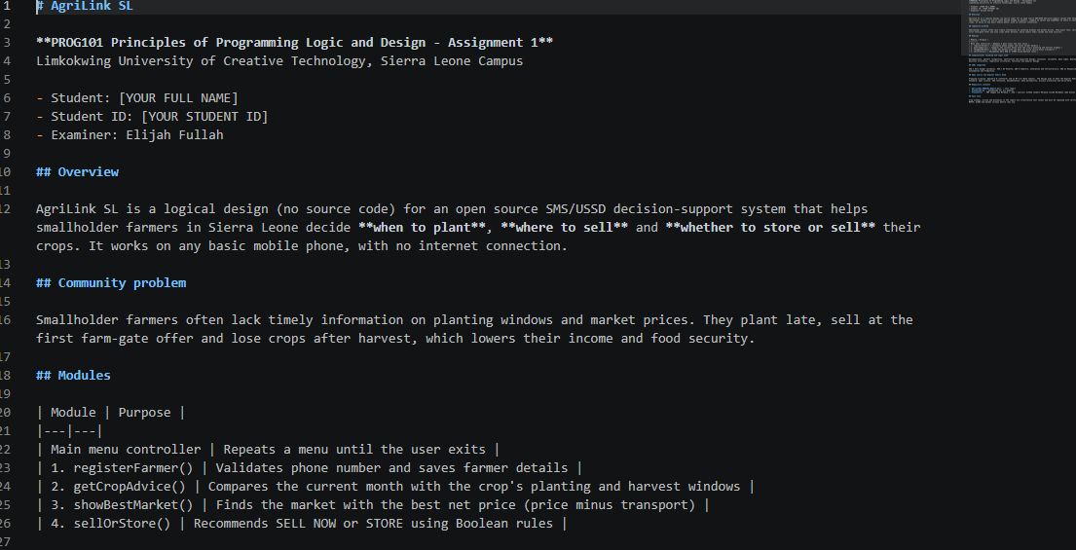]
Repository screenshot | []

Repository contents: README.md, report (PDF or DOCX), pseudocode.md, and a flowcharts folder holding PNG images and Mermaid (.mmd) sources.

8. References
- United Nations (n.d.) The 17 Sustainable Development Goals. Available at: https://sdgs.un.org/goals (Accessed: October 2026).
- Digital Public Goods Alliance (n.d.) The Digital Public Goods Standard. Available at: https://digitalpublicgoods.net/standard (Accessed: October 2026).
- Open Source Initiative (n.d.) The Open Source Definition. Available at: https://opensource.org/osd (Accessed: October 2026).
- Food and Agriculture Organization of the United Nations (n.d.) FAO in Sierra Leone. Available at: https://www.fao.org (Accessed: October 2026).
- Ministry of Agriculture and Food Security, Government of Sierra Leone (n.d.) Agricultural information for farmers. [Verify the exact page before citing].
- Chacon, S. and Straub, B. (2014) Pro Git. 2nd edn. Apress. Available at: https://git-scm.com/book (Accessed: October 2026).

