Docker Installation:

<https://docs.docker.com/docker-for-mac/install/>

Once installed you will see:

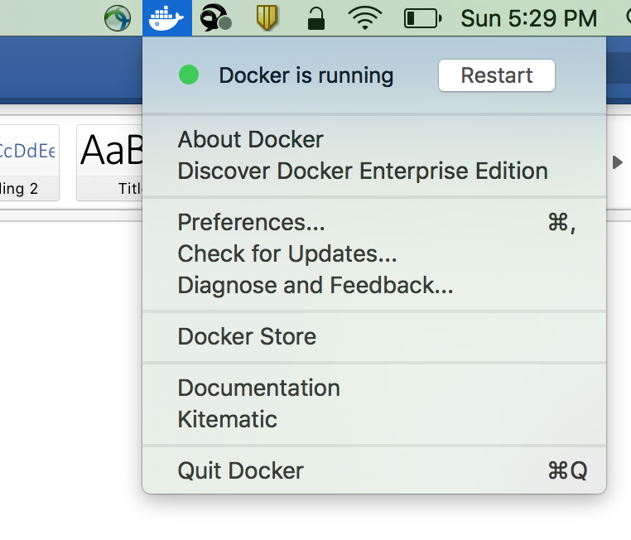

**Validate the installation:**

m-C02S23PLG8WM:docker-python-app aramar1$ ***docker version***

Client:

 Version:      17.03.1-ce

 API version:  1.27

 Go version:   go1.7.5

 Git commit:   c6d412e

 Built:        Tue Mar 28 00:40:02 2017

 OS/Arch:      darwin/amd64

Server:

 Version:      17.03.1-ce

 API version:  1.27 (minimum version 1.12)

 Go version:   go1.7.5

 Git commit:   c6d412e

 Built:        Fri Mar 24 00:00:50 2017

 OS/Arch:      linux/amd64

 Experimental: true

**Docker commands:**

docker build -t <app name> .

docker run <appname>

docker stats

docker ps —>

**Step 1. How to write a Docker File:**

Write a Docker file with name **Dockerfile**

**Add your commands to build your application:**

**Eg:**

FROM python:2.7

ADD trackLocationFromWeb.py /

RUN pip install flask

RUN pip install web.py

RUN pip install geocode

EXPOSE 5000

CMD [ "python", "./<your server program>.py" ]

**Step 2. To build an App**

to build the app >**docker build -t <app name> .**

**Step 3. To verify the image created:**

**$docker images**

REPOSITORY                         TAG                 IMAGE ID            CREATED             SIZE

track-python-app-exampl   933d4845ac4c        933d4845ac4c        2 days ago          740 MB

**Step 4. To run your app.**

to run with log >**docker run —name    logging-01 -t -d -v $(pwd):/tmp  -w /tmp  -p 5000:5000 <appName>**

Eg.

docker run --name logging-01 -t -d -v $(pwd):/tmp  -w /tmp  -p 5000:5000 track-python-app-exampl

**Step 5. To check the status of the Docker and check your application**

to see process >**docker ps or docker stats**

TO ssh  into the container >**sudo docker exec -it <image-id-or-container id>  bash**

To view the Docker Logs > **docker logs -f logging-02**

To test the application > **curl 127.0.0.1:5000 -v**

**Step 6: Pushing the Docker to a public hub:**

**To do this you must sign to Docker hub :** [**https://docs.docker.com/engine/getstarted/step_five/**](https://docs.docker.com/engine/getstarted/step_five/)

**To push to google container registry:** [**https://cloud.google.com/container-registry/docs/pushing**](https://cloud.google.com/container-registry/docs/pushing)

#To Create an image with latest tag> docker tag fb37732d54a9 <imagename>:<tagid>

#To Push Docker image to hub > docker push <yourhubname/imagename>

Kubernetes Installation :

Refer: Kubernetes_install.pdf

<https://confluence.walmart.com/download/attachments/189837932/Kubernetes_install.pdf?version=1&modificationDate=1491794785000&api=v2>

**To Star the Kubernetes:**

minikube start

**Get Kubernetes cluster info :**

1. kubectl cluster-info

Kubernetes master is running at https://192.168.99.100:8443

KubeDNS is running at https://192.168.99.100:8443/api/v1/proxy/namespaces/kube-system/services/kube-dns

kubernetes-dashboard is running at https://192.168.99.100:8443/api/v1/proxy/namespaces/kube-system/services/kubernetes-dashboard

1. The above address would give unauthorized so you need to proxy with the

kubectl proxy --address="0.0.0.0"  --port=9090

1. in Broswser access the port using local host
2. <http://127.0.0.1:9090/api/v1/proxy/namespaces/kube-system/services/kubernetes-dashboard/#/pod?namespace=default>

**Create the Deployment:**

**kubectl run <app-image-name> --image=<image-path> --port=5000**

**kubectl get deployments**

m-C02S23PLG8WM:docker-python-app aramar1$ **kubectl get deployments**

NAME                DESIRED   CURRENT   UP-TO-DATE   AVAILABLE   AGE

docker-python-app   1         1         1            1           3m

**check the status of the pod created:**

m-C02S23PLG8WM:docker-python-app aramar1$ **kubectl get pods -o wide**

NAME                                 READY     STATUS    RESTARTS   AGE       IP           NODE

docker-python-app-3657222991-t5kb9   1/1       Running   0          3m        172.17.0.4   minikube

**Check the Events: (event log)**

**kubectl get events**

**Check the Deployment in Dash board:**

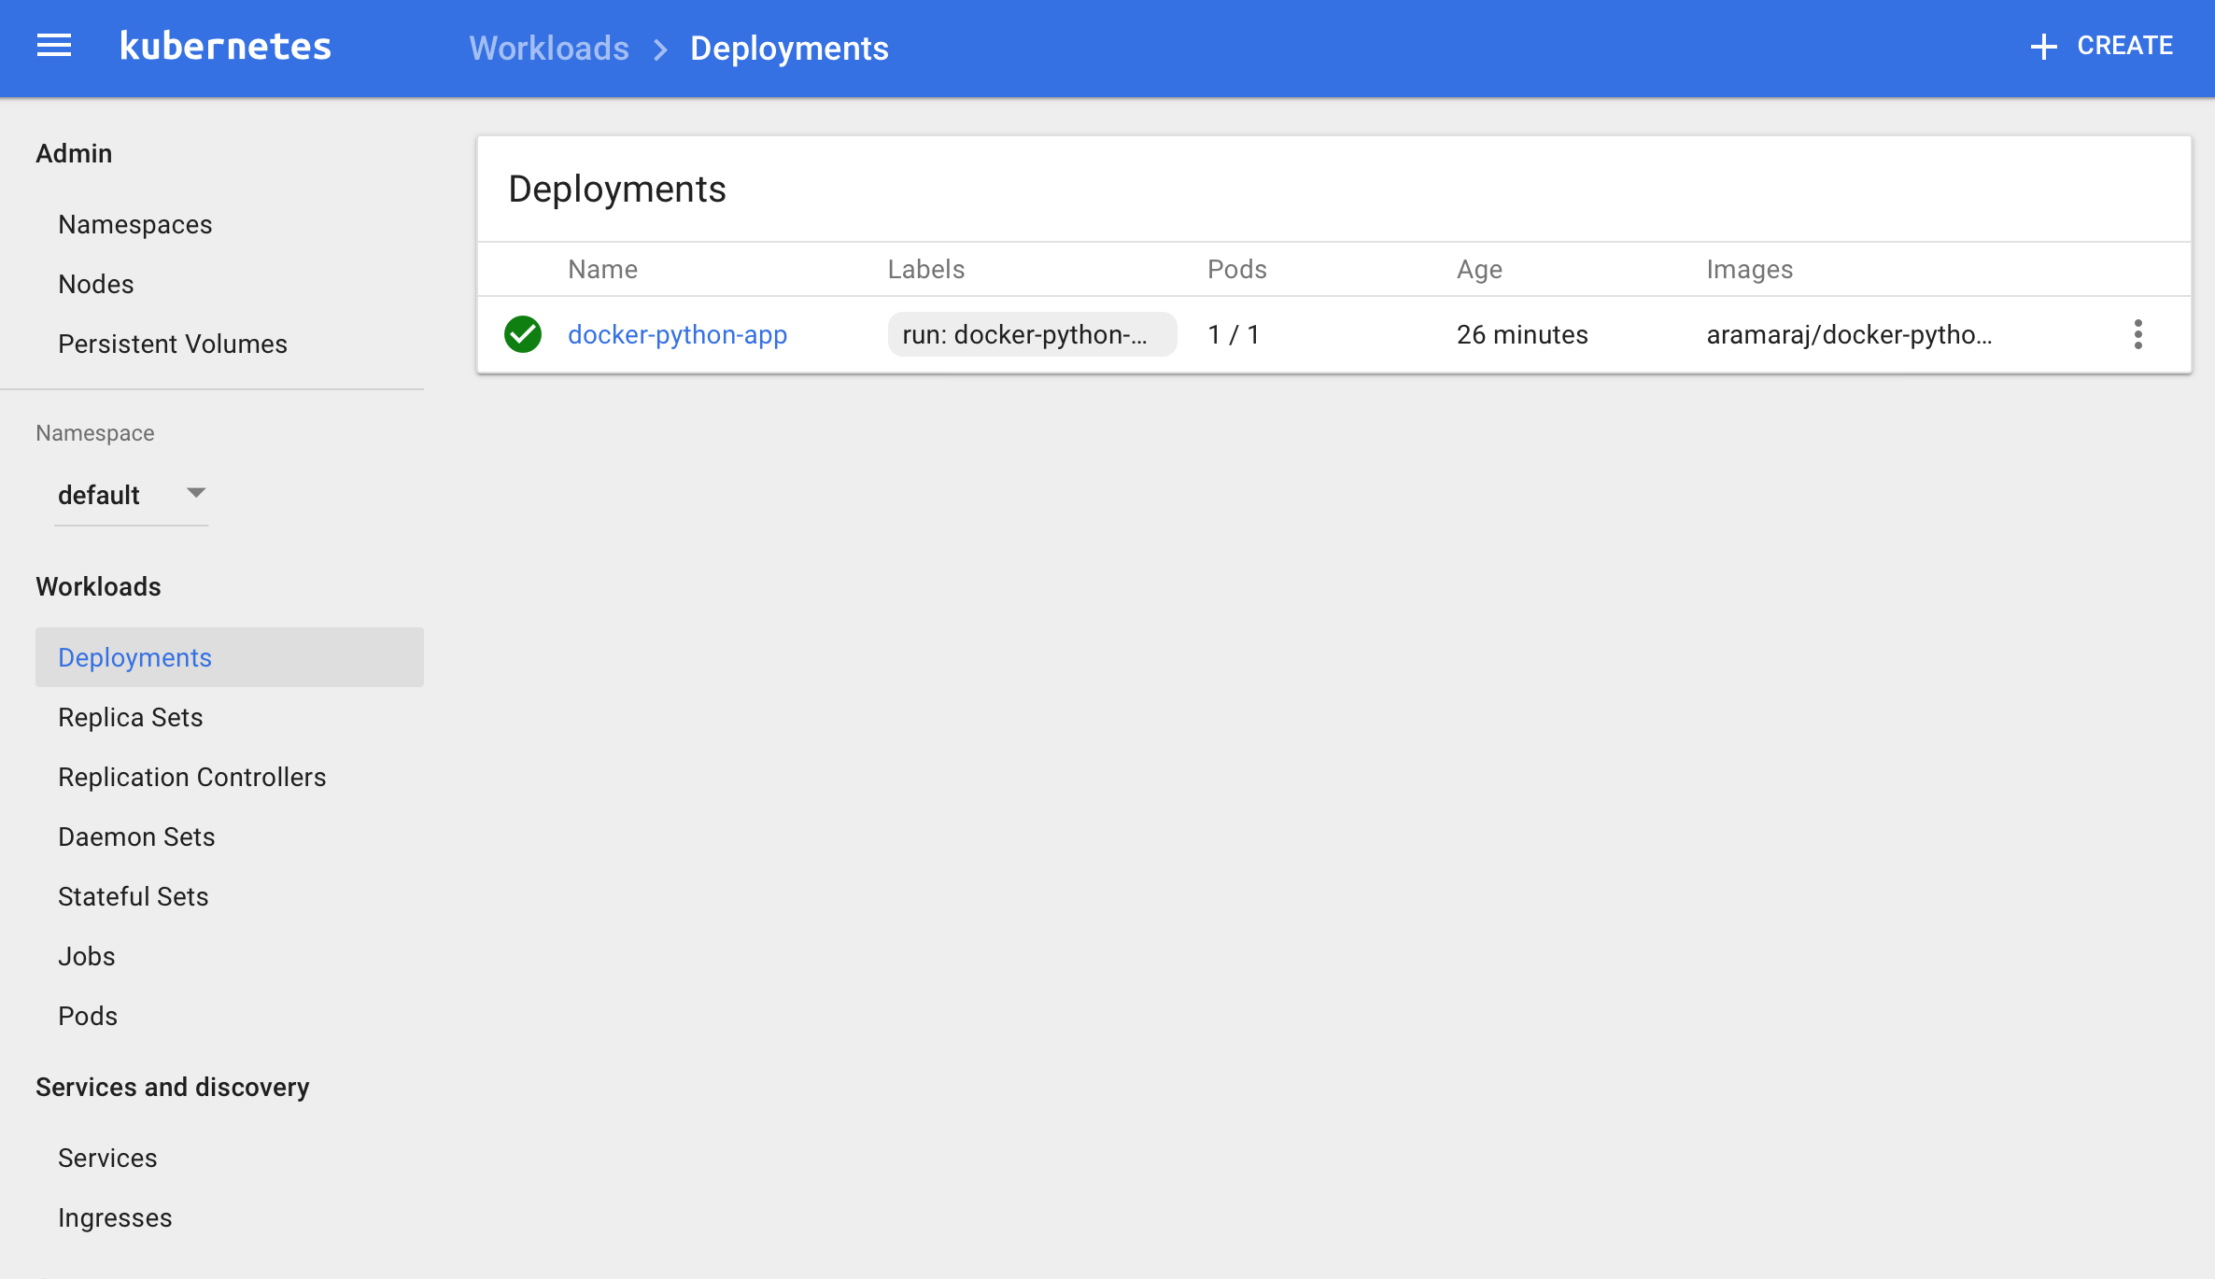

**Check the configuration:**

kubectl config view

m-C02S23PLG8WM:docker-python-app aramar1$ kubectl config view

apiVersion: v1

clusters:

- cluster:

    certificate-authority: /Users/aramar1/.minikube/ca.crt

    server: https://192.168.99.100:8443

  name: minikube

contexts:

- context:

    cluster: minikube

    user: minikube

  name: minikube

current-context: minikube

kind: Config

preferences: {}

users:

- name: minikube

  user:

    client-certificate: /Users/aramar1/.minikube/apiserver.crt

    client-key: /Users/aramar1/.minikube/apiserver.key

**Check if the application runs on the POD:**

m-C02S23PLG8WM:docker-python-app aramar1$ minikube ssh

$ curl 172.17.0.4:5000/track?name=ashok

Location of the Delivery truck number ashok  is  315-317 N 10th St, San Jose, CA 95112, USA and Map URL is <http://maps.google.com/?q=37.345622600,-121.884722400>

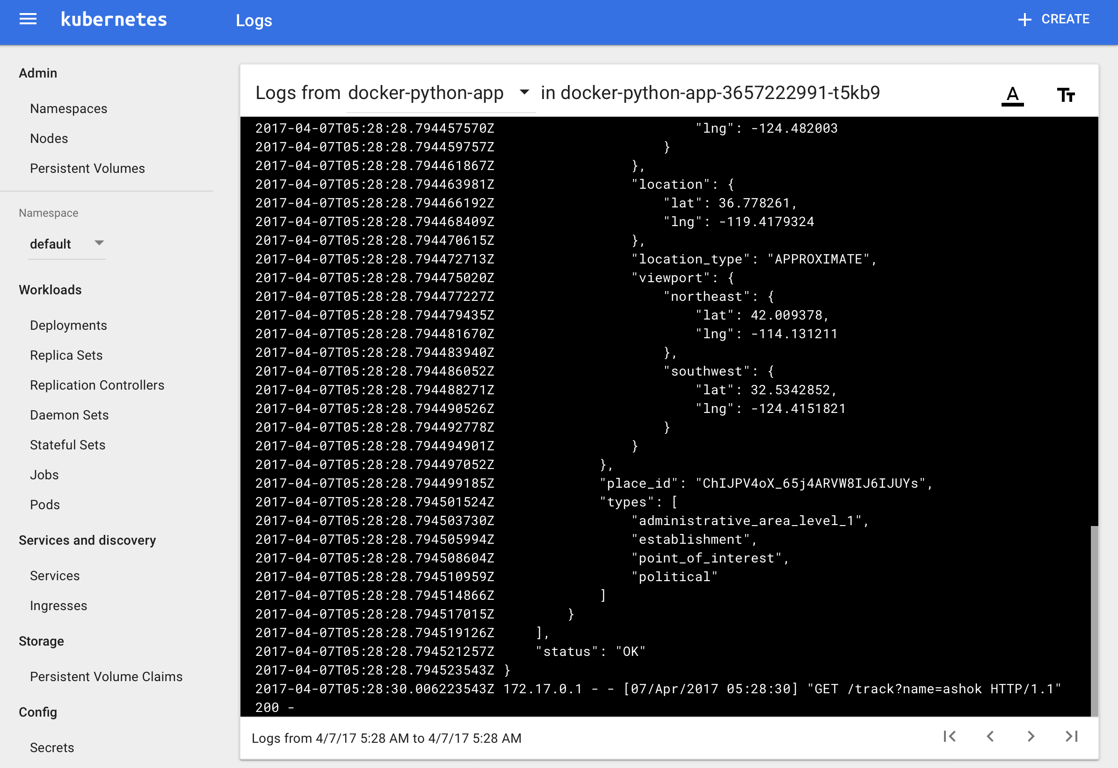

**Create a Service to expose the service outside:**

Note we must use the *type=NodePort* because *minikube* doesn’t support the *LoadBalancer* service. We can check if the service was exposed by listing services:

m-C02S23PLG8WM:docker-python-app aramar1$ **kubectl expose deployment <service-name>  --type=NodePort**

service "docker-python-app" exposed

m-C02S23PLG8WM:docker-python-app aramar1$

Get the services:

kubectl get svc

**Services Dash board:**

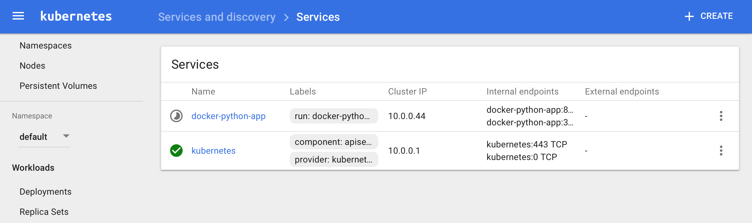

m-C02S23PLG8WM:kubernetes aramar1$ **kubectl get svc**

NAME         CLUSTER-IP   EXTERNAL-IP   PORT(S)        AGE

kubernetes   10.0.0.1     <none>        443/TCP        8h

web          10.0.0.34    <nodes>       80:30940/TCP   3m

**Get the Exposed Service URL:**

minikube service -n default --url docker-python-app

http://192.168.99.100:30587

**Kubernetes Scale:**

**Scale the deployment pod:**

m-C02S23PLG8WM:docker-python-app aramar1$ **kubectl scale deployments/docker-python-app --replicas=3**

deployment "docker-python-app" scaled

**get the deployments:**

m-C02S23PLG8WM:docker-python-app aramar1$ **kubectl get deployments**

NAME                DESIRED   CURRENT   UP-TO-DATE   AVAILABLE   AGE

docker-python-app   3         3         3            3           23m

**get pods**

m-C02S23PLG8WM:docker-python-app aramar1$ **kubectl get pods -o wide**

NAME                                 READY     STATUS    RESTARTS   AGE       IP           NODE

docker-python-app-2874657604-3h5j4   1/1       Running   0          4m        172.17.0.2   minikube

docker-python-app-2874657604-llb6c   1/1       Running   0          4m        172.17.0.5   minikube

docker-python-app-2874657604-xlghv   1/1       Running   0          24m       172.17.0.6   minikube

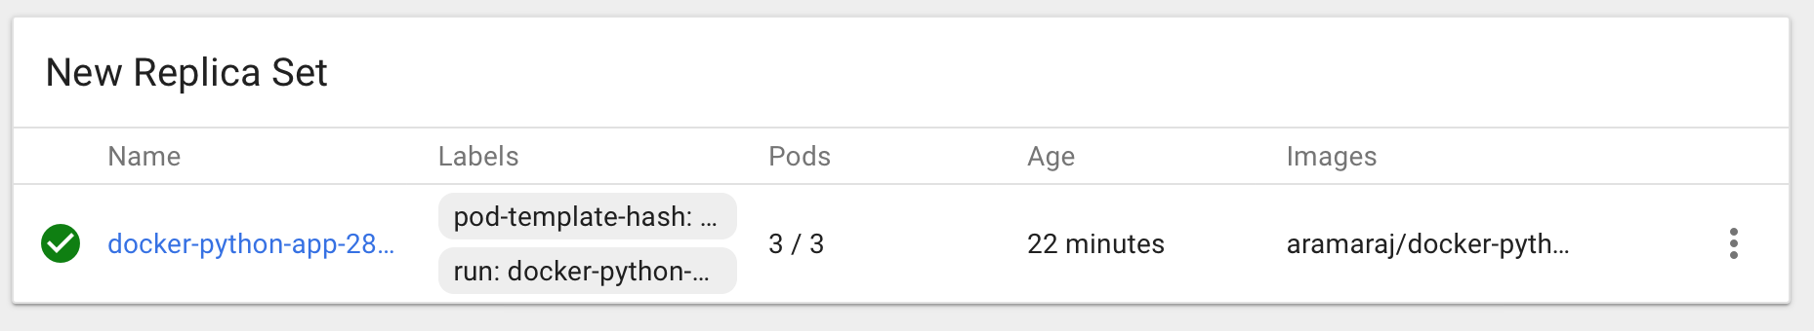

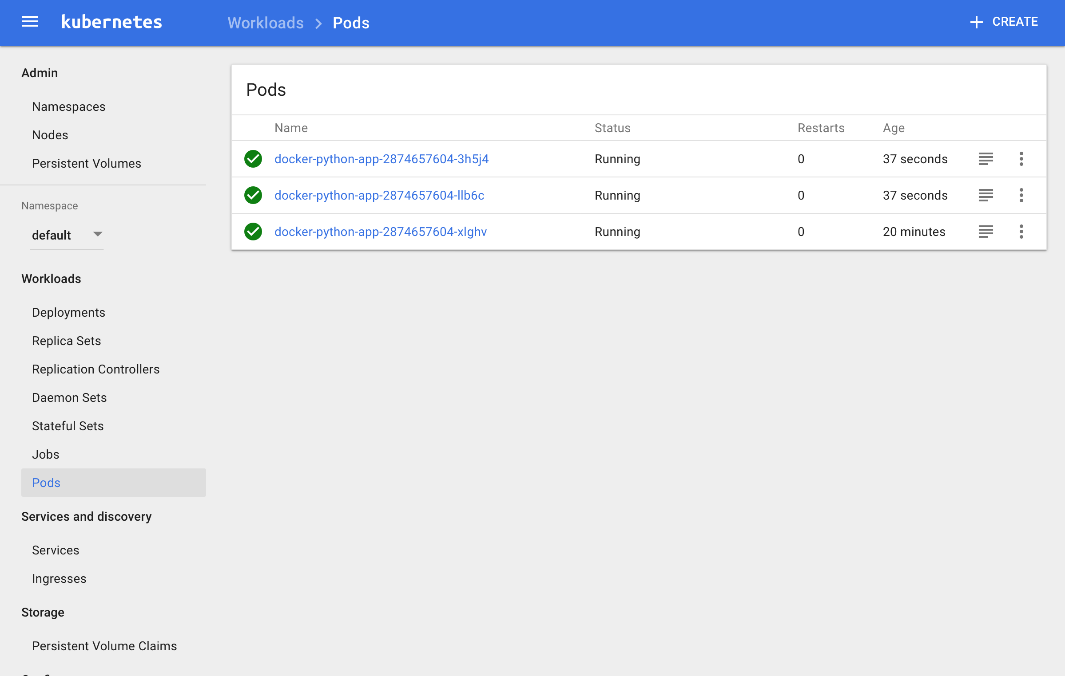

**Describe the Deployment:**

m-C02S23PLG8WM:docker-python-app aramar1$ **kubectl describe deployments/docker-python-app**

Name: docker-python-app

Namespace: default

CreationTimestamp: Fri, 07 Apr 2017 01:30:37 -0700

Labels: run=docker-python-app

Annotations: deployment.kubernetes.io/revision=3

Selector: run=docker-python-app

Replicas: 3 desired | 3 updated | 3 total | 3 available | 0 unavailable

StrategyType: RollingUpdate

MinReadySeconds: 0

RollingUpdateStrategy: 1 max unavailable, 1 max surge

Pod Template:

  Labels: run=docker-python-app

  Containers:

   docker-python-app:

    Image: aramaraj/docker-python-app

    Port: 5000/TCP

    Environment: <none>

    Mounts: <none>

  Volumes: <none>

Conditions:

  Type Status Reason

  ---- ------ ------

  Available True MinimumReplicasAvailable

OldReplicaSets: <none>

NewReplicaSet: <none>

Events:

  FirstSeen LastSeen Count From SubObjectPath Type Reason Message

  --------- -------- ----- ---- ------------- -------- ------ -------

  26m 26m 1 deployment-controller Normal ScalingReplicaSet Scaled up replica set docker-python-app-2874657604 to 1

  26m 26m 1 deployment-controller Normal ScalingReplicaSet Scaled down replica set docker-python-app-3657222991 to 0

  5m 5m 1 deployment-controller Normal ScalingReplicaSet Scaled up replica set docker-python-app-2874657604 to 3

**Load Balancing Kubernetes**

Show the service hit by the URL

kubectl logs docker-python-app-2874657604-3h5j4

Running in Cloud:

Before you begin

1. Select or create a Cloud Platform project -
2. Enable billing for your project.
3. Enable the Cloud Datastore, Cloud Storage, and Cloud Pub/Sub APIs.
   1. https://console.cloud.google.com/apis/dashboard?project=kuernetes-java&duration=PT1H
4. [Install and initialize the Cloud SDK](https://cloud.google.com/sdk/docs/). https://cloud.google.com/sdk/docs/

|  |
| --- |
| m-C02S23PLG8WM:Downloads aramar1$ cd google-cloud-sdk/  m-C02S23PLG8WM:google-cloud-sdk aramar1$ ls  LICENSE VERSION completion.zsh.inc install.sh path.fish.inc properties  README bin help lib path.zsh.inc  RELEASE_NOTES completion.bash.inc install.bat path.bash.inc platform  m-C02S23PLG8WM:google-cloud-sdk aramar1$ ./google-cloud-sdk/install.sh  -bash: ./google-cloud-sdk/install.sh: No such file or directory  m-C02S23PLG8WM:google-cloud-sdk aramar1$ ./install.  -bash: ./install.: No such file or directory  m-C02S23PLG8WM:google-cloud-sdk aramar1$ ./install.sh  Welcome to the Google Cloud SDK!  To help improve the quality of this product, we collect anonymized usage data  and anonymized stacktraces when crashes are encountered; additional information  is available at <https://cloud.google.com/sdk/usage-statistics>. You may choose  to opt out of this collection now (by choosing 'N' at the below prompt), or at  any time in the future by running the following command:      gcloud config set disable_usage_reporting true  Do you want to help improve the Google Cloud SDK (Y/n)?  Y  Your current Cloud SDK version is: 150.0.0  The latest available version is: 150.0.0  ┌─────────────────────────────────────────────────────────────────────────────────────────────────────────────┐  │                                                  Components                                                 │  ├───────────────┬──────────────────────────────────────────────────────┬──────────────────────────┬───────────┤  │     Status    │                         Name                         │            ID            │    Size   │  ├───────────────┼──────────────────────────────────────────────────────┼──────────────────────────┼───────────┤  │ Not Installed │ App Engine Go Extensions                             │ app-engine-go            │  47.7 MiB │  │ Not Installed │ Bigtable Command Line Tool                           │ cbt                      │   3.9 MiB │  │ Not Installed │ Cloud Datalab Command Line Tool                      │ datalab                  │   < 1 MiB │  │ Not Installed │ Cloud Datastore Emulator                             │ cloud-datastore-emulator │  15.4 MiB │  │ Not Installed │ Cloud Datastore Emulator (Legacy)                    │ gcd-emulator             │  38.1 MiB │  │ Not Installed │ Cloud Pub/Sub Emulator                               │ pubsub-emulator          │  21.0 MiB │  │ Not Installed │ Emulator Reverse Proxy                               │ emulator-reverse-proxy   │  56.8 MiB │  │ Not Installed │ Google Container Registry's Docker credential helper │ docker-credential-gcr    │   3.4 MiB │  │ Not Installed │ gcloud Alpha Commands                                │ alpha                    │   < 1 MiB │  │ Not Installed │ gcloud Beta Commands                                 │ beta                     │   < 1 MiB │  │ Not Installed │ gcloud app Java Extensions                           │ app-engine-java          │ 128.6 MiB │  │ Not Installed │ gcloud app PHP Extensions (Mac OS X)                 │ app-engine-php-darwin    │  21.9 MiB │  │ Not Installed │ gcloud app Python Extensions                         │ app-engine-python        │   6.1 MiB │  │ Not Installed │ kubectl                                              │ kubectl                  │  14.8 MiB │  │ Installed     │ BigQuery Command Line Tool                           │ bq                       │   < 1 MiB │  │ Installed     │ Cloud SDK Core Libraries                             │ core                     │   5.8 MiB │  │ Installed     │ Cloud Storage Command Line Tool                      │ gsutil                   │   2.9 MiB │  │ Installed     │ Default set of gcloud commands                       │ gcloud                   │           │  └───────────────┴──────────────────────────────────────────────────────┴──────────────────────────┴───────────┘  To install or remove components at your current SDK version [150.0.0], run:    $ gcloud components install COMPONENT_ID    $ gcloud components remove COMPONENT_ID  To update your SDK installation to the latest version [150.0.0], run:    $ gcloud components update  Modify profile to update your $PATH and enable shell command  completion? (Y/n)?  Y  The Google Cloud SDK installer will now prompt you to update an rc  file to bring the Google Cloud CLIs into your environment.  Enter a path to an rc file to update, or leave blank to use  [/Users/aramar1/.bash_profile]:  Backing up [/Users/aramar1/.bash_profile] to [/Users/aramar1/.bash_profile.backup].  [/Users/aramar1/.bash_profile] has been updated.  ==> Start a new shell for the changes to take effect.  For more information on how to get started, please visit:    https://cloud.google.com/sdk/docs/quickstarts  m-C02S23PLG8WM:google-cloud-sdk aramar1$ ./google-cloud-sdk/bin/gcloud init  -bash: ./google-cloud-sdk/bin/gcloud: No such file or directory  m-C02S23PLG8WM:google-cloud-sdk aramar1$ ./bin/gcloud init  Welcome! This command will take you through the configuration of gcloud.  Your current configuration has been set to: [default]  You can skip diagnostics next time by using the following flag:    gcloud init --skip-diagnostics  Network diagnostic detects and fixes local network connection issues.  Checking network connection...done.  Reachability Check passed.  Network diagnostic (1/1 checks) passed.  You must log in to continue. Would you like to log in (Y/n)?  Y  Your browser has been opened to visit:      https://accounts.google.com/o/oauth2/auth?redirect_uri=http%3A%2F%2Flocalhost%3A8085%2F&prompt=select_account&response_type=code&client_id=32555940559.apps.googleusercontent.com&scope=https%3A%2F%2Fwww.googleapis.com%2Fauth%2Fuserinfo.email+https%3A%2F%2Fwww.googleapis.com%2Fauth%2Fcloud-platform+https%3A%2F%2Fwww.googleapis.com%2Fauth%2Fappengine.admin+https%3A%2F%2Fwww.googleapis.com%2Fauth%2Fcompute+https%3A%2F%2Fwww.googleapis.com%2Fauth%2Faccounts.reauth&access_type=offline  You are logged in as: [ashok.ramaraj@gmail.com].  Pick cloud project to use:   [1] crack-case-134420   [2] culverttracker-1473314615838   [3] daring-harmony-142406   [4] inbound-object-131706   [5] kuernetes-java   [6] sammydemo-154906   [7] trackerdemojs-1473447840777  Please enter numeric choice or text value (must exactly match list  item):  5  Your current project has been set to: [kuernetes-java].  Not setting default zone/region (this feature makes it easier to use  [gcloud compute] by setting an appropriate default value for the  --zone and --region flag).  See https://cloud.google.com/compute/docs/gcloud-compute section on how to set  default compute region and zone manually. If you would like [gcloud init] to be  able to do this for you the next time you run it, make sure the  Compute Engine API is enabled for your project on the  https://console.developers.google.com/apis page.  Created a default .boto configuration file at [/Users/aramar1/.boto]. See this file and  [https://cloud.google.com/storage/docs/gsutil/commands/config] for more  information about configuring Google Cloud Storage.  Your Google Cloud SDK is configured and ready to use!  * Commands that require authentication will use ashok.ramaraj@gmail.com by default  * Commands will reference project `kuernetes-java` by default  Run `gcloud help config` to learn how to change individual settings  This gcloud configuration is called [default]. You can create additional configurations if you work with multiple accounts and/or projects.  Run `gcloud topic configurations` to learn more.  Some things to try next:  * Run `gcloud --help` to see the Cloud Platform services you can interact with. And run `gcloud help COMMAND` to get help on any gcloud command.  * Run `gcloud topic -h` to learn about advanced features of the SDK like arg files and output formatting  m-C02S23PLG8WM:google-cloud-sdk aramar1$ |

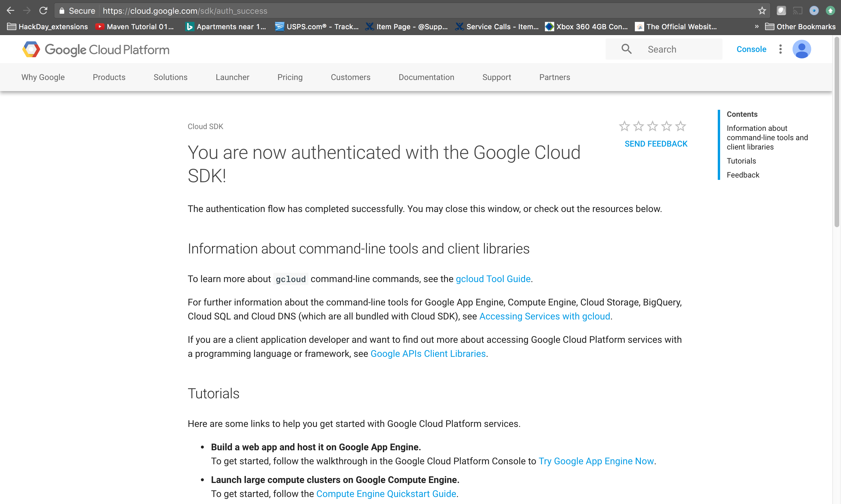

1. Install [Docker](https://www.docker.com/). Docker is used to build container images locally.

Creating a Container Engine cluster

m-C02S23PLG8WM:bin aramar1$ ./gcloud container clusters create docker-python-app --scopes "cloud-platform" --num-nodes 2

Creating cluster docker-python-app...|

m-C02S23PLG8WM:bin aramar1$ ./gcloud container clusters create docker-python-app --scopes "cloud-platform" --num-nodes 2

Creating cluster docker-python-app...done.

Created [https://container.googleapis.com/v1/projects/kuernetes-java/zones/us-central1-b/clusters/docker-python-app].

kubeconfig entry generated for docker-python-app.

NAME               ZONE           MASTER_VERSION  MASTER_IP     MACHINE_TYPE   NODE_VERSION  NUM_NODES  STATUS

docker-python-app  us-central1-b  1.5.6           <MASTER_IP>  n1-standard-1  1.5.6         2          RUNNING

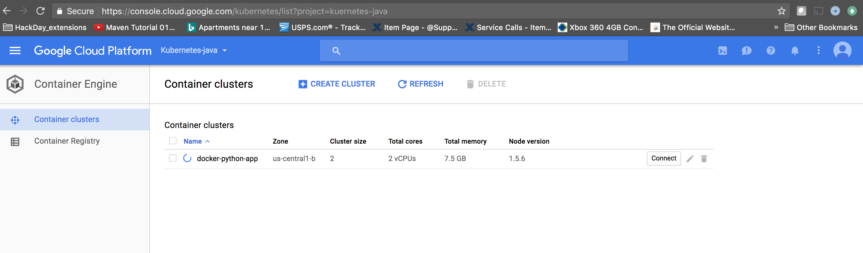

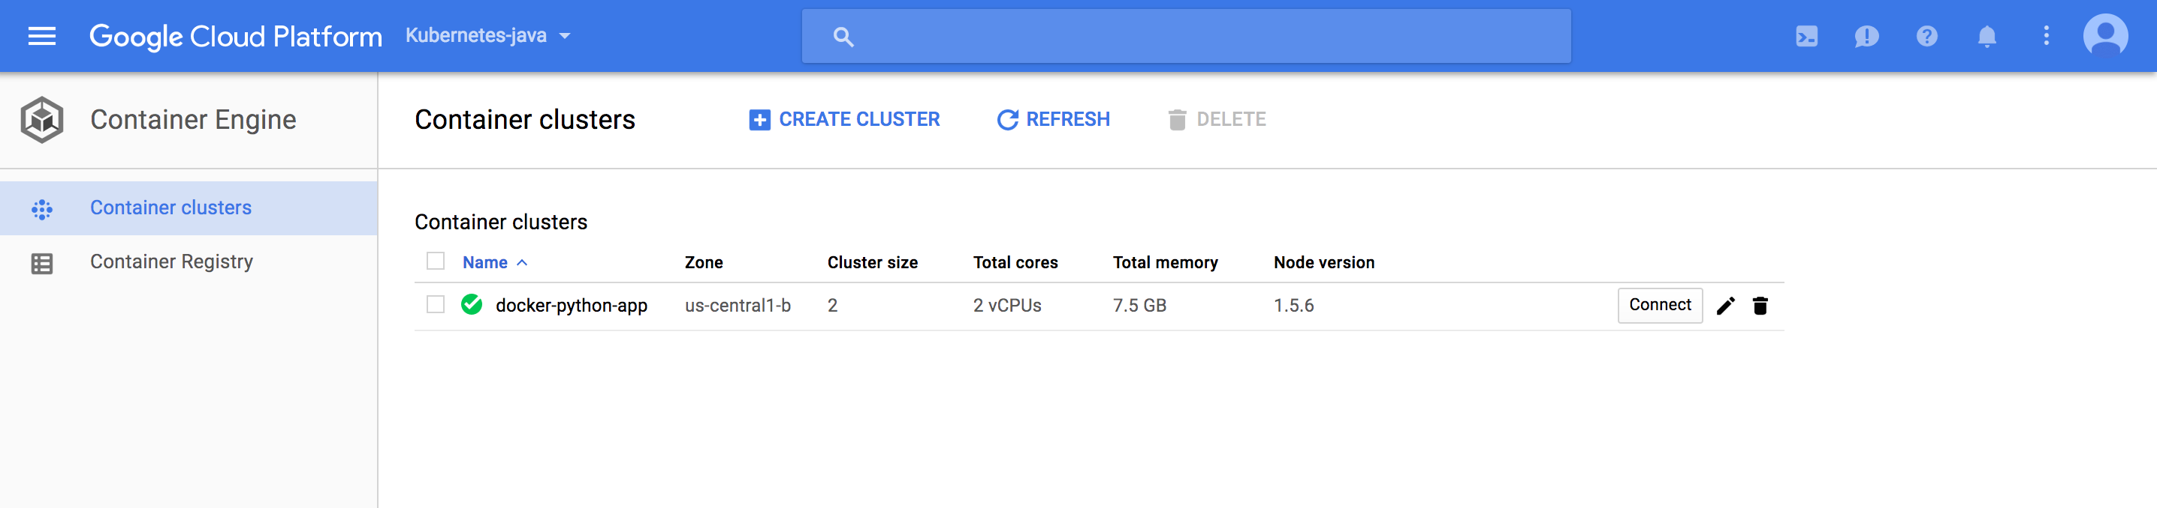

Get the credentials for the cluster:

./gcloud container clusters get-credentials docker-python-app

Fetching cluster endpoint and auth data.

kubeconfig entry generated for docker-python-app.

Status

m-C02S23PLG8WM:bin aramar1$ kubectl cluster-info

Kubernetes master is running at https://<extenalip>

GLBCDefaultBackend is running at https://<extenalip>/api/v1/proxy/namespaces/kube-system/services/default-http-backend

Heapster is running at https://<extenalip>/api/v1/proxy/namespaces/kube-system/services/heapster

KubeDNS is running at https://<extenalip>/api/v1/proxy/namespaces/kube-system/services/kube-dns

kubernetes-dashboard is running at https://<extenalip>/api/v1/proxy/namespaces/kube-system/services/kubernetes-dashboard

Accesss the Dash board:

m-C02S23PLG8WM:bin aramar1$ kubectl proxy

Starting to serve on 127.0.0.1:8001

http://127.0.0.1:8001/api/v1/proxy/namespaces/kube-system/services/kubernetes-dashboard/#/workload?namespace=default

**Create the deployment :**

m-C02S23PLG8WM:bin aramar1$ kubectl run docker-python-app --image=aramaraj/docker-python-app --port=5000

deployment "docker-python-app" created

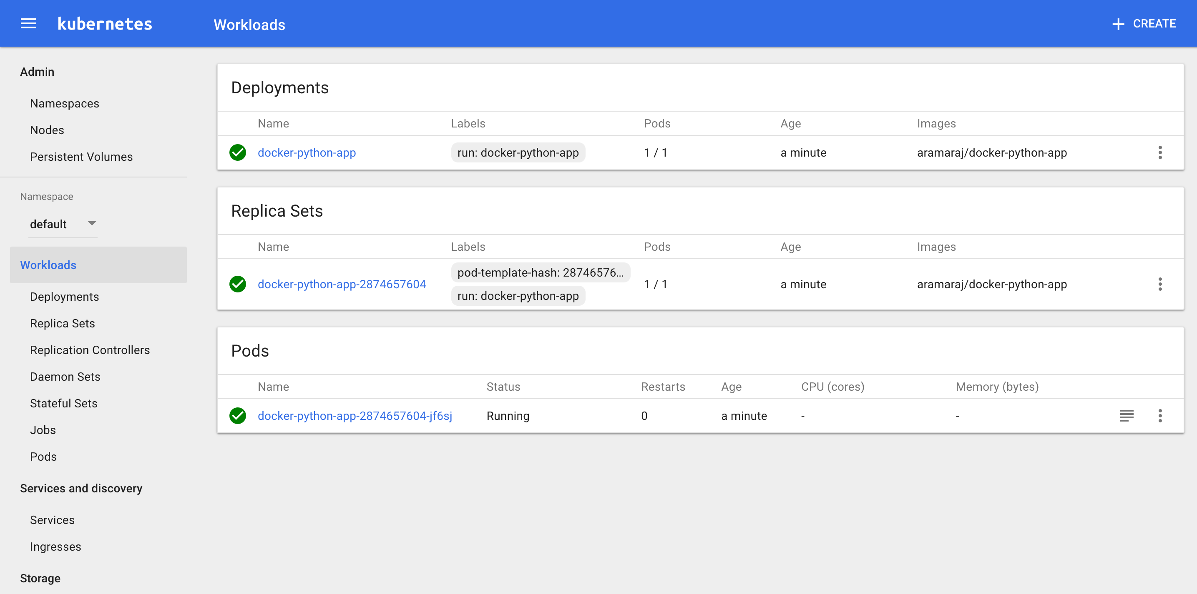

**Create the services**

m-C02S23PLG8WM:bin aramar1$ kubectl expose deployment docker-python-app --type=LoadBalancer

service "docker-python-app" exposed

**Get the Service details:**

m-C02S23PLG8WM:bin aramar1$ kubectl get svc

NAME                CLUSTER-IP      EXTERNAL-IP       PORT(S)          AGE

docker-python-app   <clusterIP> <EXTERNAL_IP>   5000:30398/TCP   1m

kubernetes          <kubernetes-ip>     <none>            443/TCP          40m

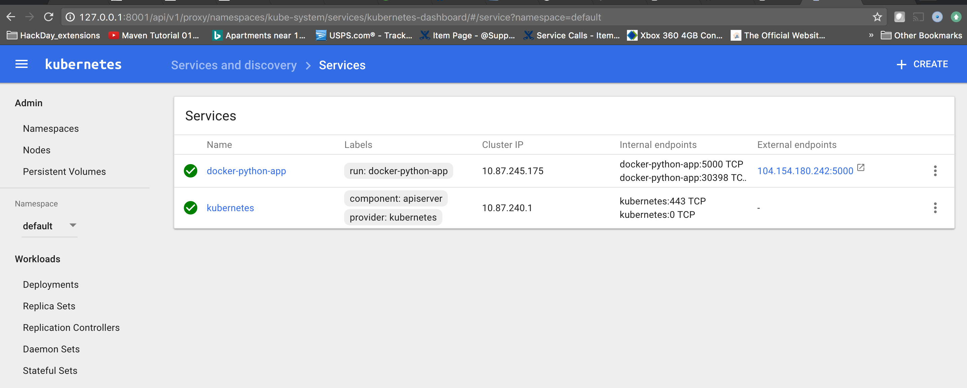

http://<externalip>:5000/

Output:

welcome !