SECTION | Introduction
@Sebastian cutting buzzwords; shorten introduction; more of the empirical argument in the introduction
Stressing the purpose of the paper: introducing the concept of ABN and delivering a descriptive account of ABNs
Introduce the RDIF (as a state-led investment vehicle) and Dmitriev (as a prime Putin crony)

SECTION | Adaptation Brokerage Networks: A Conceptual Framework
@Sebastian Shorten conceptual part of the paper; cut part with the propositions
Reference existing network studies; cut/clarify sentence on missing SNA studies
Get rid of causal arguments (“resilience”, “reactive/strategic”, “success/failure” etc.)
Make clear what co-occurrence actually means: transaction, cooperation/conflict
@Aram I need the visual “academic_core_structure” without badges, names etc. The idea is to have a purely conceptual visualisation, to which we can refer in the conceptual section of the paper. The item should represent the trias of stable core, persistent domestic networks and international partners. There should be no name labels in the visual, only a legend

SECTION | Methodology
@Aram Can you please derive a list of all included INTEGRUM media outlets from the dataset, including the years for which we have articles from the respective outlets?
@Anna Can you please organize this list into something that we could attach to the paper as an appendix (ideally in Overleaf)?
@Aram Regarding the issue of robustness checks: Can you run the codes with only two national media outlets included? The idea is to check whether the same or similar patterns emerge.
@Aram Can you please re-run the analysis for the post-Crimea period with the period cut to 2014 (you can keep the existing date) to 2017 (31.01.2017). This is something you should probably do first because it impacts basically all visuals, tables and calculations.
@Aram As a last stage before submission, can you create a little work flow chart with your Python pipeline?

SECTION | Kirill Dmitriev’s RDIF Network: Structure, Evolution, Function
@Sebastian generally, account more for internal conflict: network data does not show whether edge is actually about cooperation or conflict
SUB-SECTION | GENERAL PATTERNS
@Aram We need the visual on the “evolution of jurisdictions“ with all jurisdictions except “Russia”. By simply zooming into the non-Russian jurisdictions, we should get a more intuitive idea of how they change over time.
It would be nice to have the visual on the “evolution of sectors“ also zoomed into the “non-financial” sectors, to see clearer their evolution. However, I also like that we see the dominance of finance in the initial graph because that’s important to characterize the network as a financial one (especially with regard to the follow-up paper, which compares the finance network with other sectoral networks.) So we need the initial visual in the most updated version and the new one without the financial sector.
We need the visual on the evolution of core, domestic network and international partners WITHOUT labels.
There are some issues with the pie charts: Why is actor type “Fund” so dominant? Seems to be a bug.
I want to keep the following visuals (in the most updated form):
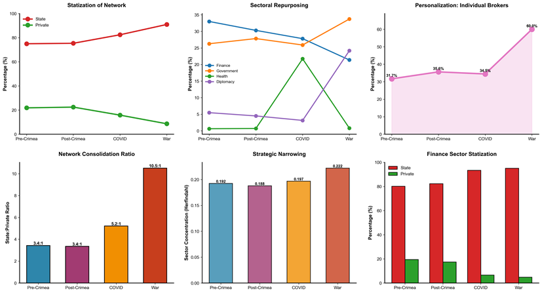

From the following set of visuals, we should keep “evolution of community types” and “network density over time” (couldn’t find the links/file in GDrive). The “network size evolution” only makes sense, once we have cut the post-Crimea phase to 2014-2017. In fact, you could use it to see whether the time frame cut for the post-Crimea period is sufficient.
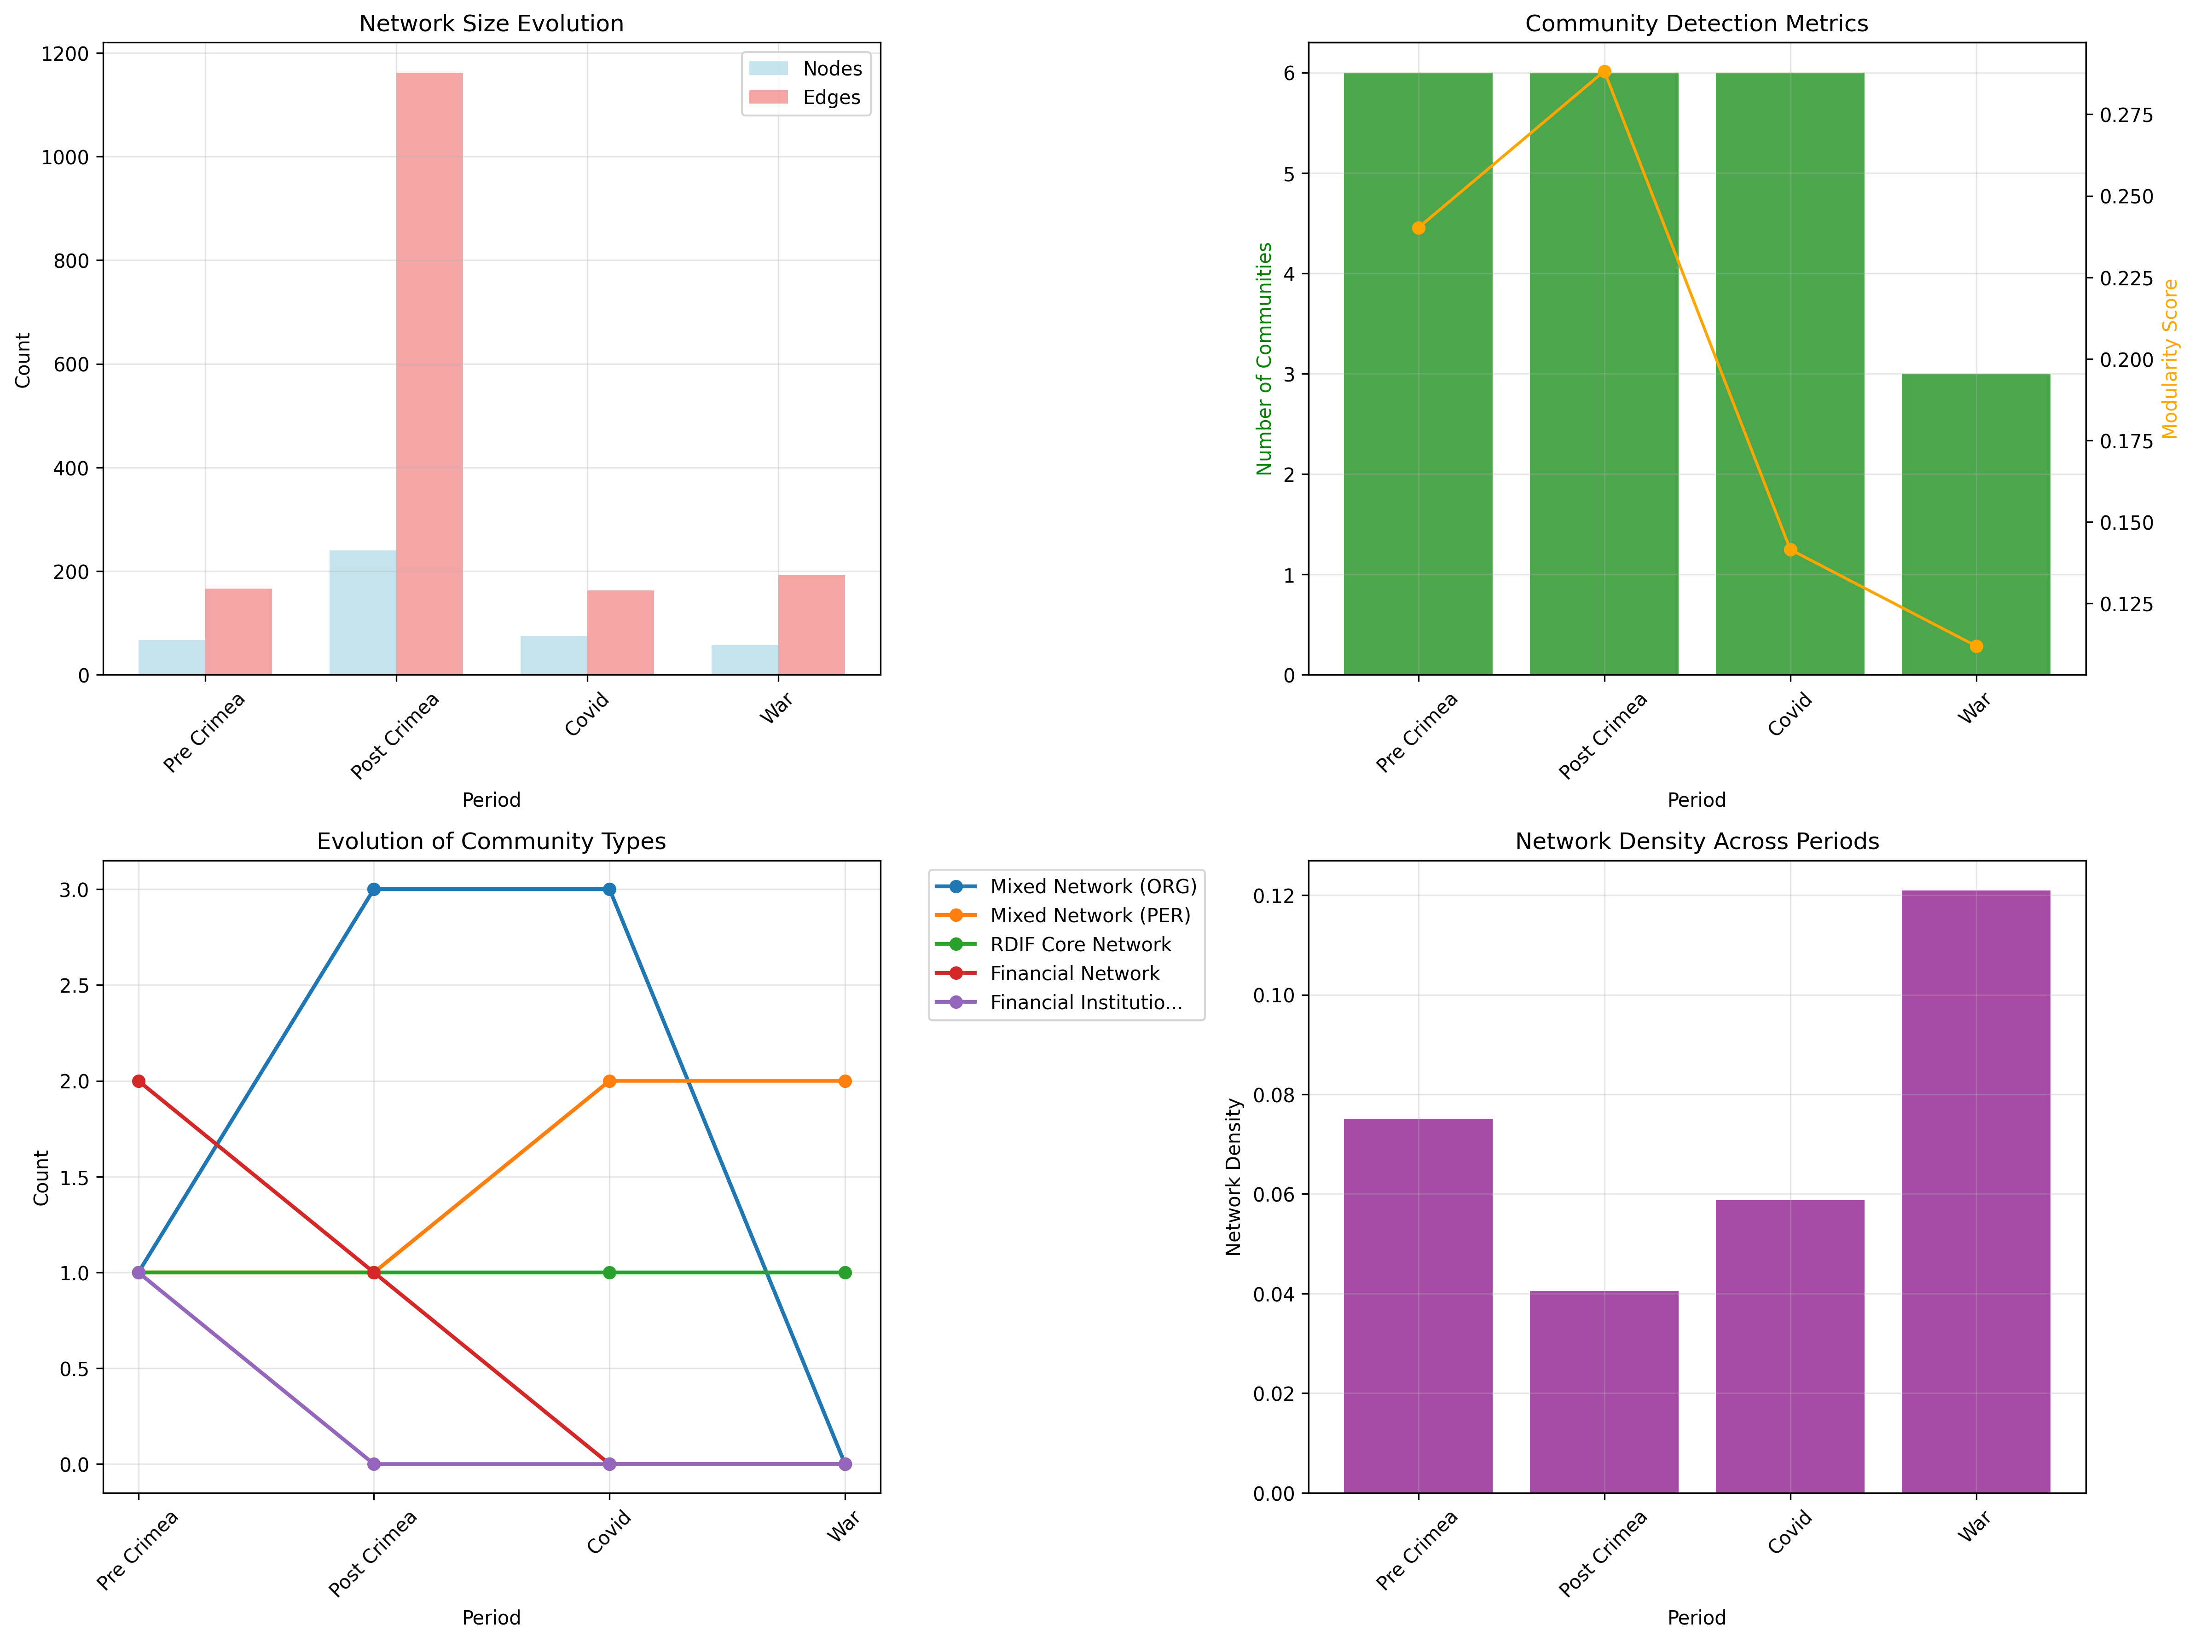

@Aram We should keep the following visuals (for all four periods) for the Louvain communities – but without the name labels.

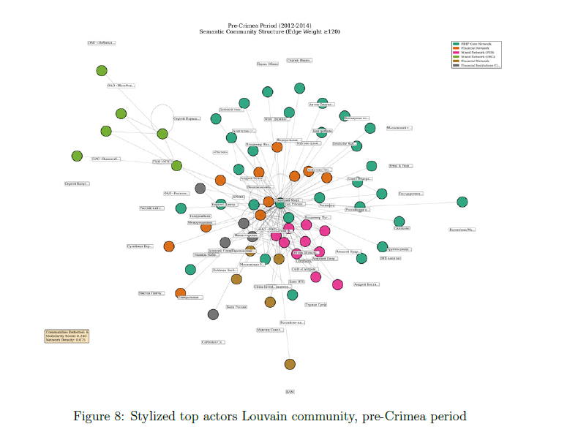

@Aram I’d like to keep the following visual (for all four time periods) in the most updated form. However, we should strip them down: no name labels, clear legends for the most important actors joining and leaving, respectively.
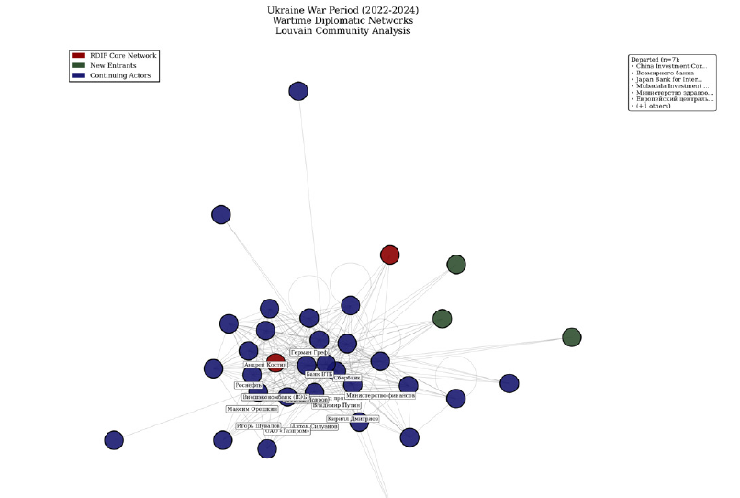

@Aram After re-running the analysis for the post-Crimea period (aka cutting the time span), it would be great to have a “Top 50 Actors by Composite Score – All Periods Combined” table (our old table was TOP20 for all periods combined but I think 50 is even better – makes for a nice full page of actors in a paper).
Once we have that, we should briefly exchange views and then decide on 8 actors from the table for which we then create regression graphs.
General remark: We should consequently exclude Dmitriev and the RDIF from all tables and visuals where their appearance would be redundant or self-explanatory.
@Aram You had the idea to create some jurisdiction-based regression graphs or scatterplots. Cannot remember exactly what you had in mind but it sounded cool. So if you have time feel free to come up with something (no necessity though).

SUB-SECTION | 2010-2013
@Sebastian Re-structure the section around a synopsis of the VEB.RF
@Aram For each of the four period sections in the paper, we need one revised item on the basis of the following visual. Please delete all name labels and the legend right to the item. Instead, please add a little table in Overleaf, indicating the “gone” and “newly joined” actors. But keep the colors for new actors in the visual.
ACTORS GONE | ACTORS INCOMING
Actor A gone | Actor C new
Actor B gone | Actor D new

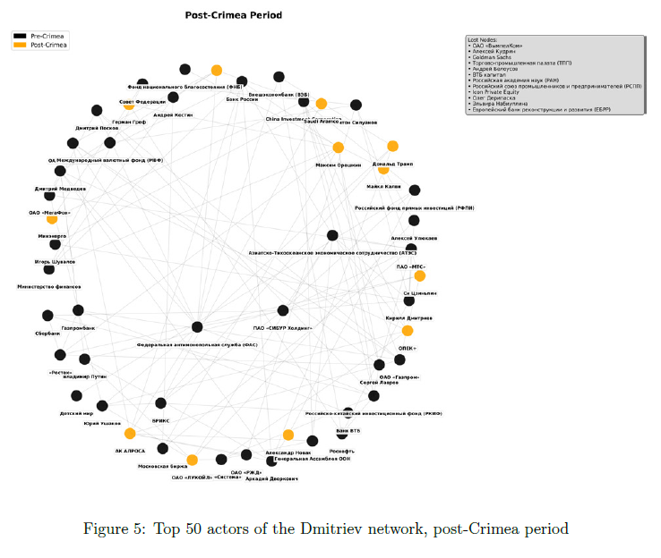

SUB-SECTION | 2014-2020 (2017?)
@Sebastian Re-structure the section around a synopsis of the Gulf/China/diversification agenda

SUB-SECTION | 2020-2022
@Sebastian Re-structure the section around a synopsis of the COVID-financing scheme

SUB-SECTION | 2022-2025
@Sebastian Re-structure the section around a synopsis of the Dmitriev-Wittkoff diplomacy

SECTION | Conclusion
@Sebastian Instead of discussing „alternative explanations“, focus on contribution to the literature on Russian elite (see Fabian’s literature suggestions)
Close with relevance for study of transnational authoritarianism and with hint at the comparative research pursued in the SOVBROKE framework

