**Rsq vs different MAF**

* Fixed the Rsq = 0.8 and adjusted to different values of MAF to see the changes

|  |  |  |
| --- | --- | --- |
| **Rsq** | **MAF** | **# of SNPs** |
| 0.8 | 0.005 | 257785 |
| 0.8 | 0.01 | 218842 |
| 0.8 | 0.02 | 177284 |
| 0.8 | 0.03 | 153731 |

* To calculate the MAF vs Rsq, I took the dose files for chr21, Rsq = 0.8 and use different filters of MAF varying from 0.005 to 0.03 to see the variation in the # of SNPs.
* Ran a code on the updated vcf file to obtain only the column containing the MAF and Rsq files, cleaned the data points to ensure every row was populated
* Used R to code for box plots of binned MAF vs Rsq, while setting the alpha=0.2.

**MAF = 0.005**

**MAF = 0.01 MAF = 0.02**

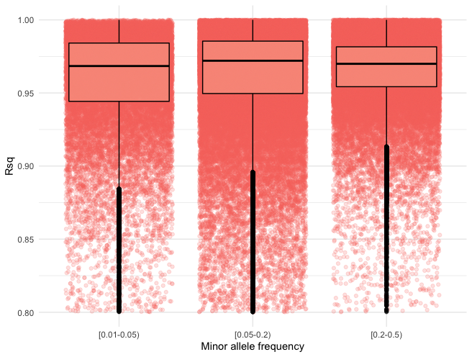

**MAF = 0.03 MAF = 0.05**