

**UNIVERSITY OF WASHINGTON BOTHELL**

**DIVISION OF COMPUTING AND SOFTWARE SYSTEMS**

**STUDENT WORK PUBLICATION PERMISSION FORM**

**To the Student:** *The University of Washington Bothell, Division of Computing and Software Systems would like your permission to publish some of your student work from CSS 343: Data Structure and Algorithms II. Publication would consist of posting student work (including source code written by students and graphics created by students) on publicly accessible internet sites and/or including examples of such work in scholarly publications or presentations. Please provide the information requested below and indicate whether you are willing to grant the Division this permission. GRANTING PERMISSION TO PUBLISH YOUR STUDENT WORK IS NOT A COURSE REQUIREMENT.*

Name: ____Aram Antonyan______________________________

UW Netid: _________aram97_________________________

Quarter/Year: ________Winter 2020-2021__________________________

**Put X next to one of the options below:**

**_X__** I grant permission to the University of Washington to release and/or publication of coursework, including computer source codes, submitted by me in CSS 343. I understand that publication may consist of posting this work on one or more public access internet websites and/or publishing examples of the work in scholarly publications or presentations.

**_X__** I do not consent to the University’s release or publication of my student work in CSS343.

_______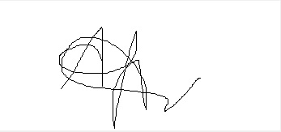_____________________ ____________

Student Signature (electronic or scanned) Date 2/21/2021