Title: Advocacy of the Voiceless: A case study on #NoDogNoVote

Mr. Riddhiman Ghose
Assistant Professor, Department of Media Science
Institute of Leadership, Entrepreneurship and Development- ILEAD, Kolkata

Abstract:

A man’s best friend, nightguard, security- some of the words synonymous to a DOG. On the 7th of November, the Supreme Court of India passed an order for removal of stray dogs from the streets, to be specific any public institution. Following the order, protests erupted across the nation demanding the earliest removal of the verdict. Animal lovers spammed the highest legislative body with letters, petitions urging the immediate rollback of the removal order. In this scenario, citizen-journalism took the main lime-light surpassing the mainstream traditional media in highlighting the major crisis. Social media were flooded with posts with a common hashtag #NoDogNoVote. The quick viral nature of social media has facilitated multiple opinions from various netizens which included celebrities, renowned politicians and the common public.

Citizen journalism fundamentally upsets the established gatekeeping role of mainstream media by sharing quick, uncensored descriptions of events, often from the epicenter of breaking news. Here, citizens casually neglect traditional editorial scrutiny. This immediacy gives exceptional transparency and a range of opinions, particularly during crises.

In respect to this research, a mixed method approach will be employed. Tentative outcomes will aim to reveal that the rise of citizen reporting has significantly challenged the authority of traditional news gatekeepers, evaluation of quality, credibility and reliability of citizen-generated content and also the cultural transformation from active consumers to active producers of news. The study will try to conclude that citizen reporting is not an ancillary phenomenon but a powerful force that is permanently transforming the professional boundaries, power dynamics, and societal expectations of the news media. This paper will try to examine the intricate relationship between this emerging phenomena, the accompanying challenge to established journalistic authority, and the consequent cultural shift in public discourse.

Keywords: Social media, citizen journalism, journalistic authority, viral nature, mainstream media

- Introduction:
The twenty-first century's journalism and mass communication landscape has been drastically altered by the quick growth of social media platforms. Participatory, decentralized, and user-driven forms of communication are posing a growing threat to traditional patterns of news creation and distribution, which were formerly dominated by professional journalists and institutional gatekeepers. Social media sites like Facebook, Instagram, and X (previously Twitter) have made it possible for regular people to record events, express their thoughts, organize groups, and instantly impact public conversation. The parameters of journalism have been redefined as a result of this change, giving rise to what is sometimes referred to as citizen journalism.
In today's media ecosystems, citizen journalism has become a powerful force, especially in times of social, political, and ethical conflict. Narratives that were formerly dominated by major media outlets are now actively shaped by citizens through user-generated content, hashtags, and online communities. Although this change has made communication more accessible and given voice to underrepresented groups, it has also brought up important issues with agenda-setting, ethics, legitimacy, and the shifting power of professional journalists. News is no longer just consumed in the social media age; consumers actively create, analyze, and debate it.
The #NoDogNoVote movement offers a strong argument to investigate shifting patterns in mass communication and journalism within this changing media landscape. The Supreme Court of India's orders regarding the removal and relocation of stray dogs from public areas gave rise to the movement. The directive was fiercely opposed by animal rights activists and citizens nationwide, who claimed that the removal and culling of community dogs was cruel and ignored the underlying causes of human-animal conflict, such as inadequate enforcement of current animal welfare laws and poor waste management. The Animal Birth Control (ABC) Rules, which support vaccination, sterilization, and returning stray canines to their natural habitats rather than permanent removal, must be effectively implemented, protesters stressed.
Collective action and widespread mobilisation were also made possible by citizen journalism. Social media platforms were used by activists, animal welfare volunteers, and digital influencers to plan large-scale demonstrations, organise petition drives, and start campaigns to write letters to legal authorities. One prominent example of this kind of mobilisation was spearheaded by animal rights activist and internet celebrity Manavi Rai, who used Internet channels to plan a statewide campaign of handwritten letters to the Chief Justice of India. The movement, which attracted thousands of participants from many districts, is a noteworthy illustration of a decentralised, bannerless, citizen-led public protest that was largely enabled by digital communication.
Beyond organising, citizen journalism was essential in defining the public discourse. Citizen-generated content transformed the issue from one of public safety to a more comprehensive ethical and democratic concern by highlighting compassion, coexistence, and constitutional responsibilities towards sentient animals. This counter-narrative emphasised firsthand accounts, poignant testimonies, and graphic documentation, encouraging broader public participation and igniting fresh examination of administrative readiness and policy execution. Judicial review, including the creation of a larger bench and ensuing changes in the court's methodology, was prompted by the persistent internet outcry and the pragmatic concerns expressed by the public.
Additionally, the #NoDogNoVote campaign emphasises the value of linguistic and geographical diversity in online campaigning. The movement was able to spread outside metropolitan, English-dominated digital areas by sharing content in regional and vernacular languages, which promoted inclusivity and participation in a variety of social and geographic situations. Celebrities and public figures' participation enhanced citizen-generated narratives and demonstrated how visibility and influence function in networked public spheres.
In light of this, the current study uses an empirical examination of the #NoDogNoVote movement to investigate how citizen journalism shapes public discourse, inspires group action, and redefines journalistic techniques in the age of social media. The study advances knowledge of how citizen-driven media practices are transforming modern journalism and mass communication in India by placing this instance within larger discussions on participatory journalism, digital activism, and democratic communication.

- Literature Review
The rapid expansion of social media has significantly transformed the nature of journalism, public participation, and civic engagement. Scholars argue that digital platforms have disrupted the traditional one-way flow of information, replacing it with participatory, networked communication systems where citizens actively contribute to news creation and dissemination (Castells, 2009). This shift has led to the emergence of citizen journalism as a crucial component of contemporary media landscapes, particularly in advocacy-driven and movement-based communication.
2.1 Citizen Journalism as a Counter-Narrative Force
Citizen journalism is widely understood as a form of participatory media where non-professionals gather, report, and distribute information, often outside institutional news organizations (Gillmor, 2006). Research suggests that citizen journalism becomes especially influential during moments of social conflict, policy disputes, and moral crises, when mainstream media may be constrained by editorial norms, political pressures, or institutional framing (Allan, 2013).
Several studies indicate that citizen-generated content often challenges dominant narratives by foregrounding lived experiences, emotional testimony, and visual evidence (Bruns, 2008). Hermida (2012) highlights that social media platforms allow citizens to perform “ambient journalism,” where continuous updates shape public understanding even before formal news reports emerge. This ability to influence early framing is critical in advocacy movements, as initial narratives often determine long-term public perception.
However, scholarship also identifies tensions surrounding credibility and verification. Singer et al. (2011) note that while citizen journalism democratizes voice, it simultaneously complicates journalistic authority. Despite this, research increasingly acknowledges that credibility in digital spaces is often socially negotiated through sharing, endorsement, and repetition rather than institutional validation alone (Metzger et al., 2010).

2.2 Public Discourse and the Networked Public Sphere
The transformation of public discourse in the digital age has been examined extensively through revisions of Habermas’s public sphere theory. Papacharissi (2015) introduces the concept of the “networked public sphere,” emphasizing how emotional expression, personal narratives, and affective engagement are central to political communication on social media. Unlike traditional deliberative models, digital discourse allows fragmented yet interconnected conversations to coexist.
Citizen journalism contributes to this networked public sphere by enabling alternative framings of issues that may otherwise be marginalized. Deuze (2005) argues that modern journalism increasingly blends information, interpretation, and advocacy, especially within participatory media environments. Advocacy-oriented citizen journalism thus reflects broader shifts in journalistic norms rather than deviations from them.
In the context of social movements, research demonstrates that digital discourse often prioritizes moral and ethical framing over procedural or legal analysis (Castells, 2012). This framing strategy resonates strongly in movements centered on social justice, human rights, and animal welfare, where emotional appeals play a significant role in mobilizing support.
2.3 Hashtags, Digital Communities, and Collective Action
Hashtags function as organizing mechanisms that connect individual expressions into collective narratives. Bruns and Burgess (2015) conceptualize hashtags as tools that create “ad hoc publics,” enabling users to participate in issue-based discussions without formal membership. Empirical studies on hashtag activism show that these digital markers facilitate visibility, solidarity, and rapid dissemination of information (Bonilla & Rosa, 2015).
Research on movements such as #MeToo, #BlackLivesMatter, and #FarmersProtest reveals that hashtag-based mobilization allows decentralized participation while maintaining narrative coherence (Jackson et al., 2020). These studies emphasize that hashtags are not merely symbolic but function as infrastructures for coordination, documentation, and memory.
However, scholars also caution against overestimating the political impact of digital activism. Gladwell (2010) argues that online engagement often lacks the organizational depth required for sustained structural change. In response, later research suggests that the effectiveness of hashtag activism depends on its integration with offline action, media coverage, and institutional response (Tufekci, 2017). This perspective underscores the importance of examining hashtags alongside digital communities and citizen journalism practices rather than in isolation.
2.4 Celebrity and Influencer Participation in Digital Advocacy
The role of celebrities and public figures in digital movements has attracted growing scholarly attention. Celebrities possess symbolic power, media capital, and extensive follower networks that can significantly amplify social issues (Driessens, 2013). Jenkins, Ford, and Green (2013) argue that in a convergent media environment, content spreads not solely because of institutional promotion but due to social endorsement, often facilitated by influential figures.
Empirical research demonstrates that celebrity participation increases engagement metrics and mainstream media attention, particularly in advocacy campaigns (Marwick & boyd, 2011). Celebrities often act as “attention brokers,” translating niche concerns into widely discussed public issues. However, scholars also raise concerns regarding authenticity, performative activism, and the potential overshadowing of grassroots voices.
Despite these critiques, contemporary research increasingly views celebrity involvement as a structural feature of digital activism rather than an anomaly. When celebrities amplify citizen-generated content rather than replacing it, they contribute to participatory discourse rather than dominating it (Street, 2012). This dynamic is especially relevant in movements where emotional appeal and moral framing are central.
2.5 Regional, Linguistic, and Cultural Dimensions of Digital Journalism
In multilingual and culturally diverse societies such as India, language plays a crucial role in shaping digital participation. Scholars argue that English-dominant digital spaces often exclude large sections of the population, reinforcing existing inequalities (Thussu, 2018). The rise of regional-language content on social media has therefore been identified as a significant democratizing force.
Research on vernacular digital journalism suggests that regional languages enable localized framing of issues, making advocacy movements culturally resonant and socially accessible (Udupa, 2015). Rao and Johal (2006) highlight that vernacular media often prioritize community-based narratives and moral storytelling, aligning closely with citizen journalism practices.
Studies further indicate that regional and linguistic diversity enhances inclusivity by enabling participation from semi-urban and rural populations, who may otherwise remain marginalized in national debates (Neyazi, 2014). This dimension is particularly important when examining digital movements that rely on widespread public engagement rather than elite discourse.
2.6 Citizen Journalism, Advocacy, and Democratic Participation
The intersection of citizen journalism and advocacy has prompted scholars to reconsider traditional notions of journalistic objectivity. Waisbord (2018) argues that advocacy-driven journalism reflects a broader transformation of democratic communication, where journalism functions as a space for civic negotiation rather than neutral observation.
Castells (2007) emphasizes that networked communication empowers citizens to challenge institutional authority and construct counter-hegemonic narratives. Citizen journalism thus contributes to democratic participation by enabling agenda-setting, mobilization, and accountability, particularly in contexts where institutional responses are perceived as inadequate or unjust.
2.7 Identified Research Gap
Although extensive research papers exists on citizen journalism, hashtag activism, celebrity influence, and vernacular digital media, these dimensions are often studied separately. There is limited empirical research that integrates these elements within a single case study, particularly in the Indian context of animal welfare advocacy. Existing studies rarely examine how citizen journalism, amplified by celebrities and shaped by linguistic diversity, collectively influences public discourse and mobilization.
The present study addresses this gap by examining the #NoDogNoVote movement as a case of citizen-driven digital advocacy, situating it within broader debates on changing trends in journalism and mass communication in the era of social media.

- Methodology
3.1 Research Objectives
- To investigate how celebrities and public figures influenced the momentum of the #NoDogNoVote movement through the amplification of citizen-generated content.
- To examine the role of citizen journalism in shaping public discourse around the #NoDogNoVote movement on social media platforms.
- To analyze how hashtags, digital communities, and regional–linguistic diversity contributed to collective action and inclusive participation in the #NoDogNoVote campaign.
3. 2 Research Design
The present study follows a mixed-method research design, combining quantitative and qualitative approaches to examine the role of citizen journalism in the #NoDogNoVote movement. The mixed-method approach was adopted to gain both measurable insights into public perceptions and an in-depth understanding of the movement as a case of citizen-led digital advocacy. This design is suitable for media and communication studies as it allows integration of audience responses with contextual analysis.
3.3 Research Methods
i. Quantitative Method
The quantitative component of the study was conducted using a semi - structured questionnaire designed to assess respondents’ awareness, engagement, and perceptions regarding citizen journalism, social media activism, and the #NoDogNoVote movement. The questionnaire consisted mainly of objective-type questions, including multiple-choice and Likert-scale items, to ensure clarity, uniformity, and ease of analysis.
The questionnaire focused on areas such as:
- Exposure to citizen-generated content
- Trust in citizen journalism compared to mainstream media
- Role of hashtags and digital communities
- Influence of celebrities and public figures
- Perceptions of regional and linguistic inclusivity
The questionnaire was circulated online through Google Forms, enabling responses from participants across different regions.
ii. Qualitative Method
The qualitative component of the research employed the case study method to examine the #NoDogNoVote movement as an example of citizen journalism in action. This method was used to understand how citizen-generated content, digital platforms, and advocacy-driven narratives contributed to shaping public discourse and mobilizing collective action.
The case study analysis focused on:
- Citizen-led reporting and documentation on social media
- Use of hashtags and digital communities for mobilisation
- Role of activists, influencers, and public figures
- Framing of the issue by citizen journalists in contrast to mainstream media narratives
Data for the case study were collected from publicly available sources, including social media posts, digital campaigns, activist content, and media reports related to the movement.
3.4 Sample and Sampling Technique
For the questionnaire survey, a non-probability snowball sampling technique was used. The final sample consisted of approximately 60–70 respondents who were active social media users and had varying levels of exposure to digital news and advocacy content. Due to the exploratory nature of the study and its focus on digital media practices, this sampling method was considered appropriate.

3.5 Data Collection
Primary data were collected through the online questionnaire administered via Google Forms. Secondary data for the case study were gathered from social media platforms, digital activism content, and relevant news coverage. All data used in the study were collected ethically and responsibly.
3.6 Data Analysis
Quantitative data obtained from the questionnaire were analyzed using descriptive statistical methods, to identify trends and patterns in respondent perceptions. Qualitative data from the case study were analyzed thematically to understand recurring themes related to citizen journalism, mobilisation, and public discourse. The findings from both methods were integrated to provide a comprehensive interpretation of the research objectives.
3.7 Ethical Considerations
Participation in the questionnaire was voluntary, and respondents were informed about the academic purpose of the study. Anonymity and confidentiality were maintained, and no personal identifiers were collected. The case study relied solely on publicly accessible information, in accordance with ethical standards of social media research.
3.8 Limitations of the Study
The study is limited by its sample size and the use of convenience sampling, which may restrict the generalization of findings. Additionally, as the research focuses on a single case study, the conclusions are context specific. However, the methodology provides meaningful insights into changing trends in journalism and mass communication in the social media era.

4. Results:

4.1 Case Study Findings (Objective 1)

4.1.1 Influence of Celebrities and Public Figures on the Momentum of the #NoDogNoVote Movement
The qualitative case study analysis reveals that celebrities and public figures played a significant role in intensifying the visibility, reach, and continuity of the #NoDogNoVote movement. Their involvement functioned primarily as an amplifying mechanism for citizen-generated content rather than as an independent source of information.

4.1.2 Visibility and Reach Enhancement
Findings indicate that posts related to the #NoDogNoVote campaign received substantially higher engagement when shared or endorsed by public figures. Citizen-generated videos, photographs, and textual updates gained wider circulation after being reposted by celebrities and digital influencers, allowing the movement to extend beyond animal welfare communities into mainstream social media spaces. The presence of recognizable public figures increased the likelihood of content being shared, commented upon, and referenced in wider online discussions.

4.1.3 Case Evidence: Role of Manavi Rai
Manavi Rai emerged as a key digital public figure whose sustained engagement contributed directly to the momentum of the movement. The case study findings show that her role was characterized by three distinct functions: content amplification, mobilization, and narrative continuity. Rai consistently reshared citizen-generated updates, contextualized legal developments for lay audiences, and issued clear calls to action through her social media platforms.
A significant outcome associated with this involvement was the nationwide handwritten letter-writing campaign addressed to judicial authorities. The campaign, coordinated primarily through digital platforms, witnessed participation from citizens across multiple regions, indicating a translation of online engagement into organized offline action. The scale and coordination of this initiative demonstrate the capacity of digital public figures to convert symbolic support into structured civic participation.

4.1.4 Celebrity Endorsement and Agenda Visibility
The findings further reveal that endorsements by traditional celebrities increased the agenda visibility of the movement. Statements and posts by well-known public figures introduced the issue to audiences not previously engaged with animal welfare activism. This resulted in renewed attention from mainstream media outlets, many of which referenced social media reactions and celebrity responses while reporting on the issue. Such coverage indicates a reverse agenda-setting process, where digitally amplified citizen narratives influenced institutional media attention.

4.1.5 Sustaining Momentum Over Time
The case study also shows that continuous engagement by public figures played a role in sustaining the movement over time. In contrast to short-lived digital trends, the repeated posting and reinforcement of key messages by celebrities and influencers helped maintain public attention. This sustained visibility prevented the issue from dissipating in the fast-paced social media environment and contributed to prolonged public scrutiny.

4.1.6 Nature of Influence
Importantly, the findings suggest that celebrities and public figures did not replace citizen journalism but functioned as intermediaries who strengthened its impact. Their influence was most effective when aligned with grassroots reporting and advocacy, indicating a collaborative dynamic between citizens and public figures within the networked public sphere.
The case study findings demonstrate that celebrities and public figures significantly influenced the momentum of the #NoDogNoVote movement by amplifying citizen-generated content, expanding audience reach, enabling mobilization, and sustaining public engagement. The results highlight the evolving role of public figures as facilitators of citizen journalism rather than dominant narrators in digital advocacy movements.
4.2 Role of Citizen Journalism in Shaping Public Discourse (Objective II)
The questionnaire was circulated digitally and received responses from approximately 60–70 participants, reflecting a demographically diverse yet digitally active sample. Most respondents belonged to the young adult age group (18–35 years) and reported frequent use of social media platforms for news consumption and social awareness. Instagram, WhatsApp, YouTube, and X (formerly Twitter) emerged as the most commonly used platforms. The sample included respondents from both urban and non-urban locations, as well as individuals who consumed content in English and regional languages. This diversity allows the study to meaningfully examine digital participation, inclusivity, and the role of citizen journalism in a networked media environment.

4.2.1 Source of Awareness and Agenda Setting
A large majority of respondents indicated that their first exposure to the #NoDogNoVote movement occurred through citizen-generated social media content. This finding suggests that citizen journalism played a primary agenda-setting role, particularly during the initial phase of the movement, when mainstream media coverage was limited or delayed.
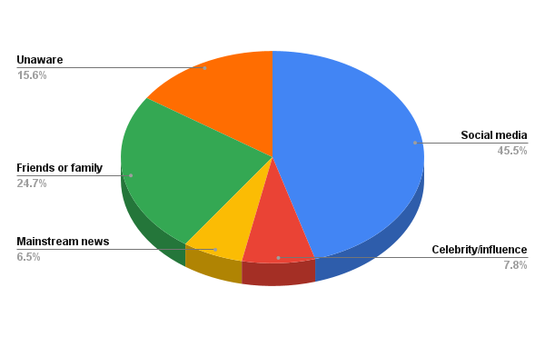
📊 Figure 4.2.1: Source of initial awareness
This early exposure through social media shaped the direction of subsequent discussions, highlighting the increasing reliance on participatory media for awareness of emergent social issues.

4.2.2 Trust and Credibility Assessment
When asked to evaluate trustworthiness, respondents expressed moderate to high levels of trust in citizen journalism during social movements. While mainstream media was still considered relevant, citizen journalism was perceived as more authentic due to its firsthand and experiential nature.
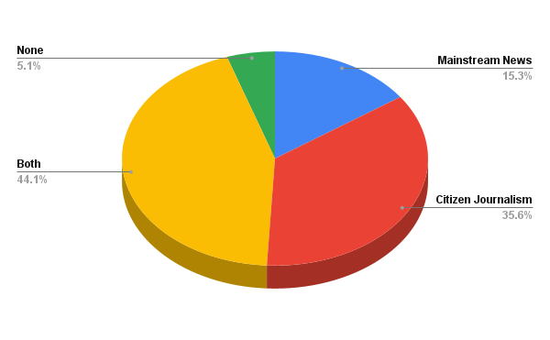
📊 Figure 4.2.2: Perceived trust in citizen journalism vs mainstream media
This reflects a shift in credibility assessment, where authenticity and proximity to events are valued alongside institutional authority.

4.2.3 Depth of Information and Perspective Diversity
Respondents overwhelmingly agreed that citizen-generated content offered greater contextual depth and alternative perspectives. Videos, images, and narrative posts provided insights into ground realities that were perceived as missing from mainstream media narratives.
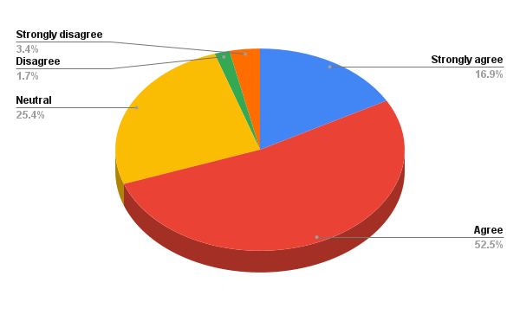
📊 Figure 4.2.3: Citizen-generated content offered greater contextual depth and alternative perspectives

4.2.4 Influence on Opinion Formation
When asked which source influenced their understanding the most, respondents were divided between citizen journalism alone and a combination of citizen journalism and mainstream media. This indicates that public discourse is increasingly shaped within a hybrid media system, rather than by a single dominant source.
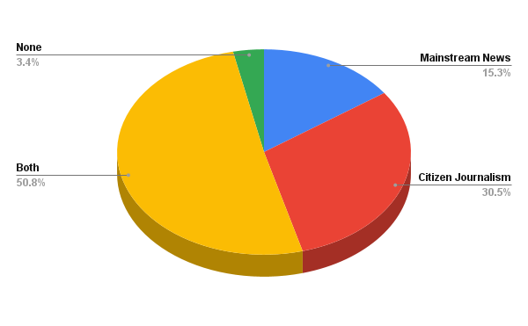
📊 Figure 4.2.4: Source influencing understanding
Overall, the findings demonstrate that citizen journalism functioned not only as a source of information but as a powerful discursive space that shaped how the issue was framed, debated, and understood by the public.
4.3 Hashtags, Digital Communities, and Linguistic Inclusivity (Objective III)

4.3.1 Hashtags and Collective Identity Formation
Survey responses reveal strong agreement that the hashtag #NoDogNoVote helped connect individuals around a shared cause. Respondents reported that the hashtag enabled easy tracking of information and participation in ongoing discussions.
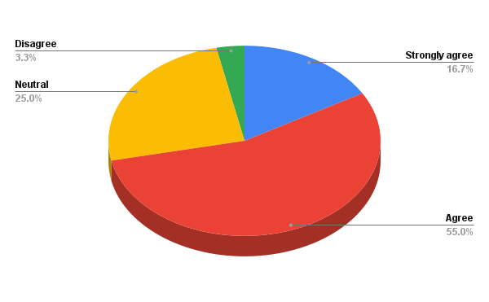
📊 Figure 4.3.1: Role of hashtag in collective action.

4.3.2 Patterns of Digital Engagement
Respondents reported active engagement through multiple forms, including liking, sharing, commenting, and reposting. Sharing behavior was particularly prominent, indicating a willingness to disseminate the movement’s message beyond personal networks.
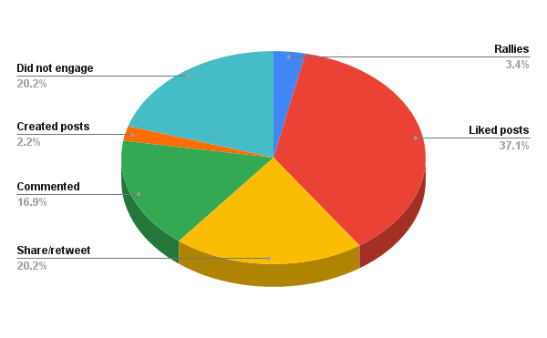
📊 Figure 4.3.2: Forms of engagement

4.3.3 Role of Platforms and Digital Communities
Different platforms served different functions. Instagram and WhatsApp were commonly used for awareness and sharing, while X (Twitter) facilitated discussion and advocacy. These platform-specific communities enabled sustained interaction and movement continuity.
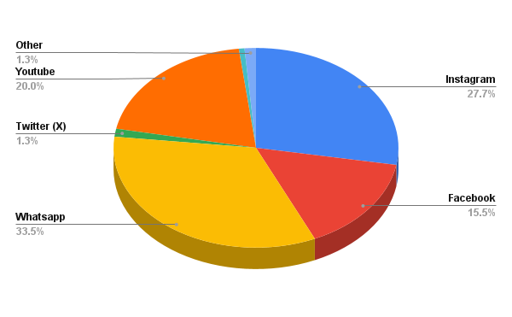
📊 Figure 4.3.3: Platforms used for engagement

4.3.4 Language Preference and Inclusivity
A majority of respondents reported greater comfort engaging with content in their preferred language as a regular mode of viewing content (English). Regional-language content was perceived as more accessible and emotionally resonant, particularly for non-elite digital users.

4.3.5 Urban–Rural Digital Participation
Responses indicate that both urban and non-urban participants actively engaged with the movement, suggesting that digital platforms reduced spatial barriers and enabled inclusive participation.
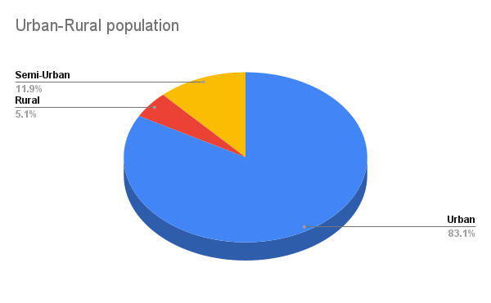
📊 Figure 4.3.5: Urban–rural participation

4.4 Overall Interpretation of Findings
Taken together, the findings across all three objectives reveal a transformed media environment in which citizen journalism, celebrity advocacy, and participatory digital tools collectively shape public discourse and collective action. Citizen journalism influenced how the issue was framed and understood, celebrities amplified visibility and momentum, and hashtags and digital communities enabled inclusive participation. The #NoDogNoVote movement thus exemplifies the changing dynamics of journalism and mass communication in the social media era, where audiences actively participate in the production, circulation, and interpretation of news.

5. Discussion:
The present study examined the #NoDogNoVote movement to understand changing trends in journalism and mass communication in the era of social media, with particular attention to the roles of celebrity influence, citizen journalism, and digital mobilization. The findings of the study reveal significant shifts in how news is produced, circulated, and legitimized, reinforcing the argument that social media platforms have reconfigured traditional journalistic practices and public discourse.

5.1 Celebrity Influence and the Reconfiguration of Authority
One of the central findings of this study is the role of celebrities and public figures in accelerating the momentum of the #NoDogNoVote movement without originating it. This supports existing scholarship that views celebrities in digital activism not as agenda-setters but as amplifiers within networked public spheres (Jenkins, Ford, & Green, 2013). The case study of Manavi Rai demonstrates how sustained engagement, rather than episodic endorsement, enhances the credibility and continuity of a movement.
Unlike traditional celebrity advocacy, which often functions symbolically, the involvement observed in this movement was operational and participatory. The organisation of a nationwide letter-writing campaign illustrates how celebrity-led citizen journalism can translate digital visibility into tangible civic action. This finding aligns with Bennett and Segerberg’s (2012) theory of connective action, where digitally networked individuals mobilize through personalized content rather than centralized organisational structures.
The study further indicates that celebrities legitimized emotional narratives and ethical framing. By publicly endorsing citizen-generated content, they challenged conventional norms of journalistic objectivity and reinforced the idea that compassion and affect are valid components of public discourse. This reflects a broader shift in journalistic values in the social media era, where emotional resonance often complements factual reporting.

5.2 Citizen Journalism and the Transformation of Public Discourse
The findings related to citizen journalism affirm its growing role as an agenda-setting and discourse-shaping force. Respondents’ reliance on citizen-generated content as their primary source of awareness highlights the declining monopoly of mainstream media over information dissemination. This supports earlier studies that argue social media has transformed audiences from passive consumers into active participants in news production (Allan, 2013).
The perceived credibility of citizen journalism, as reflected in survey responses, stems largely from its immediacy and experiential nature. Visual documentation, real-time updates, and firsthand accounts were valued for their transparency and authenticity. However, the study also reveals a hybrid media consumption pattern, where audiences cross-verify information through mainstream media. This finding complicates binary distinctions between citizen journalism and professional journalism, suggesting instead a complementary relationship.
Citizen journalism in the #NoDogNoVote movement functioned as a counter-narrative, reframing the issue beyond dominant institutional discourses. While official narratives emphasized public safety and administrative concerns, citizen journalists foregrounded ethical responsibility, governance failures, and compassion toward animals. This aligns with Fraser’s (1990) concept of subaltern counter-publics, wherein marginalized voices create alternative discursive spaces to challenge dominant narratives.

5.3 Hashtags, Digital Communities, and Collective Action
The study’s findings underscore the central role of hashtags in enabling collective identity and sustained engagement. The hashtag #NoDogNoVote served not merely as a categorization tool but as a symbol of collective resistance and shared concern. This supports Bruns and Burgess’s (2015) assertion that hashtags function as organizing mechanisms in digital activism, facilitating visibility and coordination without centralized leadership.
Survey responses reveal that hashtags contributed to a sense of legitimacy and scale. Participants perceived the movement as significant because of its visibility across platforms, demonstrating how algorithmic amplification and networked participation influence public perception. This reinforces the idea that digital metrics—such as trending hashtags—play a role in shaping contemporary notions of newsworthiness.
Digital communities formed around the movement enabled varied modes of participation, ranging from passive engagement to active advocacy. These findings align with Castells’ (2012) concept of networked social movements, where communication networks enable decentralized yet coordinated action. The study highlights that participation in such communities is layered, allowing individuals to engage according to their capacities and motivations.

5.4 Linguistic Diversity and Democratic Participation
A significant contribution of this study lies in its examination of linguistic diversity within digital activism. Survey findings indicate that content in regional and vernacular languages enhanced emotional connection and inclusivity. This challenges the dominance of English-language discourse in digital public spheres and underscores the importance of linguistic plurality in democratic communication.
By enabling participation across urban–rural and linguistic divides, the #NoDogNoVote movement illustrates how social media can democratize activism. This finding aligns with research on digital inclusion, which emphasizes the role of local languages in expanding civic engagement in the Global South (Papacharissi, 2015). The study suggests that multilingual citizen journalism strengthens the representational capacity of digital movements.

5.5 Implications for Journalism and Mass Communication
Collectively, the findings of this study highlight a reconfiguration of journalistic authority in the social media era. Journalism is no longer confined to professional institutions but is increasingly produced through collaborative networks involving citizens, activists, and public figures. The #NoDogNoVote movement exemplifies how advocacy, reporting, and mobilisation intersect within digital spaces.
The study also raises important ethical considerations. While citizen journalism amplifies marginalized voices, it also relies heavily on emotional narratives, which may blur the line between advocacy and reporting. This underscores the need for evolving ethical frameworks that account for participatory media practices.

5.6 Limitations and Scope for Future Research
While the study provides valuable insights, it is limited by its sample size and reliance on self-reported data. Future research could adopt longitudinal designs to examine the sustained impact of citizen journalism on policy outcomes. Comparative studies across different movements could further deepen understanding of digital activism in diverse socio-political contexts.

6. Conclusion:
This study set out to examine the changing trends in journalism and mass communication in the era of social media through an empirical analysis of the #NoDogNoVote movement. By focusing on the roles of celebrities and public figures, citizen journalism, and digital mobilization through hashtags and linguistic diversity, the research highlights how contemporary media practices are being reshaped by participatory and networked communication.
The findings of the study demonstrate that journalism in the digital age is no longer the exclusive domain of professional news organizations. Instead, it is increasingly produced through interactions between citizens, activists, and influential public figures within online platforms. The #NoDogNoVote movement illustrates how ordinary individuals can document events, frame narratives, and mobilize collective action, thereby challenging traditional models of news production and agenda-setting.
The case study analysis reveals that celebrities and public figures played a crucial role in amplifying citizen voices rather than originating the movement. Their sustained engagement enhanced visibility, legitimacy, and emotional resonance, enabling citizen-generated narratives to reach wider and more diverse audiences. This underscores a shift in celebrity activism from symbolic endorsement to participatory advocacy within digital ecosystems.
Survey-based findings further establish citizen journalism as a significant force in shaping public discourse. Participants relied heavily on user-generated content for information and interpretation, particularly during the initial stages of the movement. Citizen journalism provided alternative perspectives and ethical framing that complemented and, at times, challenged mainstream media narratives. However, the coexistence of citizen journalism and traditional media consumption suggests a hybrid media environment rather than a complete replacement of institutional journalism.
The study also highlights the central role of hashtags and digital communities in facilitating collective action. The hashtag #NoDogNoVote functioned as a unifying symbol that connected dispersed individuals into a cohesive digital movement. Digital communities enabled varied forms of participation, allowing individuals to engage according to their capacities while contributing to a shared cause. Importantly, linguistic diversity within these spaces enhanced inclusivity and broadened participation across geographic and socio-cultural boundaries.
Overall, the #NoDogNoVote movement exemplifies how social media platforms have transformed journalism into a more collaborative, emotional, and inclusive practice. While these developments offer opportunities for democratizing communication and amplifying marginalized voices, they also raise questions about credibility, ethics, and the evolving role of professional journalism.
In conclusion, this study contributes to ongoing discussions on media transformation by demonstrating how citizen journalism, amplified by celebrities and structured through digital networks, can shape public discourse and civic engagement. As social media continues to evolve, understanding these dynamics will remain critical for scholars, journalists, and policymakers seeking to navigate the complexities of contemporary communication.

References:
Allan, S. (2013). Citizen witnessing: Revisioning journalism in times of crisis. Polity Press.
Bennett, W. L., & Segerberg, A. (2012). The logic of connective action: Digital media and the personalization of contentious politics. Information, Communication & Society, 15(5), 739–768. https://doi.org/10.1080/1369118X.2012.670661
Bruns, A., & Burgess, J. (2015). Twitter hashtags from ad hoc to calculated publics. In N. Rambukkana (Ed.), Hashtag publics: The power and politics of discursive networks (pp. 13–28). Peter Lang.
Castells, M. (2012). Networks of outrage and hope: Social movements in the Internet age. Polity Press.
Fraser, N. (1990). Rethinking the public sphere: A contribution to the critique of actually existing democracy. Social Text, 25/26, 56–80. https://doi.org/10.2307/466240
Hermida, A. (2010). Twittering the news: The emergence of ambient journalism. Journalism Practice, 4(3), 297–308. https://doi.org/10.1080/17512781003640703
Jenkins, H., Ford, S., & Green, J. (2013). Spreadable media: Creating value and meaning in a networked culture. New York University Press.
Papacharissi, Z. (2015). Affective publics: Sentiment, technology, and politics. Oxford University Press.
Singer, J. B., Hermida, A., Domingo, D., Heinonen, A., Paulussen, S., Quandt, T., Reich, Z., & Vujnovic, M. (2011). Participatory journalism: Guarding open gates at online newspapers. Wiley-Blackwell.

