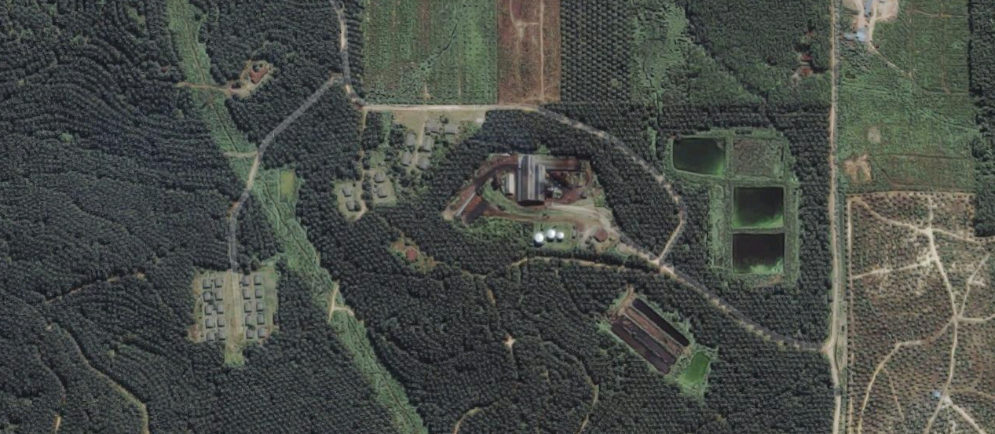

**MONITOR THE ACTIVITY NEAR PALM OIL MILLS**

**SUPPLIER MONITORING**

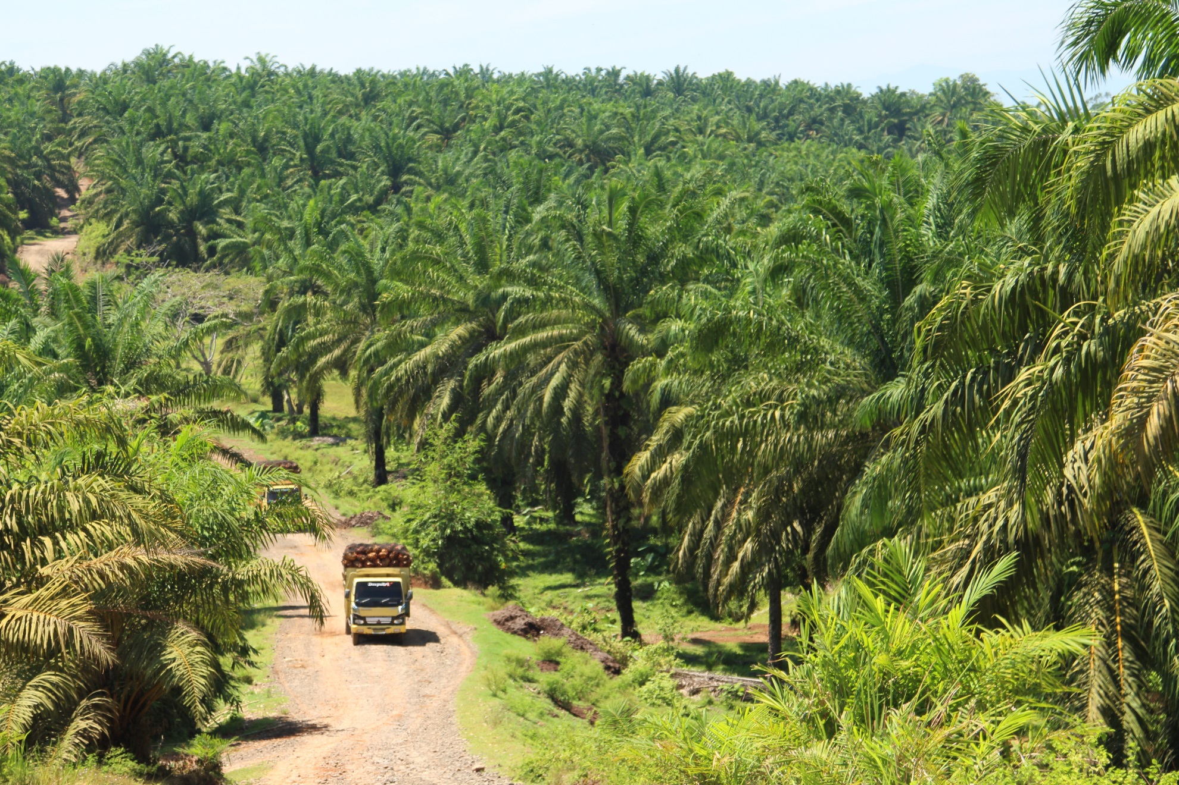

**SIGN UP FOR TREE CLEARANCE AND FIRE ALERTS FORS AREAS IN YOUR SUPPLY CHAIN**

**ALERTS**

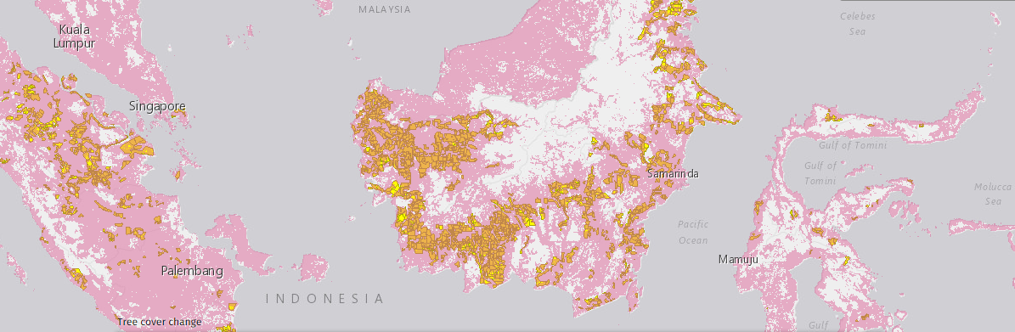

**ANALYSIS**

**ANALYZE FOREST COVER CHANGE IN A CONCESSION OR CUSTOM AREA**

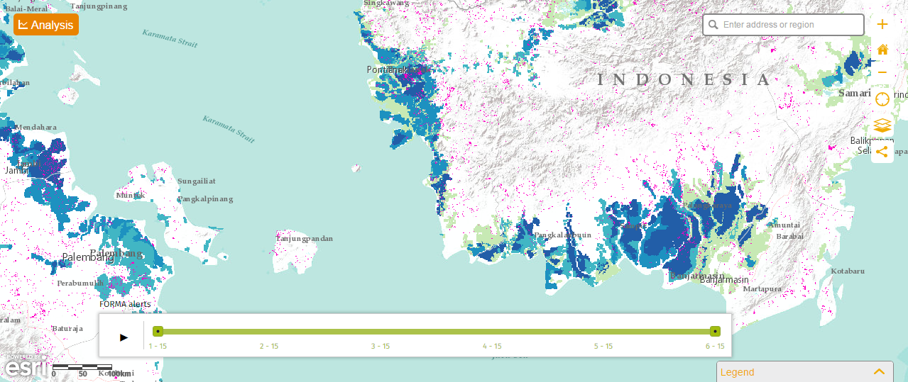

**EXPLORE GLOBAL DATA ON THE GFW COMMODITIES MAP**

**COMMODITIES MAP**