Text and images used:

1. Commodities Map
   1. Text: EXPLORE THE COMMODITIES MAP
   2. Image: same as on the GFW homepage for “explore the map” suggestion
   3. Link: [Commodities Map](http://commodities.globalforestwatch.org/#v=map&x=114.37&y=2.08&l=5&lyrs=tcc%2Closs)—
2. Analysis
   1. Text: ANALYZE FOREST COVER CHANGE IN A CONCESSION OR CUSTOM AREA
   2. Image: screenshot of custom area in Indonesia with forest loss data turned on
   3. Link: [Commodities map with analysis wizard open](http://commodities.globalforestwatch.org/#v=map&x=104.27&y=2.08&l=5&lyrs=tcc%2Closs&wiz=open)—
3. Supplier Monitoring
   1. Text: MONITOR THE ACTIVITY NEAR OIL PALM MILLS
   2. Image: Screenshot of map with FORMA alerts turned on
   3. Link: [map with analysis wizard open](http://commodities.globalforestwatch.org/#v=map&x=104.27&y=2.08&l=5&lyrs=tcc%2Closs&wiz=open)
4. Alerts
   1. Text: SIGN UP FOR TREE CLEARANCE AND FIRE ALERTS FOR AREAS IN YOUR SUPPLY CHAIN
   2. Image: screenshot of map with fire alerts turned on
   3. Link: map w/ analysis wizard to select area for alerts
5. Data Download:
   1. Text: LEARN ABOUT AND DOWNLOAD GFW DATA
   2. Image: screenshot of protected areas data set
   3. Link: Open Data Portal
6. Newsletter
   1. Text: SIGN UP FOR GFW COMMODITIES NEWSLETTERS
   2. Image: GFW Commodities logo
   3. Link: [Newsletter signup](http://www.wri.org/global-forest-watch-updates-and-newsletter)
7. Tutorial Videos
   1. Text: WATCH TUTORIAL VIDEOS AND LEARN HOW TO USE GFW COMMODITIES
   2. Image: Same as on the GFW homepage for “watch tutorial videos” suggestion
   3. Link: [Tutorial videos page](http://commodities.globalforestwatch.org/#v=about&n=Videos)

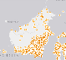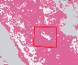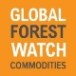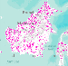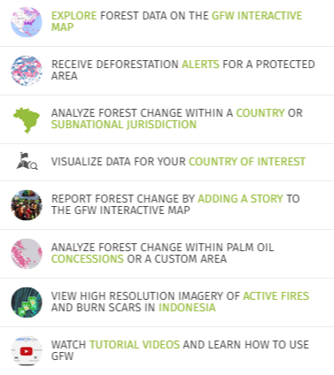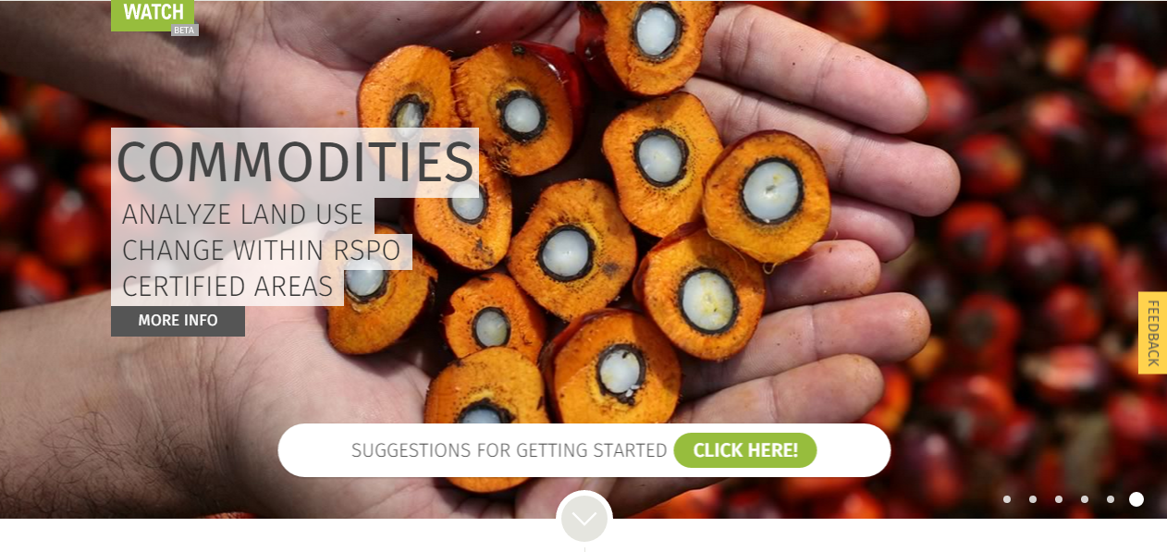

SIGN UP FOR TREE CLEARANCE AND FIRE ALERTS IN YOUR SUPPLY CHAIN

MONITOR THE ACTIVITY NEAR PALM OIL MILLS

ANALYZE FOREST COVER CHANGE IN A CONCESSION OR CUSTOM AREA

LEARN ABOUT AND DOWNLOAD GFW COMMODITIES DATA

SIGN UP FOR GFW COMMODITIES NEWSLETTERS

WATCH TUTORIAL VIDEOS AND LEARN HOW TO USE GFW COMMODITIES

EXPLORE GLOBAL DATA ON THE GFW COMMODITIES MAP