Substance Painter Custom Exporter

**Goal:** Automated way of exporting texture sets with consideration of Project requirements.

Key Features:

* Generate export path
* Validate Texture set Name and Resolution
* Support Multiple Asset Types and Export Presets

**Table of content:**

UI overview

Main Widget Window

Resolution over budget Dialog Window

Hotkeys

Supported Asset Types

Supported Export Presets (Shader Types)

Basic

Armament

Morph

Validation rules

Texture Set Naming rules

General rules

Naming rules for Props

Naming rules for Weapons

Naming rules for Characters

Texture Set Resolution rules

Contact point

# 

# UI overview

## Main Widget Window

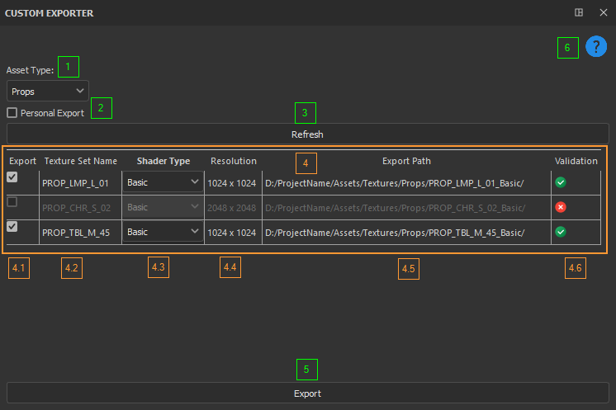

**1. Asset Type**. Dropbox to specify Asset Type. It affects the Export Path generation process as well as Naming and Resolution validation.

**2.** **Personal Export**. Checkbox to specify either the Export Path should be generated in Official project path (unchecked) or Personal (checked)

**3.** **Refresh** button. Used to refresh the Table widget below.

**4. Table widget** has 6 columns that contains information about texture sets currently present in the opened .spp project. One row per one texture set.

**4.1 Export checkbox**. Used to specify either the texture set in that row should be exported (checked) or ignored (unchecked). When validation is OK, the user can change the state of this checkbox. When validation is Failed, this checkbox becomes disabled and unchecked automatically to prevent export until validation is OK.

**4.2 Texture Set Name**. Name of the texture set, driven from the values specified in the Texture Set List tab. Not allowed for direct users edit.

**4.3. Shader Type**. Dropdown list to specify which shader (export preset) should be used during the export for texture set in that row. User can always modify it.

**4.4. Resolution**.Resolution of the texture set, driven from the values specified in the Texture Set Settings tab. Not allowed for direct users edit.

**4.5 Export Path**. Shows path in which textures of the texture set in that row will be exported to. Generated automatically based on the Asset Type, Shader Type and Texture Set name.

**4.6. Validation**. Shows status of Name and Resolution validations. Green checkmark icon represents Passed status, Red X – Failed.

**5. Export button**. Used to trigger exporting selected texture sets.

**6. Help** button. Used to open this help menu.

## Resolution over budget Dialog Window

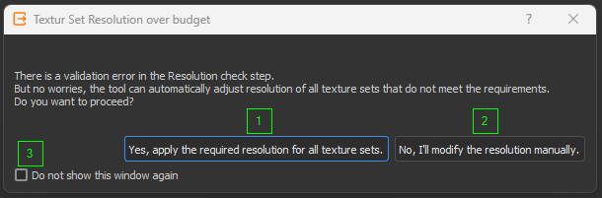

That Dialog Window appears if there is at least one texture set in the opened .spp project that exceeds the specified Resolution limitations.

**1.** Allows the tool to apply max required resolution for all texture sets listed in the opened .spp file.

**2.** Skips the automated resolution adjustment.

**3.** Checkbox to not show this dialog window further on even if there is resolution validation failed.

## Hotkeys

* Alt + F1 – Open Help Menu.
* Alt + R – Refresh Table widget.
* Alt + E – Export selected Texture Sets.

# Supported Asset Types

* Props;
* Weapons;
* Characters.

# Supported Export Presets (Shader Types)

## **Basic**

Originally intended for asset type Props.

Channels:

* + Albedo (RGB)
  + Normal (RBG)
  + Roughness (Grayscale)
  + Metallic (Grayscale)

Format: .png, 8 bits

Output Template: Custom_Basic.spexp

## Armament

Originally intended for asset type Weapons.

Channels:

* + Albedo (RGBA)
  + Normal (RBG)
  + Roughness (Grayscale)
  + Metallic (Grayscale)
  + Height (Grayscale)

Format: .tga, 8 bits

Output Template: Custom_Armament.spexp

## Morph

Originally intended for asset type Characters.

Channels:

* + Albedo (RGBA)
  + Normal (RBG)
  + Roughness (Grayscale)
  + Metallic (Grayscale)
  + Height (Grayscale)
  + User0 (Grayscale). Custom channel for Details.

Format: .png, 8 bits

Output Template used: Custom_Characters.spexp

# Validation rules

## Texture Set Naming rules

### General rules

* Name should consist of 4 Acronyms separated by underscore (“_”).
* Order of Acronyms is constant and important: AssetType_AssetDetail1_AssetDetail2_AssetID
* AssetID has the same rules for all asset types and are the following: 2 numbers from 0 to 9 representing values from 00 to 99.

### Naming rules for **Props**

* Asset Type is “PROP”
* AssetDetail1 describes the type of the prop. Valid options are:
  + “CHR” for Chair;
  + “TBL” for Table;
  + “LMP” for Lamp;
  + “WIN” for Window.
* AssetDetail2 describes the size of the prop. Valid options are:
  + “S” for Small;
  + “M” for Medium;
  + “L” for Large.

Valid examples of Texture Set name for **Props**:

PROP_CHR_S_01

PROP_TBL_M_02

### Naming rules for **Weapons**

* Asset Type is “WPN”
* AssetDetail1 describes the type of the weapon. Valid options are:
  + “SWD” for Sword;
  + “BOW” for Bow;
  + “RFL” for Rifle;
  + “EXP” for Explosive.
* AssetDetail2 describes the rarity of the weapon. Valid options are:
  + “COM” for Common;
  + “RAR” for Rare;
  + “EPC” for Epic.

Valid examples of Texture Set name for **Weapons**:

WPN_BOW_COM_01

WPN_RLF_EPC_04

### Naming rules for **Characters**

* Asset Type is “CHAR”
* AssetDetail1 describes the type of the character. Valid options are:
  + “PLR” for Player;
  + “ENM” for Enemy;
  + “CIV” for Civilian.
* AssetDetail2 describes the Gender of the character. Valid options are:
  + “ML” for Male;
  + “FL” for Female.

Valid examples of Texture Set name for **Weapons**:

CHAR_PLR_ML_01

CHAR_CIV_FM_05

## Texture Set Resolution rules

Max allowed resolution for each asset type:

* **Props**: 1024 x 1024
* **Weapons**: 2048 x 2048
* **Characters**: 4096 x 4096

Lower resolution is allowed.

# Contact point

Viacheslav Makhynko, email: viacheslav.makhynko@gmail.com