PHP MYSQL

# (koneksi, tampil data, tambah data, ubah data, hapus data)

1. **Buat database dan tabel**

Buatlah database dan tabel dari PHPMyadmin (localhost/phpmyadmin) dengan struktur database sebagai berikut:

* + Nama Database : db_akademik
  + Nama Tabel : mahasiswa
  + Struktur tabel : nim Char(10)

nama Varchar(30) alamat Varchar(30) jurusan Varchar(30)

* + Isi data mahasiswa sebanyak 2 baris data

# Koneksi

* + 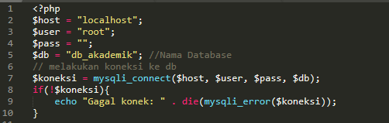Buat file baru ketikkan kode berikut simpan dengan nama koneksi.php
  + Buka file **index.php** pada folder **admin**
  + 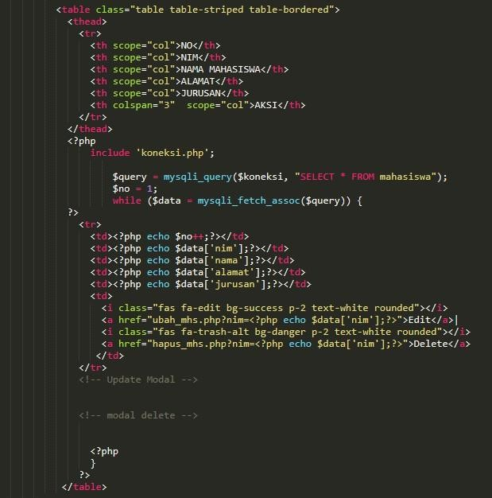Tambahkan kode berikut dibawah teks **“TAMBAH DATA MAHASISWA </a>”**
  + Jalankan di web browser tuliskan hasilnya dibawah ini

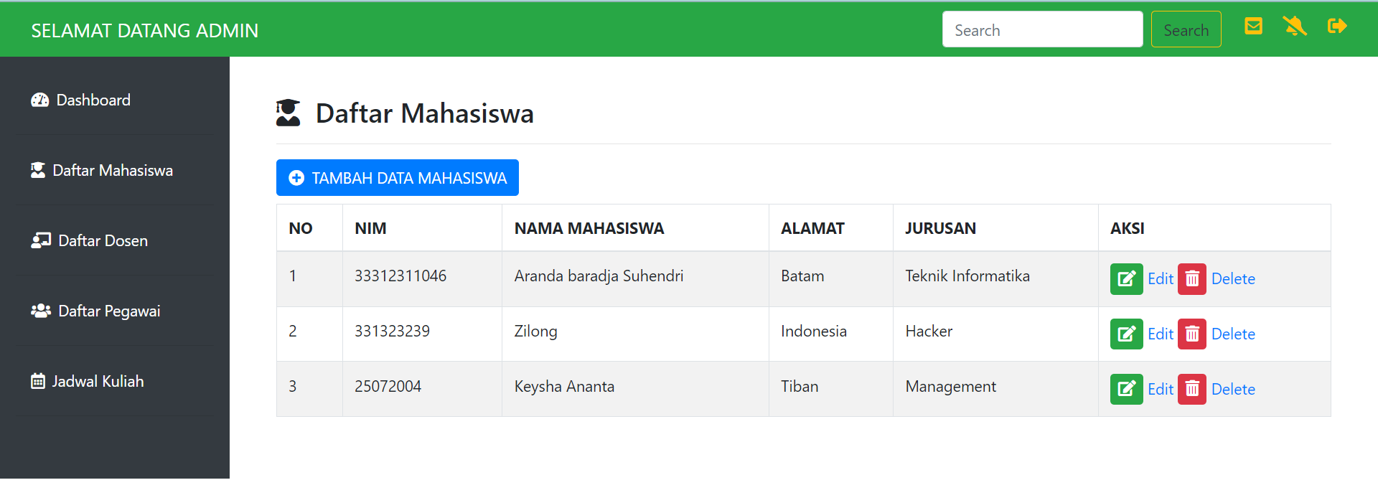

# Tambah Data

* + Buka file baru ketikkan (**copy**) kode berikut simpan dengan nama **tambah_mhs.php**

<!doctype html>

<html lang="en">

<head>

<!-- Required meta tags -->

<meta charset="utf-8">

<meta name="viewport" content="width=device-width, initial-scale=1, shrink-to-fit=no">

<!-- Bootstrap CSS -->

<link rel="stylesheet" href="css/bootstrap.min.css" >

<link rel="stylesheet" type="text/css" href="admin.css">

<link rel="stylesheet" type="text/css" href="fontawesome/css/all.min.css">

<title>ADMINISTRATOR</title>

</head>

<body>

<nav class="navbar navbar-expand-lg navbar-light bg-warning fixed-top">

<a class="navbar-brand" href="#">SELAMAT DATANG ADMIN</a>

<button class="navbar-toggler" type="button" data-toggle="collapse" data- target="#navbarSupportedContent" aria-controls="navbarSupportedContent" aria-expanded="false" aria-label="Toggle navigation">

<span class="navbar-toggler-icon"></span>

</button>

<div class="collapse navbar-collapse" id="navbarSupportedContent">

<form class="form-inline my-2 my-lg-0 ml-auto">

<input class="form-control mr-sm-2" type="search" placeholder="Search" aria-label="Search">

<button class="btn btn-outline-success my-2 my-sm-0" type="submit">Search</button>

</form>

<div class="icon ml-4">

<h5>

<i class="fas fa-envelope-square mr-3"></i>

<i class="fas fa-bell-slash mr-3"></i>

<i class="fas fa-sign-out-alt mr-3"></i>

</h5>

</div>

</div>

</nav>

<div class="row no-gutters mt-5">

<div class="col-md-2 bg-dark mt-2 pr-3 pt-4">

<ul class="nav flex-column ml-3 mb-5">

<li class="nav-item">

<a class="nav-link active text-white" href=""><i class="fas fa-tachometer-alt mr- 2"></i>Dashboard</a><hr class="bg-secondary">

</li>

<li class="nav-item">

<a class="nav-link text-white" href=""><i class="fas fa-user-graduate mr-2"></i>Daftar Mahasiswa</a><hr class="bg-secondary">

</li>

<li class="nav-item">

<a class="nav-link text-white" href="" ><i class="fas fa-users mr-2"></i>Daftar Pegawai</a><hr class="bg-secondary">

</li>

<li class="nav-item">

<a class="nav-link text-white" href="" ><i class="far fa-calendar-alt mr-2"></i>Jadwal Kuliah</a><hr class="bg-secondary">

</li>

</ul>

</div>

<div class="col-md-10 p-5 pt-2">

<h3><i class="fas fa-user-graduate mr-2"></i> Input Data Baru</h3><hr>

## <form action="simpan_mhs.php" method="post">

<div class="form-row">

<div class="form-group col-md-4">

<label >NIM</label>

<input type="text" name="nim" class="form-control" id="nim">

</div>

</div>

<div class="form-row">

<div class="form-group col-md-6">

<label >NAMA</label>

<input type="text" name="nama" class="form-control" id="nama">

</div>

</div>

<div class="form-row">

<div class="form-group col-md-6">

<label >ALAMAT</label>

<input type="text" name="alamat" class="form-control" id="alamat">

</div>

</div>

<div class="form-row">

<div class="form-group col-md-6">

<label >JURUSAN</label>

<input type="text" name="jurusan" class="form-control" id="jurusan">

</div>

</div>

<button type="submit" class="btn btn-primary">SIMPAN</button>

</form>

</div>

</div>

</body>

</html>

1. Buat file baru ketikkan kode berikut simpan dengan nama **simpan_mhs.php**

<?php

include 'koneksi.php';

$nim = $_POST['nim'];

$nama = $_POST['nama'];

$alamat= $_POST['alamat'];

$jurusan = $_POST['jurusan'];

$input = mysqli_query($koneksi,"INSERT INTO mahasiswa VALUES('$nim','$nama','$alamat','$jurusan')") or die(mysql_error()); if($input){

echo "Data Berhasil Disimpan"; header("location:index.php");

}else{

echo "Gagal Disimpan";

}

?>

1. Jalankan di web browser “Klik tombol kemudian isi **data mahasiswa dan simpan**.
2. Tuliskan hasilnya dibawah ini:

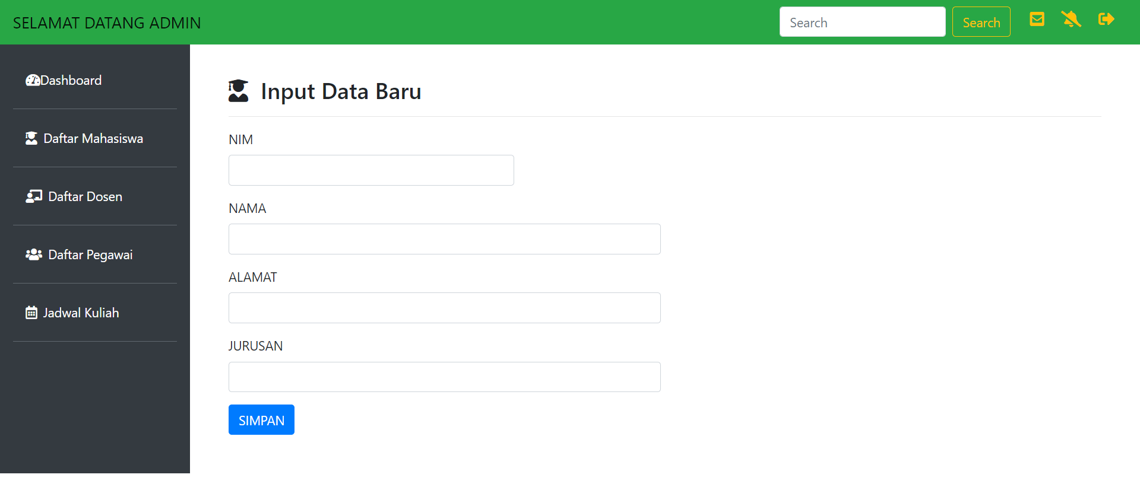

1. Ubah Data
   * Buat file baru ketikkan kode berikut simpan dengan nama file **ubah_mhs.php**

<?php

include 'koneksi.php';

$nim = $_GET['nim'];

$result = mysqli_query($koneksi, "SELECT * FROM mahasiswa WHERE nim='$nim'"); while($user_data = mysqli_fetch_array($result))

{

$nama = $user_data['nama'];

$alamat = $user_data['alamat'];

$jurusan = $user_data['jurusan'];

}

?>

<!doctype html>

<html lang="en">

<head>

<!-- Required meta tags -->

<meta charset="utf-8">

<meta name="viewport" content="width=device-width, initial-scale=1, shrink-to-fit=no">

<!-- Bootstrap CSS -->

<link rel="stylesheet" href="css/bootstrap.min.css" >

<link rel="stylesheet" type="text/css" href="admin.css">

<link rel="stylesheet" type="text/css" href="fontawesome/css/all.min.css">

<title>ADMINISTRATOR</title>

</head>

<body>

<nav class="navbar navbar-expand-lg navbar-light bg-warning fixed-top">

<a class="navbar-brand" href="#">SELAMAT DATANG ADMIN</a>

<button class="navbar-toggler" type="button" data-toggle="collapse" data- target="#navbarSupportedContent" aria-controls="navbarSupportedContent" aria-expanded="false" aria- label="Toggle navigation">

<span class="navbar-toggler-icon"></span>

</button>

<div class="collapse navbar-collapse" id="navbarSupportedContent">

<form class="form-inline my-2 my-lg-0 ml-auto">

<input class="form-control mr-sm-2" type="search" placeholder="Search" aria-label="Search">

<button class="btn btn-outline-success my-2 my-sm-0" type="submit">Search</button>

</form>

<div class="icon ml-4">

<h5>

<i class="fas fa-envelope-square mr-3"></i>

<i class="fas fa-bell-slash mr-3"></i>

<i class="fas fa-sign-out-alt mr-3"></i>

</h5>

</div>

</div>

</nav>

<div class="row no-gutters mt-5">

<div class="col-md-2 bg-dark mt-2 pr-3 pt-4">

<ul class="nav flex-column ml-3 mb-5">

<li class="nav-item">

<a class="nav-link active text-white" href=""><i class="fas fa-tachometer-alt mr- 2"></i>Dashboard</a><hr class="bg-secondary">

</li>

<li class="nav-item">

<a class="nav-link text-white" href=""><i class="fas fa-user-graduate mr-2"></i>Daftar Mahasiswa</a><hr class="bg-secondary">

</li>

<li class="nav-item">

<a class="nav-link text-white" href=""><i class="fas fa-chalkboard-teacher mr-2"></i>Daftar Dosen</a><hr class="bg-secondary">

</li>

<li class="nav-item">

<a class="nav-link text-white" href="" ><i class="fas fa-users mr-2"></i>Daftar Pegawai</a><hr class="bg-secondary">

</li>

<li class="nav-item">

<a class="nav-link text-white" href="" ><i class="far fa-calendar-alt mr-2"></i>Jadwal Kuliah</a><hr class="bg-secondary">

</li>

</ul>

</div>

<div class="col-md-10 p-5 pt-2">

<h3><i class="fas fa-user-graduate mr-2"></i> Ubah Data Mahasiswa</h3><hr>

## <form action="update_mhs.php" method="post">

<div class="form-row">

<div class="form-group col-md-4">

<label >NIM</label>

<input type="text" name="nim" class="form-control" id="nim" value=<?php echo $nim;?>>

</div>

</div>

<div class="form-row">

<div class="form-group col-md-8">

<label >NAMA</label>

<input type="text" name="nama" class="form-control" id="nama" value=<?php echo $nama;?>>

</div>

</div>

<div class="form-row">

<div class="form-group col-md-6">

<label >ALAMAT</label>

<input type="text" name="alamat" class="form-control" id="alamat" value=<?php echo $alamat;?>>

</div>

</div>

<div class="form-row">

<div class="form-group col-md-6">

<label >JURUSAN</label>

<input type="text" name="jurusan" class="form-control" id="jurusan" value=<?php echo

$jurusan;?>>

</div>

</div>

<button type="submit" class="btn btn-primary">SIMPAN</button>

</form>

</div>

</div>

</body>

</html>

* + Buat file baru ketikkan kode berikut simpan dengan nama file **update_mhs.php**

<?php

// include database connection file include 'koneksi.php';

$nim= $_POST['nim'];

$nama=$_POST['nama'];

$alamat=$_POST['alamat'];

$jurusan=$_POST['jurusan'];

$result = mysqli_query($koneksi, "UPDATE mahasiswa SET nama='$nama',alamat='$alamat',jurusan='$jurusan' WHERE nim='$nim'");

// Redirect to homepage to display updated user in list header("Location: index.php");

?>

* + 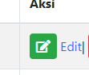Jalankan file index.php klik tombol pada salah satu record, kemudian ubah data dan simpan.
  + Tuliskan hasilnya dibawah ini

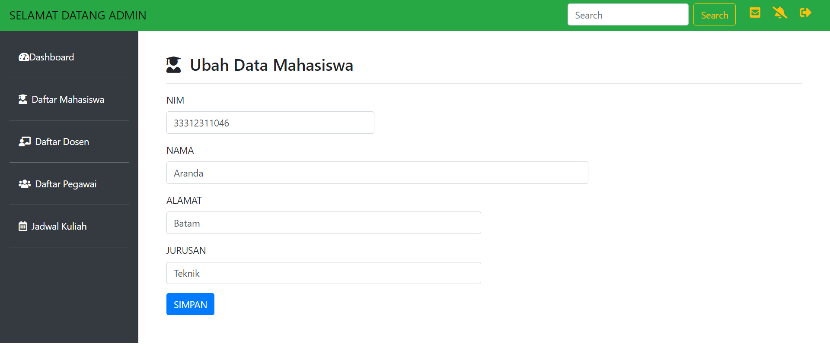

1. Hapus Data
   * Buat file baru ketikkan kode berikut simpan dengan nama file **hapus_mhs.php**

<?php

// include database connection file include 'koneksi.php';

$nim = $_GET['nim'];

$result = mysqli_query($koneksi, "DELETE FROM mahasiswa WHERE nim='$nim'"); header("Location:mahasiswa.php");

?>

* + Jalankan file index.php klik tombol pada salah satu bari record.

# Modifikasi menggunakan Modal

1. Buka file **index.php** pada folder **admin**
2. Tambahkan **Modal** pada tombol **TAMBAH DATA MAHASISWA** menjadi seperti berikut:



1. Tambahkan **Modal** pada tombol **Edit dan Delete** sehingga menjadi seperti berikut:

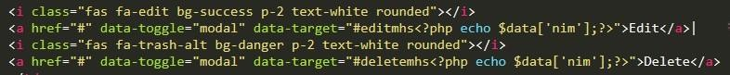

1. Tambahkan Form Modal untuk masing-masing tombol Simpan, Edit dan Hapus seperti dibawah ini:
   1. Simpan Modal →letakkan kode berikut dibawah komentar **<!-- Simpan Modal -->**

<div class="example-modal">

<div id="tambahmhs" class="modal fade" role="dialog" style="display:none;">

<div class="modal-dialog">

<div class="modal-content">

<div class="modal-header">

<h3 class="modal-title">Tambah Data Baru</h3>

</div>

<div class="modal-body">

<form action="simpan_mhs.php" method="post" role="form">

<div class="form-group">

<div class="row">

<label class="col-sm-3 control-label text-right">NIM</label>

<div class="col-sm-8"><input type="text" class="form-control" name="nim" placeholder="NIM" value=""></div>

</div>

</div>

<div class="form-group">

<div class="row">

<label class="col-sm-3 control-label text-right">Nama Mahasiswa</label>

<div class="col-sm-8"><input type="text" class="form-control" name="nama" placeholder="Nama Mahasiswa" value=""></div>

</div>

</div>

<div class="form-group">

<div class="row">

<label class="col-sm-3 control-label text-right">Alamat</label>

<div class="col-sm-8"><input type="text" class="form-control" name="alamat" placeholder="Alamat" id="alamat" value="">

</div>

</div>

</div>

<div class="form-group">

<div class="row">

<label class="col-sm-3 control-label text-right">Jurusan </label>

<div class="col-sm-8"><input type="text" name="jurusan" class="form-control" placeholder="Jurusan">

</input>

</div>

</div>

</div>

<div class="modal-footer">

<button id="nosave" type="button" class="btn btn-danger pull-left" data- dismiss="modal">Batal</button>

<input type="submit" name="submit" class="btn btn-primary" value="Simpan">

</div>

</form>

</div>

</div>

</div>

</div>

</div>

* 1. Edit modal →letakkan kode berikut dibawah komentar **<!-- Update Modal -->**

<div class="example-modal">

<div class="modal fade" id="editmhs<?php echo $data['nim'];?>" role="dialog">

<div class="modal-dialog">

<div class="modal-content">

<div class="modal-header">

<h3 class="modal-title">Edit Data Mahasiswa</h3>

</div>

<div class="modal-body">

<form action="update_mhs.php" method="post" role="form">

<?php

$nim = $data['nim'];

$query1 = mysqli_query($koneksi, "SELECT * FROM mahasiswa WHERE nim='$nim'"); while ($data1 = mysqli_fetch_assoc($query1)) {

?>

<div class="form-group">

<div class="row">

<label class="col-sm-3 control-label text-right">NIM </label>

<div class="col-sm-8"><input type="text" class="form-control" name="nim" value="<?php echo

$data1['nim']; ?>"></div>

</div>

</div>

<div class="form-group">

<div class="row">

<label class="col-sm-3 control-label text-right">Nama Mahasiswa</label>

<div class="col-sm-8"><input type="text" class="form-control" name="nama" value="<?php echo

$data1['nama']; ?>"></div>

</div>

</div>

<div class="form-group">

<div class="row">

<label class="col-sm-3 control-label text-right">Alamat </label>

<div class="col-sm-8"><input type="text" class="form-control" name="alamat" value="<?php echo

$data1['alamat']; ?>">

</div>

</div>

</div>

<div class="form-group">

<div class="row">

<label class="col-sm-3 control-label text-right">Jurusan </label>

<div class="col-sm-8"><input type="text" name="jurusan" class="form-control" value="<?php echo

$data1['jurusan']; ?>">

</input>

</div> </div> </div>

<div class="modal-footer">

<button id="noedit" type="button" class="btn btn-danger pull-left" data- dismiss="modal">Batal</button>

<input type="submit" name="submit" class="btn btn-primary" value="Update">

</div>

<?php

}

?>

</form> </div> </div> </div> </div></div>

* 1. Hapus modal →letakkan kode berikut dibawah komentar **<!-- modal delete -->**

<div class="example-modal">

<div id="deletemhs<?php echo $data['nim']; ?>" class="modal fade" role="dialog" style="display:none;">

<div class="modal-dialog">

<div class="modal-content">

<div class="modal-header">

<h3 class="modal-title">Konfirmasi Hapus Data</h3>

</div>

<div class="modal-body">

<h5 align="center" >Apakah anda yakin ingin menghapus NIM <?php echo

$data['nim'];?><strong><span class="grt"></span></strong> ?</h5>

</div>

<div class="modal-footer">

<button id="nodelete" type="button" class="btn btn-danger pull-left" data- dismiss="modal">Cancle</button>

<a href="hapus_mhs.php?nim=<?php echo $data['nim']; ?>" class="btn btn-primary">Delete</a>

</div>

</div>

</div>

</div>

</div>

# TUGAS

Buatlah program tambah, ubah, update, hapus data untuk data dosen, pegawai dan jadwal kuliah dengan struktur tabel sebagai berikut:

1. Tabel dosen:
   * nidn char (10)
   * nama Varchar(30)
   * alamat Varchar(30)
   * jabatan Varchar(10)
2. Tabel Pegawai:
   * nik char(10)
   * nama Varchar(30)
   * bagian Varchar(20)
3. Tabel jadwal kuliah disesuaikan dengan jadwal kuliah masing yang ada di Politeknik Batam.