Module 1 - Foundation

Question: Do search for web-site, http, URL etc given topics in lecture.

Answer:

Web site: a website is a collection of multimedia such as images, videos, text and pages.

Ex: Wikipedia, Reddit

HTTP: Hyper Text Transfer Protocol, it’s a protocol to communicate with the websites.

Ex: https://www.google.com/

URL: Uniform Resource Locator, URL is used to address a website.

Ex: https://www.google.com/

MODULE 2 - Fundamentals of IT

Question: Do search for domain, hosting, SEO etc.

Answers:

Domain: Domain is used as a identifier of the entity.

Example: <https://www.google.com/>

Hosting: Hosting is a process of putting something to the world wide web to make it accessible to everyone outside the network, too.

SEO: Search Engine Optimization, it’s used to generate organic traffic.

Module 3 - HTML

Question: Are the HTML tags and elements the same thing?

Answers:

No, html tag and elements are not same thing.

Tag: Tag is just an html code

<br>

<hr>

Output:

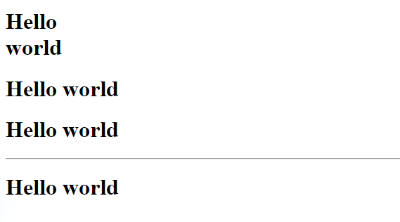

Element:Element contains the content inside the tag.

<p>Hello world</p>

<h1>Title</h1>

Output:

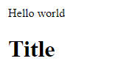

Question:What are tags and attributes in HTML?

Answers:

Tags: Tags are just html code

<p>Lorem ipsum dolor, sit amet <br>consectetur adipisicing elit. Pariatur, vitae.</p>

<p>Lorem ipsum dolor sit amet consectetur adipisicing elit. Molestias, dolorum!</p>

<p>Lorem ipsum dolor sit amet consectetur adipisicing elit. Molestias, dolorum!</p>

<p>Lorem ipsum dolor sit amet consectetur adipisicing elit. Molestias, dolorum!</p>

<hr>

<p>Lorem ipsum dolor sit amet consectetur adipisicing elit. Molestias, dolorum!</p>

Output:

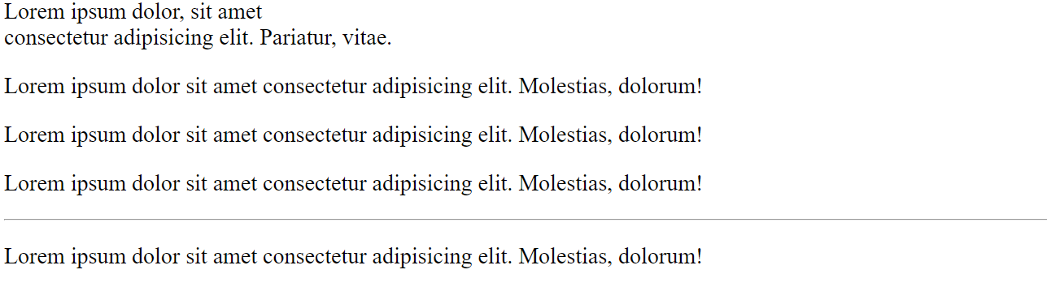

Attributes: Attributes are special words used to describe more about tags,

Such as height and width.

<table border=1></table>

<img src="https://static.vecteezy.com/system/resources/previews/022/448/291/original/save-earth-day-poster-environment-day-nature-green-ai-generative-glossy-background-images-tree-and-water-free-photo.jpg" height=1000 width=1000>

Output:



Question:What are void elements in HTML? With Example

Answer:

Void elements are type of elements which do not have closing tag.

Such as <hr>,<img>,<br>

<p>Lorem ipsum dolor sit amet consectetur<br> adipisicing elit. Repudiandae, ipsam?</p>

<hr>

<img src="https://static.vecteezy.com/system/resources/previews/022/448/291/original/save-earth-day-poster-environment-day-nature-green-ai-generative-glossy-background-images-tree-and-water-free-photo.jpg" height="500" width="800"><br>

<input type="text" placeholder="test">

Output:

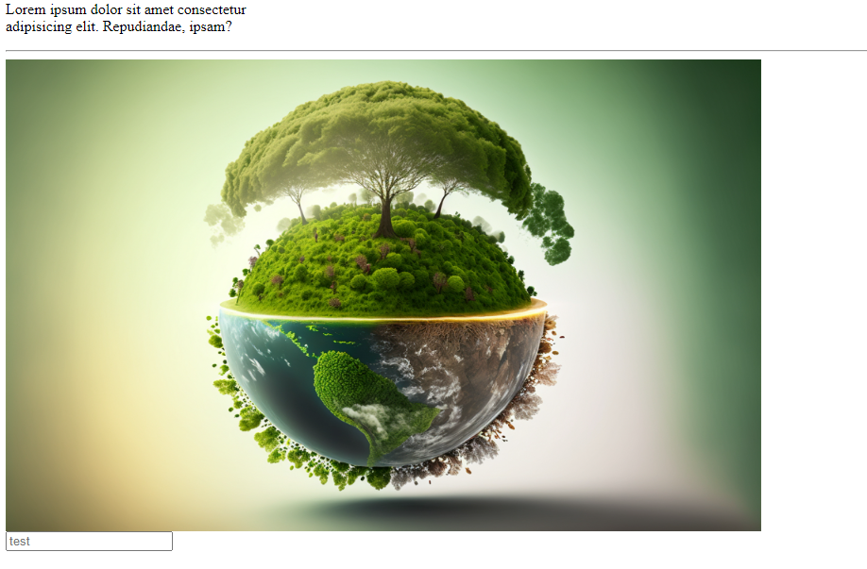

Question:What are HTML Entities? With Example

Answer:

HTML entities are used to represent symbolic characters

&copy;

&reg;

&dollar;

Output:

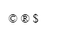

Question: What are different types of lists in HTML? With Example

Answer:

There are three types of lists:

1. Ordered list
2. Unordered list
3. Defined list

<ol>

<li>A</li>

<li>B</li>

<li>C</li>

</ol>

<ul>

<li>A</li>

<li>b</li>

<li>c</li>

</ul>

<dl>

<dt>Tea</dt>

<dd>Hot</dd>

<dd>Hot</dd>

</dl>

Output:

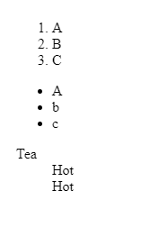

Question: What is the ‘class’ attribute in HTML? With Example

Answer:

Class: Class is used to group multiple html elements.

<!DOCTYPE html>

<html>

<head>

<title>Hello, World!</title>

<link rel="stylesheet" href="styles.css" />

<style>

.one{

background-color: blue;

color: white;

}

#unique{

background-color: yellow;

}

</style>

</head>

<body>

<div class="one">

<h3>Hello</h3>

<h3>World</h3>

<h3>How are you?</h3>

</div>

<h4 id="unique">Unique ID</h4>

</body>

</html>

Output:

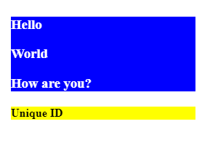

Question: What is the difference between the ‘id’ attribute and the ‘class’ attribute of HTML elements? With Example

Answer:

Class: Class is used to group multiple html elements. Classes can exist with the same name again and again in the same page.

Id: id is used to target a single element. It should be unique. Id of same name cannot exist in the same page.

<!DOCTYPE html>

<html>

<head>

<title>Hello, World!</title>

<link rel="stylesheet" href="styles.css" />

<style>

.one{

background-color: blue;

color: white;

}

#unique{

background-color: yellow;

}

</style>

</head>

<body>

<div class="one">

<h3>Hello</h3>

<h3>World</h3>

<h3>How are you?</h3>

</div>

<h4 id="unique">Unique ID</h4>

</body>

</html>

Output:



Question: What are the various formatting tags in HTML?

Answer:

There are several types of html tags to format the content

<pre> Hello</pre>

<code>Hello </code>

<b>Hello</b>

Output:

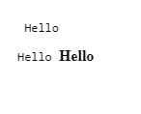

Question: How is Cell Padding different from Cell Spacing? With Example

Answer:

Cell Padding: Cell padding is used for more space inside the cell

Cell Spacing: Cell spacing is used to give space between the cells.

<table border="1" cellpadding="20">

<h1>Cell padding</h1>

<tr>

<td>1</td>

<td>2</td>

</tr>

<tr>

<td>1</td>

<td>2</td>

</tr>

<tr>

<td>1</td>

<td>2</td>

</tr>

</table>

<table border="1" cellspacing="20">

<h1>Cell Spacing</h1>

<tr>

<td>1</td>

<td>2</td>

</tr>

<tr>

<td>1</td>

<td>2</td>

</tr>

<tr>

<td>1</td>

<td>2</td>

</tr>

</table>

Output:

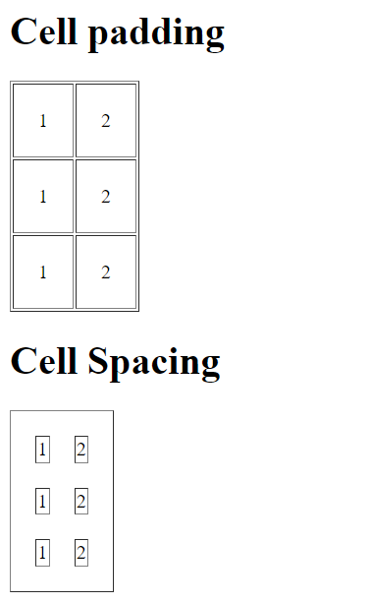

Question: How can we club two or more rows or columns into a single row or column in an HTML table? With Example

Answer:

Rowspan: Rowspan is used to merge rows.

Colspan: Colspan is used to merge columns.

<table border="1" >

<h1>colspan</h1>

<tr>

<td colspan="2">1</td>

</tr>

<tr>

<td>1</td>

<td>2</td>

</tr>

<tr>

<td>1</td>

<td>2</td>

</tr>

</table>

<table border="1">

<h1>rowspan</h1>

<tr>

<td rowspan="2">1</td>

<td>2</td>

</tr>

<tr>

<td>2</td>

</tr>

<tr>

<td>1</td>

<td>2</td>

</tr>

</table>

Output:

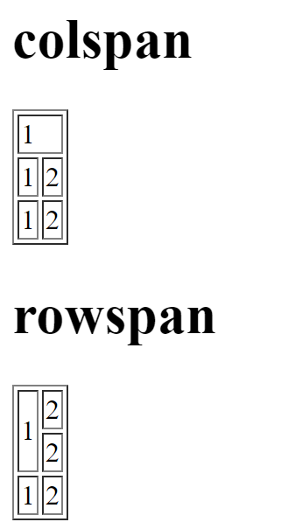

Question: What is the difference between a block-level element and an inline element

Answer:

Block-Level-Elements: Block level elements takes the full width.

Inline-Element: Inline elements takes the width according to the content.

<h1>Block level element</h1>

<div style="background-color: yellow;">

<p>Lorem ipsum dolor sit amet.</p>

</div>

<h1>Inline element</h1>

<span style="background-color: yellow;">

Lorem ipsum dolor sit amet.

</span>

Output:

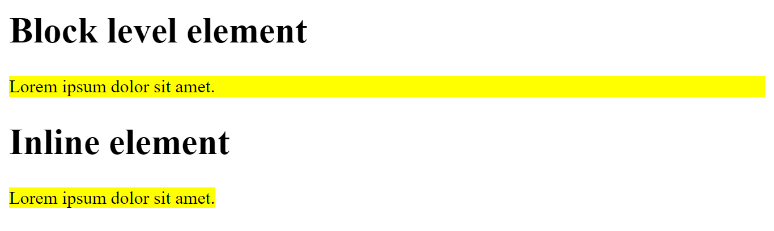

Question: How to create a Hyperlink in HTML? With Example

Answer:

Hyperlinks are used to navigate through pages when the user clicks on it.

<a href="https://google.com"></a>

Output:



Question: What is the use of an iframe tag? With Example.

Answer: The use of iframe tag is to load another web page into the current web page.

<iframe width="560" height="315" src="https://www.youtube.com/embed/4tywp83zkmk" title="YouTube video player" frameborder="0" allow="accelerometer; autoplay; clipboard-write; encrypted-media; gyroscope; picture-in-picture; web-share" allowfullscreen></iframe>

Output:



Question: What is the use of a span tag? Explain with example?

Answer:

Span tag is used to give different stylings to a particular text in the content.

<p>Lorem ipsum dolor sit amet, consectetur adipisicing elit.<span style="background-color: red;"> Rerum quam expedita repellendus, </span>enim in omnis quos pariatur nobis sed nihil.</p>

Output:



Question: How to insert a picture into a background image of a web page? With Example.

Answer:

We can insert a picture to the background using css.

<!DOCTYPE html>

<html>

<head>

<title>Hello, World!</title>

<link rel="stylesheet" href="styles.css" />

<style>

body{

color:green;

background: url('images.jpg')

}

</style>

</head>

<body>

<h3>Hello world!</h3>

</body>

</html>

Output:



Question: How are active links different from normal link

Answer:

When a working url is the href attribute then the link becomes active and color changes to blue.

When a link is not given in the href attribute then the link becomes inactive and color changes to purple.

<a href="">Normal link</a><br>

<a href="https://www.google.com">Active link</a>

Output:

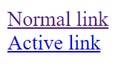

Question: What are the different tags to separate sections of text?

Answer:

The different tags to separate sections of text are:

Span tag and Div tag.

<div>

<p>Lorem ipsum dolor sit.</p>

</div>

<span>Lorem ipsum dolor sit.</span>

Output:

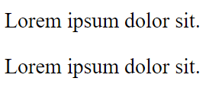

Question: What is SVG?

Answer: The full form of SVG is Scalable Vector Graphics. We can scale up SVG image a lot without losing the graphics.

Output:



Question: What is difference between HTML and XHTML

Answer:

HTML is just hyper text markup language.

XHTML is Extensible hypertext markup language which is just an extension of html.

XHTML:

<!DOCTYPE html PUBLIC "-//W3C//DTD XHTML 1.1//EN"

"http://www.w3.org/TR/xhtml11/DTD/xhtml11.dtd">

<html xmlns="http://www.w3.org/1999/xhtml">

<head>

<title>First Webpage</title>

</head>

<body>

The body of the page goes here...

</body>

</html>

HTML:

<html>

<head>

<meta charset="UTF-8">

<meta name="viewport" content="width=device-width, initial-scale=1.0">

<meta http-equiv="X-UA-Compatible" content="ie=edge">

<title>HTML 5 Boilerplate</title>

<link rel="stylesheet" href="style.css">

</head>

<body>

<script src="index.js"></script>

</body>

</html>

Output:





Question: What are logical and physical tags in HTML?

Answer:

Logical Tags: These tags are used for logic

Physical Tags: These tags are used for physical visual appearance

<h3>Physical tags</h3>

<b><p>Lorem ipsum dolor sit amet.</p></b>

<h3>Logical tags</h3>

Welcome to <abbr title="Hello world"> Hello world</abbr> <br>

Output:

