Module 4 ) CSS and CSS3

Question: What are the benefits of using CSS?

Answer: CSS is used to give styling to the HTML elements.

Code:

h1{

color: red;

}

Output:

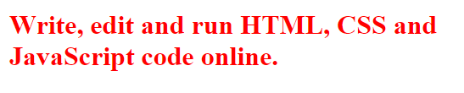

Question:What are the disadvantages of CSS?

Answer: Using multiple css files can take long time to load the web page.

Old browsers may not support CSS3.

Question: What is the difference between css2 and css3

Answer: We can breakdown the code in modules in css3 but not in css2.

Creating responsive design is not possible in css2 but in css3.

Question: Name a few css style components?

Answer: The few css style components are:

h1{

color: red;

background-color: blue;

margin: 10px;

padding: 10px;

}

Output:

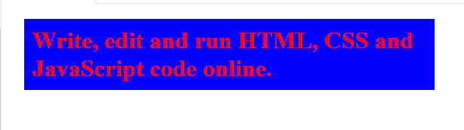

Question: What do you understand by opacity?

Answer: The opacity property is used to define the transparency of an element.

h1{

opacity: 0.5;

}

Output:

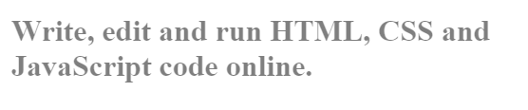

Question: How can the background color of an element be changed?

Answer: We can change the background color of an element by using the property background-color

h1{

background-color: purple;

}

Output:

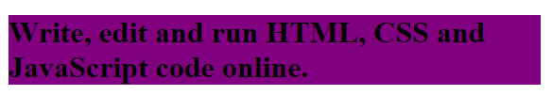

Question: How can image repetition of the backup be controlled?

Answer: We can stop image repetition of the background image with css property background-repeat: no-repeat;

<!DOCTYPE html>

<html lang="en">

<head>

<meta charset="UTF-8">

<meta name="viewport" content="width=device-width, initial-scale=1.0">

<link rel="stylesheet" href="style.css">

<title>Document</title>

<style>

.repeating{

height: 500px;

background-image: url('https://images.ctfassets.net/hrltx12pl8hq/5ZjPpfAhn1rZWeopnHiXb/3e1b9a709297905672a0d24eac94a873/thumb_nov22_03.jpg');

}

.not-repeating{

height: 500px;

background-repeat: no-repeat;

background-image: url('https://images.ctfassets.net/hrltx12pl8hq/5ZjPpfAhn1rZWeopnHiXb/3e1b9a709297905672a0d24eac94a873/thumb_nov22_03.jpg');

}

</style>

</head>

<body>

<h1>Image repeating</h1>

<br>

<div class="repeating"></div><br>

<h1>Image not repeating repeating</h1>

<br>

<div class="not-repeating"></div>

</body>

</html>

Output:

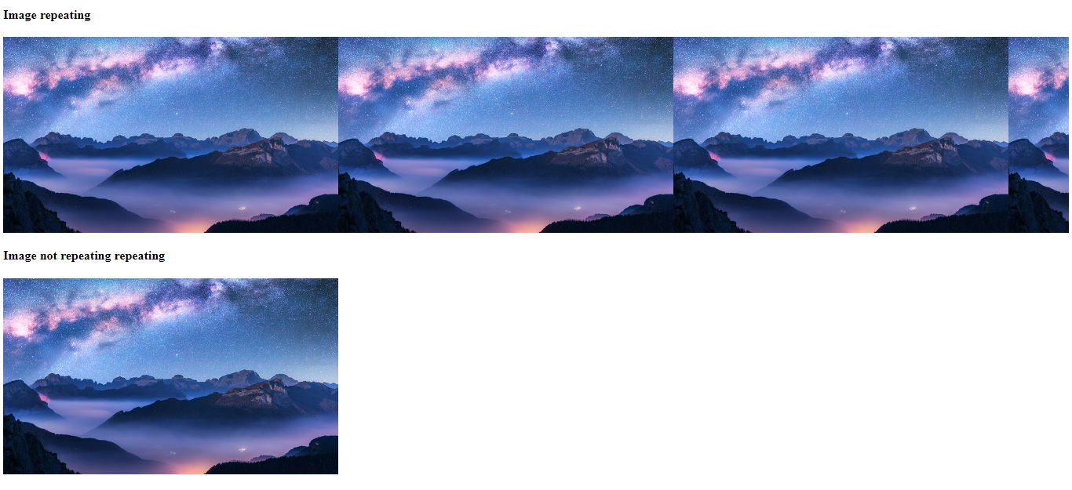

Question: What is the use of the background-position property?

Answer: background-position property is used to put the position in the four directions such as top, left, right, bottom.

<!DOCTYPE html>

<html lang="en">

<head>

<meta charset="UTF-8">

<meta name="viewport" content="width=device-width, initial-scale=1.0">

<link rel="stylesheet" href="style.css">

<title>Document</title>

<style>

.top{

height: 300px;

background-image: url(https://images.ctfassets.net/hrltx12pl8hq/5ZjPpfAhn1rZWeopnHiXb/3e1b9a709297905672a0d24eac94a873/thumb_nov22_03.jpg);

background-repeat: no-repeat;

background-position: top;

}

.left{

height: 300px;

background-image: url(https://images.ctfassets.net/hrltx12pl8hq/5ZjPpfAhn1rZWeopnHiXb/3e1b9a709297905672a0d24eac94a873/thumb_nov22_03.jpg);

background-repeat: no-repeat;

background-position: left;

}

.right{

height: 300px;

background-image: url(https://images.ctfassets.net/hrltx12pl8hq/5ZjPpfAhn1rZWeopnHiXb/3e1b9a709297905672a0d24eac94a873/thumb_nov22_03.jpg);

background-repeat: no-repeat;

background-position: right;

}

</style>

</head>

<body>

<div class="top"></div>

<div class="right"></div>

<div class="left"></div>

</body>

</html>

Output:

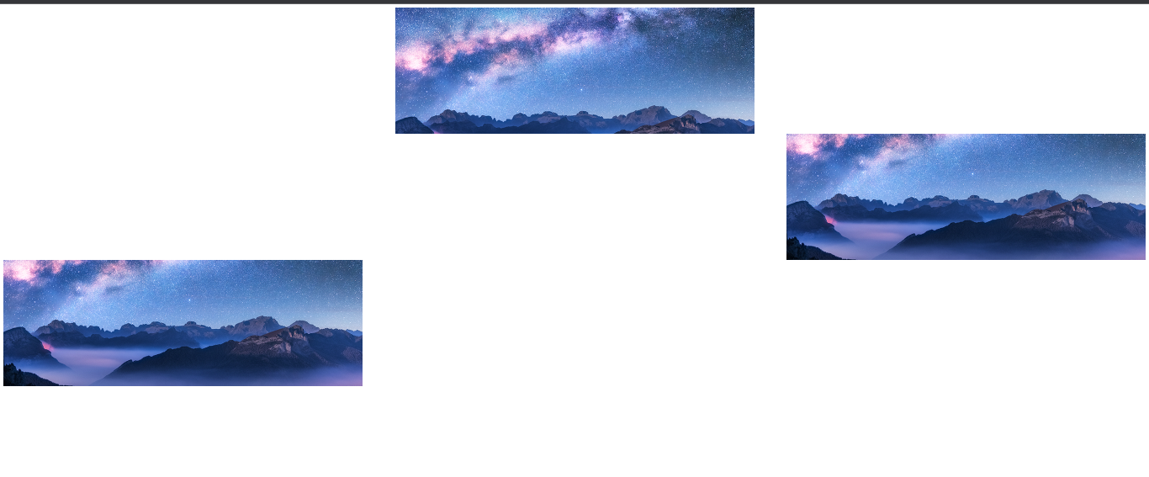

Question: Which property controls the image scroll in the background?

Answer: The css property overflow:auto; controls the image scroll in the background.

.main{

height: 500px;

color: black;

background-image: url('https://img.freepik.com/free-photo/wide-angle-shot-single-tree-growing-clouded-sky-during-sunset-surrounded-by-grass_181624-22807.jpg?w=2000');

overflow: auto;

width: 800px;

background-repeat: no-repeat;

}

Output:

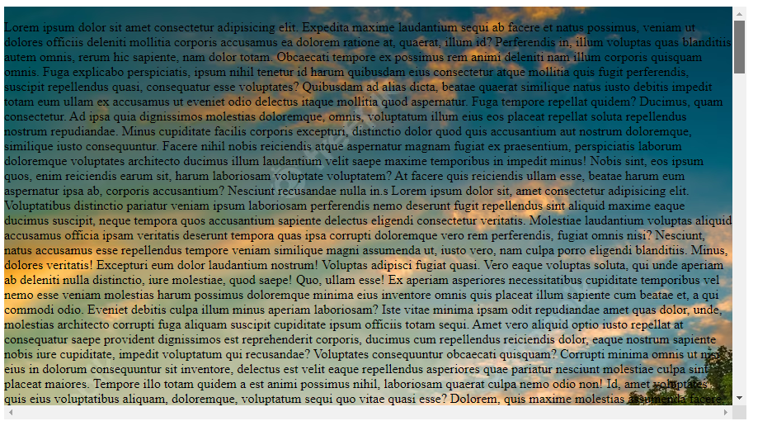

Question: Why should background and color be used as separate properties?

Answer: We use background-color property to change the color of the background, while color property is only used to change the color of the font.

<!DOCTYPE html>

<html lang="en">

<head>

<meta charset="UTF-8">

<meta name="viewport" content="width=device-width, initial-scale=1.0">

<title>Demo</title>

<style>

h1{

background-color: red;

color: white;

}

</style>

</head>

<body>

<h1>Hello, World!</h1>

</body>

</html>

Output:



Question: How to center block elements using CSS1?

Answer: We can center the div using following css1 code.

<!DOCTYPE html>

<html lang="en">

<head>

<style>

*{

margin:0px;

padding:0px;

box-sizing: border-box;

}

body {

background: brown;

}

#box {

background: black;

color:white;

text-align: center;

}

/* For centering the element */

#box {

height: 100%;

width:300px;

margin:25% auto;

}

</style>

</head>

<body>

<div id="box">

<h3>this is a box</h3>

</div>

</body>

</html>

Output:

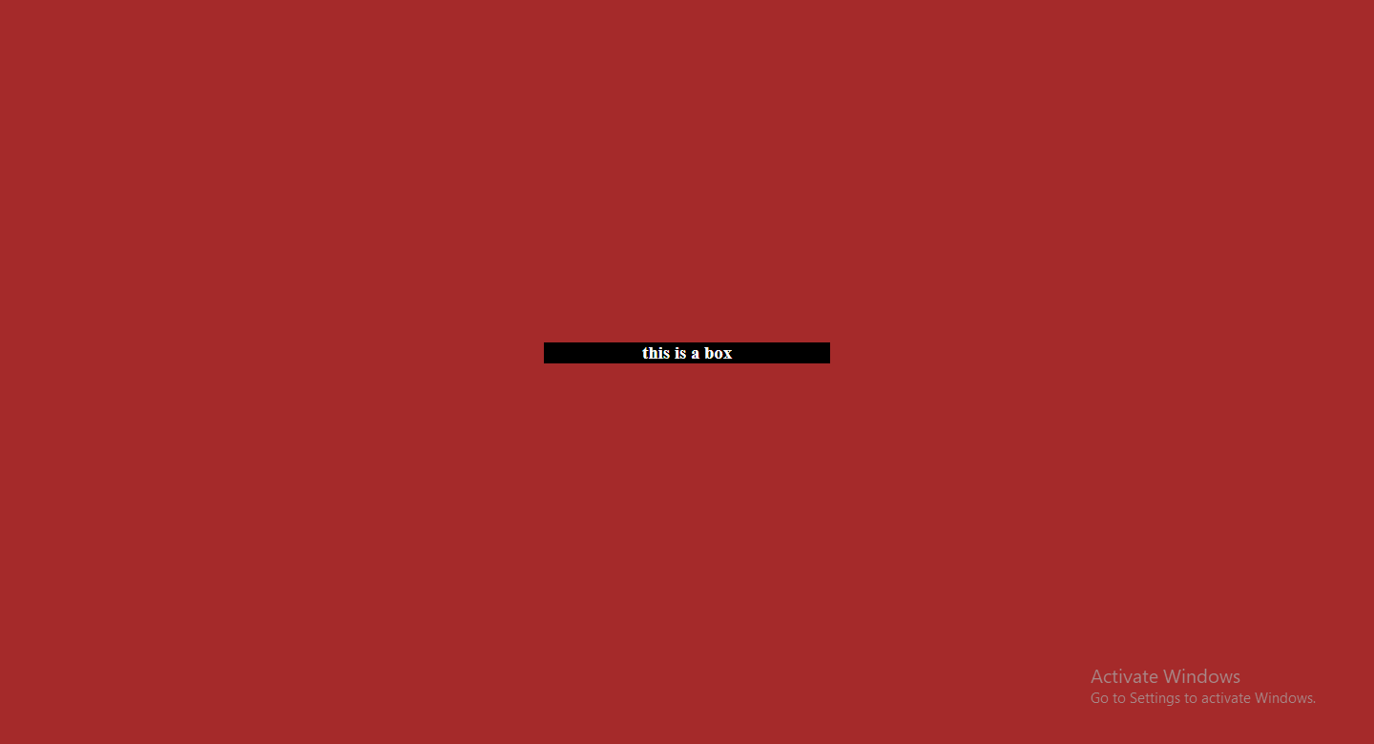

Question: How to maintain the CSS specifications?

Answer:

If the css code is larger than 400 lines then the html could should use external css file.

Question: What are the ways to integrate CSS as a web page?

Answer: There are three ways to integrate css in the web page.

1. Inline css- <h1 style=”color:red”>Hello, World!</h1>
2. Internal CSS - <style>h1{color: red};</style>
3. External CSS - <link rel="stylesheet" href="style.css">

Question: What is embedded style sheets?

Answer: Embedded style sheets means css code inside the style tag in the same html document.

<!DOCTYPE html>

<html lang="en">

<head>

<meta charset="UTF-8">

<meta name="viewport" content="width=device-width, initial-scale=1.0">

<title>Demo</title>

<style>

h1{

background-color: red;

color: white;

}

</style>

</head>

<body>

<h1>Hello, World!</h1>

</body>

</html>

Output:



Question: What are the external style sheets?

Answer: External style sheets means to load css from different files.

<link rel="stylesheet" href="style.css">

h1{

background-color: red;

color: white;

}

Output:



Question: What are the advantages and disadvantages of using external style sheets?

Answer:

Advantage:

1. It makes the code cleaner.
2. Easy to read

Disadvantage:

1. It can increase the network load.
2. CSS on the page will not be applied until the css is loaded correctly.

<link rel="stylesheet" href="style.css">

h1{

background-color: red;

color: white;

}

Output:



Question: What is the meaning of the CSS selector?

Answer: It is a pattern of elements and other terms that tell the browser which HTML elements should be selected to have the CSS property values inside the rule applied to them.

h1{

background-color: red;

color: white;

}

Output:



Question: What are the media types allowed by CSS?

Answer: All type of medias are allowed such as mp3, mp4, png, jpeg, gif, etc…

<!DOCTYPE html>

<html lang="en">

<head>

<meta charset="UTF-8">

<meta name="viewport" content="width=device-width, initial-scale=1.0">

<title>Demo</title>

<link rel="stylesheet" href="style.css">

</head>

<body>

<h1>Audio</h1><br>

<audio src="file_example_MP3_700KB.mp3" controls></audio>

<h1>Video</h1><br>

<video src="video.mp4" controls></video>

<h1>PNG</h1><br>

<img src="test.png">

<h1>JPG</h1><br>

<img src="testpng.jpg"

</body>

</html>

Output:

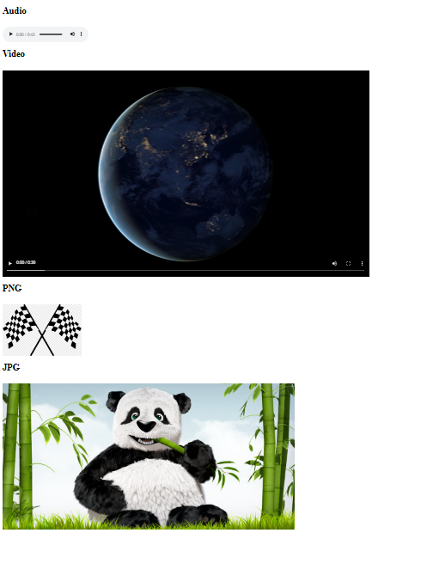

Question: What is the rule set?

Answer: A CSS rule set contains one or more selectors and one or more declarations

<!DOCTYPE html>

<html lang="en">

<head>

<meta charset="UTF-8">

<meta name="viewport" content="width=device-width, initial-scale=1.0">

<title>Demo</title>

<style>

h1 {

color: blue;

text-align: center;

}</style>

</head>

<body>

<h1>Hello, World!</h1>

</body>

</html>

Output:

