Automatic border crossing detection and navigation for fishing vessels

**K. LAKSHMINARAYANA 1**

**G. NAGA JYOTHI2, A. ANIL3, B. NANDA KISHORE SAI4, A. NAVEENA5 CH. VAMSI6**

## Sr. Asst Professor, Sir C R Reddy College of Engineering [1]

**UG Scholars, Sir C R Reddy College of Engineering [2,3,4,5,6]**

# ABSTRACT:

*This project is designed to save the lives of fisherman who unknowingly enter the international borders of other countries and has been caught and shot dead by the naval forces of other countries. This application helps the fisherman by identifying the Indian borders and alerts the fisherman in the boat before entering into international borders and if they recklessly enter into other country borders it will be automatically guided into the Indian borders without any involvement of the fisherman. This can be achieved by the GPS module by tracking the longitude and latitudes*

*and then comparing it with the location of Indian borders if the boat is crossed the specified co-ordinates it gives a buzzer alert to the fisherman and then sends SMS alert with the exact location of the boat to the coastal guards by making use of GSM module. An RF transmitter is placed in the coastal guard’s security room and the receiver is placed in the boat for communication to alert the fisherman and sends necessary commands to save the lives of the fisherman.*

***Keywords: Google Maps, GPS, GSM Module, International Borders, RF Tx & Rx.***

# INTRODUCTION

Fishing is the main livelihood for most of the people in India but due to a lack of proper knowledge about the international borders of other countries and lack of proper technical equipment and technical support they are unknowingly entering into the neighbouring country borders and has been detained and killed by the navy forces for a crime they are unaware of this they are losing their lives and leaving their families on the roads, So to save their lives and their families we designed an application which gives an alert by making buzzer sound before entering into the borders of another country by tracking the location of the boat with help of GPS module and then sends the SMS alert to coastal guards and fisherman by making use of GSM module if they enter by ignoring the alerts the application will automatically guide the boat into Indian

borders and saves their lives**.** This would tremendously aid the underprivileged and defenceless fishermen in continuing to operate within Indian boundaries.

# LITERATURE SURVEY

## DESIGN OF BORDER ALERT SYSTEM FOR FISHERMEN USING GPS, ARUNVIJAY et al., MARCH 2014.

The microcontroller's preset values for the maritime border's latitude and longitude are what the method's creator uses. When a Boat's GPS position is tracked as it approaches a border and is compared to a stored value; if the difference is higher, it is presumed that the boat has crossed the border, and a fishermen warning message is sent. The advantage of using GPS is the high precision range. The drawback is that saving requires more memory. each latitude, longitude, and other

coordinate points.

# MARCH 2015, VIGNESH M et al., "GPS-BASED BORDER ALERT SYSTEM FOR FISHERMEN WITH BOAT SPEEDOMETER."

The author imagines doing this using a GPS- tracking device. GPS is used to locate the boat, and the motor speed In a catastrophe is under control. An alert notification is delivered to the user. (fisherman). The advantage is that it provides mariners with the safest and most efficient way to locate fishermen using GPS72h technology utilised for sea navigation. This technique also allows for greater degrees of effectiveness and safety. it's a drawback in this scenario is that only the fishermen are aware of the border alert; the control station is not.

# MICHALSKI et al.'s "DESIGN FOR BORDER SAFETY SYSTEM,"

**March 2013**.

This method uses GPS to locate the boat, and when it gets close to the border, the system issues a warning. which indicates that the motor has been turned off; the boat can only move forward by shifting into reverse. The boat stops as it enters the restricted area, and it can only restart by reversing the motor. It provides the fishermen's utmost safety well in advance, However, reversing the motor can cause the boat to be misled by wave currents.

## N.R RAJALAKSHMI AND K. SRAVANAN

The (IoT) Internet of Things, which links billions of sensors globally, makes major technological advancements in the Internet sector. The technical developments in the IoT vision have an impact on a wide range of economic sectors, including communications, computing, construction, and logistics. The rapidly expanding Internet of Things invention will significantly alter how people live. IOT devices' computation and storage are offloaded into the cloud environment in order to operate their operations efficiently, making it their client. The use of cloud-based IOT applications makes it possible to develop scalable and cost-effective solutions. Using the GPS and IoT data obtained from this study, we talk about an IoT-based border warning system. cellular LoRa devices, Suresh

and Sharath designed a GPS-based device for identifying maritime borders that is inexpensive that can be used by fishermen for border guiding and navigation. The system was proposed by Surekha et al. using an ARM CPU. In order to warn the fisherman who is crossing the boundary, GPS is used to pinpoint the position of the travelling boat. Additionally, the control portion will receive this crossing information via the RF transmitter.

## Ranjith and Naveen

## Naveen and Ranjith suggested DGPS and GSM as a technique for border alerts and smart monitoring with built-in alarms. Using DGPS, the boat's position could be followed. If the border is breached, an alarm will ring. The control room and family members are also occasionally sent crossing information by the GSM. Sivagnanam et al. suggested a coastguard alert and rescue system for unauthorised international maritime line crossings, and an integrated GPS system was used to pinpoint the precise location of the fisherman

## N. R. Rajalakshmi and K. Saravanan

## sensor for the (Global Positioning System). This location is transmitted via GSM to the relevant Coast Guard station. (Global System for Mobile Communication). The idea of an Advanced Border Alert System Using GPS and an Intelligent Engine Control Unit, which is used to prevent fishermen from navigating towards the border of another nation, was put forth by Jim and Eugene [11]. If smugglers or intruders ignore the alert, an intelligent engine control unit will shut off the boat's engine to stop them from trespassing into the other border. They locate the boat using a GPS module, which is the most accurate and quick method of doing so. after which notify the coast patrol. Kamala Kannan and other’s inability to the cellular network's deep water coverage and information transmission to the coast, border crossing information cannot be communicated over GSM Because Zigbee transmission only covers a meter, it is impossible to use a Zigbee transmitter to monitor officials. Despite the challenging climate in the maritime region, the transmission must be trustworthy. To address the aforementioned problems, our suggested border alert system is built with LoRa and GPS. LoRa is a single-hop, long-range, low-power, and low-bit-rate wireless transmission technology.

It is mainly designed for Internet of Things (IoT) devices with low throughput and low-powered batteries. LoRa has been used as a mobile smart sensing device to send data about border crossings as a result.

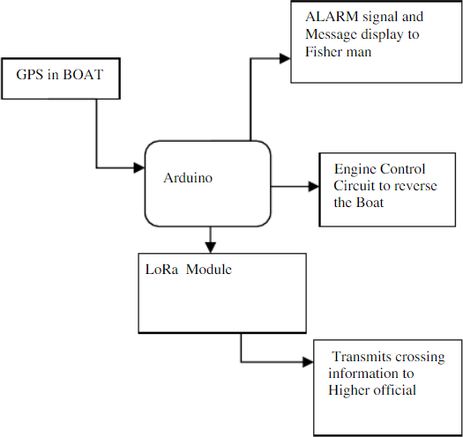

FIG.1.Block diagram of a border alert system.

# EXISTING MODEL

As there are several existing systems of border alert systems which identify the current position and coordinates using a GPS tracking system which gives only alerts to the fishermen inside guards but the guards are not in a position to take any action as they already entering into international borders and caught by the naval officers and being punished brutally and up to death too. And the existing model only allows starting and destination locations tracking this will become more critical to the system to identify the route that the boat is travelling and this will lead to accidents and even more difficulty to find the exact location whenever the boat/ship got missing and leads to huge losses like man and

money.

# PROPOSED MODEL

The suggested method makes use of a GPS receiver to determine the boat's current location by decoding a signal from a satellite. The proposed system is used to determine a country's border using the position's longitude and latitude, not just between Sri Lanka and India but everywhere in the globe. It is possible to predefine and keep in memory the specific layer level, or border. The current value is compared to predefined values, and if they are identical, the specific procedure, i.e The Arduino instructs the warning buzzer to sound. Additionally, it employs a transmitter to communicate data to the base station that keeps track of the seafaring vessels. Both fishermen and coastal guards are indicated by the method. Thus, it keeps the fishermen alive and alerts the base station to assist. There are three pre-stored locations, each of which is only a few nautical miles from the border. At each location, a warning system is announced; at the first location, a warning buzzer will sound, and an SMS will show the precise distance between the current location and the border motor will automatically navigate into Indian borders and send the location of that point to the navy control room so they can come and verify the legitimacy of fishermen before crossing the border, saving lives of fishermen. there is also a reduction of boat speed if fishermen miss warning and he moved ahead then it shows distance information.

**ARCHITECTURE**

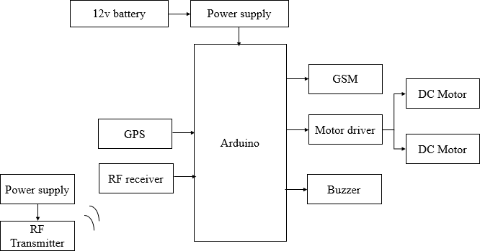

FIG.2.Block diagram of automatic border crossing detection and navigation of fishing vessels

The border latitudes and longitudes are predefined and stored in a memory and the GPS continuously track the locations whenever the defined coordinates is being exceeded by the current location it will give the buzzer sound and also sends the alert through SMS via GSM and RF transmitter to both fisherman and coastal guards receives through RF receiver.

# IDENTIFICATION OF FISHING VESSELS

Firstly the stored location is passed to the system to compare with the tracked locations by the GPS tracker and generates the alert.

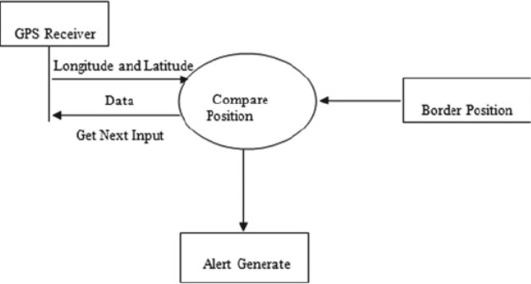

FIG.3.Flow diagram

When the system gets powered on it immediately checks for the instructions from the transmitter to the receiver, and then the GPS track the location first and then sent to the controller in the digital data, there in the processor, the stored locations and the tracked locations are compared if the tracked location exceeds the stored location the system gives buzzer sound and then the boat is automatically guided into the Indian borders if they do not respond to the buzzer sound and SMS alerts with boat exact location is also sent to the coastal guards and persons in the boat and then the exact location of the boat is being identified and have a chance to rescue if any boat missing or accidents takes place.

# How GPS Works

The GPS receiver determines its precise location no matter where it is by using a constellation of satellites and a ground station With the help of this received information, a ground station or GPS module can compute its position and time.

How GPS Receiver Calculates its Position and Time

GPS receiver receives information signals from GPS satellites and calculates their distance from satellites. This is done by measuring the time required for the signal to travel from the satellite to the receiver.

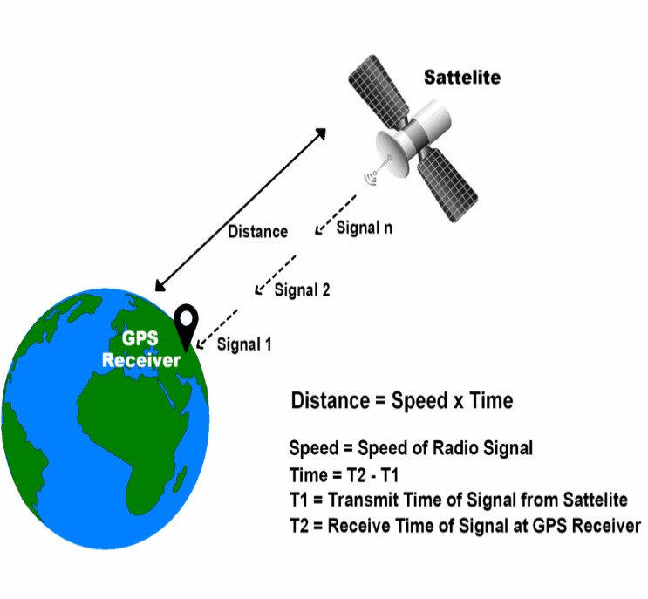

Fig.4. GPS Distance Calculation



Where

A signal's transit period from a satellite to a receiver is measured in time. The speed of radio communication is comparable to the speed of light. By subtracting the sent and received times, we can find the journey's duration.

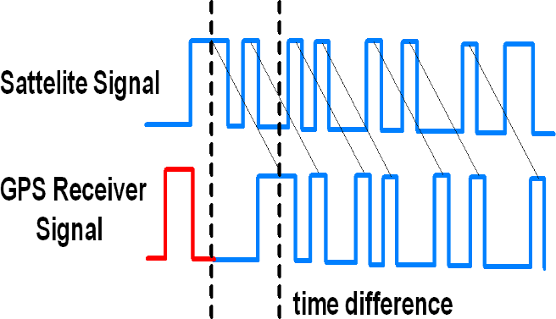

Fig.5. GPS Signal Time Difference

[**Trilateration**](http://electronics.howstuffworks.com/gadgets/travel/gps1.htm)**:**

The satellite and GPS device simultaneously produce the same pseudocode signal that is used to calculate distance. The pseudocode that the spacecraft transmits is received by the GPS receiver. The travel times of these two signals are different from one another when contrasted. Now, using the trilateration technique, the receiver can determine its location if it is aware of its distance from three or more satellites and those satellites' locations (which are transmitted by the satellites).

Trilateration, a mathematical technique, is used by a global positioning system (GPS) device to determine a user's location, speed, and elevation. A GPS can use the geometry of circles, spheres, and triangles to calculate the exact range or distance of each satellite being tracked by continuously gathering and examining radio signals from numerous GPS satellites.

Trilateration is a more complicated form of triangulation, even though it does not use angles to compute its results. A single satellite that covers a large circular area can provide information that can be used to approximately pinpoint a spot on the surface of the Earth. By incorporating data from a second satellite, the GPS can pinpoint a point's exact position to a region where the two satellite data areas overlap. Combining information from a third satellite allows for the precise location of the point on the Earth's surface. Three satellites are necessary for an exact position calculation on all GPS devices. The data from a fourth satellite, or even more, improve the precision of the point's position. More satellites allow for the calculation of additional factors, such as slope or, in the case of aircraft, height. GPS receivers frequently employ the trilateration method to analyse the data as they simultaneously track four to seven satellites.

**GPS MODULE**

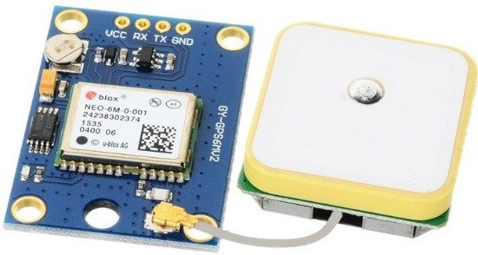

Fig .6. GPS module

The output from the GPS sensor module is in the NMEA (National Marine Electronics Association) string format. It outputs in serial over the Tx port at a standard 9600 Baud rate. In this NMEA string output from the GPS device, various factors like longitude, latitude, altitude, time, etc. are separated by commas. Each string has a "$" at the beginning and a carriage return/line feed at the conclusion.

**E.g.**

# GPGGA,184237,000,1829,9639, N,07347,6174,E,1,05,2.1,607.1,M,- 64.7,M,,0000*7D

# GPGSA 3,1,11,15,47,133,46,25,44,226,45,18,37,2 38,45,26,34,087,40*72 GPGSV 3,1,11,15,47,133,46,25,44,226,45,18,37,2

# 49,05,26,034,*7F $GPGSV,3,2,11,12,27,184,45,24,02,164,26,29,58,

# $GPGSV,3,3,11,21,25, 303,,02,11,071,,22,01,228,*40

# $GPRMC,184237.00, A,1829.9639, N,07347.6174, E,0.05, 180.19, 230514,,,A*64

# GSM MODULE

A computer or any other processor can interact over a network using a GSM modem, which can be either a mobile phone or a modem device. A GSM modem requires a SIM card to operate, and it uses a network range that the network provider controls. has signed up for. It can be linked to a computer via Bluetooth, USB, or serial. A normal GSM mobile phone can work as a GSM modem when connected to a computer's serial port or USB port using the right cable and software driver. Typically, a GSM modem is preferred over a GSM cell phone 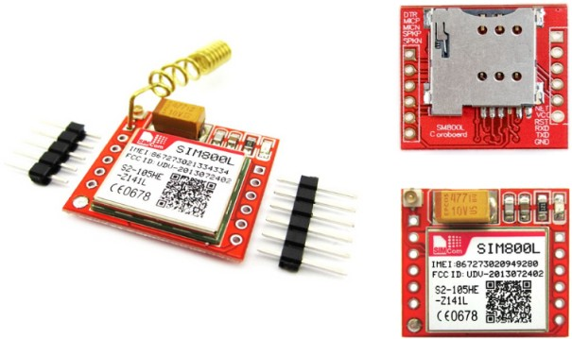The GSM modem can be used for a wide range of applications, including transaction terminals, supply chain management, security applications, weather sensors, and remote data logging via the GPRS protocol.

Fig.7.GSM module

It requires a SIM (Subscriber Identity Module) card, just like mobile phones, to connect to the network and begin talking. They also have IMEI (International Mobile Equipment Identity) codes for identification, which are comparable to those on mobile devices. A GSM/GPRS MODEM is capable of carrying out the following tasks:

1. Use a SIM to receive, transmit, or delete SMS communications.

2. Browse, add, and find the SIM's phonebook entries. 3. Place, accept, or decline a voice contact. The MODEM needs AT instructions to communicate with the processor or controller, which is done via serial transmission. These instructions are issued by the processor/controller. In response to an instruction, the MODEM sends back a response. The processor, controller, or computer can send any of the AT instructions that the MODEM supports in order to communicate with the GSM and GPRS cellular networks.

# 4.2 Hardware implementation

Fig.7.hardware kit

Arduino, a GPS module, a GSM module, RF Tx and Rx, a power source board, a battery, and DC motors make up the system

**4.3 EXPERIMENTAL RESULTS**

In this diagram, the link will show the locations on google maps and gives accurate location indicating latitudes and longitudes for location tracking and identification of Indian borders.

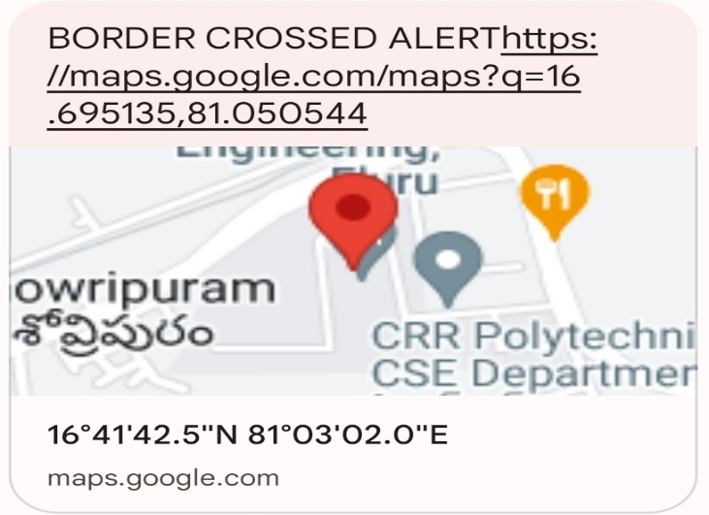

FIG.8. Crossed alert message view.

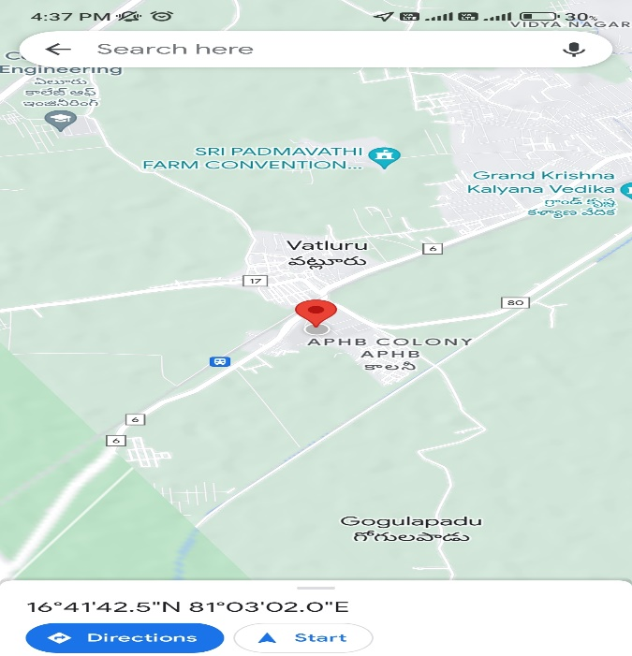

Fig.9. Location

In this diagram, the link will show the locations on google maps and gives accurate location indicating latitudes and longitudes for location tracking and identification of Indian borders.

**5. Conclusion**

With the help of this application, fishermen can quickly locate the borders of their neighbours' countries, preventing them from entering from their territory, saving their lives, upholding friendly relations with their neighbours, and protecting the privacy of the boat or ship's information.

**6. References**

1. K. Suresh Kumar et. Al, “Design of low-cost maritime boundary identification device using
2. K. Suresh Kumar et. Al, “Design of low-cost maritime boundary identification device using

GPS”, International Journal of Engineering Science and Technology Vol. 2(9), 2010,

4665-4672.

1. M. Sivaramaganesh, International journal of innovative research in electrical, electronics, instrumentation and control engineering vol. 2, issue 3, March 2014

<http://www.thehindu.com/multimedia/dynami> c/01689/TH_

09_GROWING_rev 1689954g.

1. S. Mani Sunder, “Deepsea fishermen patrol system for coastal intruder positioning” Scientific Engineering and Technology (ISSN: 1581) Volume 2 Issue 3, PP: 129
2. P. Satheesh, “Maritime Border Refuge System [MBR]”, National Conference on Emerging Trends in Computer, Communication & Instrumentation in Strength Security.
3. GPS-based vessel position monitoring and display system. IEEE Aerospace and Electronic Systems

Magazine. 1990.

1. [www.falcomusa.com.](http://www.falcomusa.com/)
2. A. Michalski, J C zajewski. The accuracy of the global positioning systems. IEEE Instrumentation &

Measurement Magazine. 2004; 7(1): 56-60.

1. <http://earth.google.com/>
2. Design and Implementation of GPS- Based Border alert And Identification System for Fishermen By P. Deepak, R.P. Shrianbarasu In First International Conference On Nexgen Technologies On 5th & 6th January 2018.
3. Embedded System for Sea Buoy to Locate, Detect and Collect Data About Marine Systems by Nivetha P, Thamarai Selvi D In International Journal of Advanced Research in Electrical, Electronics And Instrumentation Engineering Vol. 4, Issue 4, April 2015.
4. K. Suresh Kumar et. Al, “Design of low-cost maritime boundary identification device using

GPS”, International Journal of Engineering Science and Technology Vol. 2(9), 2010,

4665-4672.

1. M. Sivaramaganesh, International journal of innovative research in electrical, electronics, instrumentation and control engineering vol. 2, issue 3, March 2014

<http://www.thehindu.com/multimedia/dynami> c/01689/TH_

09_GROWING_rev 1689954g.

1. S. Mani Sunder, “Deepsea fishermen patrol system for coastal intruder positioning” Scientific Engineering and Technology (ISSN: 1581) Volume 2 Issue 3, PP: 129
2. P. Satheesh, “Maritime Border Refuge System [MBR]”, National Conference on Emerging Trends in Computer, Communication & Instrumentation in Strength Security.
3. GPS-based vessel position monitoring and display system. IEEE Aerospace and Electronic Systems

Magazine. 1990.

1. [www.falcomusa.com.](http://www.falcomusa.com/)
2. A. Michalski, J C zajewski. The accuracy of the global positioning systems. IEEE Instrumentation &

Measurement Magazine. 2004; 7(1): 56-60.

1. <http://earth.google.com/>
2. Design and Implementation of GPS- Based Border alert And Identification System for Fishermen By P. Deepak, R.P. Shrianbarasu In First International Conference On Nexgen Technologies On 5th & 6th January 2018.