**Question 1: Singleton Pattern**

Implement the Singleton design pattern to ensure only one instance of a class exists throughout the application.

**Code:**

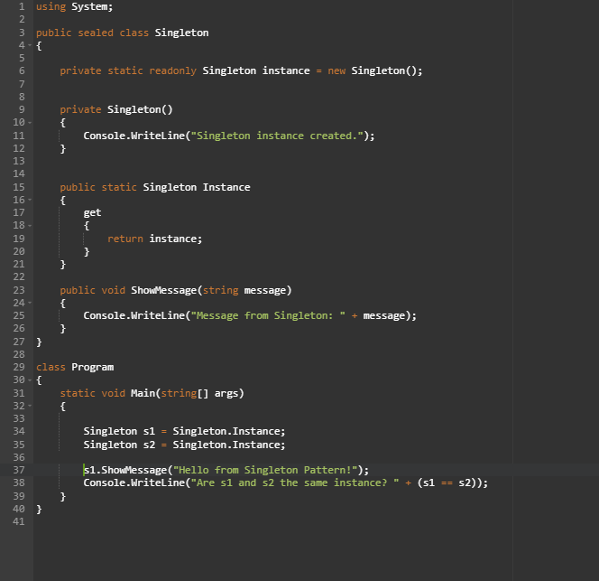

**Output:**

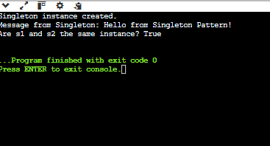

**Question 2: Factory Method Pattern**

Implement the Factory Method pattern to create objects without specifying the exact class.

**Code:**

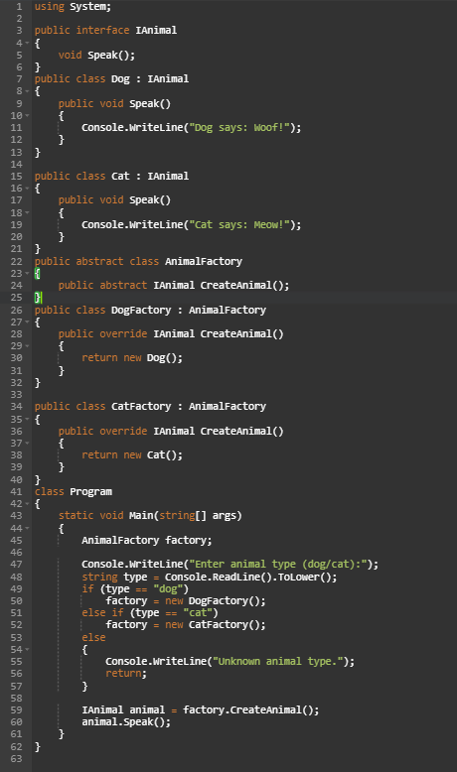

**Output:**

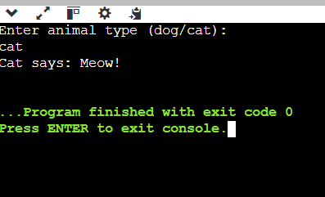

**Question 3: E-commerce Search Function**

Write a search function for an e-commerce platform to find a product by name

**Code:**

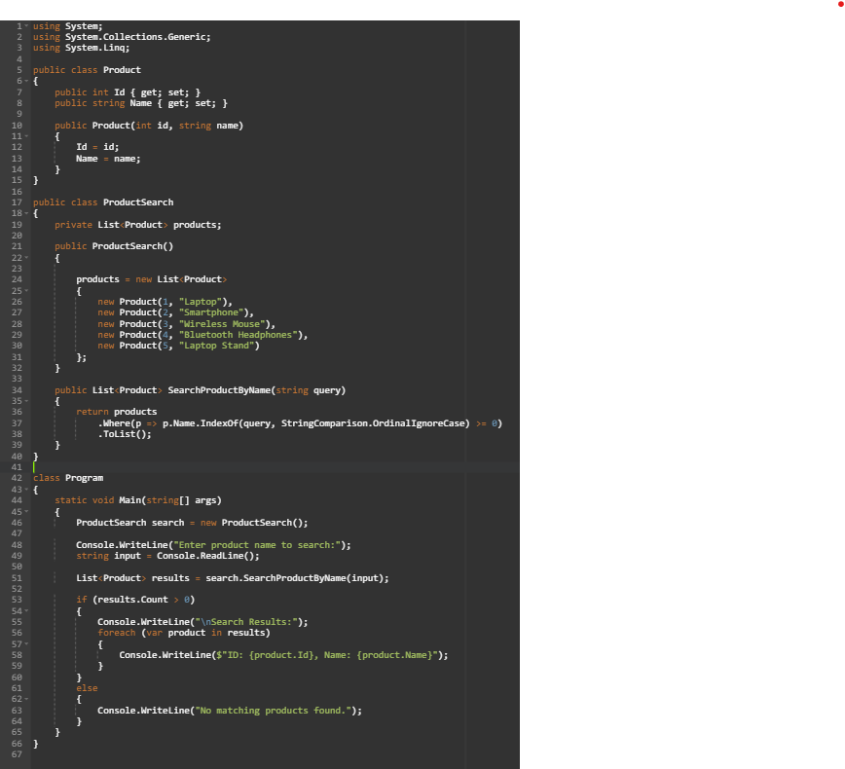

**Output:**

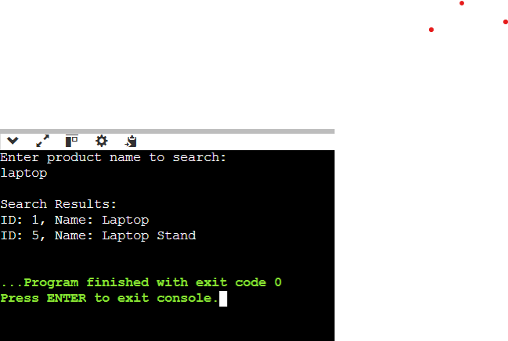

**Question 4: Financial Forecasting**

Implement a simple function that forecasts next month's revenue based on previous months' average

**Code:**

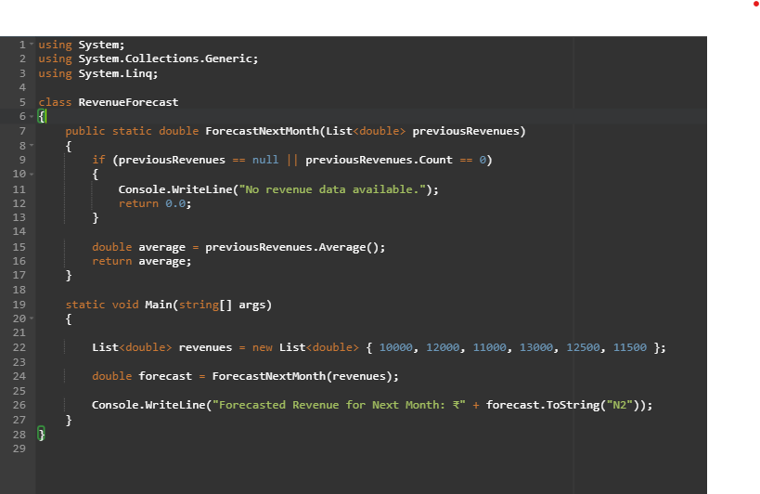

**Output:**

