**LAB 1: Understanding ORM**

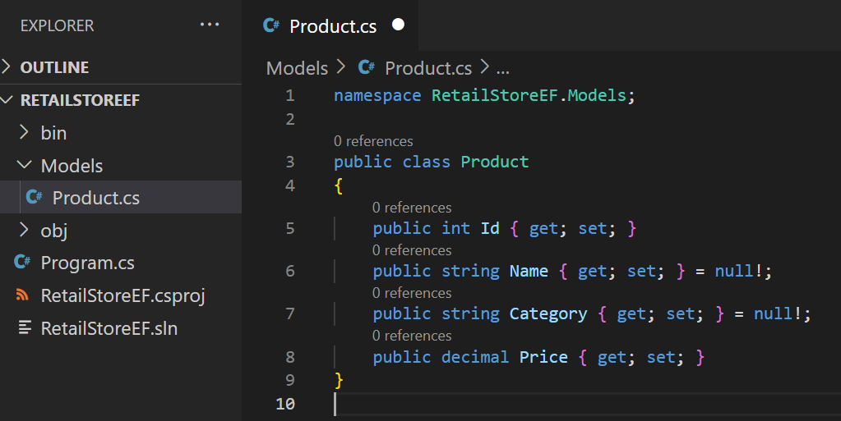

**LAB 2: Create DbContext**

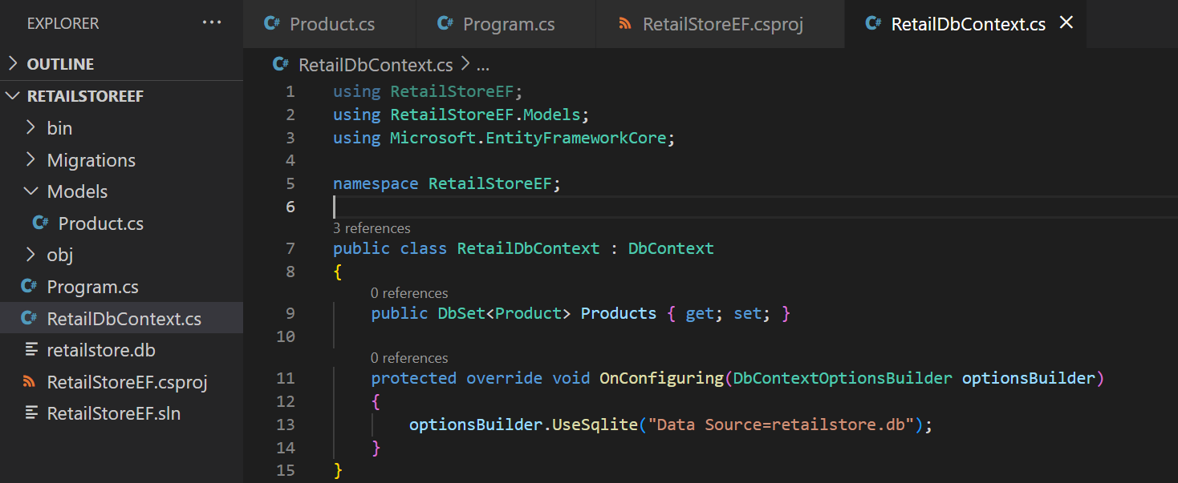

**LAB 3: Create Migration and Database**

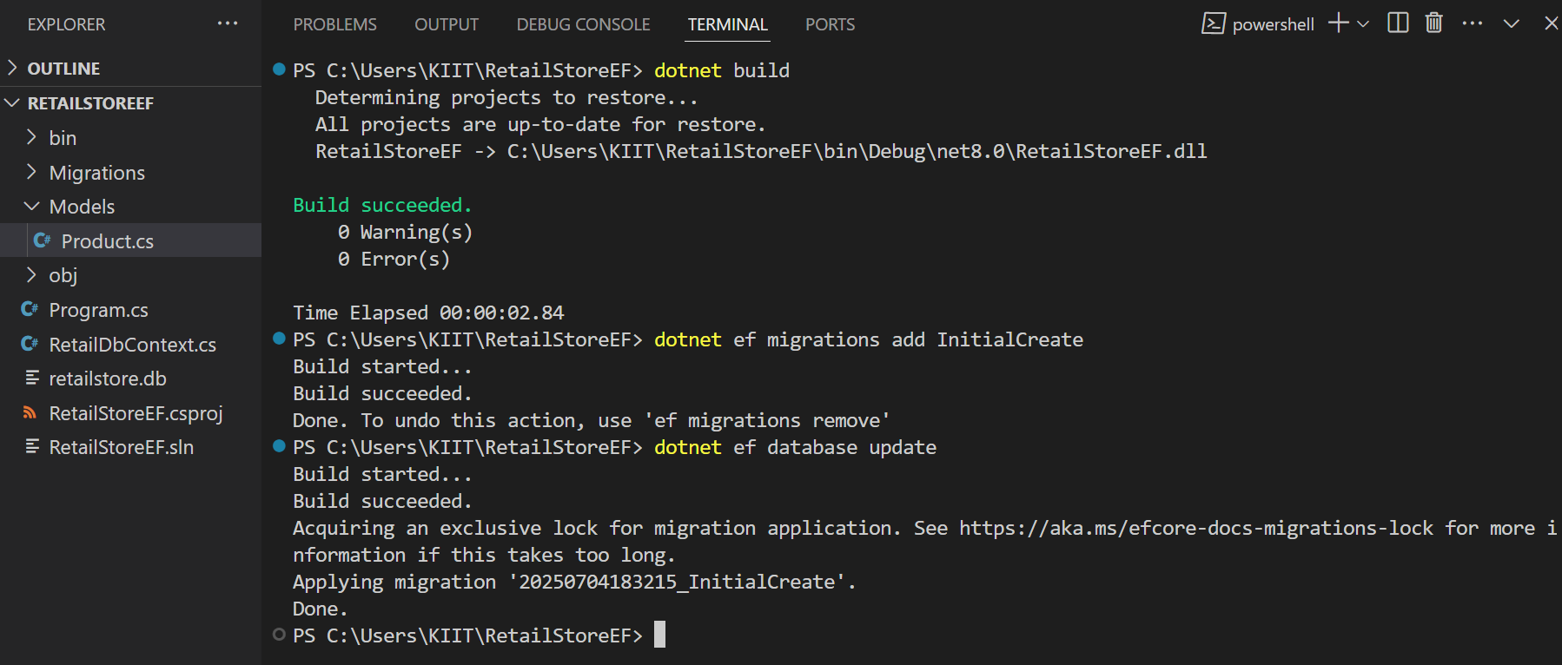

****LAB 4: Insert Initial Data****

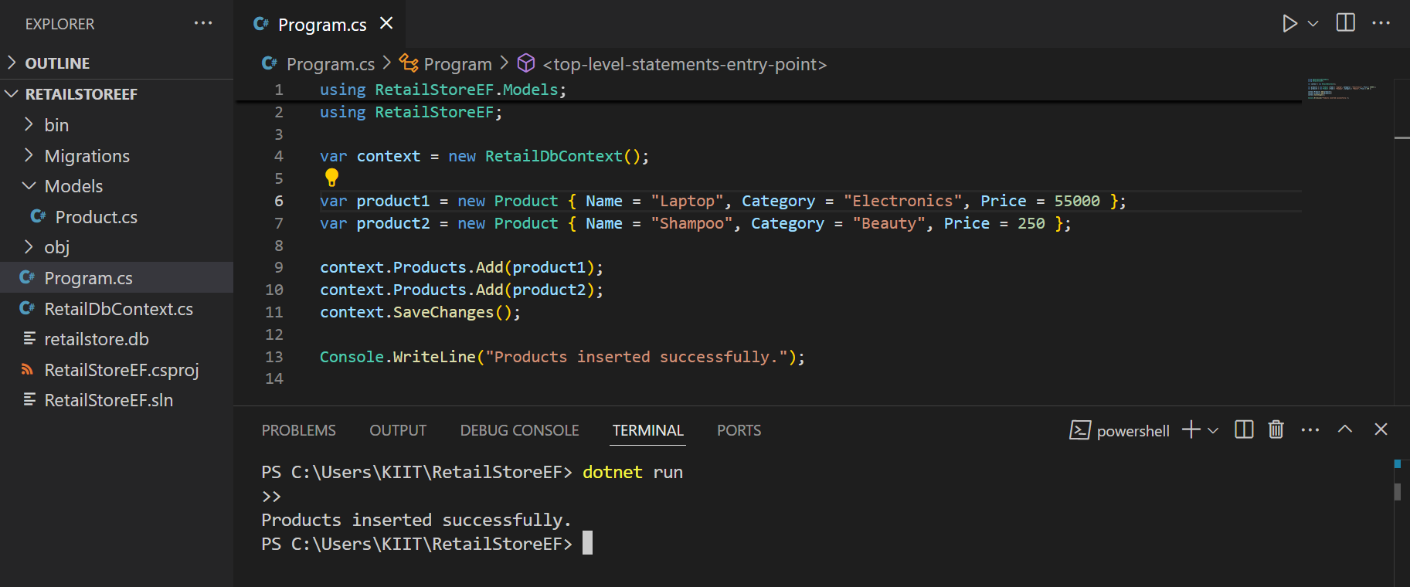

**LAB 5: Retrieve Data**

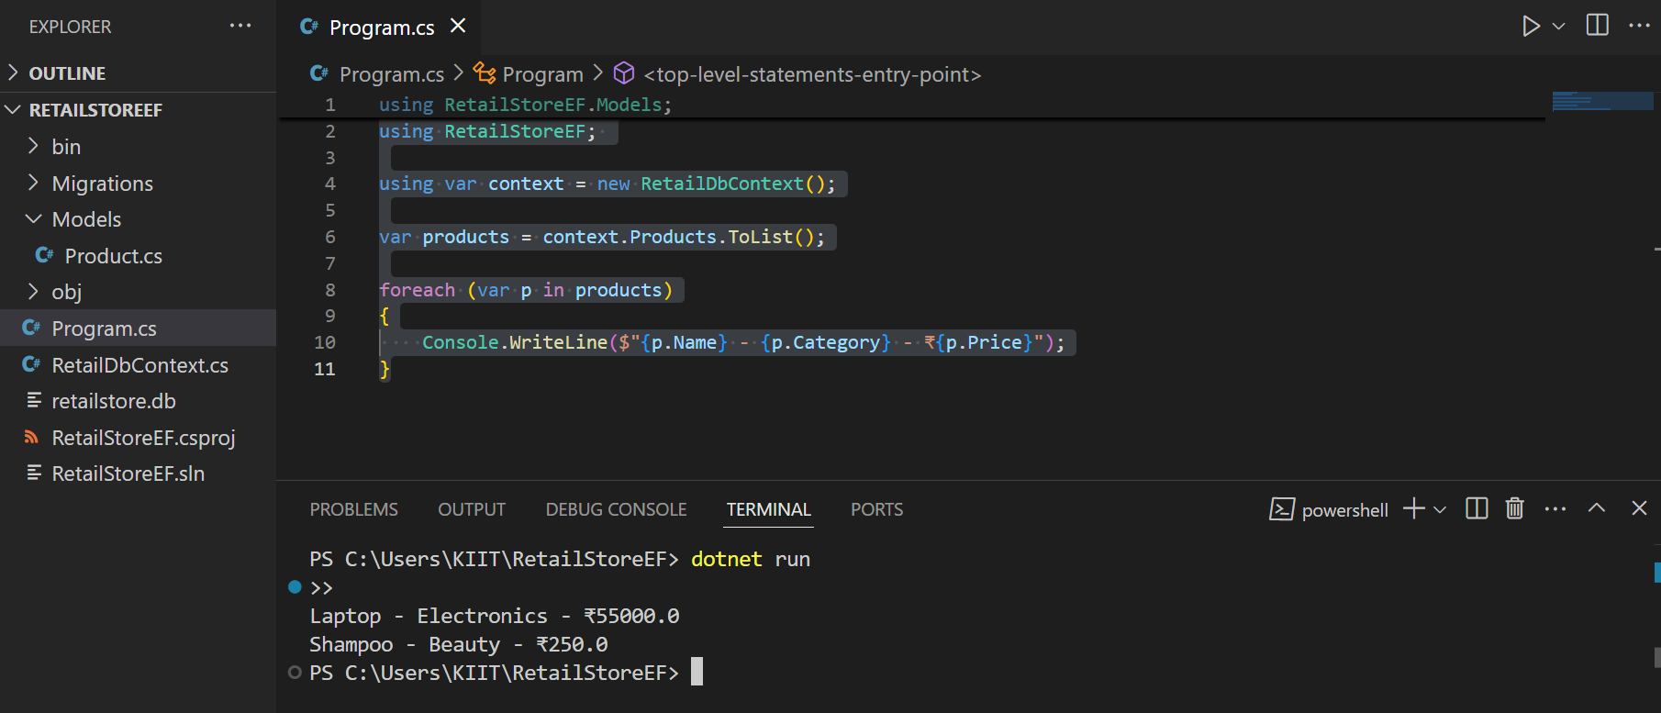

**LAB 6: Update & Delete**

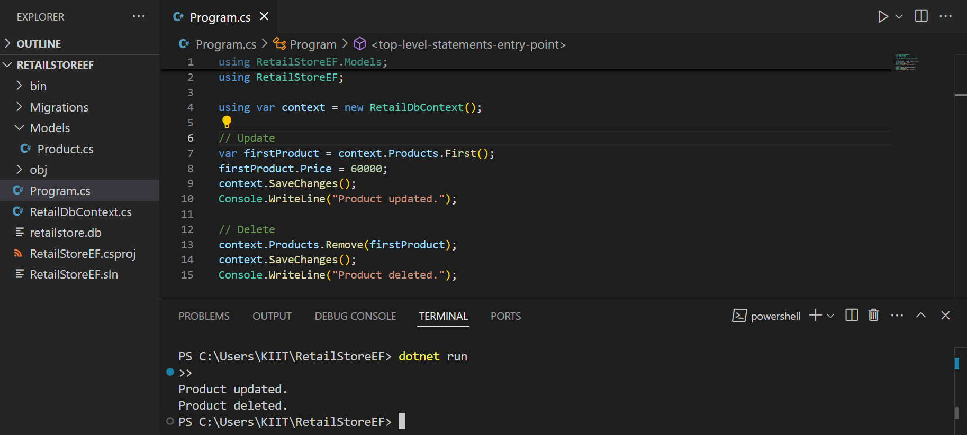

**LAB 7: LINQ Query**

