**Question 1:**

Design a Web API for managing product inventory. Implement endpoints to get all products, add a new product, and fetch product details by ID.

**Code:**

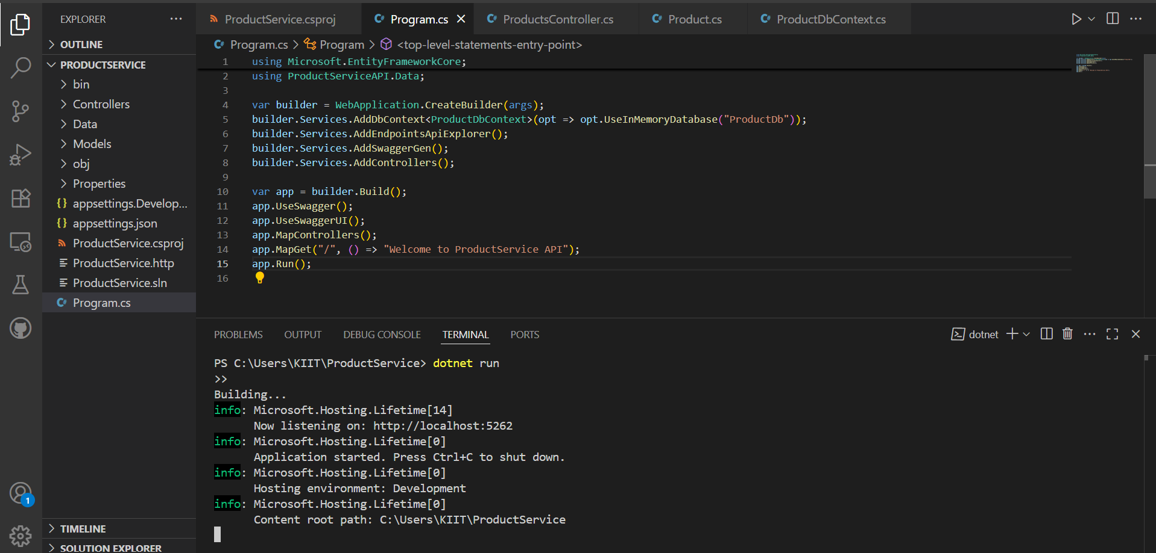

**Output:**

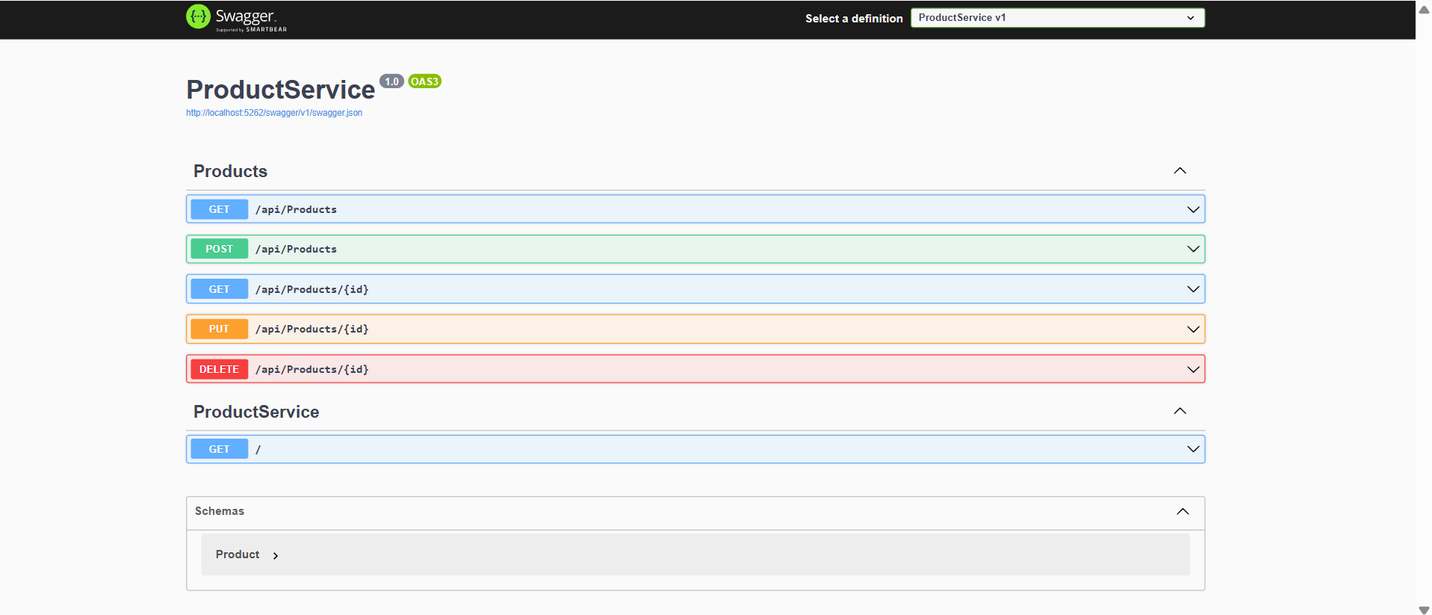

**Question 2:**

Create a Web API to manage customer data. Implement endpoints to get customer list, add a new customer, and get customer by email or ID.

**Code:**

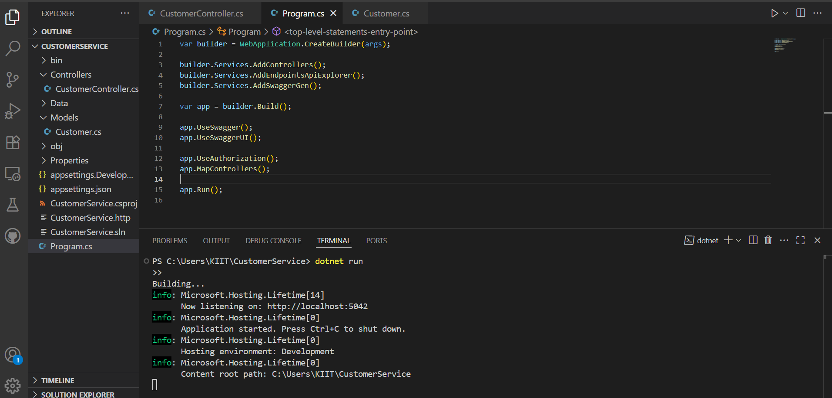

**Output:**

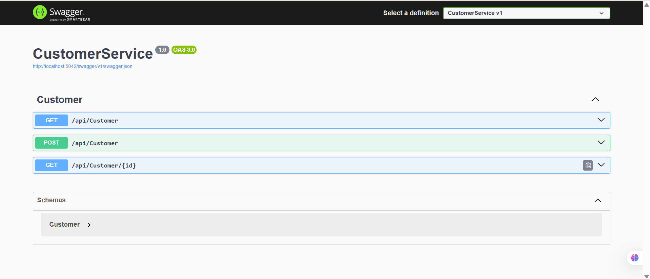

**Question 3:**

Build a Web API to process orders. Provide endpoints to place a new order, get all orders, and get order status by ID.

**Code:**

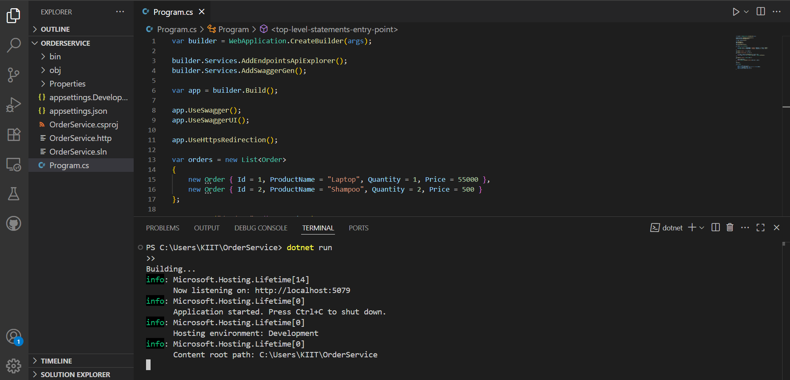

**Output:**

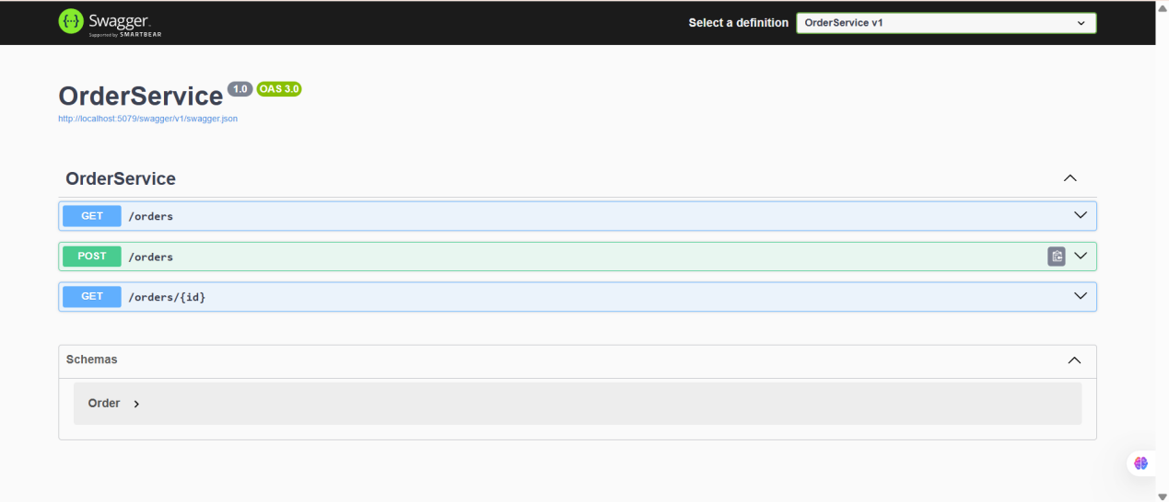

**Question 4:**

Develop a Web API to handle payment transactions. Implement endpoints to make a payment and fetch payment status.

**Code:**

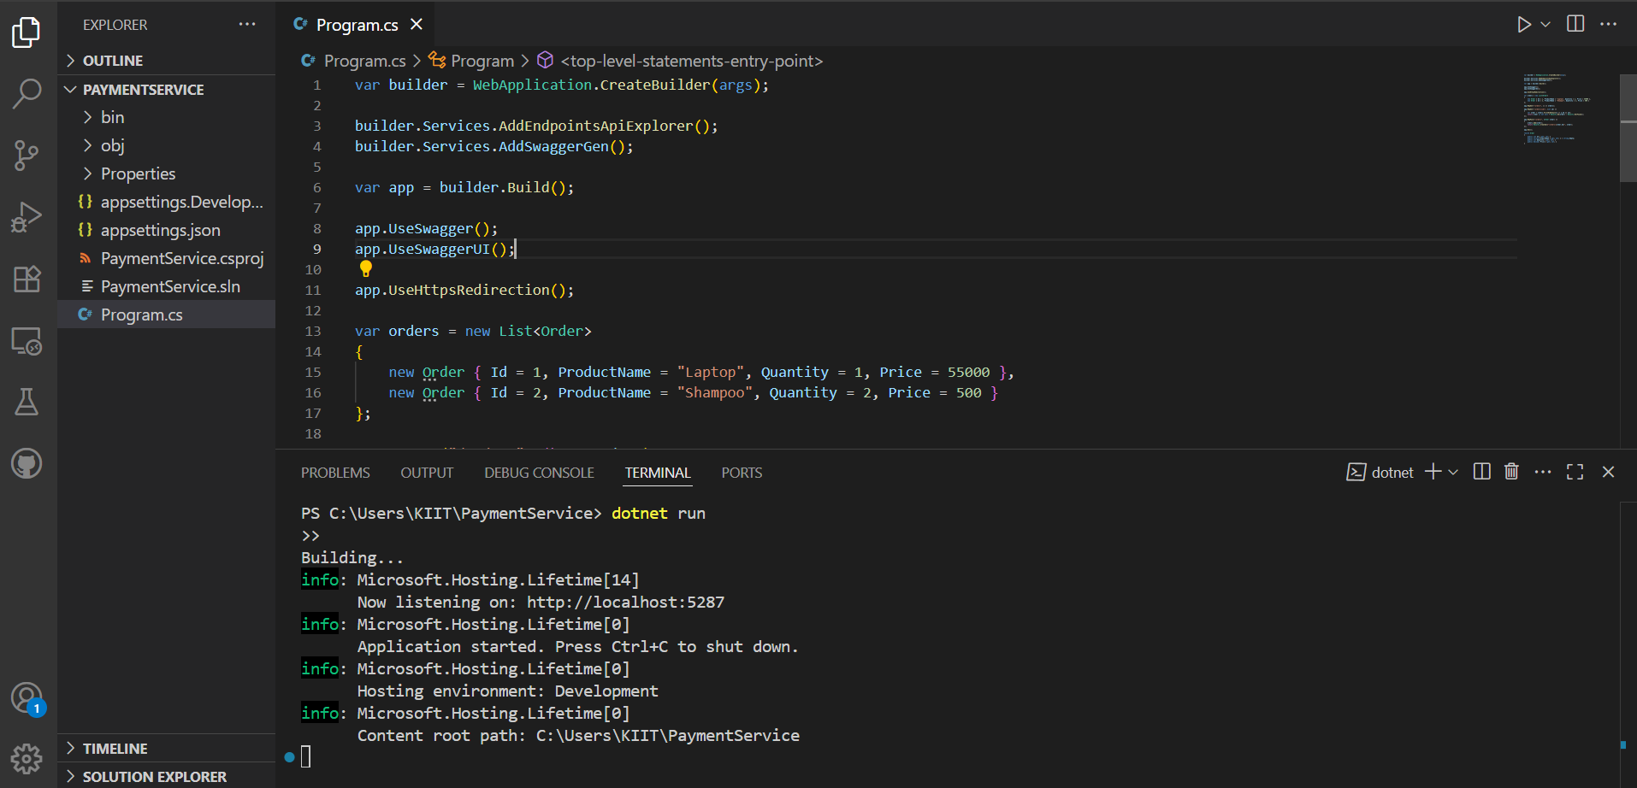

**Output:**

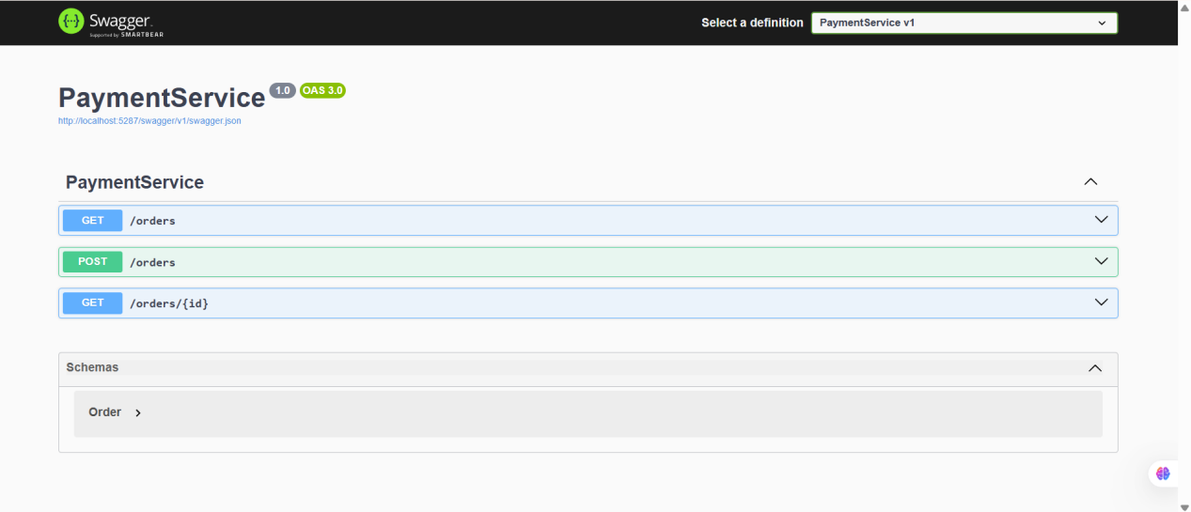

**Question 5:**

Design an Admin API to manage system administrators. Provide endpoints to get admin profile and update admin roles.

**Code:**

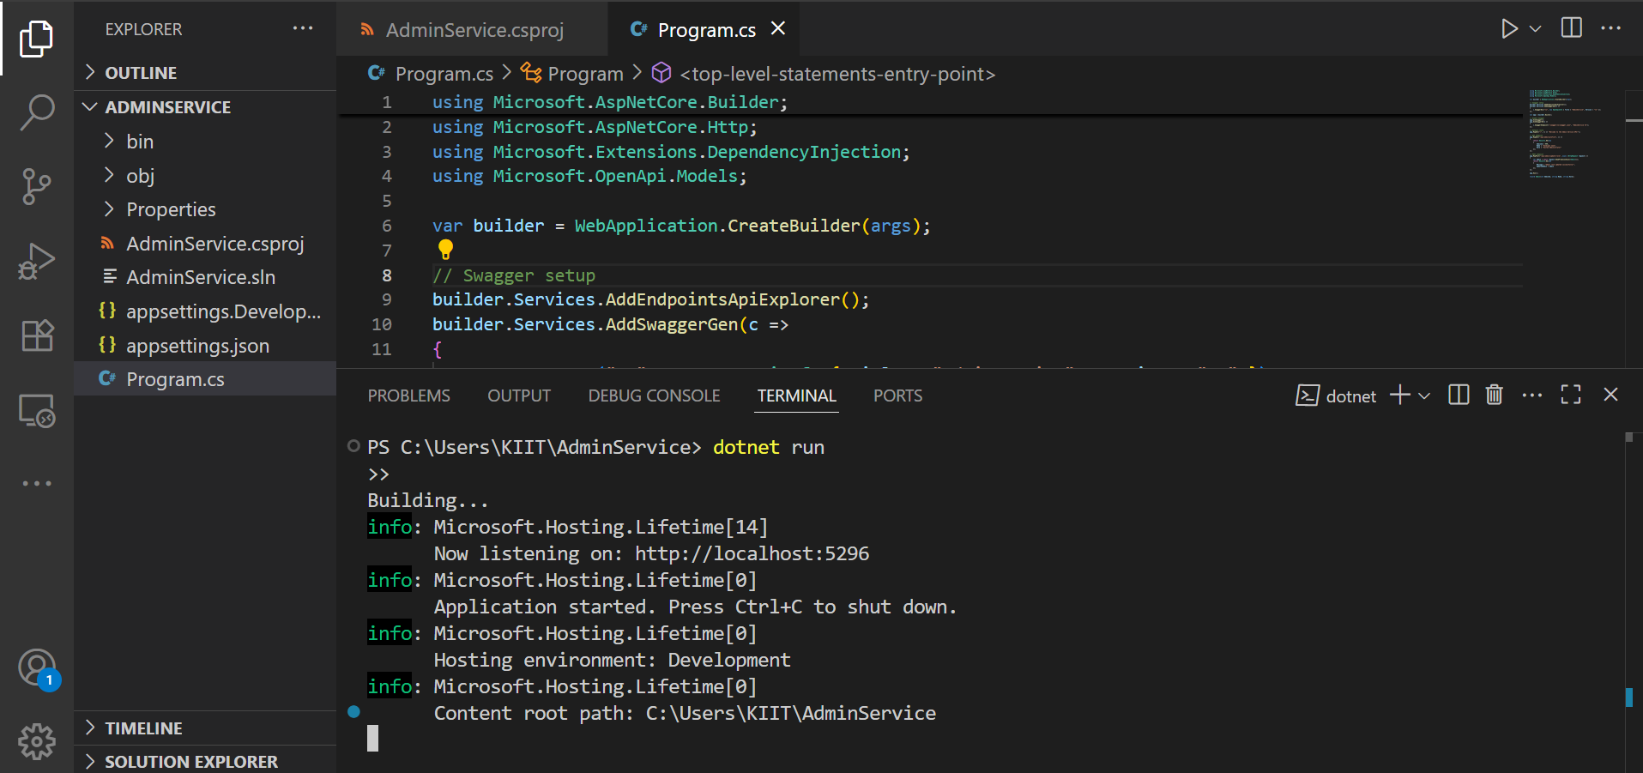

**Output:**

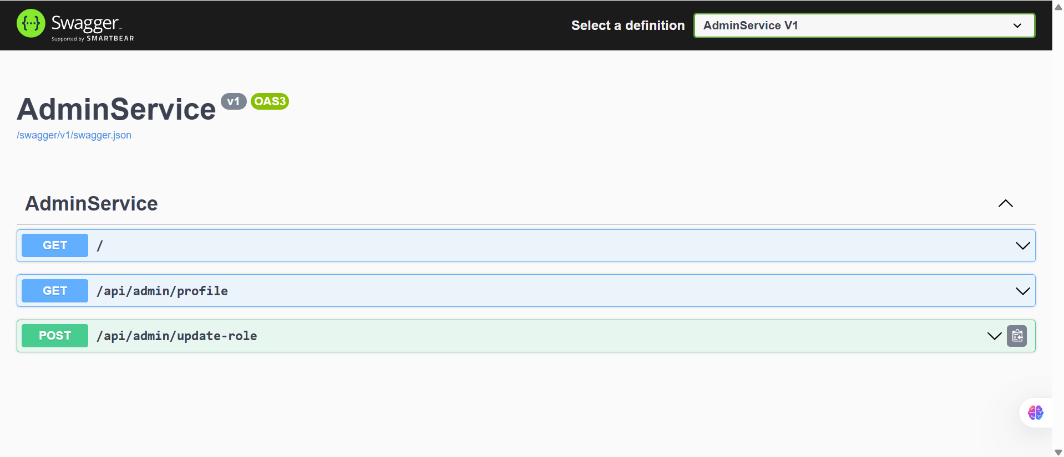

**Question: 6**

Implement JWT Authentication in ASP.NET Core Web API.

**Code:**

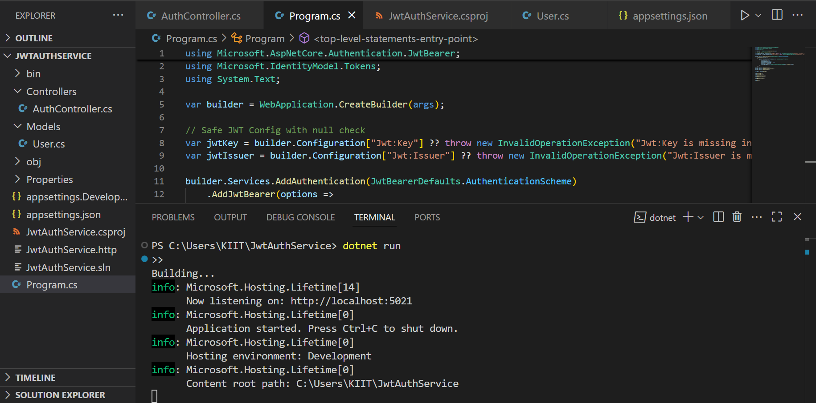

**Output:**

