Apache JMeter Installation:
Step 1: Verify Java Installation
Before installing JMeter, ensure that Java (JDK 8 or later) is installed on your system.
- Open Command Prompt / PowerShell / Terminal
Run the following command: java -version
- If Java is not installed, download and install from the links below:
Oracle JDK: https://www.oracle.com/java/technologies/javase-downloads.html
- After installation, open command prompt verify again using: java -version
Step 2: Download Apache JMeter
a. Go to the official JMeter download page:
https://jmeter.apache.org/download_jmeter.cgi
- Under Binaries, download the latest .zip file (for Windows) or .tgz file (for Linux/macOS).
- Example file name: apache-jmeter-5.6.3.zip
Step 3: Extract JMeter
a. Extract the downloaded file to a preferred location, such as:
C:\Users\<your_username>\jmeter\apache-jmeter-5.6.3
Step 4: Launch JMeter
- Open the terminal and open the bin folder inside the extracted JMeter directory. Run the following command: jmeter.bat

Step 5: Run JMeter in Non-GUI Mode
a. For load testing or CI/CD use, you can run JMeter without the GUI:
jmeter -n -t testplan.jmx -l results.jtl -e -o report_folder
jmeter: Path of your jmeter file
-n → Non-GUI mode
-t → Test plan file path {{path of your past plan}}
-l → Log results file {{path of your file}}
-e → Generate report
-o → Output report directory {{path of your report folder}}
Step 6: Install JMeter Plugins Manager
a. Download the Plugins Manager JAR from: https://jmeter-plugins.org/install/Install/
b. Copy the downloaded file JMeterPluginsManager.jar to: <JMETER_HOME>\lib\ext
Example: C:\Users\<your_username>\jmeter\apache-jmeter-5.6.3\lib\ext
c. Restart JMeter and Go to Options → Plugins Manager
d. If the Plugins Manager window appears, the installation is successful
Step 7: Install Plugins through Plugins manager in the JMeter.
a. Go to Options → Plugins Manager
- Select plugins under Available Plugins. Select the following plugins.
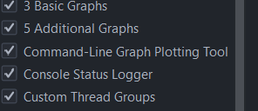
- Click Apply Changes and Restart JMeter.

Step8: Install faker and snake jars To generate fake Names
- Use the following link to download faker jar: https://mvnrepository.com/artifact/com.github.javafaker/javafaker/1.0.2
- Use the following link to download snakeyaml jar( snakeyaml-2.5.jar )
https://repo1.maven.org/maven2/org/yaml/snakeyaml/2.5/
- Copy these two jar files in to in both \lib\ext and \lib\ folders in jmeter.
example : C:\Users\<your_username>\jmeter\apache-jmeter-5.6.3\lib\ext
: C:\Users\<your_username>\jmeter\apache-jmeter-5.6.3\lib\

Payment- Processing load test plan explanation:

After opening the test plan file, navigate to Test plan Variables and configure the following parameters based on your server:
baseUrl | {{Name of the server}}
existing_businessMerchant_1 | {{Enter a existing business Merchant in the system}}
existing_businessMerchant_2 | {{Enter a existing business Merchant in the system}}
existing_businessMerchant_3 | {{Enter a existing business Merchant in the system}}
existing_businessMerchant_4 | {{Enter a existing business Merchant in the system}}
existing_businessMerchant_5 | {{Enter a existing business Merchant in the system}}
existing_businessMerchant_6 | {{Enter a existing business Merchant in the system}}
existing_individualMerchant_1 | {{Enter a existing individual Merchant in the System}}
existing_individualMerchant_2 | {{Enter a existing individual Merchant in the System}}
existing_individualMerchant_3 | {{Enter a existing individual Merchant in the System}}
existing_individualMerchant_4 | {{Enter a existing individual Merchant in the System}}
existing_individualMerchant_5 | {{Enter a existing individual Merchant in the System}}
existing_individualMerchant_6 | {{Enter a existing individual Merchant in the System}}
credhit_hit_once_businessMerchant | {{ Enter a New business merchant Name}}
debit_hit_once_IndividualMerchant | {{Enter a New Individual Merchant Name }}
accessId_1 | {{Enter a access_id of member 1}}
accessKey_1 | {{Enter a access_key of member 1}}
accessSecret_1 | {{Enter a secrert_key of member 1}}
accountId_1 | {{Enter a account_id of member 1}}
accountNumber_1 | {{Enter a access_id of member 1}}
accessId_2
accessKey_2
accessSecret_2
accountId_2
accountNumber_2

Like this structure you want to create user defined variables for the Member accounts.
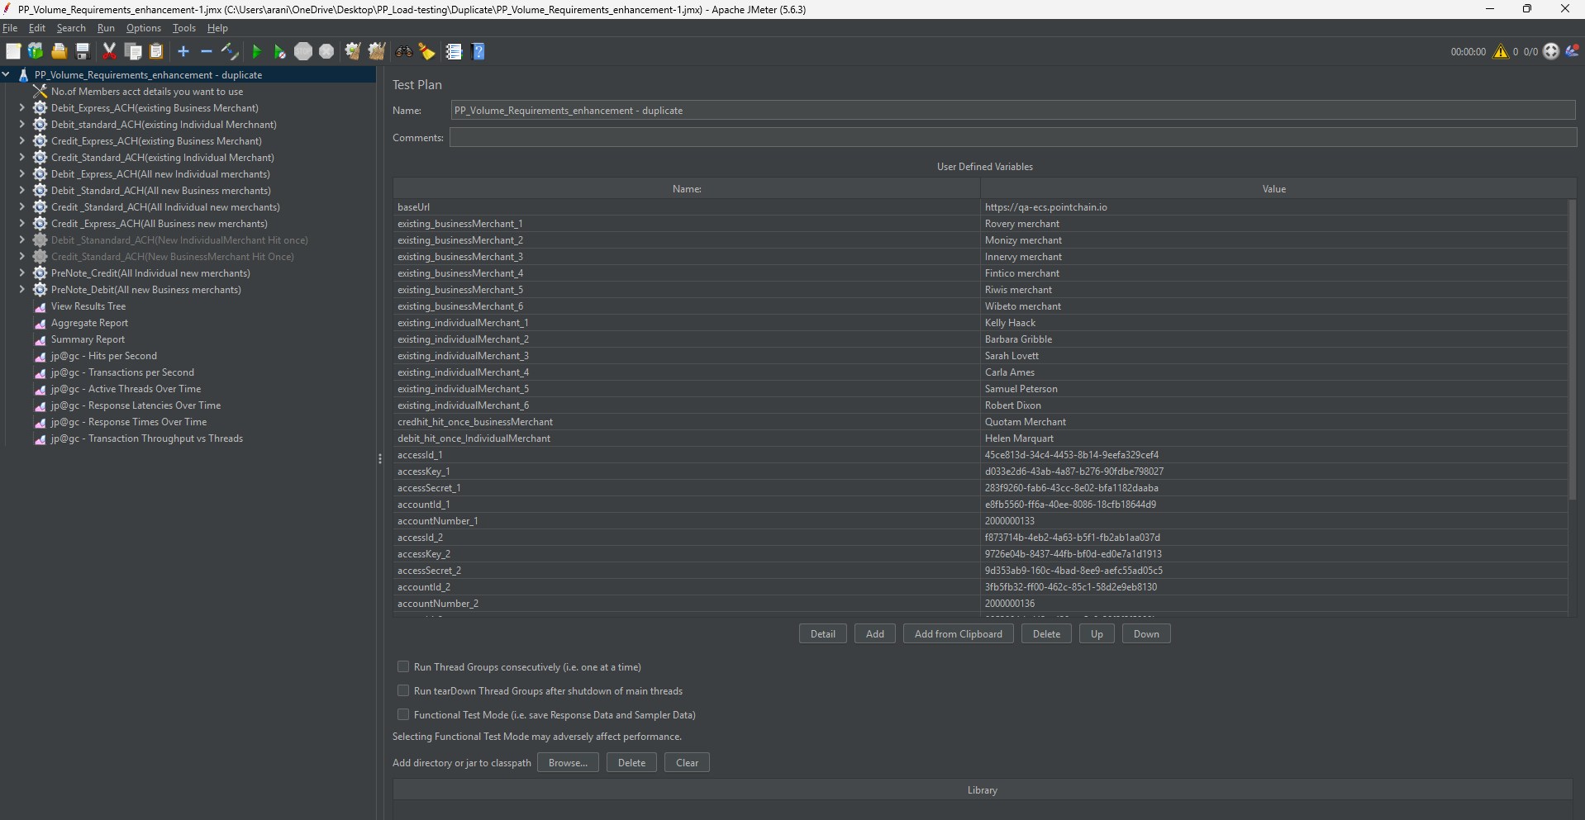

- In the test plan, you will find a User Defined Variable called:
“No. of Member Account Details to Use”.
This variable specifies how many member accounts should be used at a time during the test execution.
Example:
- Suppose you have entered 5 member account details in your test plan variables.
- If you want to process transactions for only one member at a time, set “No. of Member Account Details to Use” = 1.
  - In this case, the system will pick only the member account details ending with “_1”
- If you want to use all 5 members at once, set the value to 5.
  - The system will then process all 5 member accounts together.
- And also specify the merchants also

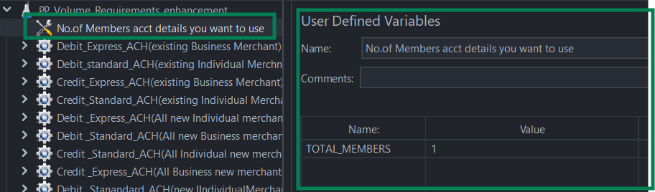
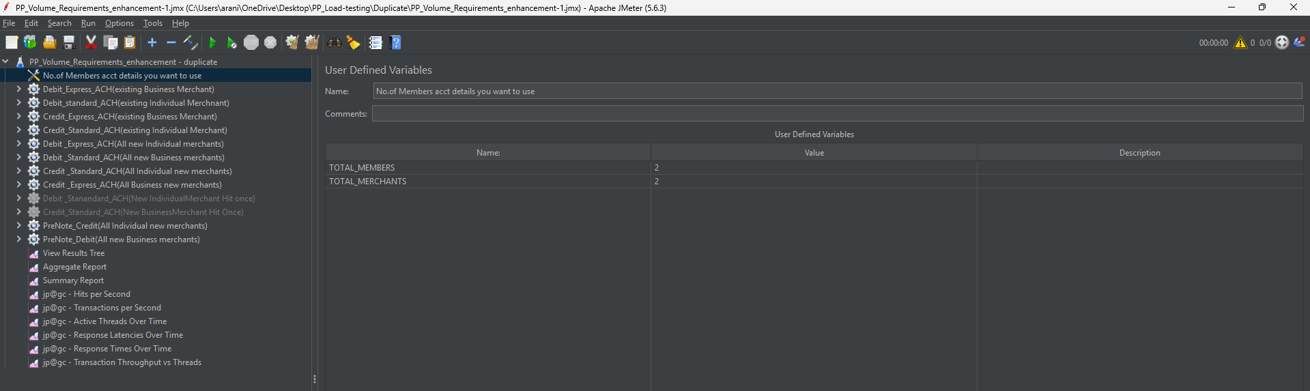
- In the payment processing plan, currently, we have 12 threads.
- Credit API for New Individual Merchant (All new merchants):
  - Should create a new INDIVIDUAL merchant for every CREDIT request
- Credit API for New Business Merchant (All new merchants):
  - Should create a new BUSINESS merchant for every CREDIT request
- Credit API for Exiting Business Merchant:
  - No onboarding should happen for any CREDIT request as we are hitting this thread with a registered BUSINESS merchant.
- Credit API for Exiting Individual Merchant:
  - No onboarding should happen for any CREDIT request as we are hitting this thread with a registered INDIVIDUAL merchant.
- Debit API for New Individual Merchant (All new merchants):
  - Should create a new INDIVIDUAL merchant for every DEBIT request
- Debit API for New Business Merchant (All new merchants):
  - Should create a new BUSINESS merchant for every DEBIT request
- Debit API for Exiting Business Merchant:
  - No onboarding should happen for any DEBIT request as we are hitting this thread with a registered BUSINESS merchant.
- Debit API for Exiting Individual Merchant:
  - No onboarding should happen for any DEBIT request as we are hitting this thread with a registered INDIVIDUAL merchant.
- Credit API for New Merchant (merchant onboarding on first hit):
  - Only one onboarding should happen for the first CREDIT request if we are hitting this thread with same counterparty info, rest of the requests should use the first onboarded INDIVIDUAL merchant.
- Debit API for New Merchant (merchant onboarding on first hit)
  - Only one onboarding should happen for the first DEBIT request if we are hitting this thread with same counterparty info, rest of the requests should use the first onboarded INDIVIDUAL merchant.
- Prenote Credit API ( All new Business Merchants)
a. Should create a new BUSINESS merchant for every CREDIT request.
12. Prenote Credit API ( All new Individual Merchants)
a. Should create a new INDIVIDUAL merchant for every DEBIT request.

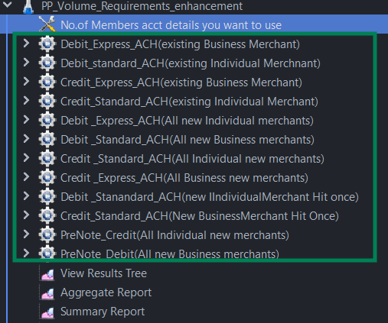

- Click on the each thread group, and it opens a Thread group page. Here, the user needs to set Thread properties such as the “number of threads”, “ramp-up period”, and “Loop Count”.

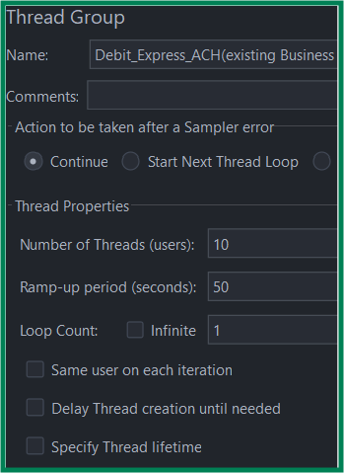

- After entering the values in each thread group, save the test plan and then run the JMeter plan.
- This will start all the threads parallelly. You can view the results in the View Results Tree, Aggregate Report, and Summary Report listeners. once the execution is complete.

