**eStockBroker**

**Stock Market Analysis and Trading Software**

**(Class and Collaboration Diagram)**



**Information System Design Project**

***Prepared By  
Group 5-***

**Arannya Monzur(1005088)**

**Kamrul Islam Shohan(1005077)**

**Asaduzzaman Noor Pavel(1005063)**

**Lais Intesham(1005084)**

**Md. Mazharul Islam(1005062)**

**Table of contents:**

1. Subsystems

2. Collaboration and Class Diagrams(sequentially)

**Subsystems:** There are four subsystems, viz-

1. User Profile Management  
2. Real-Time Stock Listing

3. Stock Analysis System

4. Transaction Handling System

# User profile system

## **Use-case Glossary:**

|  |  |  |  |  |
| --- | --- | --- | --- | --- |
| Use-Case ID | Name | Description | Participant actors and roles | |
| 1.1 | Sign-up/login | Signing up & logging in into an account | TRD signs up and logs in into his/her account, BH gives interface | |
| 1.2 | Quote stock | Displays buy price, sell price and relevant analyses of selected stock after displaying all stocks | TRD clicks on the company name to see the price per share, BH provides listing | |
| 1.3 | View owned stock | View stocks bought and held by user | TRD views his owned securities, BH stores the info | |
| 1.4 | Buy/Sell stock | Buy or sell stock in a company | TRD buys or sells stocks, BH receives transaction |
| 1.5 | View dividend | Show profits paid on owned stock | TRD views the profit distributed on held securities, BH provides info | |

# Real Time Stock Listing

## **Use-case Glossary:**

|  |  |  |  |  |
| --- | --- | --- | --- | --- |
| Use-Case ID | Name | Description | Participant actors and roles | |
| 2.1 | List stock | Generate list of all companies trading in the SE | BH generates the list with SE database | |
| 2.2 | Update price | Updates the bid/sell price and other data of shares | BH updates the list every 30 seconds with SE data | |
| 2.3 | View losers/gainers | Compares current and closing price of previous day to segregate stocks | BH compares saved data of previous day with real-time data of SE | |
| 2.4 | Top-rated stock | Lists the ten shares having the best current EPS rating (earnings-per-share) | BH evaluates EPS from net income divided by number of shares |

# Stock Analysis System

## **Use-case Glossary:**

|  |  |  |  |  |
| --- | --- | --- | --- | --- |
| Use-Case ID | Name | Description | Participant actors and roles | |
| 3.1 | Graphical Analysis | Shows relative performance of a share on a curve | BH plots points on the curve on the basis of historical data | |
| 3.2 | Market Capitalization | Evaluate net worth of a company | BH calculates the share price times number of shares | |
| 3.3 | Market Portfolio | Evaluate monetary weight of a stock versus entire market | BH works out market cap of stock over cap of total market | |
| 3.4 | Earnings-per-share | Evaluate the income generated per share of a company | BH divides net income of a company over a year by number of shares | |
| 3.5 | Average dividend | Evaluate the expected profit paid per stock | BH aggregates dividend paid over time divided by time from historical data |
| 3.6 | P/E Ratio | Evaluate the ratio of buy price to EPS | BH divides the share buy price by its EPS | |

# Transaction Handling System

## **Use-case Glossary:**

|  |  |  |  |
| --- | --- | --- | --- |
| Use-Case ID | Name | Description | Participant actors and roles |
| 4.1 | Buy/Sell receipt | Gives user a unique id as receipt to secure his transactions | TRD buys/sells and BH gives receipt |
| 4.2 | Transaction logging | All transactions of companies and users are logged in server for security reasons | BH logs all actions taken on its server in a database |
| 4.3 | Balance verification | Verification and completion of transaction | BH verifies if amount is correct, then BA verifies if the balance is valid and completes transaction |

Now the class and collaboration diagrams of the aforementioned use cases are given below sequentially in the order that they appear above.

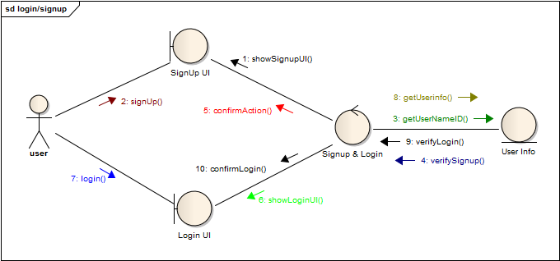

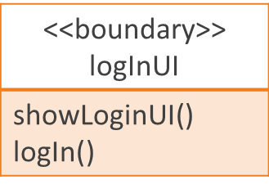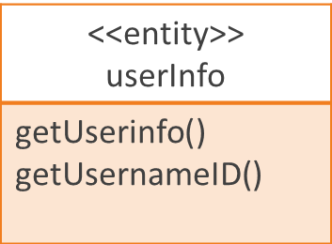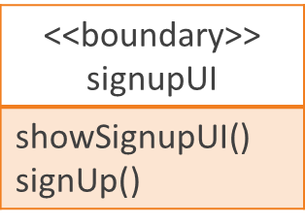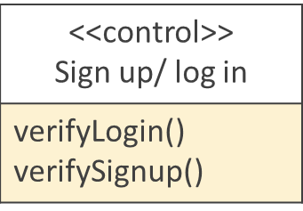

4

 



























































