E-stock broker

An Online Stock Management System

MD Asaduzzaman Noor-1005063

Md. Mazharul Islam – 1005068

Kamrul Islamm – 1005077

Lais Bin Intesham - 1005084

Arannya Monzur – 1005088

Group 5

Table of Contents

Chapter 1. Overview of the Project 4

1.1 Introduction 4

1.2 Project Overview 4

1.2.1 Trader Module 4

1.2.2 Broker Module 4

1.3 Aims of the Project 4

1.4 Motivation of the Project 4

1.5 Report Overview 5

Chapter 2. Existing System Study and Scope Definition 6

2.1 Introduction 6

2.2 Existing System Analysis 6

2.2.1 System’s Operating Mechanism 6

2.2.2 Problems: 6

2.2.3 Automation Status: 7

2.3 Scope of Implementation 7

2.3.1 What we are implementing 7

2.3.2 What we are not implementing 8

2.4 Assessment of Project Worthiness 8

2.4.1 Is the System worth implementing? 8

2.4.2 Benefits and contributions of the system: 8

2.5 Possible roadblocks for your proposed system 9

2.5.1 Problems our implemented system may face 9

2.5.2 How to counter those problems 9

Chapter 3. Requirement Analysis and Feasibility Study 10

3.1 Introduction 10

3.2 Trends Analysis 10

3.2.1 Technology Trends Analysis 10

3.2.2 Business Strategy Analysis 10

3.3 Requirement Analysis 11

3.4 Feasibility Study 12

3.4.1 Operational Feasibility 12

Chapter 4. Proposed System Design 13

4.1 Introduction 13

**User profile system** 14

***Use-case Glossary:*** 14

**Real Time Stock Listing** 20

***Use-case Glossary:*** 20

**Stock Analysis System** 25

***Use-case Glossary:*** 25

**Transaction Handling System** 31

***Use-case Glossary:*** 31

4.5 Data Flow Diagram 35

4.6 Fishbone Diagram 39

4.7 System Design 43

4.7.1 Class Diagram 43

4.7.2 Collaboration Diagrams 52

4.8 Process Design 61

4.8.1 Sequence Diagram 61

4.8.2 State Chart Diagram 72

4.8.3 Activity Diagram 78

Chapter 5. Database Design 82

5.1 Introduction 82

5.2 Overview of the design process 82

5.3 ERD and its Brief Description 82

5.3.1 The ERD at a Glance 82

5.3.2 Anatomizing the ERD 83

5.4 Database Schema 88

5.5 Triggers and Procedures 91

5.5.1 Trigger 91

5.5.2 Procedures 92

Chapter 6. Input and Output Design 93

Chapter 7. Project Phase and Activities 99

7.1 Introduction 99

7.2 Work Schedule & Project Time Analysis 99

7.2.1 Activity Network 101

7.2.2 Activity Timeline 102

7.2.3 Pert Chart 103

7.3 Cost Benefit Analysis 103

7.3.1 Development Cost 103

7.3.2 Operational Cost 104

7.3.3 SWOT Analysis 104

7.3.4 Tangible Benefit of the System 104

7.3.5 Intangible Benefit of the System 104

7.4 Risk Analysis & Management 104

7.4.1 Risk & Risk Type 105

7.4.2 Risk Analysis 106

7.4.3 Risk Planning 106

# Chapter 1. Overview of the Project

## 1.1 Introduction

Six decades into the computer revolution, four decades since the emergence of the microprocessor, and two decades into the rise of internet, software is finally a vital element in the process of automation of systems like business, education, enterprise, and politics. While software is helping us to get rid of tiresome activities, the daily need of people for software is also rising. People now-a-days rely heavily on software and websites to perform their daily tasks. To fulfil this ever growing need software engineers are coming up with revolutionary and essential products all the time. With the course of time demand of software is also rising in our country. With this in mind we have proposed a project named “eStockBroker” for Stock Management System

## 1.2 Project Overview

The main modules are given below

### 1.2.1 Trader Module

This module contains everything having to do with trader, that is, to buy and sell stocks, to see the stocks, quote stocks, see various data about the stocks etc. Is contained in trader module.

### 1.2.2 Broker Module

Broker Module has everything to do with the broker such as analysis of the various histories, graphs, datas and other things

## 1.3 Aims of the Project

Our aim is to provide a common platform for all the communities involved in a stock market. To maximize profit for stock traders as well as the owners of the stocks, that is the company owners and the broker houses is our main aim by making the best interface for them.

## 1.4 Motivation of the Project

In a recent interview Microsoft’s CEO Steve Ballmer stated that “computing will become even more ubiquitous and intelligence will become ambient”. Involvement of computers in our day-today life will grow higher each day. The number of schools in our country is very high as our population is huge. We wish to provide a common platform for all the communities involved in a stock market. To maximize profit for stock traders as well as the owners of the stocks, that is the company owners and the broker houses is our main aim by making the best interface for them.

## 1.5 Report Overview

In our report we have tried to present the whole evolution of design process of our system. We have explored existing systems to analyse them which we have put in the report. The report also contains our requirement analysis that we did in the earlier parts of designing the system. We have also included the feasibility analysis and scope of implementations. For better perception we have provided use case diagrams for each of the subsystems Moreover our report contains sequence diagram, state chart diagram to state the process model of the system. The report also contains our proposed Entity Relation Diagram with each relation elaborated. Database schema is also included here. One of the most important content of our report is full user interface that we have designed for our system.

# Chapter 2. Existing System Study and Scope Definition

## 2.1 Introduction

Before starting developing or designing an information system it is necessary to have a good overview of the existing systems available. It has to be known whether the existing system is automatic or manual, if manual then what the back draws are, what are the need of the users and so on.

## 2.2 Existing System Analysis

### 2.2.1 System’s Operating Mechanism

To study the current systems in school management we have done some field studies that involve interviewing Assistant Headmaster of Viqarunnisa Noon School & College, senior broker of Ideal School & College, traders and brokers of Viqarunnisa Noon School & College, Marie Curie and Ideal School.

We have found that most of the schools in our country don't have automated management system. The school officials and brokers have to maintain the whole school manually which is a cumbersome and tedious acts.

Few of the schools have automated systems. But those systems fail to meet the challenges that the schools face, mostly because of their incompatibility with modern management system and lack of user friendliness.

### 2.2.2 Problems:

With the existing systems the traders, brokers and brokers face a lots of problems. Some are stated below.

Problems Traders face:

* Traders don’t always get the correct routine of classes if there is any sudden change.
* Sometimes they fail to get correct syllabus and schedule for exam.
* Even booklist is hard to find sometimes. Traders misses classes because of not having continuous access to vacation list.

Problems Brokers face:

* They fail to gather correct information about their children in many aspects.
* Sometimes traders lie about their result and guardians have no way to get the correct information.
* Even brokers don’t have direct access to their children’s attendance to make sure about their regularity in class.
* In our present culture of school system, there is a broker-broker meeting tradition, but most of the times these meetings go in vein.

Problems Brokers face:

* Faces problem with their routine.
* Don’t have free access to see the duty roster again and again.
* They have to make a lots of report cards manually.
* Have to keep track of their salaries manually.
* Hard to communicate with brokers.
* Education material distributions are done manually.

### 2.2.3 Automation Status:

There are only a few stokes in our country that have already automated their system.

## 2.3 Scope of Implementation

### 2.3.1 What we are implementing

a. Profile of traders & brokers

b. buy and sell stokes

c. top 20 stock list

### 2.3.2 What we are not implementing

a. total company access

b. officer profile management

c. bank sectors money transaction

## 2.4 Assessment of Project Worthiness

### 2.4.1 Is the System worth implementing?

After studying the existing systems and our proposed solution it is quite evident that our system is worth implementing. Not only the brokers and officials of the school will get benefit but also the traders and their brokers will find solutions too many of their existing problems through this system.

### 2.4.2 Benefits and contributions of the system:

The main objective of our system is to reduce the clumsiness of existing management system. The project aims to make the whole management system as much automated as it is possible. With this system users will get the following benefits:

Benefits for Traders:

1. Easy and constant access to their stocks

2. Getting update of their stock rate.

3. Notifications about unwanted and sudden loss.

Benefits for Brokers:

1. Online office
2. Easy handling of stocks

## 2.5 Possible roadblocks for your proposed system

### 2.5.1 Problems our implemented system may face

1. Installing the system in a particular broker house.The house needs to have LAN/Internet connection.

2. Making brokers and school officials cope with this software may take some time.

3. Regular maintenance of the system can be costly.

### 2.5.2 How to counter those problems

1. Wi-Fi with protected password.

2. Training and sessions.

3. Cloud servers.

4. Having an administrator of the system.

# Chapter 3. Requirement Analysis and Feasibility Study

## 3.1 Introduction

Requirement Analysis and Feasibility Study are one of the most crucial steps in Software Engineering. If the software requirement or demand is not significant then the whole point of designing the software becomes useless. If however the software has the power to meet the demands of the consumers and better the lives of people then it is all worthwhile and the requirement analysis and feasibility study does exactly that, it sorts out the requirements of a software in the community and provides a ground for determining whether the software will be feasible or not, Technically, culturally, operationally and economically. Thus, the requirement analysis and feasibility study provides the platform for designing a demandable software meeting all the requirements of consumers and criterias of feasibility study.

## 3.2 Trends Analysis

Trend Analysis is the practice of collecting information and attempting to spot a pattern or trend, in the information. Although trend analysis is often used to predict future events, it could be used to predict uncertain events in the past or in other words how certain features of the school management software could have been designed or built differently. What new features might be added to the software in the future, how this software will change the management system of schools once introduced are all parts of the Trends analysis.

### 3.2.1 Technology Trends Analysis

The future technology trend of this software might be very broad.

* It might initially be used in desktop computers.
* But might later also be integrated in android phones, iPhones, Blackberry etc.
* And data synchronization within the software between different operating systems and devices might also be integrated as an extra added feature allowing the user to access information in the school management system from anywhere, using any device at any time.

### 3.2.2 Business Strategy Analysis

Depending on the demand of the software in various schools, different short term or long term business strategies might be chosen. If a school wants to update some features in the software the developers might need to be called on a long term basis to alter the design and features. If however the school is fully content with all the features of the software then the payment can be done at once. The price of the software may vary depending on negotiation with different institutions.

## 3.3 Requirement Analysis

Requirement Analysis is done based on the following problems faced by Traders, Brokers and Brokers that exist in Schools:

**Problems Traders Face:**

* Traders don't always get the correct routine of classes if there is any sudden change
* Sometimes they fail to get correct schedule and syllabus for exam.
* Even book list is hard to find sometimes.
* Traders miss classes because of not having continuous access to vacation list.

**Problems Brokers Face:**

* They fail to gather information about their children in many aspects.
* Sometimes traders lie about the result and guardians have no way to get the correct information.
* Even brokers don't have direct access to their children's attendance to make sure about their regularity in class.
* In our present culture of school system, there is a broker-broker meeting tradition, but most of the times these meetings go in vein.

**Problems Brokers Face**

* Faces problems with their routine.
* Don't have free access to see the duty roster again and again.
* They have to make lots of report cards manually.
* Have to keep track of their salaries manually.
* Hard to communicate with brokers.
* Education material distributions are done manually.

## 3.4 Feasibility Study

### 3.4.1 Operational Feasibility

Our proposed system meets the challenge of transforming the manual school management system into an automated process. Most of the schools in our country are manually organized. As a result traders and brokers numerous problems. The main objective of this system is to mitigate these problems faced by these communities.

**Benefits traders will get:**

1. Online buy and selling easily
2. No use of middlemen

**Benefits Brokers will get:**

a) One of the hardest tasks of brokers is to prepare mark sheets and calculate result manually.

To address this problem our system provides the brokers a sub system for making results

with ease and also forward and approve the result when it is necessary.

b) There is a gap between broker and broker community in the prevailing systems. To make a

connection bridge between these two vital communities our system provides a notice

system via which they can communicate with one another.

c) Also our system allows the brokers to make them able to view their routine and duty

roaster when they need.

mobile network.

# Chapter 4. Proposed System Design

## 4.1 Introduction

**eStockBroker**

**Stock Market Analysis and Trading Software**

**(Use Case Analysis)**

**Actors**

The system has three actors, namely:

1. Trader

2. Broker House

3. Stock Exchange

**Actors Glossary**

The actor’s glossary shows the short codes and activity scopes of every actor.

|  |  |  |
| --- | --- | --- |
| **Actor** | **Short-hand** | **Activity scope** |
| Trader | TRD | 1. making and managing user account 2. view stock 3. buy and sell stock |
| Broker House | BH | 1. provides stock listing from database   b) analysis of stock performance  c) assign unique id to every transaction  d) handle invalid orders |
| Stock Exchange | SE | a)provides BH access to database  b)updates list in real-time |
| Bank | BA | a) verifies transactions made by trader b) completes the transactions |

**Subsystems:** There are four subsystems, viz-

1. User Profile Management  
2. Real-Time Stock Listing

3. Stock Analysis System

4. Transaction Handling System

# **User profile system**

## **Use-case Glossary:**

|  |  |  |  |  |
| --- | --- | --- | --- | --- |
| Use-Case ID | Name | Description | Participant actors and roles | |
| 1.1 | Sign-up/login | Signing up & logging in into an account | TRD signs up and logs in into his/her account, BH gives interface | |
| 1.2 | Quote stock | Displays buy price, sell price and relevant analyses of selected stock after displaying all stocks | TRD clicks on the company name to see the price per share, BH provides listing | |
| 1.3 | View owned stock | View stocks bought and held by user | TRDviews his owned securities, BH stores the info | |
| 1.4 | Buy/Sell stock | Buy or sell stock in a company | TRDbuys or sells stocks, BH receives transaction |
| 1.5 | View dividend | Show profits paid on owned stock | TRD views the profit distributed on held securities, BH provides info | |



***Use Case Narrative:***This system features how the trader will make and use their profile and what functionalities they will get.

**1.1: Sign-up/Login  
Typical course of event:**A traders can create a profile in this system easily only by providing an email id, which is verified by the Broker House server. They can login into this system using that id and enjoy all the features from his/her profile.

|  |  |
| --- | --- |
| **Use-Case name** | **Sign-up/Login** |
| Use-Case ID | 1.1 |
| Priority | High |
| Primary Business Actor | TRD |
| Primary System Actor | BH |
| Description | User creates new account with email id and then uses that id to login. |
| Trigger | By TRD |

**Actors:** TRD, BH **Documentation:**Conclusion: Concludes when the request to make an account is made.  
Post-condition: Confirm the user about his account creation and log him in.  
Implementation issues:A form will be provided in the client GUI to allow users to sign-up or login.

**1.2: Quote Stock  
Typical course of event:**First all stocks of the companies trading in the stock market are displayed. When the trader clicks on the name of a company he will be provided a list of available types of stocks of that company, their latest buy and sell prices and various stock analyses by the Broker server.

|  |  |
| --- | --- |
| **Use-Case name** | **Quote Stock** |
| Use-Case ID | 1.2 |
| Priority | High |
| Primary Business Actor | TRD |
| External Server Actor | BH |
| Description | TRD clicks on name of company and gets detailed info about that stock, e.g. buy/sell price, EPS, P/E ratio etc. |
| Trigger | By TRD |

**Actors:**TRD, BH **Documentation:**Conclusion: When trader clicks on a stock.  
Post-condition: User is provided a list of available types of stocks of that company, their latest buy and sell prices and various stock analyses.  
Implementation issues:The user will access stocks through the client GUI which lists all the stocks.

**1.3: View owned stock**

**Typical course of event:**The user will be able to view the stocks he has already bought, the price at which he has bought them, date of purchase and the current buying and selling price of that stock in the market.

|  |  |
| --- | --- |
| **Use-Case name** | **View owned stock** |
| Use-Case ID | 1.3 |
| Priority | High |
| Primary Business Actor | Trader(TRD) |
| External Server Actor | BH |
| Description | TRD will be able to view his bought stocks by clicking a panel |
| Trigger | By TRD |

**Actors:**BH, TRD **Documentation:**Conclusion: When user clicks the owned stocks panel in the client GUI.  
Post-condition:User will be provided with a listing of the stocks he owns and the other information mentioned above.  
Implementation issues: It will be a part of the user GUI.

**1.4: Trade Stock**This option will allow the trader to buy or sell his stock in the stock market. Whenever the trader decides to buy or sell off his shares, a request to carry out the operation is sent back to the Broker House server which then verifies and completes the request.

It takes 3 working days (T+3) for a stock transaction to check out but the transfers themselves are instant and irreversible.

|  |  |
| --- | --- |
| **Use-Case name** | **Trade stock** |
| Use-Case ID | 1.4 |
| Priority | High |
| Primary Business Actor | Trader(TRD) |
| External Receiver Actor | BH |
| Description | Trader sends to request to buy/sell shares, BH verifies and completes that request |
| Trigger | By TRD |

**Actors:**BH,TRD **Documentation:**Conclusion: When user chooses the buy or sell option on a specific share.  
Post-condition: Amount of purchase or sale is asked and then the request is sent to the server for verification.  
Implementation issues: Part of the client GUI.

**1.5: View dividend**The user can see the income generated against the stocks he owns up to this point as well as the amount that he has received on the current day.

|  |  |
| --- | --- |
| **Use-Case name** | **View dividend** |
| Use-Case ID | 1.5 |
| Priority | High |
| Primary Business Actor | Trader(TRD) |
| External Server Actor | BH |
| Description | TRD requests to view his dividends and BH sends the data. |
| Trigger | By TRD |

**Actors:**BH,TRD

**Documentation:**Conclusion: When user chooses to view his dividend.  
Post-condition:Broker server sends the dividend data and user sees it.  
Implementation issues: Part of the client GUI.

# **Real Time Stock Listing**

## **Use-case Glossary:**

|  |  |  |  |  |
| --- | --- | --- | --- | --- |
| Use-Case ID | Name | Description | Participant actors and roles | |
| 2.1 | List stock | Generate list of all companies trading in the SE | BH generates the list withSE database | |
| 2.2 | Update price | Updates the bid/sell price and other data of shares | BH updates the list every 30 seconds with SE data | |
| 2.3 | View losers/gainers | Compares current and closing price of previous day to segregate stocks | BH compares saved data of previous day with real-time data of SE | |
| 2.4 | Top-rated stock | Lists the ten shares having the best current EPS rating (earnings-per-share) | BH evaluates EPS fromnet incomedivided by number of shares |

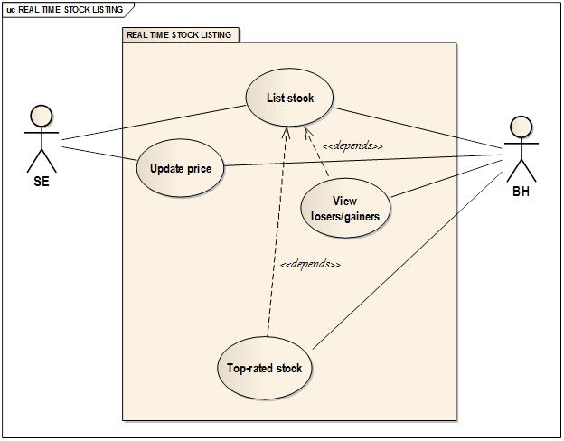

***Use case narrative:***

This subsystemcomprises the data that is collected from the Stock Exchange and used in real-time to provide instant details.

**2.1:List Stock**The BH requests the SE server to send the list of publicly traded companies on its index at the start of a working day and then stores it in its own server after receiving the data.

|  |  |
| --- | --- |
| **Use-Case name** | **List stock** |
| Use-Case ID | 2.1 |
| Priority | High |
| Primary Business Actor | BH |
| External Server Actor | SE |
| Description | BH requests SE for list of companies in SE index and then stores it locally at start of working day |
| Trigger | By BH |

**Actors:** BH, SE **Documentation:**Conclusion: Concludes when BH requests SE for stock listing.  
Post-condition: SE sends BH the requested data and BH stores it in its own database.  
Implementation issues: There will be a database in BH server to store this information.

**2.2: Update price**

The BH will periodically(30s interval) request the SE to send it current buy/sell price of a stock if there has been any change within that time and then updates the value in its database accordingly.

|  |  |
| --- | --- |
| **Use-Case name** | **Update price** |
| Use-Case ID | 2.2 |
| Priority | High |
| Primary Business Actor | BH |
| External Server Actor | SE |
| Description | BH requests SE for update and after getting the data, updates value in its database |
| Trigger | By BH |

**Actors:**BH, SE **Documentation:**Conclusion: When BH sends update requests.  
Post-condition: If there is change in any stock price within last 30 seconds, the data is sent back and updated in BH server.  
Implementation issues: Database will be provided in BH side for storage.

**2.3: View losers/gainers**This module will provide a listing of all the companies whose prices have fallen or risen in comparison to the previous day. It will use the real-time data in relation with data saved from the day before.

|  |  |
| --- | --- |
| **Use-Case name** | **View losers/gainers** |
| Use-Case ID | 2.3 |
| Priority | Medium |
| Primary Business Actor | BH |
| Description | BH uses data collected by list stock module with previous day’s data to make the required list |
| Trigger | By BH |

**Actors:**BH **Documentation:**Conclusion: When BH sends the command to view losers/gainers  
Post-condition:List of the day’s losers/gainers is brought up for the BH.  
Implementation issues: Database will be provided in BH side for storage.

**2.4: Top-Rated Stock**Lists the top ten stocks in descending order of EPS or Earnings-Per-Share. EPS is generally defined as the income generated on a single share over one year and is calculated by dividing net income of a company by its number of outstanding shares.

|  |  |
| --- | --- |
| **Use-Case name** | **Top-Rated Stock** |
| Use-Case ID | 2.4 |
| Priority | Medium |
| Primary Business Actor | BH |
| Description | BH calculates EPS of all companies and then sorts them and displays the greatest ten |
| Trigger | By BH |

**Actors:**BH **Documentation:**Conclusion: When BH sends the request.  
Post-condition:The top-rated stock for the day is shown for the BH.  
Implementation issues: Database will be provided in BH side for storage.

# **Stock Analysis System**

## **Use-case Glossary:**

|  |  |  |  |  |
| --- | --- | --- | --- | --- |
| Use-Case ID | Name | Description | Participant actors and roles | |
| 3.1 | Graphical Analysis | Shows relative performance of a share on a curve | BH plots points on the curve on the basis of historical data | |
| 3.2 | Market Capitalization | Evaluate net worth of a company | BH calculates the share price times number of shares | |
| 3.3 | Market Portfolio | Evaluate monetary weight of a stock versus entire market | BHworks out market cap of stock over cap of total market | |
| 3.4 | Earnings-per-share | Evaluate the income generated per share of a company | BH divides net income of a company over a year by number of shares | |
| 3.5 | Average dividend | Evaluate the expected profit paid per stock | BH aggregates dividend paid over time divided by time from historical data |
| 3.6 | P/E Ratio | Evaluate the ratio of buy price to EPS | BH divides the share buy price by its EPS | |



***Use case narrative:***

In this subsystem, the broker house evaluates many terms and expressions using historical data and provides graphical analysis of stock price fluctuations over an extended period of time.

**3.1: Graphical analysis**

Plots and displays a graph showing the long-term performance of a share to help the trader decide whether or not to buy the share.

|  |  |
| --- | --- |
| **Use-Case name** | **Graphical Analysis** |
| Use-Case ID | 3.1 |
| Priority | High |
| Primary Business Actor | BH |
| Description | BH plots points on the curve on the basis of historical data |
| Trigger | By BH |

**Actors:**BH **Documentation:**Conclusion: When BH is told to generate the graph.  
Post-condition: Graph is generated from the historical data stored in the database according to date.  
Implementation issues: Historical data will be needed which will be stored in a database.

**3.2: Market Capitalization**

The total market capitalization of a company, that is, the net worth of the company is assessed. This amount is obtained by multiplying the share price times the number of shares of that company.

|  |  |
| --- | --- |
| **Use-Case name** | **Market Capitalization** |
| Use-Case ID | 3.2 |
| Priority | High |
| Primary Business Actor | BH |
| Description | BH calculates the share price times number of shares |
| Trigger | By BH |

**Actors:**BH **Documentation:**Conclusion: When BH is asked to send Market Capitalization.  
Post-condition: The market capitalization is displayed.  
Implementation issues: Access to the number of shares and current share price needed.

**3.3: Market Portfolio**The market portfolio of a company is evaluated as the weighted value of the company over the value of all the companies trading in the stock exchange at that moment.

|  |  |
| --- | --- |
| **Use-Case name** | **Market Portfolio** |
| Use-Case ID | 3.3 |
| Priority | High |
| Primary Business Actor | BH |
| Description | BH works out market cap of stock over cap of total market |
| Trigger | By BH |

**Actors:**BH **Documentation:**Conclusion:When BH is asked to send Market Portfolio.  
Post-condition: Market Portfolio is displayed.  
Implementation issues: Access to the share numbers and price of all the companies in the SE.

**3.4: Earnings Per Share(EPS)**

Earnings-per-share or EPS is defined as the income generated on a single share of a company over a fixed period of time, usually a year. It is obtained by dividing net income of a company by the total number of shares.

|  |  |
| --- | --- |
| **Use-Case name** | **Earnings-Per-Share(EPS)** |
| Use-Case ID | 3.4 |
| Priority | High |
| Primary Business Actor | BH |
| Description | BH divides net income of a company over a year by number of shares |
| Trigger | By BH |

**Actors:**BH **Documentation:**Conclusion:When BH is asked to send EPS.  
Post-condition: EPS is displayed  
Implementation issues: Access to number of shares and net earnings of companies is needed.

**3.5: Average Dividend**

A company distributes its profits amongst its shareholders at different times of the years. These profits are not even all the time. When buying a share, the amount a trader can expect to earn from a share in one year is called average dividend. It is obtained by dividing the total amount paid to investors in a fixed time(i.e. one year) by that time.

|  |  |
| --- | --- |
| **Use-Case name** | **Average Dividend** |
| Use-Case ID | 3.5 |
| Priority | High |
| Primary Business Actor | BH |
| Description | BH aggregates dividend paid over time divided by time from historical data |
| Trigger | By BH |

**Actors:**BH **Documentation:**Conclusion:When BH is asked to send Average Dividend.  
Post-condition: Average Dividend is displayed  
Implementation issues: Access to net profit distribution of companies is needed.

**3.6: P/E Ratio**

P/E ratio is the price-to-earnings ratio of a share. It is generally used to measure the viability of a share. With it, a trader can calculate the time it will take to recuperate the buying price of stock from the income it generates. It is obtained by dividing buying price by EPS.

|  |  |
| --- | --- |
| **Use-Case name** | **P/E Ratio** |
| Use-Case ID | 3.6 |
| Priority | High |
| Primary Business Actor | BH |
| Description | BH divides the share buy price by its EPS |
| Trigger | By BH |

**Actors:**BH **Documentation:**Conclusion: When P/E is requested from BH.  
Post-condition: P/E ratio is displayed.  
Implementation issues: Access to both buying price and EPS is required.

# **Transaction Handling System**

## **Use-case Glossary:**

|  |  |  |  |
| --- | --- | --- | --- |
| Use-Case ID | Name | Description | Participant actors and roles |
| 4.1 | Buy/Sell receipt | Gives user a unique id as receipt to secure his transactions | TRD buys/sells and BH gives receipt |
| 4.2 | Transaction logging | All transactions of companies and users are logged in server for security reasons | BH logs all actions taken on its server in a database |
| 4.3 | Balance verification | Verification and completion of transaction | BH verifies if amount is correct, then BA verifies if the balance is valid and completes transaction |



***Use case narrative:***This subsystem consists of the following use cases-

**4.1: Buy/Sell Receipt**Whenever the TRD makes a buy or sell request, he is given an online receipt by the BH server, having a unique ID so that he has a record of his transaction.

|  |  |
| --- | --- |
| **Use-Case name** | **Buy/Sell Receipt** |
| Use-Case ID | 4.1 |
| Priority | High |
| Primary Business Actor | TRD |
| Primary System Actor | BH |
| Description | TRD buys/sells and BH gives receipt |
| Trigger | By TRD |

**Actors:**TRD, BH **Documentation:**Conclusion: When a buy/sell transaction is requested.  
Post-condition: BH generates the ID and gives it to the TRD.  
Implementation issues: BH must be able to generate a unique ID randomly that does not match with other receipts.

**4.2: Transaction Logging**

All transactions taking place in BH server, whether between BH and bank, or BH and TRD are logged and saved with timestamps for future reference and evidence.

|  |  |
| --- | --- |
| **Use-Case name** | **Transaction Logging** |
| Use-Case ID | 4.2 |
| Priority | High |
| Primary Business Actor | BH |
| Description | BH logs all actions taken on its server in a database |
| Trigger | BH |

**Actors:**BH **Documentation:**Conclusion: Whenever a transaction takes place.  
Post-condition: The log of that transaction taking place is saved with a time-stamp.  
Implementation issues:None of the logs will overlap with time or in content.

**4.3: Balance verification**

Sometimes the TRD puts in more shares to sell than he has or more shares to buy than he has the ability to purchase. The BH cross-checks this information with the bank account of the user and verifies it so that invalid transactions do not take place.

|  |  |
| --- | --- |
| **Use-Case name** | **Balance verification** |
| Use-Case ID | 4.3 |
| Priority | High |
| Primary Business Actor | BH |
| External Server Actor | BA |
| Description | BH verifies if amount is correct, then BA verifies if the balance is valid and completes transaction |
| Trigger | BH |

**Actors:**BH,BA **Documentation:**Conclusion: After a transaction is made and before it is cleared/verified.  
Post-condition: The transaction is accepted or rejected accordingly.  
Implementation issues: There has to be virtual connection between BA and BH.

## 4.5 Data Flow Diagram

Dataflow diagram of 6 subsystems are given below.



Figure 8: Dataflow Diagram of User Profile Subsystem



Figure 9: Data Flow Diagram of Trader Profile Subsystem



Figure 10: Dataflow Diagram of Course Work Subsystem



Figure 11: Dataflow Diagram of Examination Subsystem

## 4.6 Fishbone Diagram

Figure 14: Fishbone Diagram of User Profile Subsystem

Figure 15: Fishbone Diagram of Trader Profile Subsystem

Figure 16: Fishbone Diagram of Course Work Subsystem

Figure 17: Fishbone Diagram of Examination Subsystem

Figure 18: Fishbone Diagram of Result Subsystem

Figure 19: Fishbone Diagram of Notice Subsystem

## 4.7 System Design

### 4.7.1 Class Diagram

1. User Profile Subsystem

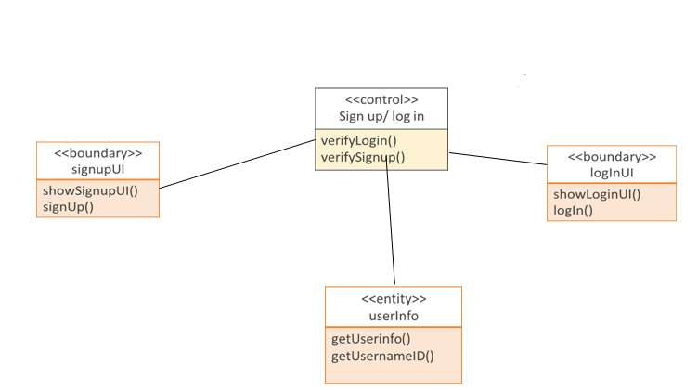

Figure 20: Class Diagram of Add User with Role



Figure 21: Class Diagram of Add/ Update/ Delete User Details



Figure 22: Class Diagram of View User Details



Figure 23: Class Diagram of Login



Figure 24: Class Diagram of Delete User

2. Trader Profile Subsystem



Figure 25: Class Diagram of Fees Status



Figure 26: Class Diagram of View Fees Status



Figure 27: Class Diagram of Update Behaviour & Performance



Figure 28: Class Diagram of Update Attendance



Figure 29: Class Diagram of View Attendance

3. Course Work Subsystem



Figure 30: Class Diagram of Assign Course Broker



Figure 31: Class Diagram of Prepare Routine



Figure 32: Class Diagram of View Routine

4. Examination Subsystem



Figure 33: Class Diagram of Update Examination Schedule

Figure 34: Class Diagram of View Examination Schedule



Figure 35: Class Diagram of Insert Marks



Figure 38: Class Diagram of View Summary and Approve Result

Figure 39: Class Diagram of Update Result

Figure 40: Class Diagram of View Result

6. Notice Subsystem

Figure 41: Class Diagram of Update Notice

Figure 42: Class Diagram of View Notice

### 4.7.2 Collaboration Diagrams

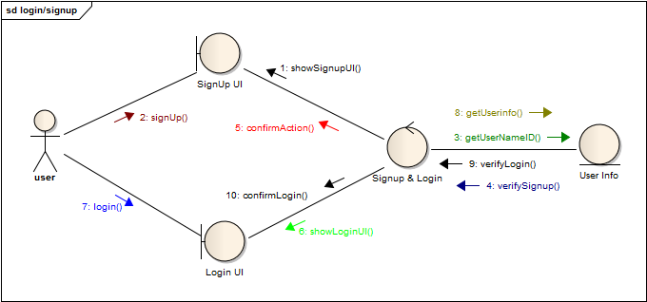

4

































## 4.8 Process Design

### 4.8.1 Sequence Diagram

1. User Profile Subsystem

Figure 70: Sequence Diagram of Delete User

2. Coursework Subsystem

Figure 71: Sequence Diagram of Assign Course Broker

Figure 72: Sequence Diagram of Prepare Routine

Figure 73: Sequence Diagram of View Routine

3. Examination Subsystem

Figure 74: Sequence Diagram of Update Examination Schedule

Figure 75: Sequence Diagram of View Examination Schedule

Figure 76: Sequence Diagram of Insert Marks

4. Result Subsystem

Figure 77: Sequence Diagram of Prepare Result

Figure 78: Sequence Diagram of Forward Result

Figure 79: Sequence Diagram of View Result Summary & Approve

Figure 80: Sequence Diagram of View Result

5. Notice Subsystem

Figure 81: Sequence Diagram of Update Notice

Figure 82: Sequence Diagram of View Notice

### 4.8.2 State Chart Diagram

Figure 83: State Chart Diagram of User

Figure 84: State Chart Diagram of Course

Figure 85: State Chart Diagram of Exam Schedule

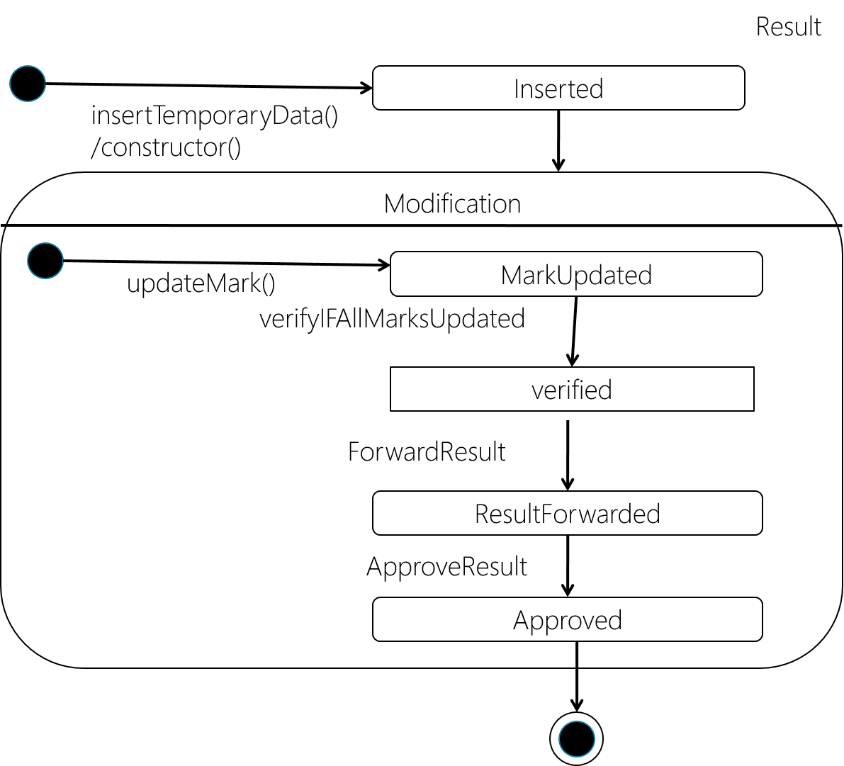

Figure 86: State Chart Diagram of Result

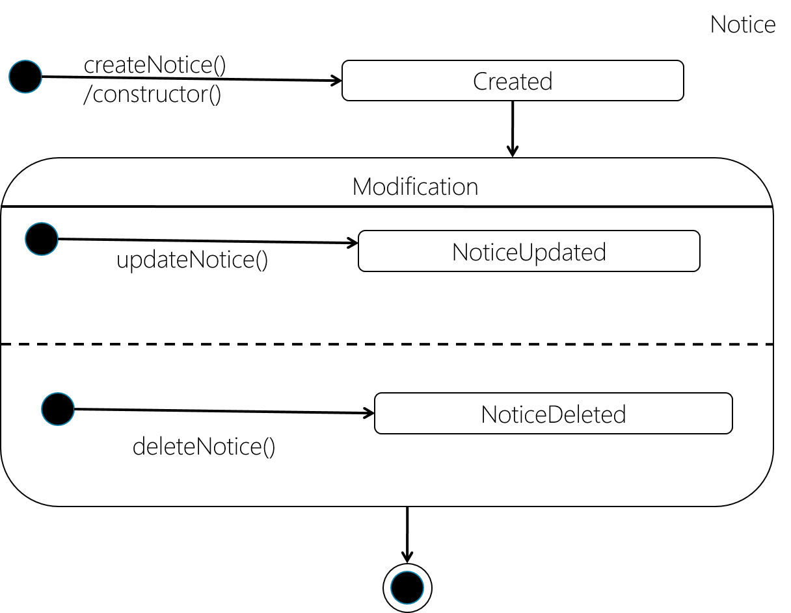

Figure 87: State Chart Diagram of Notice

### 4.8.3 Activity Diagram

Figure : Activity Diagram of View User Details

Figure 90: Activity Diagram of Login

Figure 91: Activity diagram of Delete User

Figure 92: Activity Diagram of Assign Course Broker

Figure 93: Activity Diagram of Prepare Routine

Figure 94: Activity Diagram of View Routine

Figure 95: Activity Diagram of update Exam Schedule

Figure 96: Activity Diagram of View Exam Schedule

Figure 97: Activity Diagram of Insert Mark

Figure 98: Activity Diagram of Prepare Result

Figure 99: Activity Diagram of Forward Result

Figure 100: Activity Diagram of View Result Summary and Approve

Figure 101: Activity Diagram of View Result

Figure 102: Activity Diagram of Update Notice

Figure 103: Activity Diagram of View Notice

# Chapter 5. Database Design

## 5.1 Introduction

Database design is one of the most important part where the system data structures are designed and how these are to be represented in a database. The work here depends on whether an existing database is to be reused or a new database is to be created.

## 5.2 Overview of the design process

The first step involves identifying entities. The types of information that are saved in the database are called 'entities'. Everything that needs to be put in a database fits into one of these entities. If the information doesn't fit into these entities, than it is probably not an entity but a property of an entity.

The next step is to determine the relationships between the entities and to determine the cardinality of each relationship. The relationship is the connection between the entities, just like in the real world: what does one entity do with the other, how do they relate to each other? For example brokers take classes, traders are related to a class. The cardinality shows how much of one side of the relationship belongs to how much of the other side of the relationship.

## 5.3 ERD and its Brief Description

The Entity Relationship Diagram (ERD) gives a graphical overview of the database. There are several styles and types of ER Diagrams. A much-used notation is the 'crowfeet' notation, where entities are represented as rectangles and the relationships between the entities are represented as lines between the entities. The signs at the end of the lines indicate the type of relationship. The side of the relationship that is mandatory for the other to exist will be indicated through a dash on the line. Not mandatory entities are indicated through a circle. "Many" is indicated through a 'crowfeet'; de relationship-line splits up in three lines.

### 5.3.1 The ERD at a Glance

The ERD of E-School consists of following entities:

The full overview of the ERD is given below:

Figure 104: Full ERD

### 5.3.2 Anatomizing the ERD

1. User

Figure 105: ERD of user entity

2. User with Role

Every User has an associated Role which defines the action of the user.

Figure 106: ERD of user with role

3. Trader & Attendance

Attendance of each trader of each date are stored in Attendance entity.

Figure 107: ERD of Trader & Attendance

4. Trader & Fees

Fees of each month of a trader are stored in Fees entity.

Figure 108: ERD of trader & fees

5. Course & Result of Trader

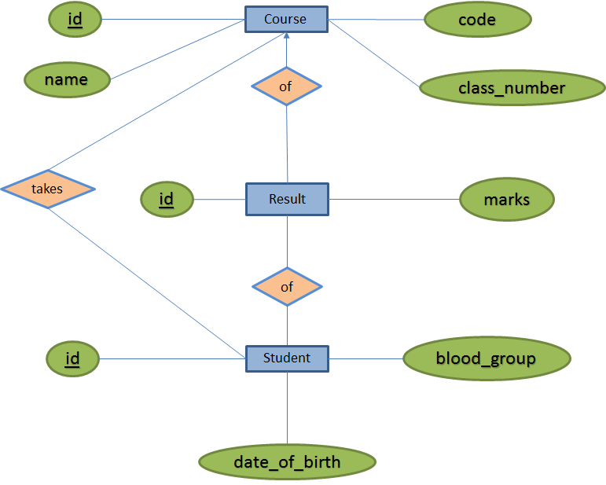

Figure 109: ERD of course & result of trader

6. Course and Exam

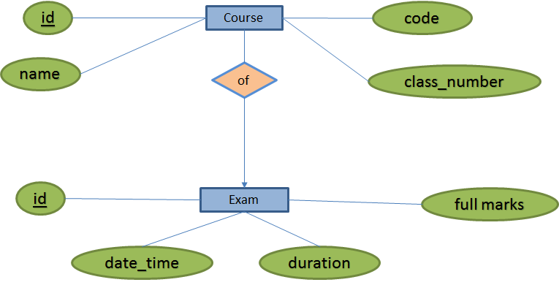

Figure 110: ERD of course and exam

## 5.4 Database Schema

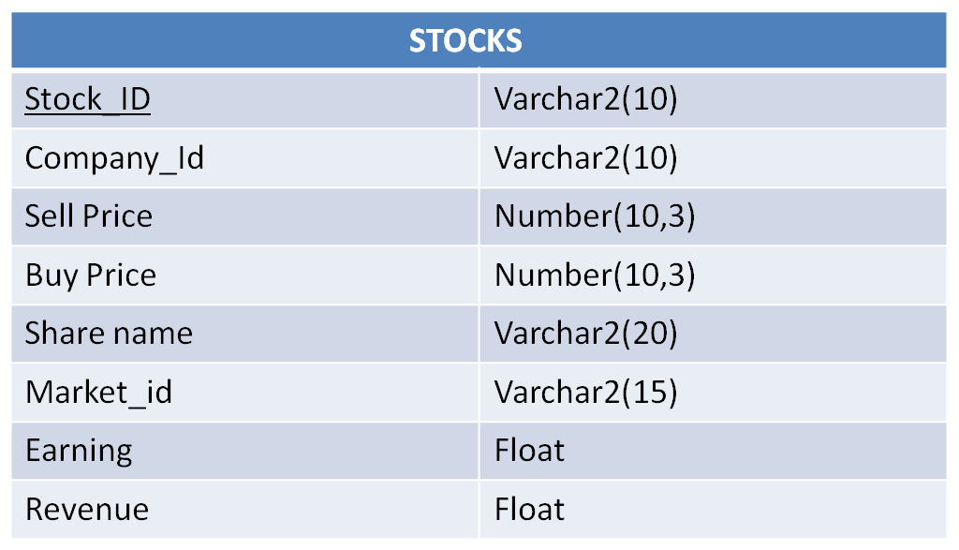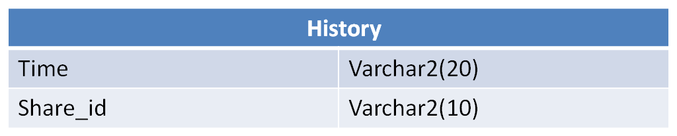

|  |  |
| --- | --- |
| **Client** | |
| ClientID | Varchar2(10) |
| Client_Name | Varchar2(30) |
| Address | Varchar2(50) |
| Bank | Varchar2(30) |
| Bank Account Number | Number |
| Phone | Number |
| UserName | Varchar2(30) |
| Password | Varchar2(50) |

|  |  |
| --- | --- |
| **PORTFOLIO** | |
| Client_Id | Varchar2(10) |
| Share_ID | Varchar2(10) |
| Buy Price | Float(5) |
| Sell price | Float(5) |
| Receipt_Id | Varchar2(10) |
| Buy time | Varchar2(15) |
| Sell time | Varchar2(15) |

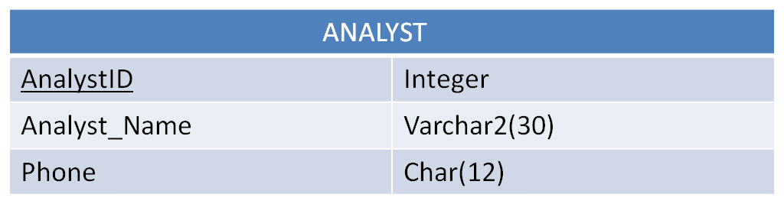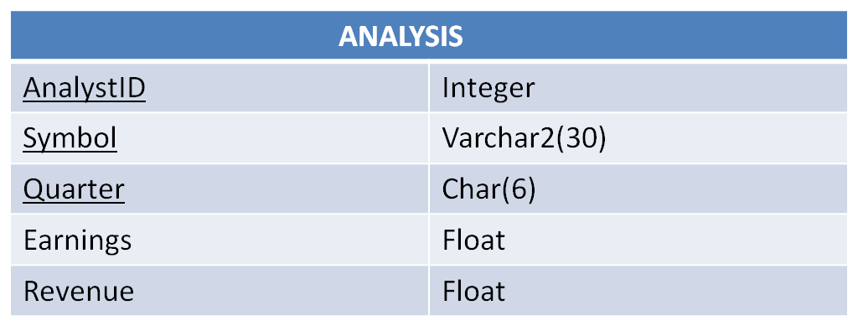

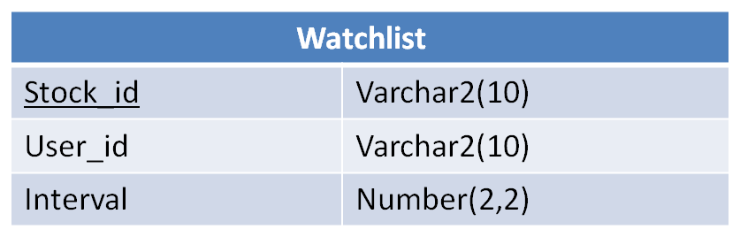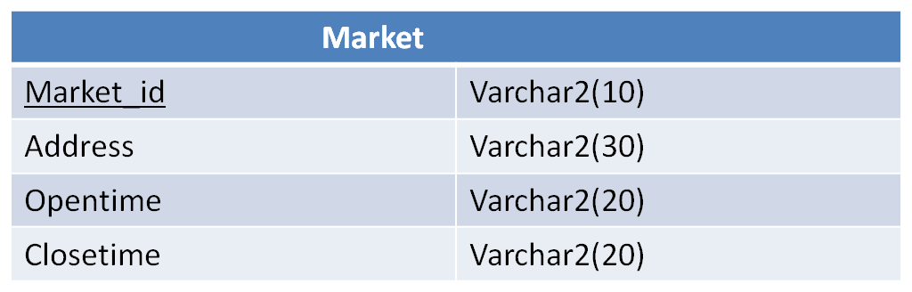

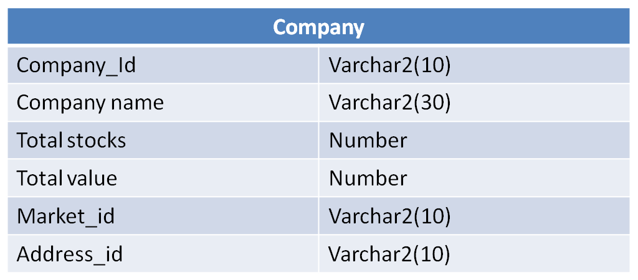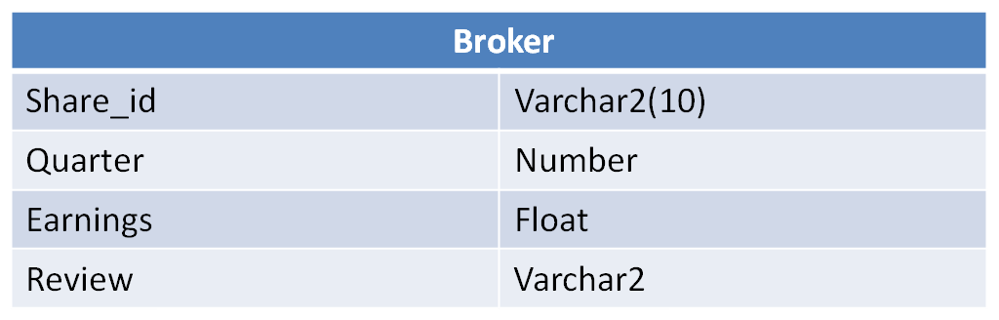

## 5.5 Triggers and Procedures

### 5.5.1 Trigger

### 5.5.2 Procedures

# Chapter 6. Input and Output Design

## 6.1 Login

Our system consists of 4 actors. For all these actors there are basically 2 modules. Here we are showing them together.

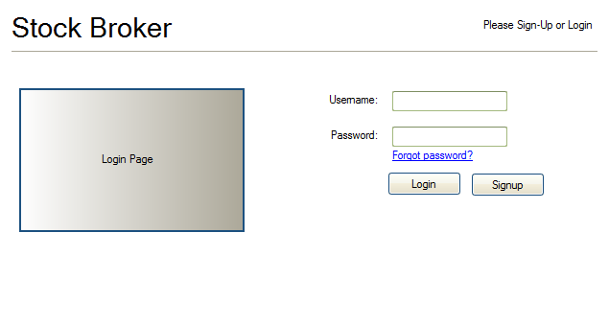

Figure :Login

## 6.1 Login(Confirmation)

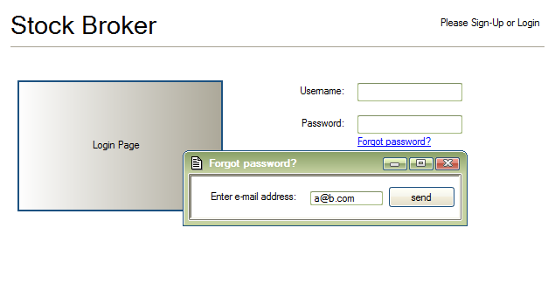

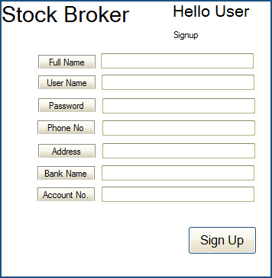

Figure :Sign up

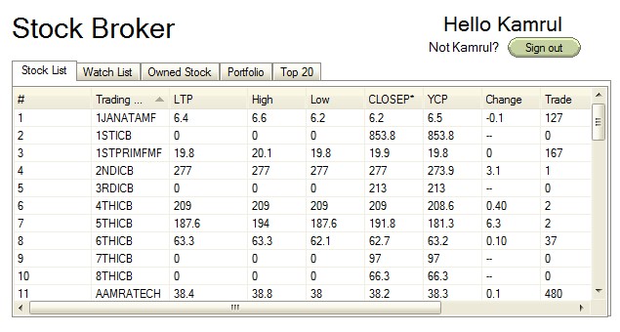 Figure :Stock list

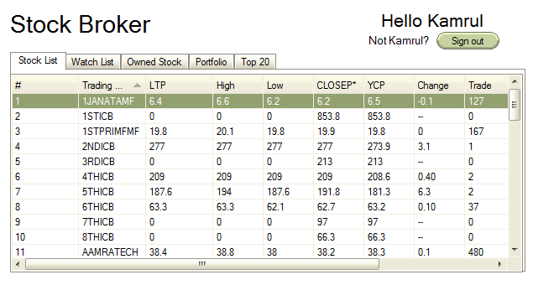

Figure : select stock

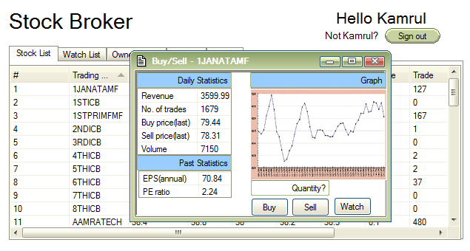 Figure :buy/sell stock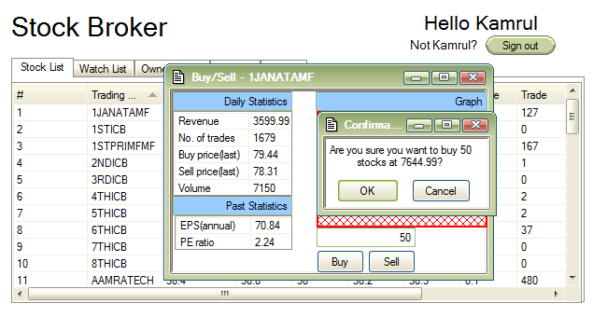

Figure :confirmation buy/sell

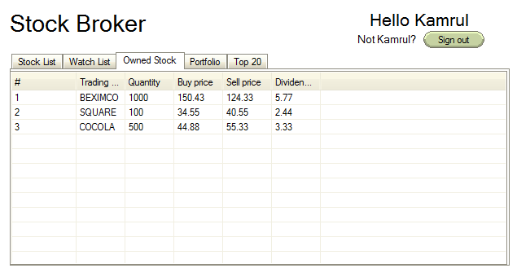

Figure :owned stock

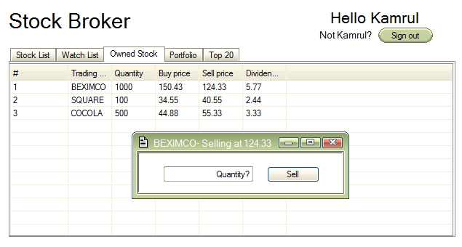

Figure :owned stock sell

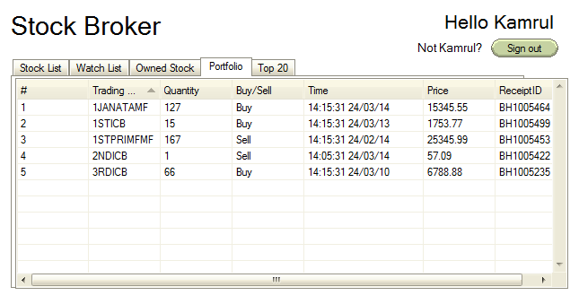

Figure : portfolio

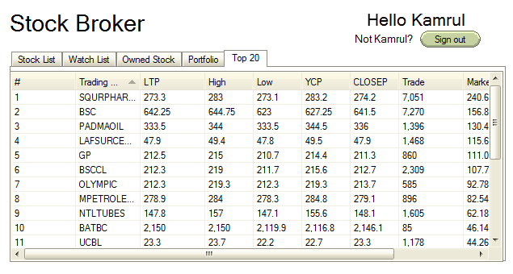

Figure :top 20 stock

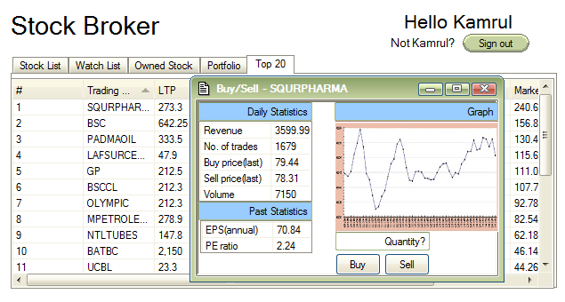

Figure : buy/sell top 20

# Chapter 7. Project Phase and Activities

## 7.1 Introduction

Project phase and activity refers to the work schedule, project time analysis, cost analysis and risk analysis. All these analysis are briefly done in this chapter.

## 7.2 Work Schedule & Project Time Analysis

Work scheduling and project time analysis refers to splitting the project into tasks and estimate time and resources required to complete each chart.

Table 61: Project time analysis

|  |  |  |  |  |
| --- | --- | --- | --- | --- |
| Tasks | Task number | Dependency | Milestone | Estimated working days |
| Analyse the current system | T1 |  |  | 10 |
| Plan the project | T2 | T1 | M1 | 11 |
| List the problems | T3 | T2 | M2 | 4 |
| Analyse the problems | T4 | T3 | M3 | 12 |
| Identifying business requirement | T5 |  |  | 6 |
| Analyse system requirement | T6 | T2, T5 | M5 | 6 |
| Design system architecture | T7 | T6, T4 | M4 | 12 |
| Design system database | T8 | T6 | M6 | 10 |
| Design system interface | T9 | T6 | M6 | 14 |
| Design application logic | T10 | T7, T8, T9 | M7 | 20 |
| Software instalment | T11 | T10 | M8 | 15 |

### 7.2.1 Activity Network

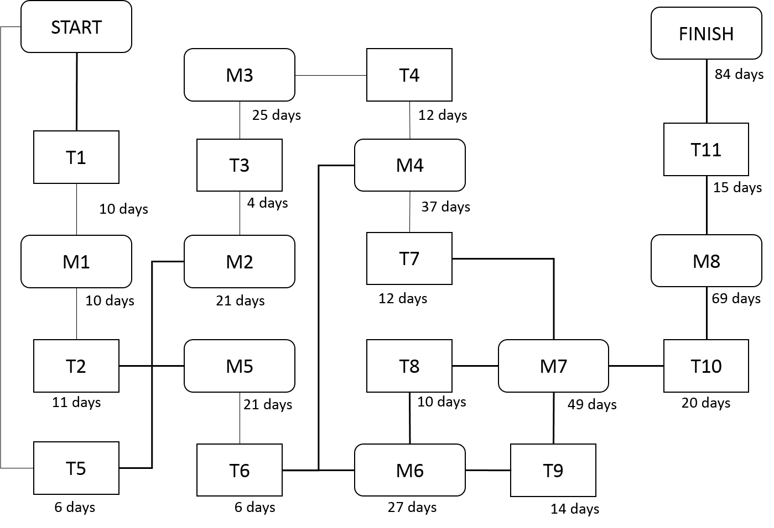

Figure 142: Activity network

### 7.2.2 Activity Timeline

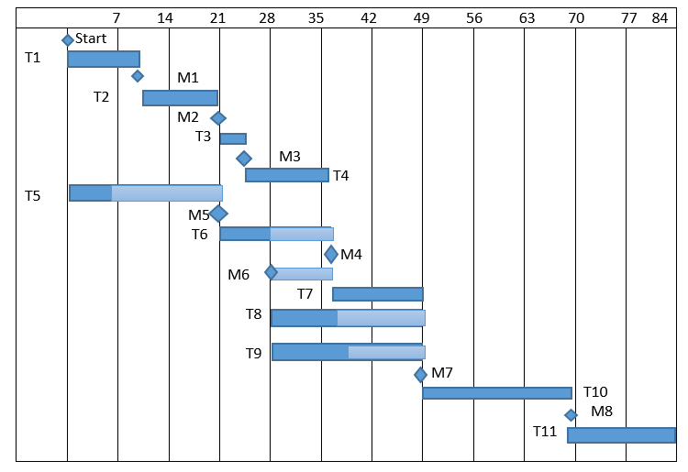

Figure 143: Activity timeline

### 7.2.3 Pert Chart

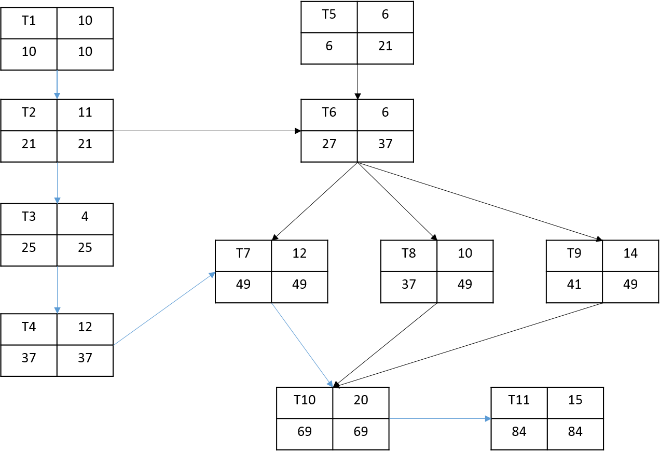

Figure 144: Part chart

## 7.3 Cost Benefit Analysis

Cost benefit analysis of a system refers to development cost, operational cost and tangible & intangible cost benefit. Swot Analysis is also a part of it. During presentation our cost analysis was marked as weak so it has been improved. One of the major fault of the previous cost analysis is that the cost of maintenance was estimated very low.

### 7.3.1 Development Cost

Table 62: Preliminary expenses

|  |  |
| --- | --- |
| Preliminary Expenses | Amount |
| Software generation code | 20,00,000 BDT |
| Hardware purchasing cost | 50,000 BDT |
| Total Preliminary Expenses | 20,50,000 BDT |

Table 63: Preliminary expenses extended

|  |  |  |  |
| --- | --- | --- | --- |
| Arena | Equipment | Cost*Item | Total Cost |
| Hardware | Computer | 30,000*4 | 1,20,000 BDT |
| Internet connection |  | 5,000 BDT |

### 7.3.2 Operational Cost

Table 64: Fixed expenses per year

|  |  |
| --- | --- |
| Fixed Expenses | Cost per Year |
| Software maintenance cost | 3,60,000 BDT |
| Salary of employee | 6,00,000 BDT |
| Hosting cost | 1,60,000 BDT |
| Office rent | 2,40,000 BDT |
| Water, gas, electricity | 5,00,000 BDT |
| Total Fixed Expenses | 18,60,000 BDT |

### 7.3.3 SWOT Analysis

Table 65: SWOT table

|  |  |
| --- | --- |
| Strength   1. Easy purchase of stocks 2. Facilitates trade 3. Easy access to stock listing | Weakness   1. Less technical usability of users 2. Internet access needed for users and admins.. |
| Opportunities   1. Increases revenue 2. Huge demand among users created | **Threats**   1. Wrong input of user. 2. Invalid class routine or exam schedule generation 3. Unavailability of internet. |

### 7.3.4 Tangible Benefit of the System

1. Save time.
2. Reduce paper work
3. No registration process needed.
4. Decrease response time.

### 7.3.5 Intangible Benefit of the System

1. Automation of sale.
2. Making receipt.
3. Transbroker system.

## 7.4 Risk Analysis & Management

Risk management is concerned with identifying risks and drawing up plans to minimise their effect on a project. The steps of risk analysis & management are given below.

### 7.4.1 Risk & Risk Type

Table 66: Risk & risk type

|  |  |
| --- | --- |
| Risk Type | Possible Risks |
| Technology | 1. High Traffic in database 2. Malfunction of server 3. Absence of internet connection in school premises. |
| People | 1. Lack of technical expertise in users. |
| Requirement | 1. Need of devices with internet connection. |
| Estimation | 1. The estimated time for development of the project can cause delay. |

### 7.4.2 Risk Analysis

Table 67: Risk analysis

|  |  |  |
| --- | --- | --- |
| Risk | Probability | Effects |
| Server malfunction | Low | Catastrophic |
| High traffic in database | Low | Tolerable |
| Absence of internet connection in school premises. | High | Serious |
| Lack of technical expertise in average users | High | Tolerable |
| Need of devices with internet connection. | High | Tolerable |
| Requirement alteration | Moderate | Tolerate |

### 7.4.3 Risk Planning

Table 68: Risk planning

|  |  |
| --- | --- |
| Risk | Strategy |
| Server malfunction | Cloud server. |
| High traffic in database | Investigate the possibility of buying a higher performance database. |
| Absence of internet connection in school premises. | Providing WIFI connection in school premises. |
| Lack of technical expertise in average users | Giving training sessions to users in school. |
| Need of devices with internet connection. | Using computers of labs and smart phone for this purpose. |
| Requirement alteration | Derive traceability information to access requirements change impact. |