DermLatBench: A Context-Aware Benchmark for
Patient-Centered Laterality in Clinical Images
Mitchell H. Liu, Avery H. Liu, and Prof. Dr. [NAME TO CONFIRM]
Brentwood School, Los Angeles, California, USA
[Department and German University affiliation to confirm]

Abstract- Medical vision-language model benchmarks usually reward pathology recognition but rarely ask whether a model can assign a visible finding to the patient's left or right, or decline when the image lacks sufficient context. DermLatBench repurposes 12,541 open-licensed wound and dermatology photographs into a context-aware laterality benchmark. Four trained annotators labeled body region, visible landmarks, patient-centered laterality, and contextual sufficiency; disagreements were adjudicated by two wound-care professionals. Of the corpus, 9,770 images (77.9%) contained sufficient visible anatomy for body-region or landmark assessment, whereas 2,771 (22.1%) did not. Overall inter-annotator agreement exceeded 95%. Preliminary testing produced laterality accuracies of 28% for a 4B medical model and 46% for a 9B general-purpose model. The benchmark adds bilateral, midline, indeterminate, and non-anatomical controls together with mirrored, rotated, and cropped variants. Its central contribution is to separate three abilities that conventional accuracy conflates: recognizing anatomy, grounding it in a patient-centered coordinate frame, and abstaining when the frame is unrecoverable.
Index Terms- anatomical laterality, clinical imaging, dataset annotation, spatial grounding, vision-language models.

I. INTRODUCTION
A clinical photograph can show the correct anatomy while omitting the information needed to determine whose left or right is visible. This distinction matters whenever an artificial-intelligence system drafts wound or dermatology documentation: an accurate description assigned to the wrong patient side becomes an inaccurate record. Generalist medical models are increasingly expected to combine visual recognition and language generation [1], yet their evaluations remain dominated by diagnostic or descriptive tasks. Patient-centered spatial grounding is usually unmeasured.
Laterality is not identical to image position. A structure on the left side of a photograph may belong to the patient's right side, depending on pose and viewpoint. A model must identify the structure, infer the relevant coordinate frame, map that frame to the patient, and recognize when the mapping is underdetermined. Vision-language models already show large deficits on controlled left-right and relational tasks [2]. Clinical photographs add variation in crop, camera angle, anatomy, and acquisition practice, making forced binary evaluation especially misleading.
DermLatBench reframes laterality as a context-aware benchmark rather than a two-class image-labeling problem. It contributes: (1) a structured annotation of 12,541 open-licensed wound and dermatology photographs; (2) an explicit answerability taxonomy including bilateral/midline, unable-to-determine, and not-applicable outcomes; (3) expert-adjudicated reference labels and controlled image perturbations; and (4) preliminary medical and general-purpose VLM baselines. The key result is structural: 22.1% of aggregated images lack sufficient visible context, so a safe benchmark must score appropriate abstention as well as correct side assignment.

A. Research Questions
The study asks four questions. RQ1 (answerability): how often do public clinical photographs contain enough evidence for patient-centered anatomical grounding? RQ2 (reliability): can trained annotators apply the context-aware taxonomy consistently? RQ3 (model competence): do representative VLMs assign laterality accurately when the answer is recoverable? RQ4 (robustness): can controlled transformations distinguish anatomical grounding from image-position and context shortcuts? The reported corpus statistics answer RQ1, aggregate agreement addresses RQ2, and two preliminary baselines provide initial evidence for RQ3. RQ4 is supported as an evaluation design; complete paired transformation results remain future work and are not claimed here.

II. RELATED WORK

A. Clinical Image Datasets
Public dermatology collections have enabled important work on disease classification, acquisition variability, and demographic representation. Fitzpatrick17k contains 16,577 clinical images with skin-type annotations [3]; PAD-UFES-20 pairs smartphone photographs with clinical metadata [4]; and the Diverse Dermatology Images dataset was curated to expose performance disparities across skin tones [5]. These resources illustrate the value of careful secondary annotation, but their principal targets are diagnostic categories or fairness attributes, not patient-centered laterality. DermLatBench asks a different question of existing photographs: does the image contain enough anatomy to ground the finding on the patient, and can a model use that evidence without guessing?

B. Spatial Grounding and Dataset Accountability
Kamath et al. found that models approaching human performance on broad visual-question-answering tasks remained weak on controlled spatial relations [2]. Clinical laterality compounds this weakness because the coordinate system belongs to the subject rather than the image. Dataset documentation is equally important: datasheets encourage creators to record provenance, collection decisions, uses, and limitations [6], while CLAIM promotes transparent reference standards and testing descriptions for medical-imaging AI [7]. DermLatBench adopts these principles by separating observable anatomy from answerability and by retaining indeterminate labels instead of treating them as annotation failures.

III. BENCHMARK DESIGN

A. Design Principles
The benchmark was built around five requirements. First, labels are patient-centered, not viewer-centered. Second, answerability is annotated independently of the desired side. Third, abstention is a valid clinical outcome. Fourth, transformed images remain linked to their source so they cannot leak across evaluation splits. Fifth, benchmark outputs must reveal response bias; an always-left model should not appear spatially competent merely because of class prevalence.

B. Threat Model and Controls
DermLatBench treats shortcut behavior as a first-class evaluation target. The threat model includes a fixed-side prior, confusion between viewer and patient coordinates, forced answers on underdetermined images, dependence on removable background cues, and leakage between an original image and its variants. Each threat has a paired control and a recognizable failure signature, summarized below.
TABLE I. SHORTCUT THREATS AND BENCHMARK CONTROLS
Threat | Control | Diagnostic signature
Fixed-side prior | Balanced, macro reporting | One label dominates predictions
Viewer-frame rule | Mirror probe | Output follows image position
Forced answer | Indeterminate controls | Low abstention sensitivity
Context shortcut | Landmark-preserving/removing crops | Confidence ignores decisive context
Variant leakage | Source-group split | Variant gains vanish by source
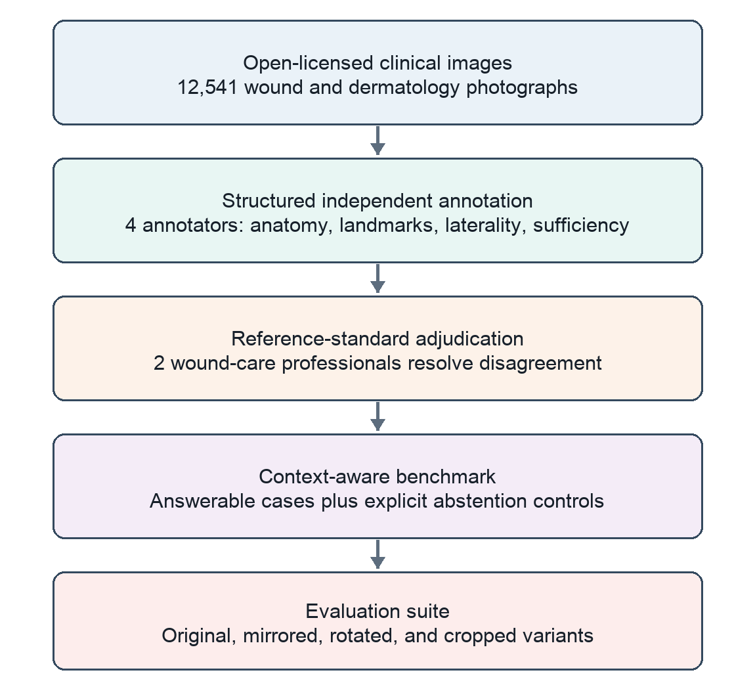
Fig. 1. DermLatBench construction and evaluation pipeline. Perturbed images remain linked to their originals and are treated as diagnostic variants, not independent samples.

C. Corpus Assembly
The corpus aggregates 12,541 wound and dermatology photographs from open-licensed repositories. Images were processed with a custom offline annotation tool. The combined corpus deliberately retains acquisition diversity: close-cropped dermatology images isolate lesions, while wider-field wound photographs more often preserve recognizable limbs, joints, facial landmarks, or other orientation cues. This variation is central to the benchmark because the presence of pathology does not imply the presence of laterality evidence.
Annotation records separate what is visible from what may be inferred. Each record includes body region, visible landmarks, patient-centered laterality, contextual sufficiency, and confidence. No label is created by mirroring the viewer's coordinate system. Instead, patient-side labels require visible anatomical evidence or reliable source information; otherwise the correct outcome is unable to determine.
TABLE II. CORE DERMLATBENCH LABEL TAXONOMY
Label | Operational rule
Left | Evidence supports the patient's left side.
Right | Evidence supports the patient's right side.
Bilateral / midline | Both sides or a midline structure are present; no single side is correct.
Unable to determine | Anatomy is visible, but the patient-centered side cannot be recovered.
Not applicable | The image does not contain relevant human anatomy.

D. Reference Standard
Four trained annotators independently labeled the corpus. Disagreements were reviewed by two wound-care professionals, producing an adjudicated reference standard rather than a majority-vote label alone. Overall inter-annotator agreement exceeded 95%. The workflow preserves disagreement as information: cases requiring adjudication identify where the taxonomy, visible context, or anatomy is genuinely difficult.
Aggregate agreement is not sufficient by itself because prevalent labels can dominate a single rate. Accordingly, the benchmark design calls for label-specific confusion matrices and a chance-corrected multi-rater statistic in the release report. This prevents high agreement on an easy majority class from obscuring weak agreement on the safety-critical unable-to-determine category.

E. Controlled Perturbations
DermLatBench supports horizontal mirroring, rotation, and cropping. These operations are diagnostic probes, not ordinary label-preserving augmentation. A crop may remove the landmark that made the original answerable; a mirror may expose dependence on image position; and rotation may test orientation shortcuts. Each derivative is therefore re-evaluated for context sufficiency and inherits a group identifier from its source. Splitting occurs at the source-image level before perturbation, preventing nearly identical variants from appearing in both development and test sets.

IV. EVALUATION PROTOCOL

A. Tasks and Outputs
The primary task requires one output from the closed taxonomy in Table II. Unilateral images measure patient-side assignment; bilateral, midline, and non-anatomical controls measure whether the model avoids a forced side; and context-reduced variants measure selective abstention. A secondary tiered task asks for the visible body region and landmark before laterality, allowing recognition failure to be separated from grounding failure.

B. Metrics
Let U denote answerable unilateral cases and A the cases on which a model commits to left or right. Primary accuracy is the fraction of correct predictions in U. Coverage is |A|/N, and selective accuracy is the correct fraction within A. These are accompanied by abstention sensitivity on unable-to-determine cases, specificity against unnecessary abstention on clear unilateral cases, macro-averaged class recall, and the full prediction distribution. Reporting the pair of coverage and selective accuracy prevents a model from appearing safe by abstaining on every image or accurate by answering only a trivial subset.

C. Preliminary Baselines
Two open-weight VLMs were used as preliminary baselines: a 4B-parameter medical model and a 9B-parameter general-purpose model. Both were evaluated through the same closed-label interface. The reported results are descriptive benchmarks rather than a claim that parameter count or medical specialization causes performance differences; exact checkpoint, prompt, decoding, and hardware information belongs in the reproducibility record.

D. Statistical Analysis Plan
The source image, not a transformed derivative, is the unit of analysis. All intervals should therefore be estimated by resampling source groups. Paired original-versus-variant changes should be reported with source-group bootstrap 95% confidence intervals, while model comparisons on identical cases can use a paired binary test. Results should be stratified by label and image source, with macro summaries alongside pooled values. This analysis plan is prospective: confidence intervals and paired robustness results are intentionally not fabricated from unavailable per-image predictions.

E. Comparator Suite and Scoring Contract
A convincing benchmark must show that a model exceeds simple policies. Required non-learning comparators are: always-left, always-right, the most frequent training label, uniform random choice, and always abstain. A vision-blind text-only condition tests whether prompt wording or label priors explain performance. The same held-out source groups, taxonomy, and parser are used for every system. These comparators establish floors for unilateral accuracy, macro recall, and abstention behavior; a VLM that does not exceed them has not demonstrated image-grounded laterality.
Evaluation should be deterministic wherever the model interface permits. The prompt defines the patient-centered coordinate frame, lists the five allowable labels once, and requests exactly one label without chain-of-thought. Outputs are normalized by case and punctuation only; aliases are fixed before evaluation, and all other responses are scored invalid rather than manually repaired. Image identifiers remain hidden from the model. The release should include the exact prompt, parser, random seed, software versions, and an item-level prediction file. A small preregistered prompt-sensitivity analysis can then test whether conclusions survive neutral rewording without selecting the best prompt on the test set.

V. RESULTS

A. Context Sufficiency
Of 12,541 annotated images, 9,770 (77.9%) contained sufficient visible anatomy to classify a body region or landmark. The remaining 2,771 images (22.1%) lacked the surrounding context needed for reliable anatomical grounding. This is not annotation loss. It is a benchmark finding: nearly one image in five would invite unsupported inference if the task forced every input into a left/right answer.
TABLE III. CORPUS-LEVEL CONTEXT SUMMARY
Context category | Images | Share
Sufficient visible anatomy | 9,770 | 77.9%
Insufficient context | 2,771 | 22.1%
Total | 12,541 | 100.0%

B. Annotation and Baselines
Overall inter-annotator agreement exceeded 95%, supporting the operational usability of the taxonomy while not eliminating the need for label-specific reliability reporting. In preliminary model testing, the medical 4B VLM achieved 28% laterality accuracy and the general-purpose 9B VLM achieved 46%, an 18-percentage-point difference. Neither result establishes safe spatial grounding, and the comparison should not be interpreted causally because only one model represents each category.

C. Answers to the Research Questions
RQ1 is answered directly: 22.1% of the corpus was insufficient for anatomical grounding, establishing that answerability cannot be assumed. For RQ2, agreement above 95% indicates that the taxonomy is operationally learnable, although class-specific and chance-corrected reliability remain required. For RQ3, both baseline accuracies were below 50%; however, unknown class balance and absent per-image outputs preclude comparison with fixed-side or abstention-aware baselines. RQ4 remains a benchmark capability rather than a completed empirical claim. This separation of established results from planned analyses is essential to interpreting the preliminary study correctly.
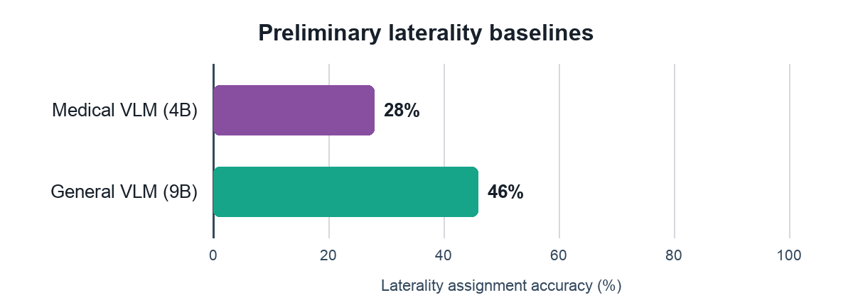
Fig. 2. Preliminary laterality accuracy for the two VLM baselines. Model-category differences are descriptive, not causal comparisons.

VI. DISCUSSION

A. Answerability Is Part of the Task
The most important result is not which preliminary model scored higher. It is that context sufficiency varies systematically with acquisition style. A benchmark that removes or silently discards indeterminate images evaluates a cleaner problem than clinical deployment. Conversely, a benchmark that counts every abstention as wrong rewards overconfident guessing. DermLatBench makes answerability explicit and evaluates the decision to answer as well as the answer itself.
This structure distinguishes three capabilities. Recognition asks what anatomy is visible. Spatial grounding asks how that anatomy relates to a patient-centered frame. Calibration asks whether the evidence is sufficient to commit. A model can succeed at the first and fail at the latter two. Reporting only aggregate left/right accuracy collapses these failures and can give a fixed-side predictor a non-trivial score.

B. Implications for Clinical AI
Laterality should not be inferred from a close crop merely because the surrounding workflow expects a side. The safer design is layered: acquisition systems should record operator-confirmed side when possible; models should describe visible findings; and automated laterality should be accepted only when the benchmark demonstrates both grounding and calibrated abstention. This does not make the model a diagnostic device, nor does DermLatBench test diagnosis. It tests whether a documentation component preserves a basic fact about where a finding is located.
Controlled perturbations also provide a route beyond static leaderboards. If a prediction changes after a crop that preserves the decisive landmark, the model may be relying on background cues. If it remains confident after the landmark is removed, calibration is suspect. If mirroring changes the output without a corresponding change in the patient-centered reference label, the model may be following image coordinates. Paired source-level analysis can expose these shortcuts with fewer assumptions than a single headline score.

C. Failure Interpretation
The benchmark is intended to diagnose why a system fails, not merely rank models. Table IV maps observable score patterns to the associated trust boundary. None of these patterns authorizes autonomous documentation; instead, each indicates which evidence must be collected before laterality can be accepted or which fallback should be used.
TABLE IV. FROM BENCHMARK SIGNAL TO SAFETY INTERPRETATION
Observed signal | Likely failure | Safe interpretation
Region correct; side wrong | Coordinate-frame failure | Do not assign patient side
Accuracy high; abstention weak | Forced-answer behavior | Require explicit sufficiency gate
Confidence persists after cue removal | Context-insensitive calibration | Reject automated commitment
Prediction follows mirror position | Viewer-frame shortcut | Not patient-grounded

D. Limitations
DermLatBench inherits the sampling and documentation limits of its source repositories. Public clinical collections may overrepresent particular diseases, institutions, capture practices, or skin appearances. Laterality is sometimes unrecoverable even for experts, which is why indeterminate labels are preserved. Overall agreement above 95% does not replace label-specific reliability. The preliminary evaluation includes only two models and reports scalar accuracy; a complete model card must add exact checkpoints, prompts, decoding settings, class counts, and source-group confidence intervals. Finally, performance on a repurposed image corpus does not establish clinical effectiveness and must not be used to automate diagnosis or treatment.

E. Reproducibility and Release
A defensible release should include a source-and-license manifest, stable image identifiers, the annotation dictionary, adjudication protocol, group-preserving split files, perturbation metadata, evaluation prompts, parsing rules, and model configuration records. Where image licenses prohibit redistribution, the release can provide annotations and retrieval scripts rather than copied images. Dataset documentation should state intended uses, excluded uses, demographic limitations, and the distinction between a research reference standard and clinical ground truth [6], [7]. Model cards should record the exact checkpoint, interface, prompt, decoding policy, hardware, and failure strata [10]; source-group reporting should make distribution shifts visible rather than averaging them away [11].

F. Intended Use and Governance
DermLatBench is intended for offline evaluation of spatial grounding and abstention in research models. It is not a diagnostic benchmark, a treatment recommendation system, or evidence that a model can write unsupervised clinical notes. Benchmark images should not be linked to external patient records, and any residual identifiers must be screened under the applicable source license and institutional policy before release. When redistribution is not permitted, annotations should be separated from retrieval instructions and access should remain with the source repository. These constraints preserve the distinction between evaluating a capability and deploying it.
Governance also requires monitoring who is represented and where errors concentrate. A release report should stratify performance by source, body region, context-sufficiency label, and any responsibly available demographic attributes. Small strata should be reported with uncertainty rather than suppressed into a pooled score. Proposed taxonomy changes should be versioned, reviewed by clinical annotators, and evaluated on a frozen legacy set so leaderboard changes reflect model behavior rather than silent label drift. Confirmed annotation errors should remain in a public change log with their effect on published scores.

G. Evidence Gates for Model Claims
A model should be described as patient-grounded only after it clears every gate in Table V. Passing unilateral accuracy alone is insufficient: the claim also requires appropriate abstention, robustness to controlled context changes, subgroup transparency, and a complete reproducibility record. Failure at any gate narrows the defensible claim rather than being averaged away by a composite score.
TABLE V. MINIMUM EVIDENCE GATES
Gate | Required evidence
Grounding | Exceeds fixed-side and vision-blind comparators
Abstention | Detects insufficient context without universal refusal
Robustness | Paired source-level transformation analysis
Reliability | Label-specific agreement and uncertainty
Transparency | Manifest, prompts, parser, splits, and predictions

VII. CONCLUSION
DermLatBench turns anatomical laterality from an assumed attribute into a measurable patient-safety task. Across 12,541 wound and dermatology photographs, 22.1% lacked sufficient context for reliable anatomical grounding. Four-annotator labeling with expert adjudication produced agreement above 95%, while preliminary VLM accuracies of 28% and 46% showed substantial room for improvement. By scoring recognition, patient-centered grounding, and appropriate abstention separately, the benchmark is designed to distinguish genuine spatial understanding from fixed-side bias, image-coordinate shortcuts, and unsupported guessing.

ACKNOWLEDGMENT
The authors thank the wound-care professionals who adjudicated difficult annotations and the maintainers of the open-licensed image repositories used in this study.

REFERENCES
[1] M. Moor et al., "Foundation models for generalist medical artificial intelligence," Nature, vol. 616, pp. 259-265, 2023, doi: 10.1038/s41586-023-05881-4.
[2] A. Kamath, J. Hessel, and K.-W. Chang, "What's up with vision-language models? Investigating their struggle with spatial reasoning," in Proc. EMNLP, 2023, pp. 9161-9175, doi: 10.18653/v1/2023.emnlp-main.568.
[3] M. Groh et al., "Evaluating deep neural networks trained on clinical images in dermatology with the Fitzpatrick 17k dataset," in Proc. IEEE/CVF CVPR Workshops, 2021, pp. 1820-1828.
[4] A. G. C. Pacheco et al., "PAD-UFES-20: A skin lesion dataset composed of patient data and clinical images collected from smartphones," Data in Brief, vol. 32, Art. no. 106221, 2020, doi: 10.1016/j.dib.2020.106221.
[5] R. Daneshjou et al., "Disparities in dermatology AI performance on a diverse, curated clinical image set," Science Advances, vol. 8, no. 32, Art. no. eabq6147, 2022, doi: 10.1126/sciadv.abq6147.
[6] T. Gebru et al., "Datasheets for datasets," Commun. ACM, vol. 64, no. 12, pp. 86-92, 2021, doi: 10.1145/3458723.
[7] J. A. Tejani et al., "Checklist for Artificial Intelligence in Medical Imaging (CLAIM): 2024 update," Radiology: Artificial Intelligence, vol. 6, no. 4, Art. no. e240300, 2024, doi: 10.1148/ryai.240300.
[8] L. Oakden-Rayner et al., "Hidden stratification causes clinically meaningful failures in machine learning for medical imaging," in Proc. ACM Conf. Health, Inference, and Learning, 2020, pp. 151-159.
[9] C. G. Northcutt, A. Athalye, and J. Mueller, "Pervasive label errors in test sets destabilize machine learning benchmarks," in Proc. NeurIPS Datasets and Benchmarks, 2021.
[10] M. Mitchell et al., "Model cards for model reporting," in Proc. Conf. Fairness, Accountability, and Transparency, 2019, pp. 220-229, doi: 10.1145/3287560.3287596.
[11] P. W. Koh et al., "WILDS: A benchmark of in-the-wild distribution shifts," in Proc. 38th Int. Conf. Machine Learning, vol. 139, 2021, pp. 5637-5664.

