1)Create a Database called music

> use music
switched to db music



2)Create a collection called songdetails

> db.createCollection("songdetails")
{ "ok" : 1 }

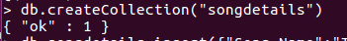

3)Create the above 5 songs

> db.songdetails.insert({"Song Name":"Thaniye Thananthaniye","file":"Rhythm","Music Director":"A.R.Rahman","Singer":"Shankar mahadevan"})
WriteResult({ "nInserted" : 1 })
> db.songdetails.insert({"Song Name":"Evano oruvan","file":"Alai payuthe","Music Director":"A.R.Rahman","Singer":"Swarnalatha"})
WriteResult({ "nInserted" : 1 })
> db.songdetails.insert({"Song Name":"Roja poonthooddam","file":"Kannukkul nilavu","Music Director":"Ilaiyaraja","Singer":"unnikrishnan,Anuradha Sriram"})
WriteResult({ "nInserted" : 1 })
> db.songdetails.insert({"Song Name":"Vennilave venilave vinnaithaandi","file":"Minsarak kanavu","Music Director":"A.R.Rahman","Singer":"Hariharan,Sadhana Sargam"})
WriteResult({ "nInserted" : 1 })
> db.songdetails.insert({"Song Name":"Sollamal thottu chellum thendral","file":"Dheena","Music Director":"Yuvan Shankar Raja","Singer":"Hariharan"})
WriteResult({ "nInserted" : 1 })

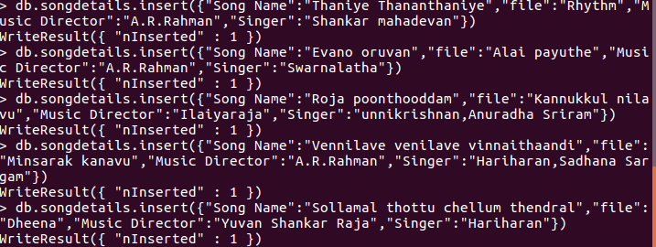

4)List all documents created

> db.songdetails.find().pretty()
{
"_id" : ObjectId("5c34d6224e646d535dfa0ac6"),
"Song Name" : "Thaniye Thananthaniye",
"file" : "Rhythm",
"Music Director" : "A.R.Rahman",
"Singer" : "Shankar mahadevan"
}
{
"_id" : ObjectId("5c34d7a44e646d535dfa0ac7"),
"Song Name" : "Evano oruvan",
"file" : "Alai payuthe",
"Music Director" : "A.R.Rahman",
"Singer" : "Swarnalatha"
}
{
"_id" : ObjectId("5c34da444e646d535dfa0ac8"),
"Song Name" : "Roja poonthooddam",
"file" : "Kannukkul nilavu",
"Music Director" : "Ilaiyaraja",
"Singer" : "unnikrishnan,Anuradha Sriram"
}
{
"_id" : ObjectId("5c34dad04e646d535dfa0ac9"),
"Song Name" : "Vennilave venilave vinnaithaandi",
"file" : "Minsarak kanavu",
"Music Director" : "A.R.Rahman",
"Singer" : "Hariharan,Sadhana Sargam"
}
{
"_id" : ObjectId("5c34db3c4e646d535dfa0aca"),
"Song Name" : "Sollamal thottu chellum thendral",
"file" : "Dheena",
"Music Director" : "Yuvan Shankar Raja",
"Singer" : "Hariharan"
}

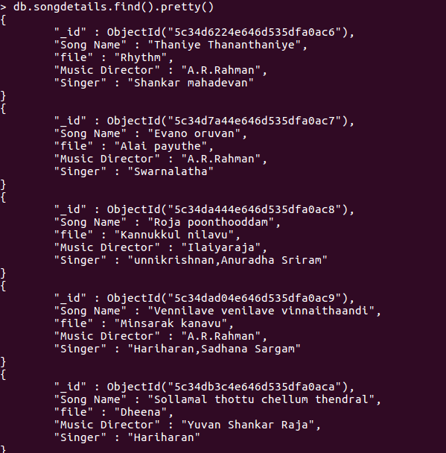

5)List A.R.Rahman songs

> db.songdetails.find({"Music Director":"A.R.Rahman"})
{ "_id" : ObjectId("5c34d6224e646d535dfa0ac6"), "Song Name" : "Thaniye Thananthaniye", "file" : "Rhythm", "Music Director" : "A.R.Rahman", "Singer" : "Shankar mahadevan" }
{ "_id" : ObjectId("5c34d7a44e646d535dfa0ac7"), "Song Name" : "Evano oruvan", "file" : "Alai payuthe", "Music Director" : "A.R.Rahman", "Singer" : "Swarnalatha" }
{ "_id" : ObjectId("5c34dad04e646d535dfa0ac9"), "Song Name" : "Vennilave venilave vinnaithaandi", "file" : "Minsarak kanavu", "Music Director" : "A.R.Rahman", "Singer" : "Hariharan,Sadhana Sargam" }

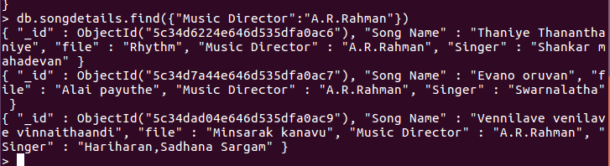

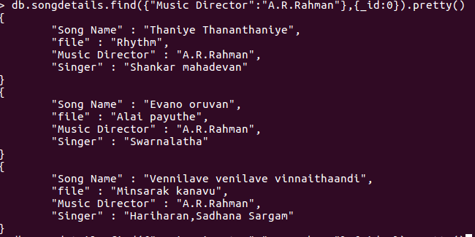

7) Delete the song which you don’t like.
> db.songdetails.remove({"Song Name" : "Roja poonthooddam"})
WriteResult({ "nRemoved" : 1 })
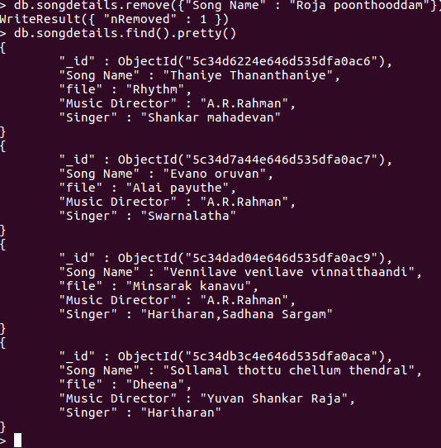

8) Add new song which is your favourite.

> db.songdetails.insert({"Song Name":"Roja poonthooddam","file":"Kannukkul nilavu","Music Director":"Ilaiyaraja","Singer":["unnikrishnan","Anuradha Sriram"]})
WriteResult({ "nInserted" : 1 })

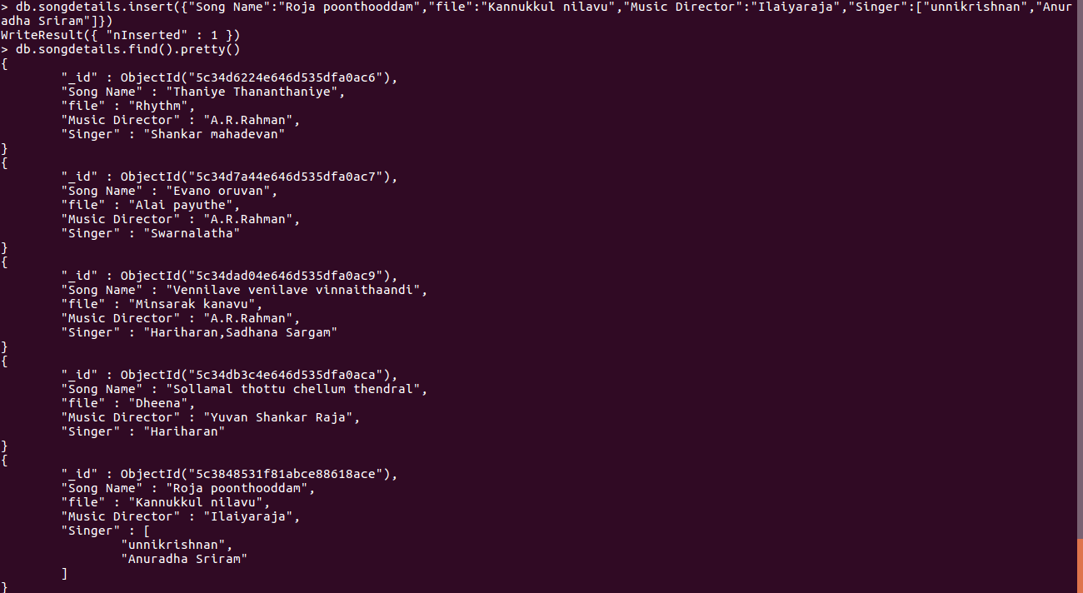

9) List Songs sung by Hariharan from Minsara kanavu film.

10)List out the singers’ names in your document.
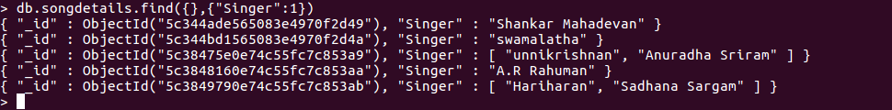
> db.songdetails.find({},{"Singer”}).pretty()

