- Create a custom module which returns the sum and average of any two numbers passed into it. Require the module and run the server by passing 123 and 321 so that the server prints out the sum and average.

var http = require('http');
var sums = require('./mydata')
http.createServer(function (req, res) {
res.writeHead(200, {'Content-Type': 'text/html'});
res.write('Sum of two numbers is :' + sums.sumAndAverage(123, 321));
res.end();
}).listen(8000);

exports.sumAndAverage = function(a,b){
var sum = a+b;
var avg = a+b/2
return 'The sum is: '+ sum +"& Average is:" + avg
}

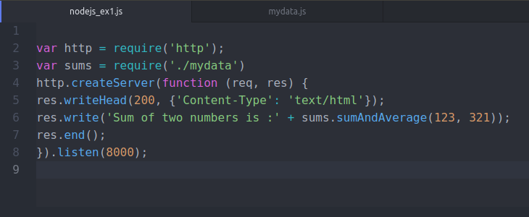

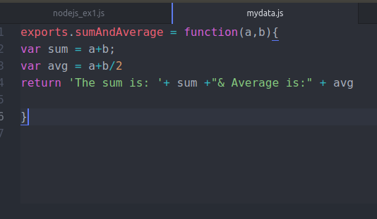
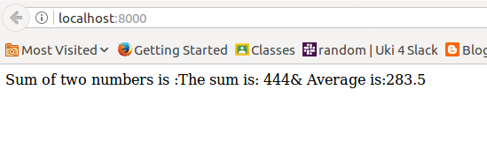

- Create a simple http server and print “Welcome to Uki. I am yourname” when a request is sent to your server via the port 8000. (Note - Change different port numbers and check)

var http = require('http');
http.createServer(function (req, res) {
res.writeHead(200, {'Content-Type': 'text/html'});
res.write('Welcome to Uki. I am Araphi');
res.end();
}).listen(8000);

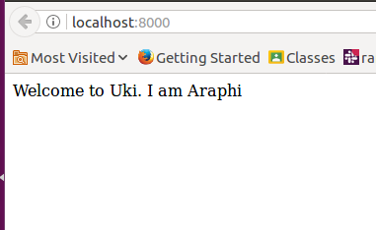

- Using the file system module create a new file called ukinode.txt
3.1 Write a paragraph about Uki into that file

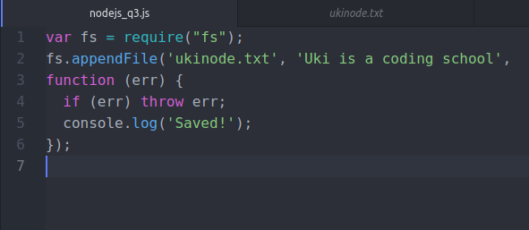
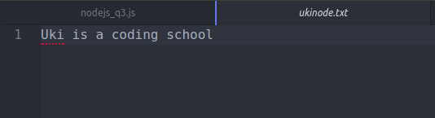

3.2 Serve that file to the client (Read File) over your server

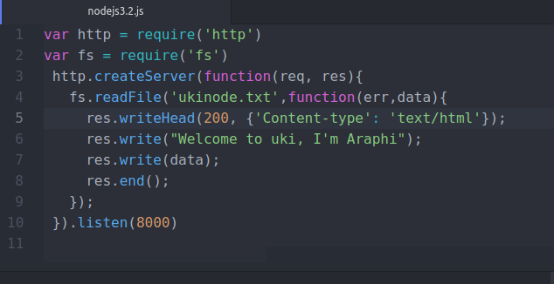
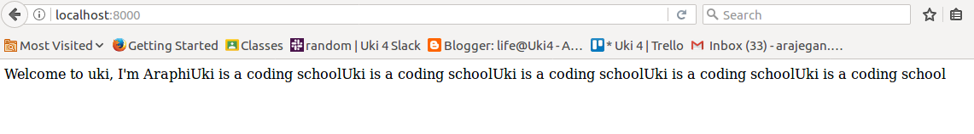
3.3 Append another paragraph about Uki and now serve the new file

var fs = require('fs');
fs.appendFile('ukinode.txt','uki is situvated in Nallur,Jaffna. It is a full stack development course for 6 months.There are two clubs. They are gavel club and fitness club.',
function (err){
if (err) throw err;
console.log('Updated!');
});
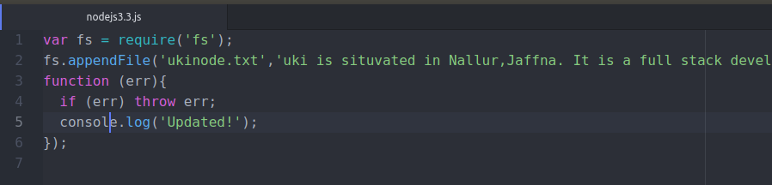
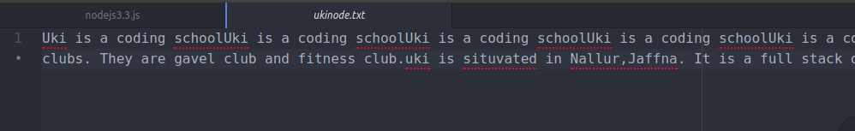

3.4 Rename the file as ukinodejsexercise1.txt

var fs = require('fs');
fs.rename('ukinode.txt','ukinodejsexercise1.txt',
function (err){
if (err) throw err;
console.log('file renamed!');
});
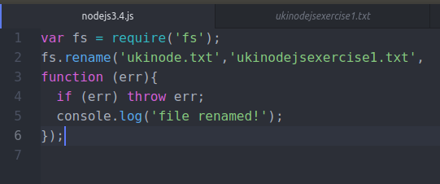

3.5 Delete the file you created

4. Create two html files called head.html which is a web page which says ‘you have got head ‘ and tail.html which is a web page which says ‘you have got tail’ and save them in the same folder as your node.js files. Create a Node.js file that opens the requested file and returns the content to the client. If anything goes wrong, throw a 404 error.
If you have followed the correct steps you should see two different results when opening these two addresses:
http://localhost:8080/head.html - > You have got head
http://localhost:8080/tail.html -> You have got tail

