DOCUMENTATION

ASSIGNMENT 3

STUDENT NAME: Andreican Rares
GROUP: 30422

CONTENTS

1. Assignment Objective 1
2. Problem Analysis, Modeling, Scenarios, Use Cases 1
3. Design 9
4. Implementation 11
5. Conclusions 27
6. Bibliography 27

Assignment Objective
Main objective:
- The main objective is to design and implement an application for managing the client orders for a warehouse
Sub-objectives:
- The user can make CRUD operations on clients, products and can create orders.
- The user can select a client and the products for the order and also select the quantity for each product in the order. If the selected quantity is greater than the sock for that product, a warning is displayed. After creating an order the stock is decremented.
- After each successfully placed order, a bill is generated.

Problem Analysis, Modeling, Scenarios, Use Cases
Functional Requirements:
- The application should allow the user to select what window to display next: operations for clients, products, create a new order or view the bills.
- After that, each specific window provides intuitive components to allow the user to perform the desired CRUD operations on the database.

Non-Functional Requirements:
- The application should be intuitive and easy to use;
- The application should provide a quick response to use inputs;
- The application should handle edge cases gracefully and display friendly error messages;

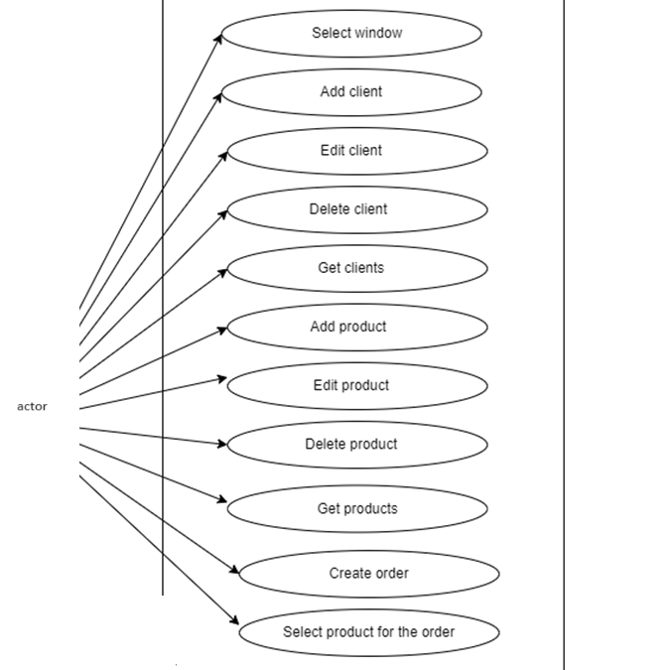

Use Case: select window
Primary Actor: employee
Main Success Scenario:
1. The employee clicks one of the buttons from the main window: clients, products, create new order or view bills.
2. If the employee chose “clients” then it will be directed to a window where it could insert, edit, delete or get all clients in a table.
3. If the employee chose “products” then it will be directed to a window where it could insert, edit, delete or get all products in a table.
4. If the employee chose “create new order” then it will be directed to a window where it could select the client for which the new order is and then it could select the products and their corresponding quantity for that order.
5. If the employee chose “view bills” then it will be directed to a window where it could view all the bills in a table.

Use Case: add product
Primary Actor: employee
Main Success Scenario:
1. The employee selects the option to add a new product
2. The application will display a form in which the product details
should be inserted
3. The employee inserts the name of the product, its price and
current stock
4. The employee clicks on the “Add” button
5. The application stores the product data in the database and
displays an acknowledge message
Alternative Sequence: Invalid values for the product’s data
- The user inserts a negative value for the stock of the product
- The application displays an error message and requests the user to
insert a valid stock
- The scenario returns to step 3

Use Case: edit product
Primary Actor: employee
Main Success Scenario:
1. The employee selects the option to edit a product
2. The application will display a form in which the updated product details
should be inserted
3. The employee inserts the new data for the product to be updated.
4. The employee clicks on the “Edit” button
5. The application stores the product data in the database and
displays an acknowledge message
Alternative Sequence: Invalid values for the product’s data
- The user inserts a negative value for the stock of the product
- The application displays an error message and requests the user to
insert a valid stock
- The scenario returns to step 3

Use Case: delete product
Primary Actor: employee
Main Success Scenario:
1. The employee selects the option to delete a product
2. The application will display a form in which the product details
should be inserted
3. The employee inserts the id of the product to be deleted
4. The employee clicks on the “Delete” button
5. The application displays an acknowledge message

Use Case: get products
Primary Actor: employee
Main Success Scenario:
1. The employee selects the option to get all products
2. The application will display a table with all the products in the database and their properties.

Use Case: add client
Primary Actor: employee
Main Success Scenario:
1. The employee selects the option to add a new client
2. The application will display a form in which the client details
should be inserted
3. The employee inserts the name of the client and its email.
4. The employee clicks on the “Insert” button
5. The application stores the client data in the database and
displays an acknowledge message
Alternative Sequence: Invalid values for the client’s data
- The user inserts an invalid email
- The application displays an error message and requests the user to
insert a valid stock
- The scenario returns to step 3

Use Case: edit client
Primary Actor: employee
Main Success Scenario:
1. The employee selects the option to edit a client
2. The application will display a form in which the updated client details
should be inserted
3. The employee inserts the new data for the client to be updated.
4. The employee clicks on the “Edit” button
5. The application stores the client data in the database and
displays an acknowledge message
Alternative Sequence: Invalid values for the client’s data
- The user inserts an invalid email
- The application displays an error message and requests the user to
insert a valid stock
- The scenario returns to step 3

Use Case: delete client
Primary Actor: employee
Main Success Scenario:
1. The employee selects the option to delete a client
2. The application will display a form in which the client details
should be inserted
3. The employee inserts the id of the client to be deleted
4. The employee clicks on the “Delete” button
5. The application displays an acknowledge message

Use Case: get clients
Primary Actor: employee
Main Success Scenario:
1. The employee selects the option to get all clients
2. The application will display a table with all the clients in the database and their properties.

Use Case: create order
Primary Actor: employee
Main Success Scenario:
1. The employee selects the option to create a new order
2. The application will display a combo box for selecting the client for which the new order is
3. The employee inserts the name of the product, its price and
4. The employee clicks on the name of the client in order to select it for the new order.
5. The application displays a radio button corresponding to the products in the database.
6. The employee clicks on the desired product for the order and a pop-up window will allow the employee to select the desired quantity for that product in the order.
7. The employee can select multiple products for an order.
8. The employee clicks the “create order" button.
Alternative Sequence: Invalid values for the product’s quantity
- The user inserts a negative value for the quantity of the product
- The user inserts a decimal value for the quantity of the product
- The user inserts a value for the quantity of the product greater than the product stock

- The application displays an error message and requests the user to
insert a valid quantity
- The scenario returns to step 6

Design

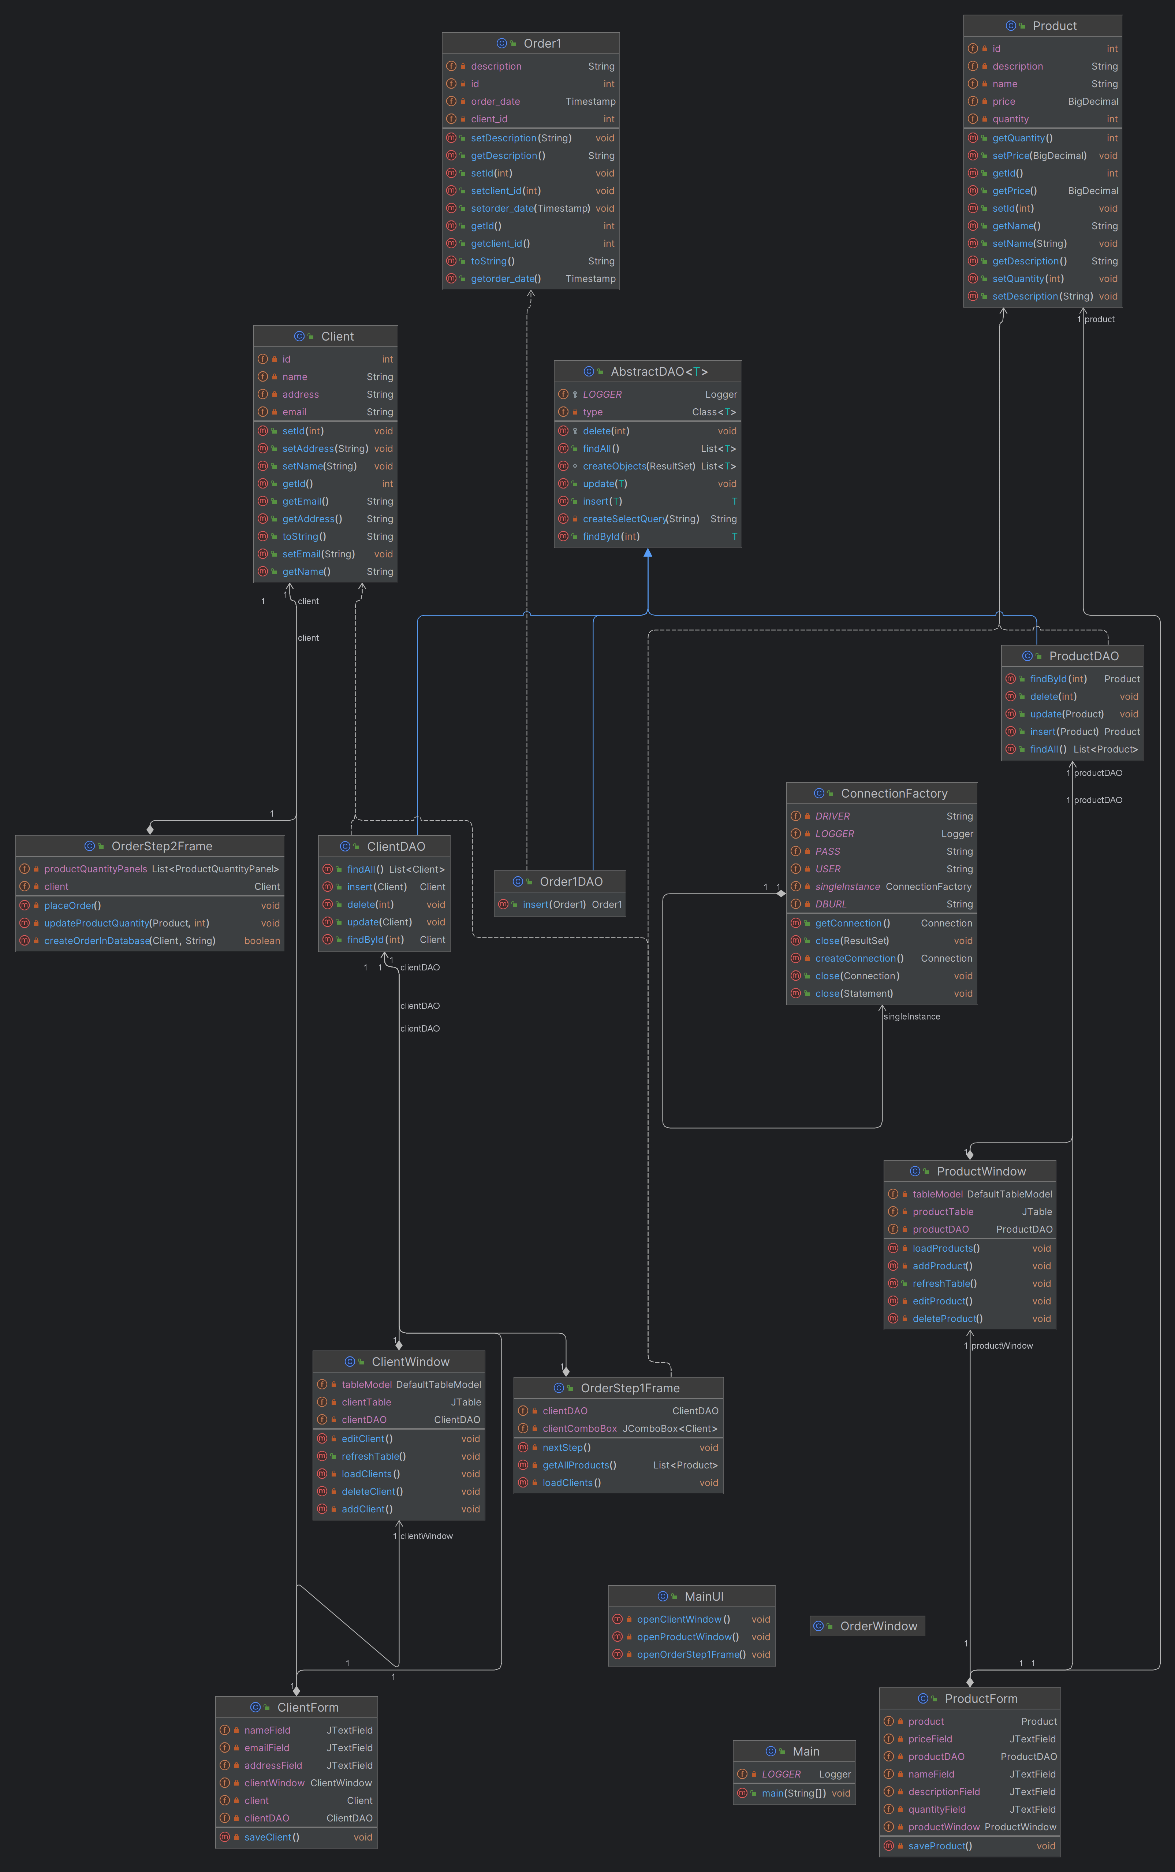

Implementation
Class: AbstractDAO<T>
Description:
The AbstractDAO class is a generic Data Access Object (DAO) that provides common database operations such as retrieving all records, finding records by ID, inserting new records, updating existing records, and deleting records by ID. It is designed to work with any type of entity class.

Fields:
- LOGGER:
Type: Logger
Description: Logger for logging messages and errors.

- type:
Type: Class<T>
Description: The class type of the entity that this DAO manages.

Constructor:
- AbstractDAO()
Description:
Initializes the DAO by determining the class type of the entity.

Methods:
- findAll()
Description:
Retrieves all records from the database table corresponding to the entity type.
Returns:
List<T> - A list of all entities.

- findById(int id)
Description:
Retrieves a record by its ID.
Parameters:
id - The ID of the record to retrieve.
Returns:
T - The entity with the specified ID, or null if not found.
Throws:
May log an SQL exception if an error occurs during retrieval.

- insert(T entity)
Description:
Inserts a new record into the database table.
Parameters:
entity - The entity to insert.
Returns:
T - The inserted entity with its ID set.
Throws:
May log SQL, introspection, or invocation target exceptions if an error occurs during insertion.

- update(T entity)
Description:
Updates an existing record in the database table.
Parameters:
entity - The entity with updated values.
Throws:
May log SQL, introspection, or invocation target exceptions if an error occurs during the update.

- delete(int id)
Description:
Deletes a record by its ID.
Parameters:
id - The ID of the record to delete.
Throws:
May log an SQL exception if an error occurs during deletion.

- createSelectQuery(String field)
Description:
Creates a SQL query to select a record based on a specific field.
Parameters:
field - The field name to use in the WHERE clause.
Returns:
String - The SQL select query.

- createObjects(ResultSet resultSet)
Description:
Converts a ResultSet into a list of entities.
Parameters:
resultSet - The ResultSet obtained from a database query.
Returns:
List<T> - A list of entities created from the ResultSet.
Throws:
May log exceptions if errors occur during object creation.

Class: ClientDAO
Description:
The ClientDAO class extends AbstractDAO to provide database operations specifically for Client entities. It includes methods for retrieving clients by ID, inserting new clients, updating existing clients, deleting clients by ID, and retrieving all clients.

Constructor:
- ClientDAO()
Description:
Initializes the DAO for Client entities.

Methods:
- findById(int clientId)
Description:
Retrieves a client by its ID.
Parameters:
clientId - The ID of the client to retrieve.
Returns:
Client - The client with the specified ID.
Throws:
May log an SQL exception if an error occurs during retrieval.

- insert(Client newClient)
Description:
Inserts a new client into the database.
Parameters:
newClient - The client to insert.
Returns:
Client - The inserted client with its ID set.
Throws:
May log SQL, introspection, or invocation target exceptions if an error occurs during insertion.

- update(Client clientWithUpdatedValues)
Description:
Updates an existing client in the database.
Parameters:
clientWithUpdatedValues - The client with updated values.
Throws:
May log SQL, introspection, or invocation target exceptions if an error occurs during the update.

- delete(int id)
Description:
Deletes a client by its ID.
Parameters:
id - The ID of the client to delete.
Throws:
May log an SQL exception if an error occurs during deletion.

- findAll()
Description:
Retrieves all clients from the database.
Returns:
List<Client> - A list of all clients.
Throws:
May log an SQL exception if an error occurs during retrieval.

Class: ConnectionFactory
Description:
The ConnectionFactory class provides methods for establishing and managing database connections using JDBC. It includes methods for obtaining a connection, closing a connection, closing a statement, and closing a ResultSet.

Fields:
- LOGGER:
Type: Logger
Description: Logger for logging messages and errors.

- DRIVER:
Type: String
Description: JDBC driver class name.

- DBURL:
Type: String
Description: URL of the database.

- USER:
Type: String
Description: Username for connecting to the database.

- PASS:
Type: String
Description: Password for connecting to the database.

Singleton Instance:
- singleInstance:
Type: ConnectionFactory
Description: Singleton instance of ConnectionFactory.

Constructor:
- ConnectionFactory()
Description:
Initializes the ConnectionFactory and loads the JDBC driver class.

Methods:
- createConnection()
Description:
Creates and returns a new database connection.
Returns:
Connection - A new database connection.
Throws:
May log an SQL exception if an error occurs during connection creation.

- getConnection()
Description:
Retrieves a connection to the database.
Returns:
Connection - A connection to the database.

- close(Connection connection)
Description:
Closes the provided database connection.
Parameters:
connection - The connection to close.

- close(Statement statement)
Description:
Closes the provided statement.
Parameters:
statement - The statement to close.

- close(ResultSet resultSet)
Description:
Closes the provided ResultSet.
Parameters:
resultSet - The ResultSet to close.

Class: Client
Description:
The Client class represents a client entity with properties such as ID, name, email, and address.

Fields:
- id:
Type: int
Description: The unique identifier of the client.

- name:
Type: String
Description: The name of the client.

- email:
Type: String
Description: The email address of the client.

- address:
Type: String
Description: The address of the client.

Constructor:
- Client()
Description:
Default constructor for the Client class.

- Client(String name, String email, String address)
Description:
Parameterized constructor for the Client class.
Parameters:
name - The name of the client.
email - The email address of the client.
address - The address of the client.

Methods:
- getId()
Description:
Gets the ID of the client.
Returns:
int - The ID of the client.

- setId(int id)
Description:
Sets the ID of the client.
Parameters:
id - The ID to set.

- getName()
Description:
Gets the name of the client.
Returns:
String - The name of the client.

- setName(String name)
Description:
Sets the name of the client.
Parameters:
name - The name to set.

- getEmail()
Description:
Gets the email address of the client.
Returns:
String - The email address of the client.

- setEmail(String email)
Description:
Sets the email address of the client.
Parameters:
email - The email address to set.

- getAddress()
Description:
Gets the address of the client.
Returns:
String - The address of the client.

- setAddress(String address)
Description:
Sets the address of the client.
Parameters:
address - The address to set.

- toString()
Description:
Returns a string representation of the client, which is its name.

Class: Order1
Description:
The Order1 class represents an order entity with properties such as ID, client ID, order date, and description.

Fields:
- id:
Type: int
Description: The unique identifier of the order.

- client_id:
Type: int
Description: The ID of the client associated with the order.

- order_date:
Type: Timestamp
Description: The timestamp indicating the date and time when the order was placed.

- description:
Type: String
Description: A description of the order.

Constructor:
- Order1()
Description:
Default constructor for the Order1 class.

- Order1(int client_id, Timestamp order_date, String description)
Description:
Parameterized constructor for the Order1 class.
Parameters:
client_id - The ID of the client associated with the order.
order_date - The timestamp indicating the date and time when the order was placed.
description - A description of the order.

Methods:
- getId()
Description:
Gets the ID of the order.
Returns:
int - The ID of the order.

- setId(int id)
Description:
Sets the ID of the order.
Parameters:
id - The ID to set.

- getClientId()
Description:
Gets the client ID associated with the order.
Returns:
int - The client ID associated with the order.

- setClientId(int client_id)
Description:
Sets the client ID associated with the order.
Parameters:
client_id - The client ID to set.

- getOrderDate()
Description:
Gets the order date.
Returns:
Timestamp - The timestamp indicating the date and time when the order was placed.

- setOrderDate(Timestamp order_date)
Description:
Sets the order date.
Parameters:
order_date - The timestamp to set as the order date.

- getDescription()
Description:
Gets the description of the order.
Returns:
String - The description of the order.

- setDescription(String description)
Description:
Sets the description of the order.
Parameters:
description - The description to set.

- toString()
Description:
Returns a string representation of the order, including its ID, client ID, order date, and description.

Package: UI
Description:
The UI package contains classes for creating graphical user interfaces (GUI) for managing clients, orders, and products in the application.

Class: OrderStep2Frame
Description:
The OrderStep2Frame class represents a frame for selecting products and quantities to place an order for a specific client. It allows the user to choose products from a list and specify quantities for each product.

Fields:
- productQuantityPanels:
Type: List<ProductQuantityPanel>
Description: A list of panels, each representing a product and its associated quantity input field.

- client:
Type: Client
Description: The client for whom the order is being placed.

Constructor:
- OrderStep2Frame(Client client, List<Product> products)
Description:
Initializes the OrderStep2Frame GUI with the specified client and a list of products.
Sets up the frame title, size, and location.
Creates panels for each product with quantity input fields.
Adds a "Place Order" button with an action listener for initiating the order placement process.

Methods:
- placeOrder()
Description:
Validates the quantities entered for each product.
If all quantities are valid, creates an order in the database and updates product quantities.
Closes the frame upon successful order placement or displays an error message if the process fails.

- createOrderInDatabase(Client client, String description): boolean
Description:
Inserts a new order into the database with the specified client and order description.
Returns true if the order creation is successful; otherwise, returns false.

- updateProductQuantity(Product product, int quantity)
Description:
Updates the quantity of a product in the database after an order is placed.
Calculates the new quantity based on the quantity ordered and subtracts it from the existing quantity.

Inner Class: ProductQuantityPanel
Description:
Represents a panel containing a product name label and a quantity input field.

Fields:
- product:
Type: Product
Description: The product associated with the panel.

- quantityField:
Type: JTextField
Description: Text field for entering the quantity of the associated product.

Constructor:
- ProductQuantityPanel(Product product)
Description:
Initializes the panel with the specified product.
Sets up a label displaying the product name and current quantity, along with a text field for entering the quantity.

Methods:
- isValidQuantity(): boolean
Description:
Checks if the quantity entered in the text field is valid (non-negative and not exceeding the available quantity).
Returns true if the quantity is valid; otherwise, returns false.
Package: UI
Description:
The UI package contains classes for creating graphical user interfaces (GUI) for managing clients, orders, and products in the application.

Class: ProductForm
Description:
The ProductForm class represents a dialog window for adding or editing product information. It allows users to input product details such as name, description, price, and quantity.

Fields:
- nameField:
Type: JTextField
Description: Text field for entering the product's name.

- descriptionField:
Type: JTextField
Description: Text field for entering the product's description.

- priceField:
Type: JTextField
Description: Text field for entering the product's price.

- quantityField:
Type: JTextField
Description: Text field for entering the product's quantity. (New field added)

- productDAO:
Type: ProductDAO
Description: Data Access Object for performing CRUD operations on Product entities in the database.

- productWindow:
Type: ProductWindow
Description: Reference to the parent ProductWindow.

- product:
Type: Product
Description: The product whose information is being edited. Null if adding a new product.

Constructor:
- ProductForm(ProductWindow productWindow, String title, Product product)
Description:
Initializes the ProductForm dialog window.
Parameters:
productWindow - The parent ProductWindow.
title - The title of the dialog window.
product - The product whose information is being edited. Null if adding a new product.

Methods:
- saveProduct()
Description:
Saves the product information to the database.
If the product is null, a new product is inserted. Otherwise, the existing product is updated.
After saving, refreshes the product table in the parent window and closes the dialog window.

Conclusions
What have I learned:
- The 4 layers architectural pattern
- Reflection technique
- Generic classes
- Working with a database from a Java application

Future developments:Adding more possible operations

Bibliography
- PT Course from TUCN - https://dsrl.eu/courses/pt/

