DOCUMENTATION

ASSIGNMENT ASSIGNMENT_1

STUDENT NAME: ANDREICAN RARES
GROUP: 30422

CONTENTS

1. Assignment Objective 3
2. Problem Analysis, Modeling, Scenarios, Use Cases 3
3. Design 3
4. Implementation 3
5. Results 3
6. Conclusions 3
7. Bibliography 3

Assignment Objective
The main objective is to design a polynomial calculator with a GUI. A user can insert polynomials and can use different operations(selected through radio buttons): addition, subtraction, division, multiplication, differentiation and integration.
Sub-objectives of this assignment would be represented by the use of Swing for GUI, asserting the correctness of the input and the correct implementation of the operations.

Problem Analysis, Modeling, Scenarios, Use Cases
Functional Requirements:

The polynomial calculator must allow users to input two polynomials as strings, mimicking conventional notation.
Users should be able to select desired mathematical operations to perform on the input polynomials.

Non-Functional Requirements:

The calculator must be user-friendly and intuitive.
It should provide prompt responses to user inputs.

Use cases:
- Addition:
  - Actor: User
  - Description: The user intends to add two polynomials.
  - Preconditions: The user has initiated the polynomial calculator and provided two polynomials as strings.
  - Steps:
    - The user inputs the first polynomial.
    - The user selects the addition operation.
    - The user inputs the second polynomial.
    - The user clicks the "Compute" button.
  - Postconditions: The calculator exhibits the result of the addition operation.
- Subtraction:
  - Actor: User
  - Description: The user wishes to subtract one polynomial from another.
  - Preconditions: The user has launched the polynomial calculator and inserted two polynomials as strings.
  - Steps:
    - The user inputs the first polynomial.
    - The user selects the subtraction operation.
    - The user inputs the second polynomial.
    - The user clicks the "Compute" button.
  - Postconditions: The calculator presents the result of the subtraction operation.
- Multiplication:
  - Actor: User
  - Description: The user aims to multiply two polynomials.
  - Preconditions: The user has activated the polynomial calculator and provided two polynomials as strings.
  - Steps:
    - The user inputs the first polynomial.
    - The user selects the multiplication operation.
    - The user inputs the second polynomial.
    - The user clicks the "Compute" button.
  - Postconditions: The calculator exhibits the result of the multiplication operation.
- Division:
  - Actor: User
  - Description: The user desires to divide one polynomial by another.
  - Preconditions: The user has opened the polynomial calculator and entered two polynomials as strings.
  - Steps:
    - The user inputs the first polynomial.
    - The user selects the division operation.
    - The user inputs the second polynomial.
    - The user clicks the "Compute" button.
  - Postconditions: The calculator displays the result of the division operation, or manages division by zero gracefully if applicable.
- Differentiation:
  - Actor: User
  - Description: The user intends to differentiate a polynomial.
  - Preconditions: The user has launched the polynomial calculator and entered a polynomial as a string.
  - Steps:
    - The user inputs the polynomial to be differentiated.
    - The user selects the differentiation operation.
    - The user clicks the "Compute" button.
  - Postconditions: The calculator exhibits the result of the differentiation operation.
- Integration:
  - Actor: User
  - Description: The user wants to integrate a polynomial.
  - Preconditions: The user has initiated the polynomial calculator and provided a polynomial as a string.
  - Steps:
    - The user inputs the polynomial to be integrated.
    - The user selects the integration operation.
    - The user clicks the "Compute" button.
  - Postconditions: The calculator presents the result of the integration operation.

Design
The project uses the MVC to design a Polynomial Calculator. We can imagine it as being a black box with 3 inputs and one output. The data structure used to store the polynomial is a HashMap. The UML can be seen in the .poml file in src.
UML:
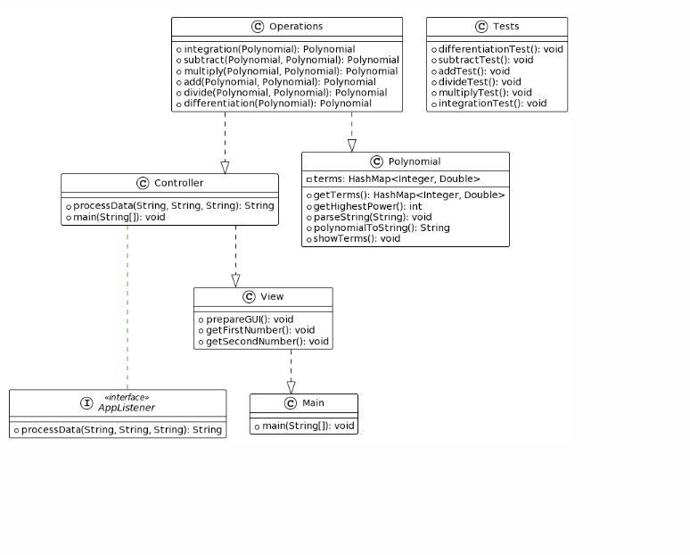

Implementation
Classes:
}
class Controller {
+ processData(String, String, String): String
+ main(String[]): void
}
class Main {
+ main(String[]): void
}
class Operations {
+ integration(Polynomial): Polynomial
+ subtract(Polynomial, Polynomial): Polynomial
+ multiply(Polynomial, Polynomial): Polynomial
+ add(Polynomial, Polynomial): Polynomial
+ divide(Polynomial, Polynomial): Polynomial
+ differentiation(Polynomial): Polynomial
}
class Polynomial {
- terms: HashMap<Integer, Double>
+ getTerms(): HashMap<Integer, Double>
+ getHighestPower(): int
+ parseString(String): void
+ polynomialToString(): String
+ showTerms(): void
}
class Tests {
+ differentiationTest(): void
+ subtractTest(): void
+ addTest(): void
+ divideTest(): void
+ multiplyTest(): void
+ integrationTest(): void
}
class View {
+ prepareGUI(): void
+ getFirstNumber(): void
+ getSecondNumber(): void
}

Controller:
- processData(String, String, String): String
  - Accepts three strings representing polynomial expressions as input.
  - Coordinates the processing of polynomial operations by invoking appropriate methods from the Operations class.
  - Returns a string representing the result of the requested operation.
- main(String[]): void
  - Entry point of the controller class.
  - Initializes necessary components and begins processing user input.
Main:
- main(String[]): void
  - Entry point of the application.
  - Initializes the controller and invokes its main method to start the application.
Operations:
- integration(Polynomial): Polynomial
  - Performs integration on the provided polynomial.
  - Returns the result polynomial after integration.
- subtract(Polynomial, Polynomial): Polynomial
  - Subtracts the second polynomial from the first polynomial.
  - Returns the result polynomial after subtraction.
- multiply(Polynomial, Polynomial): Polynomial
  - Multiplies two polynomials together.
  - Returns the result polynomial after multiplication.
- add(Polynomial, Polynomial): Polynomial
  - Adds two polynomials together.
  - Returns the result polynomial after addition.
- divide(Polynomial, Polynomial): Polynomial
  - Divides the first polynomial by the second polynomial.
  - Returns the result polynomial after division.
- differentiation(Polynomial): Polynomial
  - Performs differentiation on the provided polynomial.
  - Returns the result polynomial after differentiation.
Polynomial:
- getTerms(): HashMap<Integer, Double>
  - Retrieves the terms of the polynomial as a HashMap containing the power of each term and its corresponding coefficient.
- getHighestPower(): int
  - Determines the highest power present in the polynomial.
- parseString(String): void
  - Parses a string representation of a polynomial and populates the terms HashMap accordingly.
- polynomialToString(): String
  - Converts the polynomial into a string representation.
- showTerms(): void
  - Displays the terms of the polynomial. ( a debugging function ).
Tests:
- differentiationTest(): void
  - Tests the differentiation operation on polynomials.
- subtractTest(): void
  - Tests the subtraction operation on polynomials.
- addTest(): void
  - Tests the addition operation on polynomials.
- divideTest(): void
  - Tests the division operation on polynomials.
- multiplyTest(): void
  - Tests the multiplication operation on polynomials.
- integrationTest(): void
  - Tests the integration operation on polynomials.
View:
- prepareGUI(): void
  - Sets up the graphical user interface for the application.
- getFirstNumber(): void
  - Retrieves input for the first polynomial from the user.
- getSecondNumber(): void
  - Retrieves input for the second polynomial from the user.
I n the View class, the graphical user interface (GUI) is set up using JFrame, a class in Java's Swing framework for creating and managing windows. Here's how JFrame is handled in the View class:
- prepareGUI(): void
  - This method sets up the JFrame window, including its size, title, layout, and other properties.
  - It initializes components such as buttons, inputs, and radio buttons, and adds them to the JFrame's content pane.
  - It also configures event listeners for the components to handle user interactions.
- Components:
  - Buttons: Buttons are added to perform actions such as submitting polynomial expressions or executing operations. Event listeners are attached to these buttons to trigger actions when clicked.
  - Inputs: Text fields or text areas are provided for users to input polynomial expressions. These inputs are used as operands for polynomial operations.
  - Radio Button Group: Radio buttons are grouped together to allow users to select the type of operation they want to perform (e.g., addition, subtraction, multiplication). A ButtonGroup is used to ensure that only one radio button can be selected at a time.
- Event Listeners:
  - ActionListeners are typically added to buttons to handle button-click events. When a button is clicked, its corresponding ActionListener is invoked, triggering the associated action, such as processing the input data and displaying the result. Here, the code uses a listener for the “Compute” button.
Overall, the View class encapsulates the GUI logic using JFrame and other Swing components, providing a user-friendly interface for interacting with the polynomial calculator. By properly handling events and inputs, it ensures smooth interaction and accurate processing of polynomial operations.

Results

The Tests class contains test methods to verify the correctness of the operations implemented. Scenarios have been tested for each implemented operation, with mocked inputs and expected outputs.
All of them follow a sequence like this one:

JUnit test suites are organized into test classes, with each method representing a specific test case. For instance, a test class for addition would contain methods to verify the addition operation with different sets of polynomials. Similarly, separate test classes are created for subtraction, division, integration, differentiation, and multiplication, each containing relevant test methods.
During testing, JUnit executes these test methods automatically, checking whether the actual output matches the expected output. Any discrepancies or errors are reported, enabling developers to identify and fix issues promptly. Additionally, JUnit supports assertions to validate conditions within the test methods, ensuring that the calculator functions as intended under various circumstances.

addTest():
  - Description: Tests the addition operation.
  - Input:
    - Two polynomials:
      - p1= 4x^4+3x^3-2x^2+x-7
      - p2= 2x^3-4x^2+2x-1
  - Expected Output:
    - The result of adding p1 and p2 together, which is 4x^4+5x^3-6x^2+3x-8.
  - Explanation:
    - Parses two polynomials, adds them together using the add() method, and compares the result with the expected one.
subtractTest():
• Description: Tests the subtraction operation.
• Input:
• Two polynomials:
• p1= 4x^4+3x^3-2x^2+x-7
• p2= 2x^3-4x^2+2x-1
• Expected Output:
• The result of subtracting p2 from p1, which is 4x^4+3x^3-6x^2-1.
• Explanation:
• Parses two polynomials, subtracts the second polynomial from the first using the subtract() method, and compares the result with the expected one.

divideTest():
• Description: Tests the division operation.
• Input:
• Two polynomials:
• p1= 4x^4+3x^3-2x^2+x-7
• p2= 2x^2-1
• Expected Output:
• The result of dividing p1 by p2, which is 2x^2 + x + 3 with a remainder of -4x + 4 / (2x^2 - 1).
• Explanation:
• Parses two polynomials, divides the first polynomial by the second using the divide() method, and compares the quotient and remainder with the expected ones.

integrateTest():
• Description: Tests the integration operation.
• Input:
• A polynomial:
• p= 4x^4+3x^3-2x^2+x-7
• Expected Output:
• The result of integrating p, which is x^5 + (3/4)x^4 - (2/3)x^3 + (1/2)x^2 - 7x
• Explanation:
• Parses a polynomial, integrates it using the integrate() method, and compares the result with the expected one.

differentiateTest():
• Description: Tests the differentiation operation.
• Input:
• A polynomial:
• p= 4x^4+3x^3-2x^2+x-7
• Expected Output:
• The result of differentiating p, which is 16x^3 + 9x^2 - 4x + 1.
• Explanation:
• Parses a polynomial, differentiates it using the differentiate() method, and compares the result with the expected one.

multiplyTest():
• Description: Tests the multiplication operation.
• Input:
• Two polynomials:
• p1= 4x^4+3x^3-2x^2+x-7
• p2= 2x^3-4x^2+2x-1
• Expected Output:
• The result of multiplying p1 and p2 together, which is 8x^7 - 5x^6 + 2x^5 - 9x^4 + 22x^3 - 26x^2 + 13x - 7.
• Explanation:
• Parses two polynomials, multiplies them together using the multiply() method, and compares the result with the expected one.
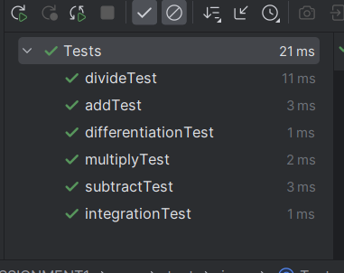

Conclusions
Here are some key points I could make about this project. It helped me with
- Application of Object-Oriented Principles:
  - Utilized classes to represent polynomials, encapsulating related functionalities within methods.
  - Enhanced code organization and reusability through object-oriented programming.
- Error Handling and Input Validation:
  - Implemented robust error handling and input validation to ensure graceful handling of unexpected inputs.
  - Enhanced user experience and prevented potential issues by validating user inputs effectively.
- Further Development:
  - Support for Different Polynomial Representations:
    - Extend the calculator to support various polynomial representations like sparse polynomials or multivariate polynomials.
    - Increase flexibility and applicability to diverse mathematical problems by accommodating different polynomial types.
  - Enhance GUI:
    - Improve the graphical user interface for the polynomial calculator to enhance usability and appeal.
    - Design a more intuitive interface for users to input polynomials and visualize results effectively.

Bibliography
PT Course from TUCN
Props to people on stackoverflow ^^

