DOCUMENTATION

ASSIGNMENT ASSIGNMENT_2

STUDENT NAME: ANDREICAN RARES BOGDAN
GROUP: 30422

CONTENTS

1. Assignment Objective 3
2. Problem Analysis, Modeling, Scenarios, Use Cases 3
3. Design 3
4. Implementation 3
5. Results 3
6. Conclusions 3
7. Bibliography 3

Assignment Objective
Main objective:
- Develop an application focused on analyzing queuing-based systems. This includes simulating the arrival of N clients, their entry into Q queues, waiting times, service times, and leave the queue after the processing time has passed.
- Compute key metrics such as average waiting time, average service time, and identify peak hours.

Sub-objectives:
- Create an intuitive interface allowing users to input parameters like the number of clients (N), queue count (Q), arrival and service time intervals, simulation duration, and selection policies.
- Build a simulation manager responsible for generating random client arrivals and service times within specified intervals.
- Simulate the queuing process, covering client arrivals, queue entry, wait times, service durations, and client departures.
- Determine the average waiting time for all clients within the system.
- Determine the average service time for clients.
- Identify peak hours using metrics like queue lengths or arrival rates.

Problem Analysis, Modeling, Scenarios, Use Cases
Functional Requirements:
- Enable users to configure the simulation parameters within the application.
- Provide the functionality to initiate the simulation process within the application.
- Display real-time updates of queue changes during the simulation.
- Create a specified number of clients (N) with random arrival and service time attributes.
- Monitor the status of each client within the system (e.g., waiting, being served, service completed).
- Present queues and current simulation time during the defined simulation interval.
- Show metrics such as average waiting time, peak hour, and average service time.

Non-Functional Requirements:
- Develop a user-friendly and responsive interface with clear controls, labels, and feedback messages.
- Ensure quick responses to user inputs, simulation controls, and result displays.
- Design for efficient handling of large simulations, considering memory usage, processing speed, and data structure scalability.
- Adhere to coding standards, modular design, and thorough documentation for code readability, maintainability, and future enhancements.

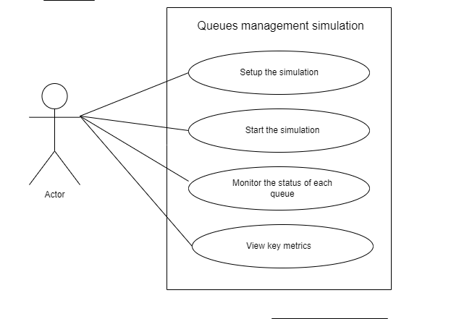
Use Case: setup the simulation
Primary Actor: user
Main Success Scenario:
1. The user inputs the number of clients, queue count, arrival time interval, service time interval, simulation duration, and selects a selection policy.
2. The arrival time interval and service time interval are entered using comma-separated interval limits.
Alternative Sequence: Invalid values for the setup parameters
  - Negative number of clients or queues
  - The simulation won’t start
  - The scenario returns to step1

Use Case: start the simulation
Primary Actor: user
Main Success Scenario:
1. The user clicks the “start” button.
2. The clients will be generated randomly and the simulation starts
3. The user can view the queues and their status in real time

Use Case: view key metrics
Main Success Scenario:
1. The user can view the servers (queues) and their evolution during the simulation time

Use Case: view key metrics
Main Success Scenario:
1. The average waiting time is displayed
2. The average service time is displayed
3. The peak hour is displayed

Although assertions are made, if inputs are not of required type(e.g. ranges are %d-%d), fail scenarios could happen:

1. Average Waiting Time Calculation Failure:
- Potential Causes:
- Incorrect data input: The input data for the simulation contains errors, such as negative values or invalid formats, leading to incorrect calculations.
- Simulation logic error: There is a bug in the simulation logic that causes incorrect waiting time calculations.
- Result:
- The system fails to calculate the average waiting time and displays an error message indicating the failure to retrieve this metric.

2. Average Service Time Calculation Failure:
- Potential Causes:
- Incomplete simulation data: The simulation data does not include complete information about service times for all tasks.
- Data corruption: The simulation data is corrupted or inaccessible, leading to errors in processing.
- Result:
- The system fails to calculate the average service time and displays an error message indicating the failure to retrieve this metric.

Design
Overall system design
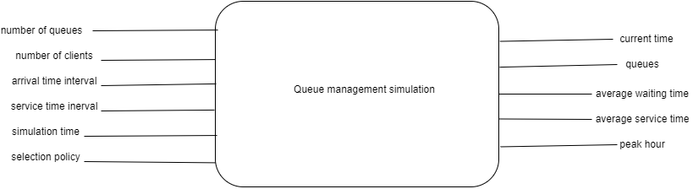

Package Diagram
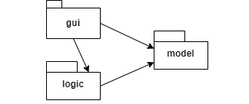

Division into classes
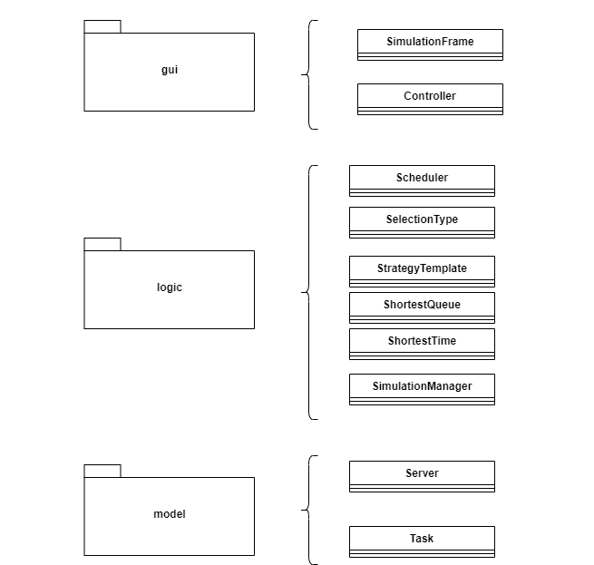

Implementation
Controller Class

Fields:
- simulationFrame: A reference to the main simulation frame.
- simulationManager: An instance of SimulationManager responsible for managing the simulation.

Constructor:
- Controller(SimulationFrame simulationFrame): Initializes the Controller with a reference to the SimulationFrame.

ActionListener Implementation:
- actionPerformed(ActionEvent e): Overrides the actionPerformed method from the ActionListener interface. This method is invoked when an action is performed, such as clicking a button.
- Retrieves the action command from the event.
- If the action command is "START":
- Retrieves input values from the simulationFrame, such as the number of clients, number of queues, arrival and service time intervals, simulation time, and selection type.
- Validates the input values with assertions.
- Creates a new instance of SimulationManager with the provided input values.
- Starts a new thread for the simulation manager.

Implementation Details:
- The Controller class serves as the intermediary between the GUI (SimulationFrame) and the simulation logic (SimulationManager).
- It listens for actions triggered in the GUI, such as clicking the "START" button.
- When the "START" button is clicked, it gathers input values from the GUI, validates them, and initiates the simulation by creating a new SimulationManager instance and starting a new thread for it.

SimulationFrame Class

Fields:
- mainPanel: JPanel for the main layout.
- clientsField: JTextField for inputting the number of clients.
- queuesField: JTextField for inputting the number of queues.
- arrivalTimeField: JTextField for inputting the arrival time interval.
- serviceTimeField: JTextField for inputting the service time interval.
- simulationTimeField: JTextField for inputting the simulation time.
- shortestTimeRadioButton: JRadioButton for selecting the shortest time selection policy.
- shortestQueueRadioButton: JRadioButton for selecting the shortest queue selection policy.
- startButton: JButton to start the simulation.
- serverStatusPane: JEditorPane for displaying the status of servers and tasks.

Constructor:
- SimulationFrame(String title): Initializes the SimulationFrame with the specified title and prepares the GUI.

prepareGUI Method:
- Creates the main layout for the SimulationFrame.
- Sets up input fields, radio buttons, and the start button.
- Adds action listeners to the start button.

displayStatus Method:
- Updates the server status pane with the current simulation status.
- Displays the current time and the status of servers and tasks.

getTasksLabel Method:
- Generates a label containing information about the tasks.

Getter Methods:
- getClientsCount(): Retrieves the number of clients from the clientsField.
- getQueuesCount(): Retrieves the number of queues from the queuesField.
- getArrivalTimeInterval(): Retrieves the arrival time interval from the arrivalTimeField.
- getServiceTimeInterval(): Retrieves the service time interval from the serviceTimeField.
- getSimulationTime(): Retrieves the simulation time from the simulationTimeField.
- getSelectionType(): Retrieves the selected selection type based on the selected radio button.

Implementation Details:
- The SimulationFrame class represents the graphical user interface (GUI) for the simulation.
- It allows users to input parameters for the simulation, such as the number of clients, number of queues, arrival and service time intervals, simulation time, and selection type.
- Users can start the simulation by clicking the "Start" button.
- The SimulationFrame also displays the status of servers and tasks during the simulation.

Scheduler Class

Fields:
- servers: ArrayList of Server objects representing the servers in the system.
- strategy: StrategyTemplate object representing the scheduling strategy to use.

Constructor:
- Scheduler(int noQueues, SelectionType policy): Initializes the Scheduler with the specified number of queues and selection policy.
- Creates and starts threads for each server in the system based on the number of queues.
- Initializes the scheduling strategy based on the specified policy.

setStrategy Method:
- Sets the scheduling strategy based on the specified selection policy.

dispatchTask Method:
- Dispatches a task to a server based on the current scheduling strategy.

getServers Method:
- Retrieves the list of servers in the system.

getNoActiveServers Method:
- Calculates and returns the number of active servers in the system.

Implementation Details:
- The Scheduler class manages the scheduling of tasks to servers in the system.
- It initializes a list of servers and sets up the scheduling strategy based on the specified selection policy.
- When a task needs to be dispatched, it delegates the task assignment to the current scheduling strategy.
- The Scheduler keeps track of the number of active servers in the system for monitoring purposes.

ShortestQueue Class

Implementation Details:
- The ShortestQueue class implements the StrategyTemplate interface and represents a scheduling strategy based on selecting the server with the shortest queue.
- When a task needs to be dispatched, the assignTask method is called.
- This method finds the server with the shortest queue by iterating through the list of servers and comparing the sizes of their queues.
- It then assigns the task to the selected server if it exists and updates the task's wait time accordingly.

ShortestTime Class

Implementation Details:
- The ShortestTime class implements the StrategyTemplate interface and represents a scheduling strategy based on selecting the server with the shortest queue.
- When a task needs to be dispatched, the assignTask method is called.
- This method finds the server with the smallest queue size by iterating through the list of servers and comparing the sizes of their queues.
- It then assigns the task to the selected server if it exists and updates the task's wait time accordingly.

SimulationManager Class

Fields:
- simulationTime: Integer representing the duration of the simulation in seconds.
- noQueues: Integer representing the number of queues in the system.
- noClients: Integer representing the number of clients in the simulation.
- tasks: LinkedBlockingQueue of Task objects representing the tasks to be processed.
- simulationFrame: Reference to the SimulationFrame for displaying status updates.
- scheduler: Instance of Scheduler for managing task scheduling.
- selectionType: SelectionType representing the selection policy used by the scheduler.

Constructor:
- SimulationManager(SimulationFrame simulationFrame, int noQueues, int noClients, int minArrivalTime, int maxArrivalTime, int minServiceTime, int maxServiceTime, int simulationTime, SelectionType selectionType): Initializes the SimulationManager with the specified parameters and generates random tasks based on the provided parameters.

generateRandomTasks Method:
- Generates random tasks with arrival and service times within the specified intervals.

clearFile Method:
- Clears the content of a file by overwriting it with an empty string.

run Method (implements Runnable):
- Runs the simulation.
- Initializes the display.txt file and writes the generated tasks to it.
- Dispatches tasks to servers based on their arrival times.
- Updates the status display on the SimulationFrame.
- Calculates peak hour, average waiting time, and average service time.
- Writes simulation statistics to the display.txt file.

Implementation Details:
- The SimulationManager class orchestrates the simulation process.
- It generates random tasks, dispatches them to servers, updates the status display, and calculates simulation statistics.
- The simulation progresses in discrete time steps, with tasks being processed based on their arrival times and server availability.
- Simulation results are written to the display.txt file for analysis and visualization.
Server Class

Fields:
- tasks: LinkedBlockingQueue of Task objects representing the tasks in the server's queue.
- waitingTime: AtomicInteger representing the total waiting time of tasks in the server's queue.
- barrier: CyclicBarrier for synchronization among multiple servers.

Constructor:
- Server(CyclicBarrier barrier): Initializes the Server with an empty task queue, a waiting time of 0, and a barrier for synchronization.

Getter Methods:
- getTasks(): Retrieves the task queue of the server.
- getWaitingTime(): Retrieves the waiting time of tasks in the server's queue.

toString Method:
- Overrides the toString method to provide a string representation of the server's task queue.

run Method (implements Runnable):
- Runs the server's task processing logic.
- Decrements the service time of the top task in the queue each second.
- Removes the top task from the queue when its service time reaches 0.
- Synchronizes with other servers using the barrier.

addTask Method:
- Adds a task to the server's queue and updates the waiting time accordingly.

isActive Method:
- Checks if the server is active (i.e., if it has tasks in its queue).

Implementation Details:
- The Server class represents a server in the system that processes tasks.
- It maintains a queue of tasks and processes them in a separate thread.
- Tasks are dequeued and processed one by one, and the waiting time of tasks is tracked.
- The Server class provides methods for adding tasks, checking if the server is active, and retrieving its status.
Task Class

Fields:
- id: Integer representing the unique identifier of the task.
- arrivalTime: Integer representing the time at which the task arrives.
- serviceTime: Integer representing the time required to process the task.
- taskWaitTime: Integer representing the total time the task spends waiting in a queue.
- initServiceTime: Integer representing the initial service time of the task.

Constructor:
- Task(int id, int arrivalTime, int serviceTime): Initializes the Task with the specified id, arrival time, and service time.

Getter Methods:
- getId(): Retrieves the id of the task.
- getArrivalTime(): Retrieves the arrival time of the task.
- getServiceTime(): Retrieves the service time of the task.
- getTaskWaitTime(): Retrieves the total waiting time of the task.
- getInitServiceTime(): Retrieves the initial service time of the task.

Setter Methods:
- setServiceTime(int serviceTime): Sets the service time of the task.

Implementation Details:
- The Task class represents a task in the system that needs to be processed by a server.
- It maintains information such as the task's id, arrival time, service time, and waiting time.
- Tasks are processed by servers in the system, and their service time is decremented over time until it reaches 0.
- The Task class provides methods for retrieving and updating task information.
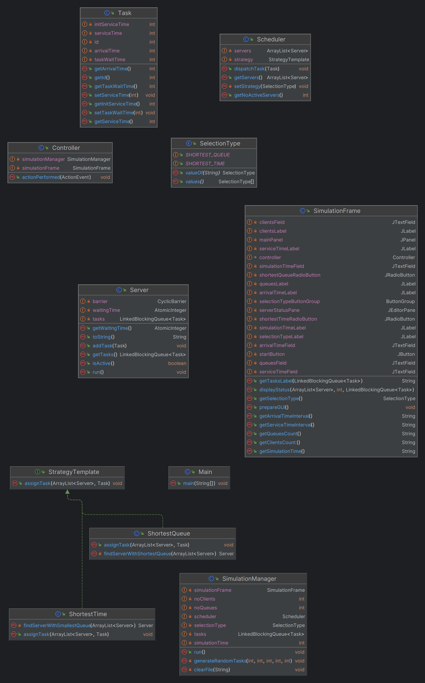
Note that his diagram can be observed in the puml file with each class in its package.

Results
The following output is generated while using the documentation’s first test:
Generated tasks:
(1,21,2)
(2,23,2)
Current time = 0
Server 1: Server Task Queue:
Server 2: Server Task Queue:
Server 3: Server Task Queue:
Server 4: Server Task Queue:
Current time = 1
Server 1: Server Task Queue:
Server 2: Server Task Queue:
Server 3: Server Task Queue:
Server 4: Server Task Queue:
Current time = 2
Server 1: Server Task Queue:
Server 2: Server Task Queue:
Server 3: Server Task Queue:
Server 4: Server Task Queue:
Current time = 3
Server 1: Server Task Queue:
Server 2: Server Task Queue:
Server 3: Server Task Queue:
Server 4: Server Task Queue:
Current time = 4
Server 1: Server Task Queue:
Server 2: Server Task Queue:
Server 3: Server Task Queue:
Server 4: Server Task Queue:
Current time = 5
Server 1: Server Task Queue:
Server 2: Server Task Queue:
Server 3: Server Task Queue:
Server 4: Server Task Queue:
Current time = 6
Server 1: Server Task Queue:
Server 2: Server Task Queue:
Server 3: Server Task Queue:
Server 4: Server Task Queue:
Current time = 7
Server 1: Server Task Queue:
Server 2: Server Task Queue:
Server 3: Server Task Queue:
Server 4: Server Task Queue:
Current time = 8
Server 1: Server Task Queue:
Server 2: Server Task Queue:
Server 3: Server Task Queue:
Server 4: Server Task Queue:
Current time = 9
Server 1: Server Task Queue:
Server 2: Server Task Queue:
Server 3: Server Task Queue:
Server 4: Server Task Queue:
Current time = 10
Server 1: Server Task Queue:
Server 2: Server Task Queue:
Server 3: Server Task Queue:
Server 4: Server Task Queue:
Current time = 11
Server 1: Server Task Queue:
Server 2: Server Task Queue:
Server 3: Server Task Queue:
Server 4: Server Task Queue:
Current time = 12
Server 1: Server Task Queue:
Server 2: Server Task Queue:
Server 3: Server Task Queue:
Server 4: Server Task Queue:
Current time = 13
Server 1: Server Task Queue:
Server 2: Server Task Queue:
Server 3: Server Task Queue:
Server 4: Server Task Queue:
Current time = 14
Server 1: Server Task Queue:
Server 2: Server Task Queue:
Server 3: Server Task Queue:
Server 4: Server Task Queue:
Current time = 15
Server 1: Server Task Queue:
Server 2: Server Task Queue:
Server 3: Server Task Queue:
Server 4: Server Task Queue:
Current time = 16
Server 1: Server Task Queue:
Server 2: Server Task Queue:
Server 3: Server Task Queue:
Server 4: Server Task Queue:
Current time = 17
Server 1: Server Task Queue:
Server 2: Server Task Queue:
Server 3: Server Task Queue:
Server 4: Server Task Queue:
Current time = 18
Server 1: Server Task Queue:
Server 2: Server Task Queue:
Server 3: Server Task Queue:
Server 4: Server Task Queue:
Current time = 19
Server 1: Server Task Queue:
Server 2: Server Task Queue:
Server 3: Server Task Queue:
Server 4: Server Task Queue:
Current time = 20
Server 1: Server Task Queue:
Server 2: Server Task Queue:
Server 3: Server Task Queue:
Server 4: Server Task Queue:
Current time = 21
Server 1: Server Task Queue:
(1,21,2)
Server 2: Server Task Queue:
Server 3: Server Task Queue:
Server 4: Server Task Queue:
Current time = 22
Server 1: Server Task Queue:
(1,21,1)
Server 2: Server Task Queue:
Server 3: Server Task Queue:
Server 4: Server Task Queue:
Current time = 23
Server 1: Server Task Queue:
(2,23,2)
Server 2: Server Task Queue:
Server 3: Server Task Queue:
Server 4: Server Task Queue:
Current time = 24
Server 1: Server Task Queue:
(2,23,1)
Server 2: Server Task Queue:
Server 3: Server Task Queue:
Server 4: Server Task Queue:
Current time = 25
Server 1: Server Task Queue:
Server 2: Server Task Queue:
Server 3: Server Task Queue:
Server 4: Server Task Queue:
Current time = 26
Server 1: Server Task Queue:
Server 2: Server Task Queue:
Server 3: Server Task Queue:
Server 4: Server Task Queue:
Current time = 27
Server 1: Server Task Queue:
Server 2: Server Task Queue:
Server 3: Server Task Queue:
Server 4: Server Task Queue:
Current time = 28
Server 1: Server Task Queue:
Server 2: Server Task Queue:
Server 3: Server Task Queue:
Server 4: Server Task Queue:
Current time = 29
Server 1: Server Task Queue:
Server 2: Server Task Queue:
Server 3: Server Task Queue:
Server 4: Server Task Queue:
Current time = 30
Server 1: Server Task Queue:
Server 2: Server Task Queue:
Server 3: Server Task Queue:
Server 4: Server Task Queue:
Current time = 31
Server 1: Server Task Queue:
Server 2: Server Task Queue:
Server 3: Server Task Queue:
Server 4: Server Task Queue:
Current time = 32
Server 1: Server Task Queue:
Server 2: Server Task Queue:
Server 3: Server Task Queue:
Server 4: Server Task Queue:
Current time = 33
Server 1: Server Task Queue:
Server 2: Server Task Queue:
Server 3: Server Task Queue:
Server 4: Server Task Queue:
Current time = 34
Server 1: Server Task Queue:
Server 2: Server Task Queue:
Server 3: Server Task Queue:
Server 4: Server Task Queue:
Current time = 35
Server 1: Server Task Queue:
Server 2: Server Task Queue:
Server 3: Server Task Queue:
Server 4: Server Task Queue:
Current time = 36
Server 1: Server Task Queue:
Server 2: Server Task Queue:
Server 3: Server Task Queue:
Server 4: Server Task Queue:
Current time = 37
Server 1: Server Task Queue:
Server 2: Server Task Queue:
Server 3: Server Task Queue:
Server 4: Server Task Queue:
Current time = 38
Server 1: Server Task Queue:
Server 2: Server Task Queue:
Server 3: Server Task Queue:
Server 4: Server Task Queue:
Current time = 39
Server 1: Server Task Queue:
Server 2: Server Task Queue:
Server 3: Server Task Queue:
Server 4: Server Task Queue:
Current time = 40
Server 1: Server Task Queue:
Server 2: Server Task Queue:
Server 3: Server Task Queue:
Server 4: Server Task Queue:
Current time = 41
Server 1: Server Task Queue:
Server 2: Server Task Queue:
Server 3: Server Task Queue:
Server 4: Server Task Queue:
Current time = 42
Server 1: Server Task Queue:
Server 2: Server Task Queue:
Server 3: Server Task Queue:
Server 4: Server Task Queue:
Current time = 43
Server 1: Server Task Queue:
Server 2: Server Task Queue:
Server 3: Server Task Queue:
Server 4: Server Task Queue:
Current time = 44
Server 1: Server Task Queue:
Server 2: Server Task Queue:
Server 3: Server Task Queue:
Server 4: Server Task Queue:
Current time = 45
Server 1: Server Task Queue:
Server 2: Server Task Queue:
Server 3: Server Task Queue:
Server 4: Server Task Queue:
Current time = 46
Server 1: Server Task Queue:
Server 2: Server Task Queue:
Server 3: Server Task Queue:
Server 4: Server Task Queue:
Current time = 47
Server 1: Server Task Queue:
Server 2: Server Task Queue:
Server 3: Server Task Queue:
Server 4: Server Task Queue:
Current time = 48
Server 1: Server Task Queue:
Server 2: Server Task Queue:
Server 3: Server Task Queue:
Server 4: Server Task Queue:
Current time = 49
Server 1: Server Task Queue:
Server 2: Server Task Queue:
Server 3: Server Task Queue:
Server 4: Server Task Queue:
Current time = 50
Server 1: Server Task Queue:
Server 2: Server Task Queue:
Server 3: Server Task Queue:
Server 4: Server Task Queue:
Current time = 51
Server 1: Server Task Queue:
Server 2: Server Task Queue:
Server 3: Server Task Queue:
Server 4: Server Task Queue:
Current time = 52
Server 1: Server Task Queue:
Server 2: Server Task Queue:
Server 3: Server Task Queue:
Server 4: Server Task Queue:
Current time = 53
Server 1: Server Task Queue:
Server 2: Server Task Queue:
Server 3: Server Task Queue:
Server 4: Server Task Queue:
Current time = 54
Server 1: Server Task Queue:
Server 2: Server Task Queue:
Server 3: Server Task Queue:
Server 4: Server Task Queue:
Current time = 55
Server 1: Server Task Queue:
Server 2: Server Task Queue:
Server 3: Server Task Queue:
Server 4: Server Task Queue:
Current time = 56
Server 1: Server Task Queue:
Server 2: Server Task Queue:
Server 3: Server Task Queue:
Server 4: Server Task Queue:
Current time = 57
Server 1: Server Task Queue:
Server 2: Server Task Queue:
Server 3: Server Task Queue:
Server 4: Server Task Queue:
Current time = 58
Server 1: Server Task Queue:
Server 2: Server Task Queue:
Server 3: Server Task Queue:
Server 4: Server Task Queue:
Current time = 59
Server 1: Server Task Queue:
Server 2: Server Task Queue:
Server 3: Server Task Queue:
Server 4: Server Task Queue:
Average waiting time: 0.0 seconds
Average service time: 2.0 seconds
Peak hour: 22

Conclusions
What I’ve learned:
  - Creating user interfaces using Swing
  - Understanding arrival times, service times, waiting times, and queue management strategies like shortest queue and shortest time is vital for simulating queuing systems accurately.
  - Managing concurrent threads for simulating servers processing tasks concurrently
  - Thread safety
Future Developments
  - Advanced Simulation Strategies: Implementing more sophisticated queuing strategies

Bibliography
1. https://dsrl.eu/courses/pt/materials/PT_2024_A2_S1.pdf

