Groundwater and Wells, Third Edition

|  |
| --- |
| Fluids Pressure Vs. Casing Strength    Depth (feet) |

|  |  |  |  |  |
| --- | --- | --- | --- | --- |
|  | LCS |  |  | Fiber lass |
|  | 10.68 | 10.78 | 21 | 2.7 |
| 0.229 | 0.23 1 | o. 15 | 0.62 |

Figure 9.7. Comparative collapse resistance.

# Tensile Strength

The axial tension loads inmparted to the casing string during installation come primarily from the weight of the suspended pipe and screen, and also from additional drag forces that could be transferred to the string assernbly during gravel packing. The weight of a single-diameter casing assembly is easily calcu— lated usmg equation 9.6.

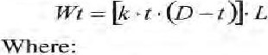 (9.6)

 = total weight casing (1b or kg); t wall thickness of pipe (in or cm); outside diameter of pipe (iìl or cm); and L total length of pipe (ft or m).

UI S. customary

Chapter 9. Production Water-Well Design

An equation commonly used for determining casing tensile strength is shown in equation 9.7 (AWWA Standard for Water Wells, ANSI/AWWA A 100-97, Appendix K, § K3).

 (9.7) 2000

Where:

Cts = casing tensile strength (tons or kg);

 = casing outside diameter (in or mm); ultimate tensile strength of material (LCS = psi or 413.7 MPa); and f easing wall thickness (in or mm).

During installation, casing assemblies are subject to buoyancy effects from the fluids in the borehole. The buoyancy factor applies only to the portion of the casing assembly that is totally immersed in fluid, and can be calculated using equation 9.8.

Dm (9.8)

Where:

B — buoyancy factor (dimensionless);

— density of casing material (lb/ftg or kg/ny3)', and density of fluid (lb/ft3 or kg/mß).

# Example

The fOrmula below can be used to determine the expected hook-load Of 1,000 ft (305 m) of 12.75-in (32.39-cm) OD steel casing, weighing 49.6 lbfft

(73.8 kg/m) set into a borehole filled with freshwater that has a static water level 400 ft ( 1 22 m) below ground surface. Hook-load is defined as the combination of screen and casing weight that must be carried by the drill-rig lifting hook during the setting of the well material into the well. The following equation is rendered in US. customary units.

|  |  |  |
| --- | --- | --- |
| 386 |  | Groundwaterand Wells. Third Edition |
|  | Dry String Wt | = 49.6 1,000 ft —49,600 1b |
|  | B | — (490 lb/ft3 — 62.4 1b/r€)/490 lb/ftÄ = 0.873 |

Hook Load = (400 ft + [600ft (49.6 , 0.873)] Hook Load = 45,820 1b less than dry string weight)

As shown, buoyancy has a relatively small effect on tensile loads and typically is ignored in tensile load calculations. Typical safety factors for tensile-strength calculations range from 1.5 to 2.0. If design loads are based on full air-weight of the easing, then the actual weight (most often) is Jess—due to a buoyancy effect as the string is set into fluid—and the true weight can be less than the wei gilt calculated using nominal wall thickness values. Ten sile strength also usually is greater than the calculated value, due to the difference between actual and specified (or publi shed) Ininimum values of yield and tensile strength used in calculations. The final safety factor should be determined by the engi neer—and be based on experience.

# Column Strength

If the downward compressive force on a laterally unsupported casing assembly exceeds the yield strength Of the material, then the casing will buckle. The axial compressive (column) strength of steel casing can be calculated using equation

9.9 (Which also is published in the AWMIA Standard for Water Wells;

ANSVAWWA A 100-97, Appendix K,

cas —  (9.9) 2000

Where:

Cas casing axial compressive strength (tons or kg); syp — material yield strength (LCS — 35,000 psi or 241 .3 MPa);

 = casing outside diameter (in or mm); and casing wall thickness (in or nun).

Correct field procedure is to suspend the casing and screen assembly from the surface until properly filter packed and cemented as required. Most screens are not designed to withstand the full total-depth weight of the assenlbly. Drilling professionals thus never should allow a full assembly to touch the bottom

Chapter 9. Production Water-Well Design 387

•of the borehole. Oftentimes; the borehole is partially filled With material sloughed from the wall orcuttings settled from drill fluid.

# Joining Casing

Field assembly of well casing is accomplished by welding or by using mechanical joints- Mechanical joints typically are threads; some are a groove and spline assembly or a snap-together locking joint. Each type has benefits and features that facilitate speed, strength, or flexibility, or Which address special application needs. Welding is a common practice but requires cutting if the casing must be removed. Threaded pipe typically is more costly, howeverjoints using such pipe can be disassembled if necessary (which might save time as compared with the cutting of a welded joint and the subsequent welding). The following sections describe methods- for joining common casing materials.

## Welding Steel Casing

Steel casing usually is prepared for welding by the beveling of the pipe ends approximately 30 degrees. The welding should follow standardized procedures (American Welding Society 198 1

The three typical casing welds are fillet, butt, and V-groove. Fillet welds are used to secure lapjoints„ corner joints, and T-joints (common with a slip collar). Weld metal is deposited in a corner formed by the fit-up of the collar shoulder to the pipe wall. Butt welds are circumferential welds around squared pipe ends in the same plane, The degree Of penetration is important in determining the quality of a fillet or butt weld.

V-groove welds are used when two squared, beveled pipe ends butt together. The entire groove should be filled, and this type of weld typically requires multiple passes to completely till the groove. Care should be taken to avoid burn-through, so that metal is not deposited inside the œasing (which can hinder or prevent tool movement or screen installation).

The proper selection of electrodes is critical to joining dissimilar metals. Either E 312-16 or E 309-16 CAWS-ASTM classification) electrodes are recommended forjoining low—carbon steel to stai nless steel. Type E 309 electrodes are readily available and cost less than E 312-16 material. Type E 308-15 or E 308— 16 electrodes are used to weld stainless steel to stainless steel. If mild steel electrodes are used to join stainless steel to stainless steel then chromium precipitates. This creates areas of low corrosion resistance that eventually lead

# Chemical- , Electrochemical- , and Microbial-Induced Corrosion

Corrosion results from chemical and electrochernical processes. Chernical cor— rosion in a water well occurs when a particular constituent is present in groundwater in a concentration sufficient to cause rapid renmoval of casing or screen materials over broad sections. The more common constituents of groundwater that can be corrosive are carbon dioxide (C02), hydrogen sulfide (H2S), dis— solved oxygen (02), and the chloride ion (Cl-) in excess Of 200 ppm mg/C). Other constituents seen in Imining operations or remediation sites, such as the acid salts Of ferric, cupric, and an-mmonium cornpounds, can be very corrosive chemically and also can increase electrolytic conductivity.

## Chemical Corrosion

The corrosive nature Of groundwater is determined using a water-chemistry analysis A proper analysis shows whether the groundwater is corrosive, incrusting, or both. Steel casing and screen corrosion can add to accumulation of iron oxides (Schnieders 2003). The accumulation Of incrustation (mineral and organic deposits) over time affects well performance.

### Characteristics Indicative of Corrosive Water

NVater that has some of the following characteristics should be considered corrosive.

* A pH level that produces a negative saturation Index (see Chapter 5 for a complete definition)

Dissolved oxygen concentration greater than 2 ppm (2 mg/C) (often found in shallow unconfined aquifers)

* Hydrogen sulfide concentration greater than I pprn 1 mg/t) (indicated by rotten-egg odor)
* Total dissolved solids concentration (TDS) greater than 1,000 ppm

( .000 mg/L) (supports electrolytic corrosion)

 Carbon dioxide concentration greater than 50 ppm (50 mg/C)

Chloride concentration greater than 200 ppm (200 mg")

The presence of 2 or more corrosive agents intensifies the corrosive attack on metals, as compared to the effect caused by individual agents. Tn most potable water wells, Type 304 stainless steel performs satisfactorily for many years.

356 Groundwater and Wells, Third Edition

Uilderanoxie conditions, or•vhen used where there are high -concentrations of chlorides or halides, it can fail quickly. Alternate materials that are more corrosion-resistant under varying conditions include: the 316 and 3161- stainless steels ; the nickel-chromiurn alloy, Inconel@; thenickel-copper alloy, MonelË: and the nickel-molybdenium alloy, A, B, and C. Other materials, such as 400 Carpenter©' 20Cb-3, and IncoloyÖ, have characteristics that are useful in specific corrosive environments. Thermoplastic screens are corrosion resistant, but might not have sufficient strength for some applications and development techniques. Well designers should contact the well-screen rnanufacturer for spec recommendations on screen materials for corrosi ve conditions. Importantly. prior to materi al selection (and when it is practical)s obtaining a laboratory analy— sis Of at least one water sample from each hydrostratigraphic unit encountered by the casing or screen is recommended.

## Characteristics Indicative of Incrusting Water

Incrusting water deposits minerals on the screen surface and in the formation and filter-pack pores adj acent to the screen , plugging both. Indicators of incrust— ing groundwater are described below.

High pH, exceeding 7 „5

Carbonate hardness exceeding 3000 pprn (300 mg/C) (calcium carbonate likely is present)

 Iron exceeding 0.5 ppm (0.5 mg/O (some precipitation might begin at 0.25 ppm (0.25 mg/O)

 Manganese exceeding 0.2 ppnl (0-2 mg/C) (and high pH if oxygen is present)

W. F. Langelier ( 1 936) denved the saturation index, a measure of solu— tion's ability to dissolve or deposit calcium carbonate (Schnieders 2003). The equation Lange] ier developed makes it possible to predict the tendency Of water either to precipitate or to dissolve -calcium carbonate. A rnore thorough discussion of the Langelier Saturation Index and incrustation issues is contained in Chapter 5. Water that deposits a carbonate layer tends to protect the metal sur— face from the effects of the corroding ions.

Mineral deposits often are removed with acids. Corrosion-resistant casing and screen materials should be selected for use where frequent acid treatments are anticipated; otherwise, less-corrosive acids should be selected (see Chapter 13). Generally, stainless-steel well casings and screens are more resistant to acid attack (with the exception of hydrochloric (muriatic) or other halide acids) than are rnaterials cornposed of carbon steel, however it is prudent to limit the exposure of any metal to an acid. Thermoplastic and fiberglass easings and screens are highly resistant to many forms of corrosion, but generally are as susceptible to incrustation as metal screens, and screen slot openmgs can become narrowed due to incrustation.

### Electrochemical CorrosiOn

In electrochemical corrosion, flow of an electric current facilitates the corrosive attack on a metal. Two conditions are necessary: a difference in electrical potential on rnetal surfaces, and water containing sufficient dissolved solids to be a conductive fluid (electrolyte). A potential (electrical) difference might develop between two different kinds of metals, or between nearby but separate areas on the surface of the same metal.

Differences in potential on the same Anetal surface, such as steel pipe, can occur at:

 Heat-affected areas around welded joints;

* Heated areas around torch-cut slots;

Work-hardened areas around machine-cut slots (e.g., louverss bridge slots, punch screens);

 Surfaces of exposed threads at pipe joints;

* Breaks in surface coatings such as paint and mill scale; and  Areas under a biological or mineral deposit.

In these cases both a cathode and an anode develop; metal is removed from the anode. Bimetallic (galvanic) corrosion results when two different metals are in contact and immersed in an electrolyte. A galvanic cell is created and corrosion occurs at the anode as the electrochemical action proceeds. A xvell casing or screen made of two different metals such as low—carbon steel and stainless steel, for exarnple, will be because the mild-steel (less noble) forms the anode and is the area that sacrifices the rnetal.

The relative potential between different metals can be estimated fronm the galvanic series shown in Table 9. 1 . The farther apart the position Of any two tnetals in this series, the greater the voltage that will develop in a galvanic cell. When two dissimilar metals are coupled in a conductive fluids the nxetal nearer the bottom of the galvanic series (less noble) becomes the anode and therefore suffers corrosion. The metal nearer the top becomes the cathode.

358 Groundwater and Wells, Third Edition

Magnesium and magnesium alloys

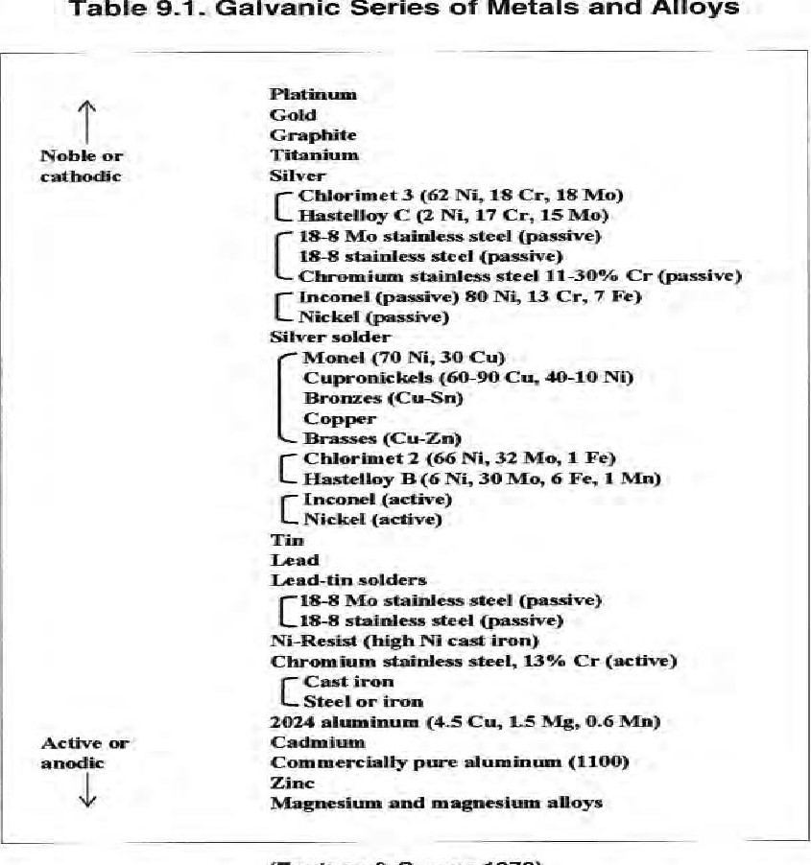

(Fontana

&

Greene

1978)

When electrochemical corrosion takes place, corrosion products can be deposited at the cathode (Figure 9 I , Figure 9.2), and these deposits usually can be voluminous. If iron or steel is corroded, then the corrosion products are iron combined with other elernents, typically ferric hydroxide or ferric oxide.

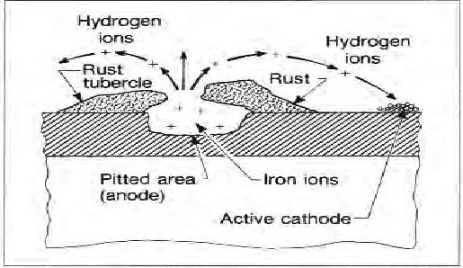

Figure 9.1. Anodes and cathodes can develop in nearby areas on the same metal surface, resulting in corrosion.

|  |  |
| --- | --- |
| Water | Anodic area corroded  film  forms  area  ions |

Figure 9.2. Corrosion Of iron at anodic areas leads to the depositing Of iron hydroxide and oxide at cathodic areas.

360 Groundwater and Wefts, Third Edition

## Prevention and Treatment of Corrosion

The following observations concerning corrosion apply to many situations in the groundwater industry.

* Work-hardened steel (such as louvers or bridge slots) corrodes Inore if not stress released than does the same metal that is In an annealed (heat-treated) condition.

Stressed metal parts are more likely to corrode than are unstressed parts.

Higher groundwater temperatures increase corrosion rates. The rate of corrosion accelerates with increasing temperature, generally doubling for each additional 500F ( IO D C).

 Higher groundwater velocities usually increase corrosion ratesEfforts should be made to reduce groundwater velocities near the well screen.

* Dissolved gases such as oxygen, carbon diox ide, hydrogen sulfide. and methane—when present in water—increase corrosion rates. Generally, electrochernical corrosion can cause loss Of ruaterial on sections of well screens and casings, with Of these corrosion products being deposited elsewhere in the well or water-distribution system. This usually occurs in A.vater that is slightlý acidic. Corrosion can result in the structural failure of a easing or screen. Corrosion also can result in a reduction in yield by plugging Of the screen openings with corrosion products.

using stainless-steel screens and low-carbon steel casing in water that has TDS greater than 500 ppm C500 a dielectric coupling should be considered for use between the stainless steel and the low-carbon steel.

Stainless steels resist corrosion caused by many types of constituents of groundwater and, although they are resistant to the low concentration of chlorides usually present; they are susceptible to increased concentrations of the ion such as when found in incidents of contamination or where hypochlorite or hydrochloric acid are used. Chromium is the element that, through oxidation, forms the passive or protective layer. Chlorides are ions that easi ly can penetrate this layer and initiate corrosion-

Chapter 9. Production Water-Well Design

### Microbial-induced Corrosion

Iron bacteria for years were thought to be the principal biological nemesis found in a water well. Much has been learned about bacterial organisms and wells since the publication of the second edition of Groundwater and Wells in 1986, and the present edition contains much of the new information. A discussion of the chemical and biological issues associated with wells and how to treat them is presented in Chapter 13 of this book. Additionally, a detailed discussion of bacteria in water wells can be found in Schnieders (2003).

There basically are three types of bacteria: aerobic, anaerobic, and facultative. Aerobic bacteria require oxygen to live, anaerobic bacteria require an oxygen-free environment. and facultative bacteria can li ve in environments with or without oxygen. Further, there are three main groups of bacteria that cause most problems in water wells and water system-ns: slinle formers, iron oxidizers, and anaerobes (Figure 9.3).

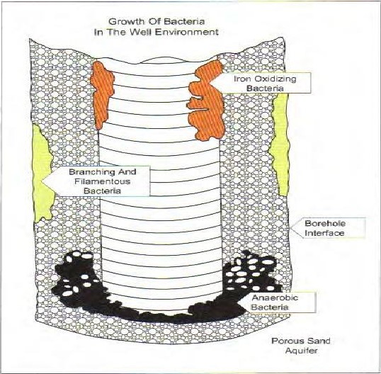

Figure 9.3. Bacteria populatiOns in a well environment (Schneiders 2003).

362 Groundwater and Wells, Third Edition

## Slime Formers

Slime formers comprise the largest group and are prolific producers Of exo— polymer (slime). This type of bacteria can be found in practically all areas of a well system.

## Iron Oxidizers

Iron oxidizers include slilne fonners. Particularly problematic are stalked sheath-forming bacteria that oxidize iron (or manganese), and which can leave dense deposits in screen intakes and gravel packs.

## Anaerobes

The most comrnon anaerobes are sulfate-reducing bacteria (SR_B) which can produce corrosive hydrogen sulfide gas (giving off the familiar rotten-egg odor), that accumulate in dead zones of well systems. Dead zones are areas that receive little or no water movement on a regular basis. The rnost common is the sump (blank casing at total depth), which is part Of many well designs.

# Well Design and Bacteria Management

Design consideration begins with an understanding that bacteria ex ist- potentially can cause prohlenms, and require future -periodic control nneasures. Key areas of design consideration to better manage well bacteria include the following.

## Nature of Aquifer

The cheunicål nature of an aquifer provides nutrients for bacteria, therefOwe the composition and features of individual aquifers should be understood and aquifers that provide rich food sources should be blanked off and not be allowed access to the well- Geologic zones of high hydraulic conductivity often are responsible for carrying large amounts Of dissolved oxygen to the well, encour— aging bacterial growth. Well design should not encourage the introduction of vadose water (which often is rich in oxygen) via cascading water or another means of entry.

Chapter 9. Production Water-Well Design

### Well Head Design

Consideration should be given to fúture maintenance and rehabilitation , access, clearances, diameters, and chemical feed for cleaningAnnular Thickness

Annular thickness has a direct bearing on the ability to clean the borehole wall during development and future redevelopment—thinner is better•

### Screen Geometry

Open area directly in»acts well development (even more so well redevelopment); high open-area, continuous-slot screens allow for consideration Of more development tool options. Popular jetting methods, for example, are not effective when used with louver, bridge-slot, or mill-slot screen designs.

### Sump

The occurrence of little or no water movement is ideal for the accunmulation of anaerobic bacteria over time. When possible the sump should be eliminated. If a sump is needed, then using a short sump (5 ft (1.5 m) to 10 ft (3.1 m)) is a nnore practical approach than use of the typical 20-ft (6. I -m) length- Even better would be to make provisions to fill the sump area once development is complete and before the pennanent pump is placed in the well.

### De velopment

Chemicals such as NuWell@ 220 Clay not polyphosphates— should be used to rernove natural clays and bentonite-based muds. Phosphates are food sources for bacteria, and their use can result -in an increase in biofouling. Development methods should be selected to transfer energy through the screen and filter pack to remove fines (see Chapter I I for xvell-development techniques).

### Pump Placement

Many studies have been conducted regarding inlet flow and pump placement. Strategic pump placement (and strategic screen placement) that minimizes low— flow zones can prevent or minimize the development of bacterial growth.