***2012BaltA..21..180M*** - *Baltic Astronomy, 21, 180-183 (2012)* - *25.06.12 25.06.12*

Abell-35 phenomena in symbiotic stars: discovery of 1.2 and 6.4 day periods in VV8 (V471 Per).

*MUNARI U.; SIVIERO A.; TAMAJO E.; FIASCHI M.; DALLAPORTA S.; CHERINI G.; FRIGO A.; CASTELLANI F.; GRAZIANI M.; MORETTI S.; TOMASELLI S.*

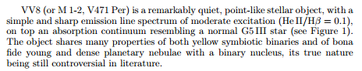

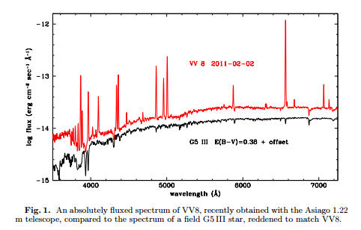

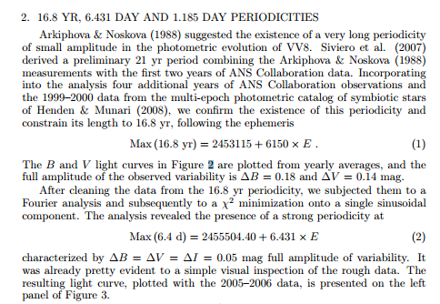



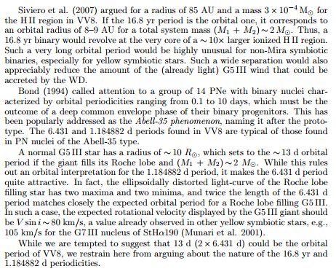

***2007BaltA..16...52S*** - *Baltic Astronomy, 16, 52-54 (2007)* - *16.04.07 14.05.07 April 2007*

A fresh look to the yellow symbiotic star V471 Per.

*SIVIERO A.; MUNARI U.; CHERINI G.; MORETTI S.; GRAZIANI M.; TOMASELLI S.; BANO I.; ENGLARO A.; CETRULO G.; DALLAPORTA S.*

