

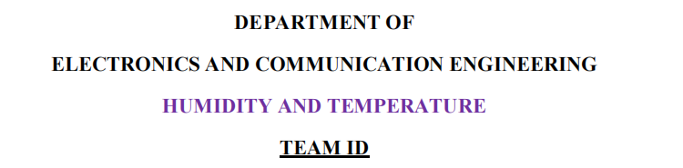
NM2023TMID13369

BATCH MEMBERS

- POOVARASAN.S (611020106019)
- KAVIRAJ.T (611020106321)
- KUMARAVEL.T (611020106323)
- LOGANATHAN.K (611020106324)

INTERNAL INCHARGE HEAD OF THE DEPARTMENT

ULEASHING POTENTIAL OF YOUTH: A STUDENT PERFORMANCE ANALYTICS

Introduction
Student performance analysis and prediction using datasets has become an essential component of modern education systems. With the increasing availability of data on student demographics, academic history, and other relevant factors, schools and universities are using advanced analytics and machine learning algorithms to gain insights into student performance and predict future outcomes. This approach helps educators identify areas of improvement, personalize learning experiences, and provide targeted support to struggling students. Furthermore, student performance analysis and prediction can also aid in decision-making processes for school administrators and policymakers, helping them allocate resources more effectively. In this article, we will explore the benefits of using datasets for student performance analysis and prediction and discuss some of the methods and tools used in this field.
Read more on what is predictive analytics for beginners here.
This article was published as a part of the Data Science Blogathon.

Table of Contents
Understanding the Problem Statement
Data Collection
Import Data and Required Packages
Dataset information
Data Checks to perform
Check Missing values analysis
Check Duplicates values analysis
Check the data types
Check the number of unique values in each column
Check statistics of the data set
Exploring Data
Exploring Data (Visualization)
Multivariate analysis using pie plot
Model Training
Splitting the X and y variables
Create column Transformer with 3 types of transformers
Separate Dataset into Train and Test
Create an Evaluate Function to give all metrics after model Training
Hyperparameter tuning
Model selection
Difference between Actual and Predicted Values
Convert the model to pickle file
Conclusion

Understanding the Problem Statement
This project understands how the student’s performance (test scores) is affected by other variables such as Gender, Ethnicity, Parental level of education, and Lunch and Test preparation course.
The primary objective of higher education institutions is to impart quality education to their students. To achieve the highest level of quality in the education system, knowledge must be discovered to predict student enrollment in specific courses, identify issues with traditional classroom teaching models, detect unfair means used in online examinations, detect abnormal values in student result sheets, and predict student performance. This knowledge is hidden within educational datasets and can be extracted through data mining techniques.
This project focuses on evaluating students’ capabilities in various subjects using a classification task. Data classification has many approaches, and the decision tree method and probabilistic classification method are utilized here. By performing this task, knowledge is extracted that describes students’ performance in the end-semester examination. This helps in identifying dropouts and students who require special attention, enabling teachers to provide appropriate advising and counseling.

Become a Full Stack Data Scientist
Transform into an expert and significantly impact the world of data science.
Download Brochure

Data Collection
Dataset Source – Students performance dataset.csv. The data consists of 8 column and 1000 rows.

Import Data and Required Packages
Importing Pandas, Numpy, Matplotlib, Seaborn and Warings Library.
import pandas as pdimport numpy as npimport matplotlib.pyplot as pltimport seaborn as snsimport warnings
warnings.filterwarnings("ignore")
Import the CSV Data as Pandas DataFrame
df = pd.read_csv("data/StudentsPerformance.csv")
Show the top 5 Recoreds
df.head()
show the top 5 records on the dataset and look at the features.
To see the shape of the dataset
df.shape
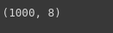
And it will help to find the shape of the dataset.

Dataset Information
- gender: sex of students -> (Male/female)
- race/ethnicity: ethnicity of students -> (Group A, B, C, D, E)
- parental level of education: parents’ final education ->(bachelor’s degree, some college, master’s degree, associate’s degree)
- lunch: having lunch before test (standard or free/reduced)
- test preparation course: complete or not complete before test
- math score
- reading score
- writing score
After that, we check the data as the next step. There are a number of categorical features contained in the dataset, including multiple missing value kinds, duplicate values, check data types, and a number of unique value types.

Data Checks to Perform
- Check Missing values
- Check Duplicates
- Check data type
- Check the number of unique values in each column
- Check the statistics of the data set
- Check various categories present in the different categorical column

Check Missing Values
To check every column of the missing values or null values in the dataset.
df.isnull().sum()
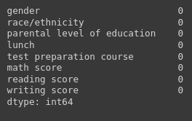
If there are no missing values in the dataset.

Check Duplicates
If checking the our dataset has any duplicated values present or not
df.duplicated().sum()

There are no duplicates values in the dataset.

Check the Data Types
To check the information of the dataset like datatypes, any null values present in the dataset.
#check the null and Dtypes
df.info()

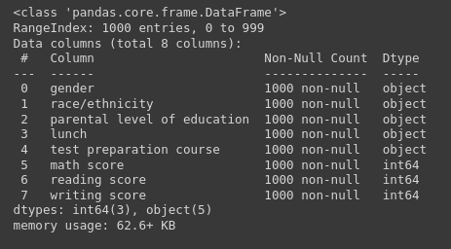

Check the Number of Unique Values in Each Column
df.nunique()

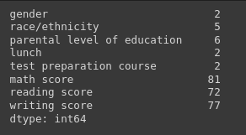

Check Statistics of the Data Set
To examine the dataset’s statistics and determine the data’s statistics.

Insight
- The numerical data shown above shows that all means are fairly similar to one another, falling between 66 and 68.05.
- The range of all standard deviations, between 14.6 and 15.19, is also narrow.
- While there is a minimum score of 0 for math, the minimums for writing and reading are substantially higher at 10 and 17, respectively.
- We don’t have any duplicate or missing values, and the following codes will provide a good data checking.

Exploring Data
print("Categories in 'gender' variable: ",end=" ")print(df["gender"].unique())
print("Categories in 'race/ethnicity' variable: ",end=" ")print(df["race/ethnicity"].unique())
print("Categories in 'parental level of education' variable: ",end=" ")print(df["parental level of education"].unique())
print("Categories in 'lunch' variable: ",end=" ")print(df["lunch"].unique())
print("Categories in 'test preparation course' variable: ",end=" ")print(df["test preparation course"].unique())
The unique values in the dataset will be provided and presented in a pleasant way in the code above.
The output will following:
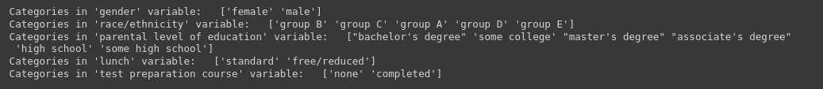
We define the numerical and categorical columns:
#define numerical and categorical columns
numeric_features = [feature for feature in df.columns if df[feature].dtype != "object"]
categorical_features = [feature for feature in df.columns if df[feature].dtype == "object"]
print("We have {} numerical features: {}".format(len(numeric_features),numeric_features))print("We have {} categorical features: {}".format(len(categorical_features),categorical_features))
The above code will use separate the numerical and categorical features and count the feature values.

Exploring Data (Visualization)

Visualize Average Score Distribution to Make Some Conclusion
- Histogram
- Kernel Distribution Function (KDE)
- Histogram & KDE

Gender Column
How is distribution of Gender?
Is gender has any impact on student’s performance?
# Create a figure with two subplots
f,ax=plt.subplots(1,2,figsize=(8,6))

# Create a countplot of the 'gender' column and add labels to the bars
sns.countplot(x=df['gender'],data=df,palette ='bright',ax=ax[0],saturation=0.95)for container in ax[0].containers:
ax[0].bar_label(container,color='black',size=15)
# Set font size of x-axis and y-axis labels and tick labels
ax[0].set_xlabel('Gender', fontsize=14)
ax[0].set_ylabel('Count', fontsize=14)
ax[0].tick_params(labelsize=14)
# Create a pie chart of the 'gender' column and add labels to the slices
plt.pie(x=df['gender'].value_counts(),labels=['Male','Female'],explode=[0,0.1],autopct='%1.1f%%',shadow=True,colors=['#ff4d4d','#ff8000'], textprops={'fontsize': 14})
# Display the plot
plt.show()
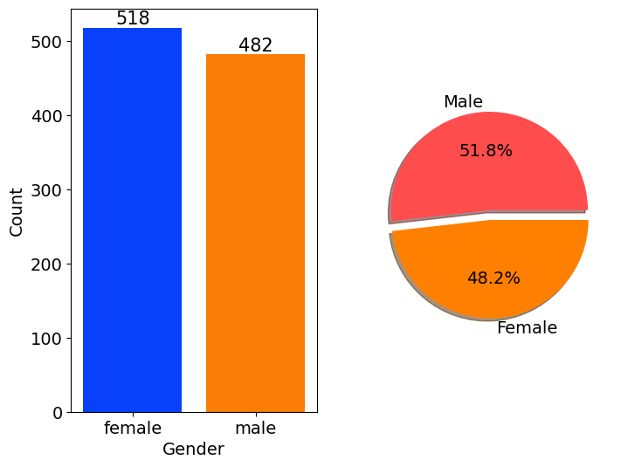
Gender has balanced data with female students are 518 (48%) and male students are 482 (52%)

Race/Ethnicity Column
# Define a color palette for the countplot
colors = ['#1f77b4', '#ff7f0e', '#2ca02c', '#d62728', '#9467bd']# blue, orange, green, red, purple are respectiively the color names for the color codes used above
# Create a figure with two subplots
f, ax = plt.subplots(1, 2, figsize=(12, 6))
# Create a countplot of the 'race/ethnicity' column and add labels to the bars
sns.countplot(x=df['race/ethnicity'], data=df, palette=colors, ax=ax[0], saturation=0.95)for container in ax[0].containers:
ax[0].bar_label(container, color='black', size=14)
# Set font size of x-axis and y-axis labels and tick labels
ax[0].set_xlabel('Race/Ethnicity', fontsize=14)
ax[0].set_ylabel('Count', fontsize=14)
ax[0].tick_params(labelsize=14)
# Create a dictionary that maps category names to colors in the color palette
color_dict = dict(zip(df['race/ethnicity'].unique(), colors))
# Map the colors to the pie chart slices
pie_colors = [color_dict[race] for race in df['race/ethnicity'].value_counts().index]
# Create a pie chart of the 'race/ethnicity' column and add labels to the slices
plt.pie(x=df['race/ethnicity'].value_counts(), labels=df['race/ethnicity'].value_counts().index, explode=[0.1, 0, 0, 0, 0], autopct='%1.1f%%', shadow=True, colors=pie_colors, textprops={'fontsize': 14})
# Set the aspect ratio of the pie chart to 'equal' to make it a circle
plt.axis('equal')
# Display the plot
plt.show()
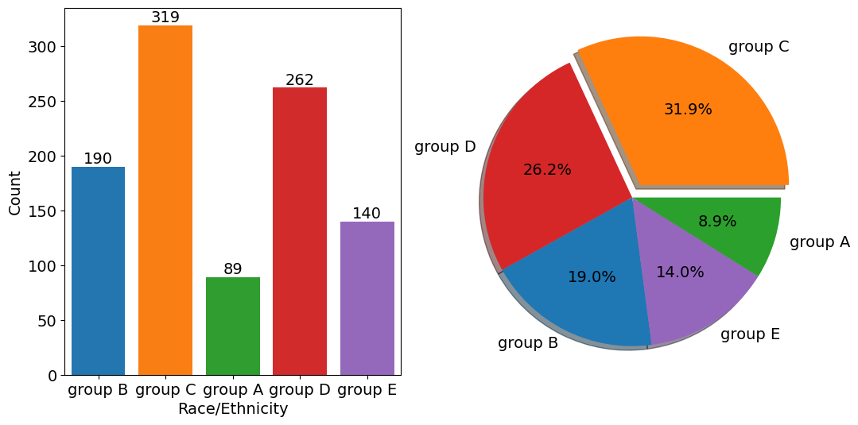
id = Insights>Insights
- Most of the student belonging from group C /group D.
- Lowest number of students belong to group A.

Parental Level of Education Column
plt.rcParams['figure.figsize'] = (15, 9)
plt.style.use('fivethirtyeight')
sns.histplot(df["parental level of education"], palette = 'Blues')
plt.title('Comparison of Parental Education', fontweight = 30, fontsize = 20)
plt.xlabel('Degree')
plt.ylabel('count')
plt.show()
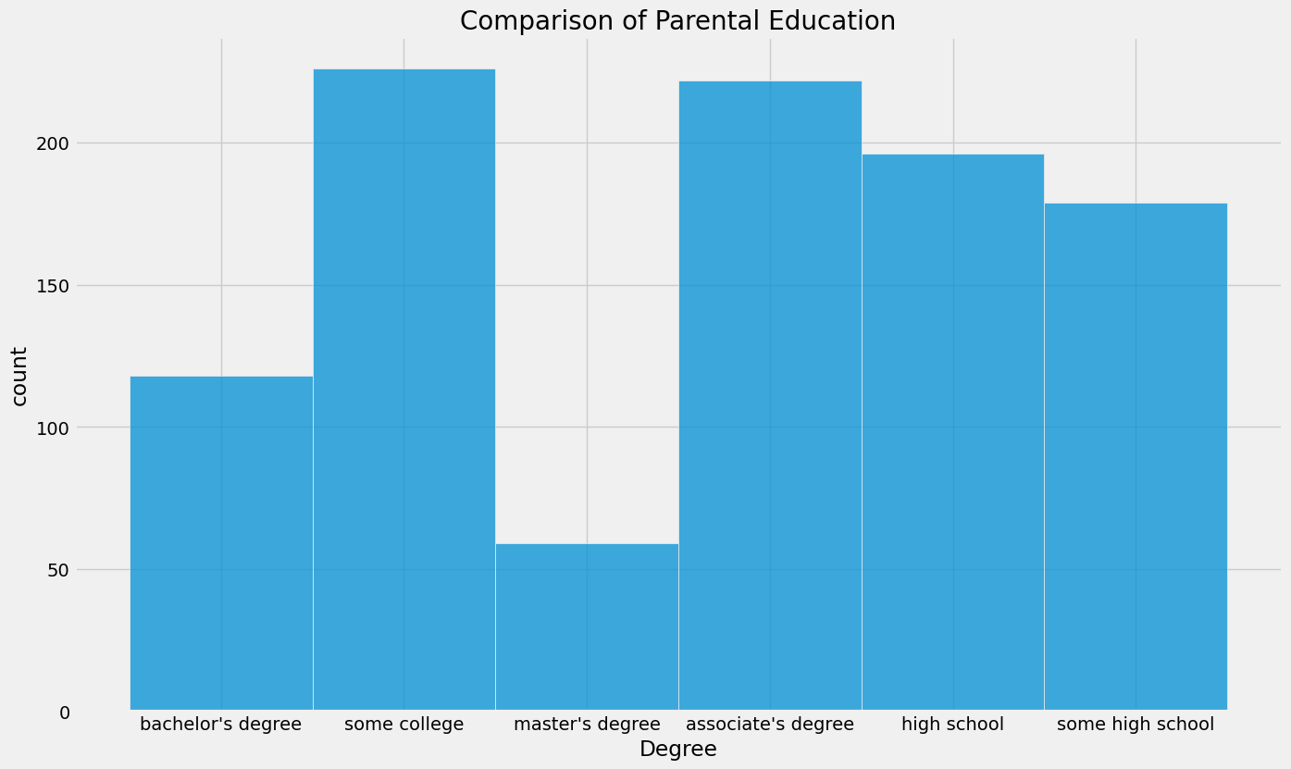
id = Insights>Insights
- Largest number of parents are from college.

Bivariate Analysis
df.groupby('parental level of education').agg('mean').plot(kind='barh',figsize=(10,10))
plt.legend(bbox_to_anchor=(1.05, 1), loc=2, borderaxespad=0.)
plt.show()
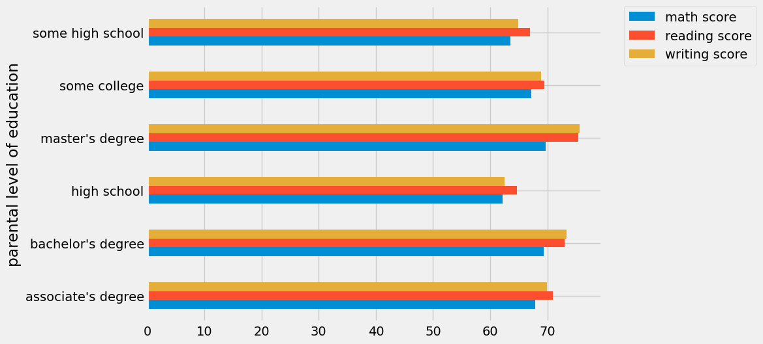
id = Insights>Insights
- The score of student whose parents possess master and bachelor level education are higher than others.

Maximum Score of Students in All Three Subjects
plt.fig
figsize=(18,8))
plt.subplot(1, 4, 1)
plt.title('MATH SCORES')
sns.violinplot(y='math score',data=df,color='red',linewidth=3) plt.subplot(1, 4, 2) plt.title('READING SCORES') sns.vi

plot(y='reading score',data=df,color='green',linewidth=3) plt.subplot(1, 4, 3) plt.title('WRITING SCORES') sns.violinplot(y='writing score',data=df,color='blue',linewidth=3) plt.show()
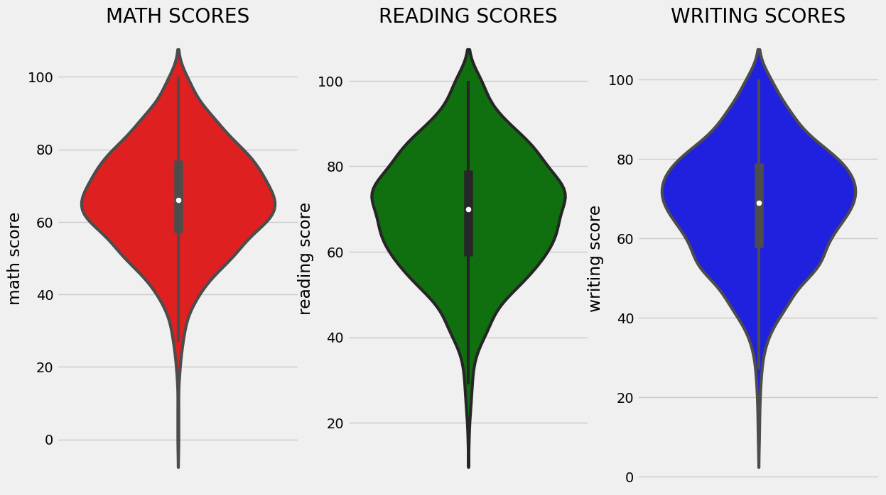
id = Insights>Insights
From the above three plots its clearly visible that most of the students score in between 60-80 in Maths whereas in reading and writing most of them score from 50-80.

Multivariate Analysis Using Pie Plot
# Set figure size
plt.rcParams['figure.figsize'] = (12, 9)
# First row of pie charts
plt.subplot(2, 3, 1)
size = df['gender'].value_counts()
labels = 'Female', 'Male'
color = ['red','green']
plt.pie(size, colors=color, labels=labels, autopct='%.2f%%')
plt.title('Gender', fontsize=20)
plt.axis('off')

plt.subplot(2, 3, 2)
size = df['race/ethnicity'].value_counts()
labels = 'Group C', 'Group D', 'Group B', 'Group E', 'Group A'
color = ['red', 'green', 'blue', 'cyan', 'orange']
plt.pie(size, colors=color, labels=labels, autopct='%.2f%%')
plt.title('Race/Ethnicity', fontsize=20)
plt.axis('off')

plt.subplot(2, 3, 3)
size = df['lunch'].value_counts()
labels = 'Standard', 'Free'
color = ['red', 'green']
plt.pie(size, colors=color, labels=labels, autopct='%.2f%%')
plt.title('Lunch', fontsize=20)
plt.axis('off')
# Second row of pie charts
plt.subplot(2, 3, 4)
size = df['test preparation course'].value_counts()
labels = 'None', 'Completed'
color = ['red', 'green']
plt.pie(size, colors=color, labels=labels, autopct='%.2f%%')
plt.title('Test Course', fontsize=20)
plt.axis('off')

plt.subplot(2, 3, 5)
size = df['parental level of education'].value_counts()
labels = 'Some College', "Associate's Degree", 'High School', 'Some High School', "Bachelor's Degree", "Master's Degree"
color = ['red', 'green', 'blue', 'cyan', 'orange', 'grey']
plt.pie(size, colors=color, labels=labels, autopct='%.2f%%')
plt.title('Parental Education', fontsize=20)
plt.axi
ff') # Remove extra subplot plt.subplot(2, 3, 6).remove() # Add super title plt.suptitle('Comparison of Student Attributes', fontsize=20, fontweight='bold') # Adjust layout and show plot # This is removed as there are only 5 subplots in this figure and we want to arrange them in a 2x3 grid. # Since there is no 6th subplot, it is removed to avoid an empty subplot being shown in the figure. plt.tight_layout() plt.subplots_adjust(top=0.85) plt.show()
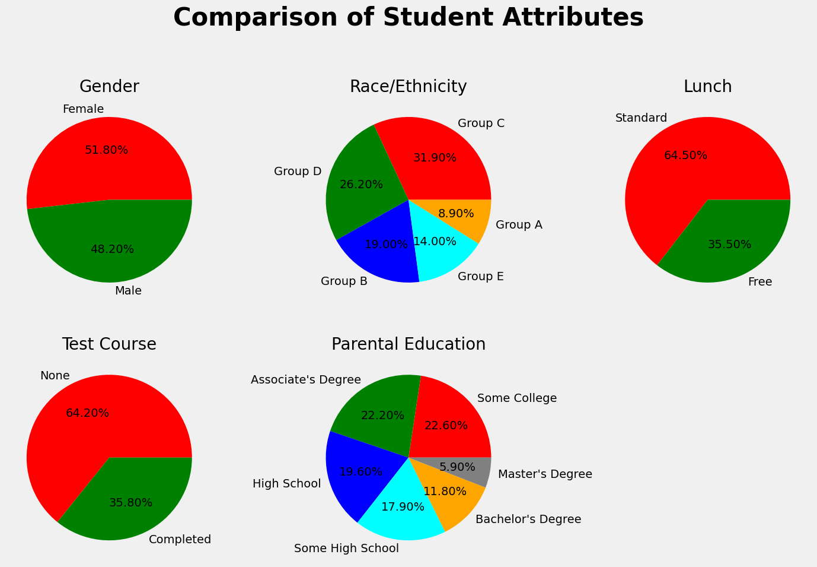
id = Insights>Insights
- The number of Male and Female students is almost equal.
- The number of students is higher in Group C.
- The number of students who have standard lunch is greater.
- The number of students who have not enrolled in any test preparation course is greater.
- The number of students whose parental education is “Some College” is greater followed closely by “Associate’s Degree”.
From the above plot, it is clear that all the scores increase linearly with each other.
Student’s Performance is related to lunch, race, and parental level education.
- Females lead in pass percentage and also are top-scorers.
- Student Performance is not much related to test preparation course.
- The finishing preparation course is beneficial.

Model Training
Import Data and Required Packages
Importing scikit library algorithms to import regression algorithms.
# Modellingfrom sklearn.metrics import mean_squared_error, r2_scorefrom sklearn.neighbors import KNeighborsRegressorfrom sklearn.tree import DecisionTreeRegressorfrom sklearn.ensemble import RandomForestRegressor,AdaBoostRegressorfrom sklearn.svm import SVRfrom sklearn.linear_model import LinearRegression,Lassofrom sklearn.metrics import r2_score, mean_absolute_error, mean_squared_errorfrom sklearn.model_selection imp
RandomizedSearchCV from catboost import CatBoostRegressor from xgboost import XGBRegressor import warnings

Splitting the X and Y Variables
This separation of the dependent variable(y) and independent variables(X) is one the most important in our project we use the math score as a dependent variable. Because so many students lack in math subjects it will almost 60% to 70% of students in classes 7-10 students are fear of math subjects that’s why I am choosing the math score as a dependent score.
It will use to improve the percentage of math scores and increase the grad f students and also remove fear in math.
X = df.drop(columns="math score",axis=1)y = df["math score"]

Create Column Transformer with 3 Types of Transformers
num_features = X.select_dtypes(exclude="object").columns
cat_features = X.select_dtypes(include="object").columns

from sklearn.preprocessing import OneHotEncoder,StandardScaler
from sklearn.compose import ColumnTransformer

numeric_transformer = StandardScaler()
oh_transformer = OneHotEncoder()

preprocessor = Column
transformer( [ ("OneHotEncoder", oh_transformer, cat_features), ("StandardScaler", numeric_transformer, num_features), ] ) X = preprocessor.fit_transform(X)

Separate Dataset into Train and Test
To separate the dataset into train and test to identify the training size and testing size of the dataset.
from sklearn.model_selection import train_test_split
X_train, X_test, y_train, y_test = train_test_split(X,y,test_size=0.2,random_state=42)
X_train.shape, X_test.shape


Create an Evaluate Function for Model Training
This function is use to evaluate the model and build a good model.
def evaluate_model(true, predicted):
mae = mean_absolute_error(true, predicted)
mse = mean_squared_error(true, predicted)
rmse = np.sqrt(mean_squared_error(true, predicted))
r2_square = r2_score(true, predicted)
return mae, mse, rmse, r2_square
To create a models variable and form a dictionary formate.
models = {
"Linear Regression": LinearRegression(),
"Lasso": Lasso(),
"K-Neighbors Regressor": KNeighborsRegressor(),
"Decision Tree": DecisionTreeRegressor(),
"Random Forest Regressor": RandomForestRegressor(),
"Gradient Boosting": GradientBoostingRegressor(),
"XGBRegressor": XGBRegressor(),
"CatBoosting Regressor": CatBoostRegressor(verbose=False),
"AdaBoost Regressor": AdaBoostRegressor()
}
model_list = []
r2_list =[]
for i in range(len(list(models))):
model = list(models.values())[i]
model.fit(X_train, y_train) # Train model

# Make predictions
y_train_pred = model.predict(X_train)
y_test_pred = model.predict(X_test)

# Evaluate Train and Test dataset
model_train_mae, model_train_mse, model_train_rmse, model_train_r2 = evaluate_model(y_train, y_train_pred)

model_test_mae, model_test_mse, model_test_rmse, model_test_r2 = evaluate_model(y_test, y_test_pred)

print(list(models.keys())[i])
model_list.append(list(models.keys())[i])

print('Model performance for Training set')
print("- Root Mean Squared Error: {:.4f}".format(model_train_rmse))
print("- Mean Squared Error: {:.4f}".format(model_train_mse))
print("- Mean Absolute Error: {:.4f}".format(model_train_mae))
print("- R2 Score: {:.4f}".format(model_train_r2))

print('----------------------------------')
print('Model performance for Test set')
print("- Root Mean Squared Error: {:.4f}".format(model_test_rmse))
print("- Mean Squared Error: {:.4f}".format(model_test_rmse))
print("- Mean Absolute Error: {:.4f}".format(model_test_mae))
print("- R2 Score: {:.4f}".
for

model_test_r2)) r2_list.append(model_test_r2) print('='*35) print('\n')
The output of before tuning all algorithms’ hyperparameters. And it provides the RMSE, MSE, MAE, and R2 score values for training and test data.
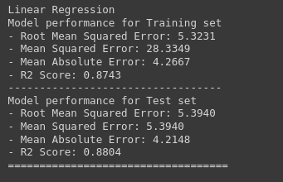
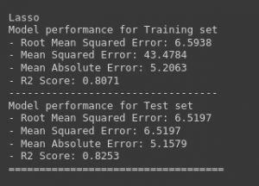
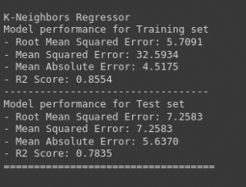
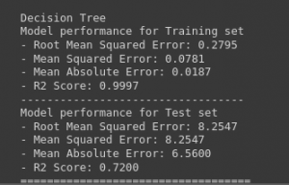
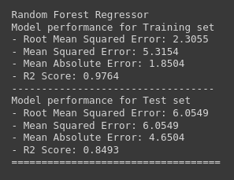

Introduction
Student performance analysis and prediction using datasets has become an essential component of modern education systems. With the increasing availability of data on student demographics, academic history, and other relevant factors, schools and universities are using advanced analytics and machine learning algorithms to gain insights into student performance and predict future outcomes. This approach helps educators identify areas of improvement, personalize learning experiences, and provide targeted support to struggling students. Furthermore, student performance analysis and prediction can also aid in decision-making processes for school administrators and policymakers, helping them allocate resources more effectively. In this article, we will explore the benefits of using datasets for student performance analysis and prediction and discuss some of the methods and tools used in this field.
Read more on what is predictive analytics for beginners here.
This article was published as a part of the Data Science Blogathon.

Table of Contents
Understanding the Problem Statement
Data Collection
Import Data and Required Packages
Dataset information
Data Checks to perform
Check Missing values analysis
Check Duplicates values analysis
Check the data types
Check the number of unique values in each column
Check statistics of the data set
Exploring Data
Exploring Data (Visualization)
Multivariate analysis using pie plot
Model Training
Splitting the X and y variables
Create column Transformer with 3 types of transformers
Separate Dataset into Train and Test
Create an Evaluate Function to give all metrics after model Training
Hyperparameter tuning
Model selection
Difference between Actual and Predicted Values
Convert the model to pickle file
Conclusion

Understanding the Problem Statement
This project understands how the student’s performance (test scores) is affected by other variables such as Gender, Ethnicity, Parental level of education, and Lunch and Test preparation course.
The primary objective of higher education institutions is to impart quality education to their students. To achieve the highest level of quality in the education system, knowledge must be discovered to predict student enrollment in specific courses, identify issues with traditional classroom teaching models, detect unfair means used in online examinations, detect abnormal values in student result sheets, and predict student performance. This knowledge is hidden within educational datasets and can be extracted through data mining techniques.
This project focuses on evaluating students’ capabilities in various subjects using a classification task. Data classification has many approaches, and the decision tree method and probabilistic classification method are utilized here. By performing this task, knowledge is extracted that describes students’ performance in the end-semester examination. This helps in identifying dropouts and students who require special attention, enabling teachers to provide appropriate advising and counseling.


Become a Full Stack Data Scientist
Transform into an expert and significantly impact the world of data science.
Download Brochure

Data Collection
Dataset Source – Students performance dataset.csv. The data consists of 8 column and 1000 rows.

Import Data and Required Packages
Importing Pandas, Numpy, Matplotlib, Seaborn and Warings Library.
import pandas as pdimport numpy as npimport matplotlib.pyplot as pltimport seaborn as snsimport warnings
warnings.filterwarnings("ignore")
Import the CSV Data as Pandas DataFrame
df = pd.read_csv("data/StudentsPerformance.csv")
Show the top 5 Recoreds
df.head()
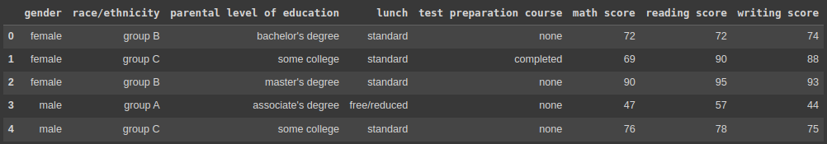
show the top 5 records on the dataset and look at the features.
To see the shape of the dataset
df.shape
And it will help to find the shape of the dataset.

Dataset Information
- gender: sex of students -> (Male/female)
- race/ethnicity: ethnicity of students -> (Group A, B, C, D, E)
- parental level of education: parents’ final education ->(bachelor’s degree, some college, master’s degree, associate’s degree)
- lunch: having lunch before test (standard or free/reduced)
- test preparation course: complete or not complete before test
- math score
- reading score
- writing score
After that, we check the data as the next step. There are a number of categorical features contained in the dataset, including multiple missing value kinds, duplicate values, check data types, and a number of unique value types.

Data Checks to Perform
- Check Missing values
- Check Duplicates
- Check data type
- Check the number of unique values in each column
- Check the statistics of the data set
- Check various categories present in the different categorical column

Check Missing Values
To check every column of the missing values or null values in the dataset.
df.isnull().sum()
If there are no missing values in the dataset.

Check Duplicates
If checking the our dataset has any duplicated values present or not
df.duplicated().sum()
There are no duplicates values in the dataset.

Check the Data Types
To check the information of the dataset like datatypes, any null values present in the dataset.
#check the null and Dtypes
df.info()

Check the Number of Unique Values in Each Column
df.nunique()

Check Statistics of the Data Set
To examine the dataset’s statistics and determine the data’s statistics.

Insight
- The numerical data shown above shows that all means are fairly similar to one another, falling between 66 and 68.05.
- The range of all standard deviations, between 14.6 and 15.19, is also narrow.
- While there is a minimum score of 0 for math, the minimums for writing and reading are substantially higher at 10 and 17, respectively.
- We don’t have any duplicate or missing values, and the following codes will provide a good data checking.

Exploring Data
print("Categories in 'gender' variable: ",end=" ")print(df["gender"].unique())
print("Categories in 'race/ethnicity' variable: ",end=" ")print(df["race/ethnicity"].unique())
print("Categories in 'parental level of education' variable: ",end=" ")print(df["parental level of education"].unique())
print("Categories in 'lunch' variable: ",end=" ")print(df["lunch"].unique())
print("Categories in 'test preparation course' variable: ",end=" ")print(df["test preparation course"].unique())
The unique values in the dataset will be provided and presented in a pleasant way in the code above.
The output will following:
We define the numerical and categorical columns:
#define numerical and categorical columns
numeric_features = [feature for feature in df.columns if df[feature].dtype != "object"]
categorical_features = [feature for feature in df.columns if df[feature].dtype == "object"]
print("We have {} numerical features: {}".format(len(numeric_features),numeric_features))print("We have {} categorical features: {}".format(len(categorical_features),categorical_features))
The above code will use separate the numerical and categorical features and count the feature values.

Exploring Data (Visualization)

Visualize Average Score Distribution to Make Some Conclusion
- Histogram
- Kernel Distribution Function (KDE)
- Histogram & KDE

Gender Column
How is distribution of Gender?
Is gender has any impact on student’s performance?
# Create a figure with two subplots
f,ax=plt.subplots(1,2,figsize=(8,6))

# Create a countplot of the 'gender' column and add labels to the bars
sns.countplot(x=df['gender'],data=df,palette ='bright',ax=ax[0],saturation=0.95)for container in ax[0].containers:
ax[0].bar_label(container,color='black',size=15)
# Set font size of x-axis and y-axis labels and tick labels
ax[0].set_xlabel('Gender', fontsize=14)
ax[0].set_ylabel('Count', fontsize=14)
ax[0].tick_params(labelsize=14)
# Create a pie chart of the 'gender' column and add labels to the slices
plt.pie(x=df['gender'].value_counts(),labels=['Male','Female'],explode=[0,0.1],autopct='%1.1f%%',shadow=True,colors=['#ff4d4d','#ff8000'], textprops={'fontsize': 14})
# Display the plot
plt.show()
Gender has balanced data with female students are 518 (48%) and male students are 482 (52%)

Race/Ethnicity Column
# Define a color palette for the countplot
colors = ['#1f77b4', '#ff7f0e', '#2ca02c', '#d62728', '#9467bd']# blue, orange, green, red, purple are respectiively the color names for the color codes used above
# Create a figure with two subplots
f, ax = plt.subplots(1, 2, figsize=(12, 6))
# Create a countplot of the 'race/ethnicity' column and add labels to the bars
sns.countplot(x=df['race/ethnicity'], data=df, palette=colors, ax=ax[0], saturation=0.95)for container in ax[0].containers:
ax[0].bar_label(container, color='black', size=14)
# Set font size of x-axis and y-axis labels and tick labels
ax[0].set_xlabel('Race/Ethnicity', fontsize=14)
ax[0].set_ylabel('Count', fontsize=14)
ax[0].tick_params(labelsize=14)
# Create a dictionary that maps category names to colors in the color palette
color_dict = dict(zip(df['race/ethnicity'].unique(), colors))
# Map the colors to the pie chart slices
pie_colors = [color_dict[race] for race in df['race/ethnicity'].value_counts().index]
# Create a pie chart of the 'race/ethnicity' column and add labels to the slices
plt.pie(x=df['race/ethnicity'].value_counts(), labels=df['race/ethnicity'].value_counts().index, explode=[0.1, 0, 0, 0, 0], autopct='%1.1f%%', shadow=True, colors=pie_colors, textprops={'fontsize': 14})
# Set the aspect ratio of the pie chart to 'equal' to make it a circle
plt.axis('equal')
# Display the plot
plt.show()
id = Insights>Insights
- Most of the student belonging from group C /group D.
- Lowest number of students belong to group A.

Parental Level of Education Column
plt.rcParams['figure.figsize'] = (15, 9)
plt.style.use('fivethirtyeight')
sns.histplot(df["parental level of education"], palette = 'Blues')
plt.title('Comparison of Parental Education', fontweight = 30, fontsize = 20)
plt.xlabel('Degree')
plt.ylabel('count')
plt.show()
id = Insights>Insights
- Largest number of parents are from college.

Bivariate Analysis
df.groupby('parental level of education').agg('mean').plot(kind='barh',figsize=(10,10))
plt.legend(bbox_to_anchor=(1.05, 1), loc=2, borderaxespad=0.)
plt.show()
id = Insights>Insights
- The score of student whose parents possess master and bachelor level education are higher than others.

Maximum Score of Students in All Three Subjects
plt.fig
figsize=(18,8))
plt.subplot(1, 4, 1)
plt.title('MATH SCORES')
sns.violinplot(y='math score',data=df,color='red',linewidth=3) plt.subplot(1, 4, 2) plt.title('READING SCORES') sns.vi

plot(y='reading score',data=df,color='green',linewidth=3) plt.subplot(1, 4, 3) plt.title('WRITING SCORES') sns.violinplot(y='writing score',data=df,color='blue',linewidth=3) plt.show()
id = Insights>Insights
From the above three plots its clearly visible that most of the students score in between 60-80 in Maths whereas in reading and writing most of them score from 50-80.

Multivariate Analysis Using Pie Plot
# Set figure size
plt.rcParams['figure.figsize'] = (12, 9)
# First row of pie charts
plt.subplot(2, 3, 1)
size = df['gender'].value_counts()
labels = 'Female', 'Male'
color = ['red','green']
plt.pie(size, colors=color, labels=labels, autopct='%.2f%%')
plt.title('Gender', fontsize=20)
plt.axis('off')

plt.subplot(2, 3, 2)
size = df['race/ethnicity'].value_counts()
labels = 'Group C', 'Group D', 'Group B', 'Group E', 'Group A'
color = ['red', 'green', 'blue', 'cyan', 'orange']
plt.pie(size, colors=color, labels=labels, autopct='%.2f%%')
plt.title('Race/Ethnicity', fontsize=20)
plt.axis('off')

plt.subplot(2, 3, 3)
size = df['lunch'].value_counts()
labels = 'Standard', 'Free'
color = ['red', 'green']
plt.pie(size, colors=color, labels=labels, autopct='%.2f%%')
plt.title('Lunch', fontsize=20)
plt.axis('off')
# Second row of pie charts
plt.subplot(2, 3, 4)
size = df['test preparation course'].value_counts()
labels = 'None', 'Completed'
color = ['red', 'green']
plt.pie(size, colors=color, labels=labels, autopct='%.2f%%')
plt.title('Test Course', fontsize=20)
plt.axis('off')

plt.subplot(2, 3, 5)
size = df['parental level of education'].value_counts()
labels = 'Some College', "Associate's Degree", 'High School', 'Some High School', "Bachelor's Degree", "Master's Degree"
color = ['red', 'green', 'blue', 'cyan', 'orange', 'grey']
plt.pie(size, colors=color, labels=labels, autopct='%.2f%%')
plt.title('Parental Education', fontsize=20)
plt.axi
ff') # Remove extra subplot plt.subplot(2, 3, 6).remove() # Add super title plt.suptitle('Comparison of Student Attributes', fontsize=20, fontweight='bold') # Adjust layout and show plot # This is removed as there are only 5 subplots in this figure and we want to arrange them in a 2x3 grid. # Since there is no 6th subplot, it is removed to avoid an empty subplot being shown in the figure. plt.tight_layout() plt.subplots_adjust(top=0.85) plt.show()
id = Insights>Insights
- The number of Male and Female students is almost equal.
- The number of students is higher in Group C.
- The number of students who have standard lunch is greater.
- The number of students who have not enrolled in any test preparation course is greater.
- The number of students whose parental education is “Some College” is greater followed closely by “Associate’s Degree”.
From the above plot, it is clear that all the scores increase linearly with each other.
Student’s Performance is related to lunch, race, and parental level education.
- Females lead in pass percentage and also are top-scorers.
- Student Performance is not much related to test preparation course.
- The finishing preparation course is beneficial.

Model Training
Import Data and Required Packages
Importing scikit library algorithms to import regression algorithms.
# Modellingfrom sklearn.metrics import mean_squared_error, r2_scorefrom sklearn.neighbors import KNeighborsRegressorfrom sklearn.tree import DecisionTreeRegressorfrom sklearn.ensemble import RandomForestRegressor,AdaBoostRegressorfrom sklearn.svm import SVRfrom sklearn.linear_model import LinearRegression,Lassofrom sklearn.metrics import r2_score, mean_absolute_error, mean_squared_errorfrom sklearn.model_selection imp
RandomizedSearchCV from catboost import CatBoostRegressor from xgboost import XGBRegressor import warnings

Splitting the X and Y Variables
This separation of the dependent variable(y) and independent variables(X) is one the most important in our project we use the math score as a dependent variable. Because so many students lack in math subjects it will almost 60% to 70% of students in classes 7-10 students are fear of math subjects that’s why I am choosing the math score as a dependent score.
It will use to improve the percentage of math scores and increase the grad f students and also remove fear in math.
X = df.drop(columns="math score",axis=1)y = df["math score"]

Create Column Transformer with 3 Types of Transformers
num_features = X.select_dtypes(exclude="object").columns
cat_features = X.select_dtypes(include="object").columns

from sklearn.preprocessing import OneHotEncoder,StandardScaler
from sklearn.compose import ColumnTransformer

numeric_transformer = StandardScaler()
oh_transformer = OneHotEncoder()

preprocessor = Column
transformer( [ ("OneHotEncoder", oh_transformer, cat_features), ("StandardScaler", numeric_transformer, num_features), ] ) X = preprocessor.fit_transform(X)

Separate Dataset into Train and Test
To separate the dataset into train and test to identify the training size and testing size of the dataset.
from sklearn.model_selection import train_test_split
X_train, X_test, y_train, y_test = train_test_split(X,y,test_size=0.2,random_state=42)
X_train.shape, X_test.shape

Create an Evaluate Function for Model Training
This function is use to evaluate the model and build a good model.
def evaluate_model(true, predicted):
mae = mean_absolute_error(true, predicted)
mse = mean_squared_error(true, predicted)
rmse = np.sqrt(mean_squared_error(true, predicted))
r2_square = r2_score(true, predicted)
return mae, mse, rmse, r2_square
To create a models variable and form a dictionary formate.
models = {
"Linear Regression": LinearRegression(),
"Lasso": Lasso(),
"K-Neighbors Regressor": KNeighborsRegressor(),
"Decision Tree": DecisionTreeRegressor(),
"Random Forest Regressor": RandomForestRegressor(),
"Gradient Boosting": GradientBoostingRegressor(),
"XGBRegressor": XGBRegressor(),
"CatBoosting Regressor": CatBoostRegressor(verbose=False),
"AdaBoost Regressor": AdaBoostRegressor()
}
model_list = []
r2_list =[]
for i in range(len(list(models))):
model = list(models.values())[i]
model.fit(X_train, y_train) # Train model

# Make predictions
y_train_pred = model.predict(X_train)
y_test_pred = model.predict(X_test)

# Evaluate Train and Test dataset
model_train_mae, model_train_mse, model_train_rmse, model_train_r2 = evaluate_model(y_train, y_train_pred)

model_test_mae, model_test_mse, model_test_rmse, model_test_r2 = evaluate_model(y_test, y_test_pred)

print(list(models.keys())[i])
model_list.append(list(models.keys())[i])

print('Model performance for Training set')
print("- Root Mean Squared Error: {:.4f}".format(model_train_rmse))
print("- Mean Squared Error: {:.4f}".format(model_train_mse))
print("- Mean Absolute Error: {:.4f}".format(model_train_mae))
print("- R2 Score: {:.4f}".format(model_train_r2))

print('----------------------------------')
print('Model performance for Test set')
print("- Root Mean Squared Error: {:.4f}".format(model_test_rmse))
print("- Mean Squared Error: {:.4f}".format(model_test_rmse))
print("- Mean Absolute Error: {:.4f}".format(model_test_mae))
print("- R2 Score: {:.4f}".
for

model_test_r2)) r2_list.append(model_test_r2) print('='*35) print('\n')
The output of before tuning all algorithms’ hyperparameters. And it provides the RMSE, MSE, MAE, and R2 score values for training and test data.
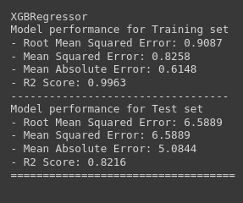
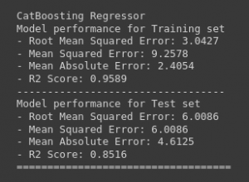

Hyperparameter Tuning
It will give the model with most accurate predictions and improve prediction accuracy.
This will give the optimized value of hyperparameters, which maximize your model predictive accuracy.
from sklearn.model_selection import GridSearchCV, RandomizedSearchCVfrom sklearn.metrics import make_scorer
# Define hyperparameter ranges for each model
param_grid = {
"Linear Regression": {},
"Lasso": {"alpha": [1]},
"K-Neighbors Regressor": {"n_neighbors": [3, 5, 7],},
"Decision Tree": {"max_depth": [3, 5, 7],'criterion':['squared_error', 'friedman_mse', 'absolute_error', 'poisson']},
"Random Forest Regressor": {'n_estimators': [8,16,32,64,128,256], "max_depth": [3, 5, 7]},
"Gradient Boosting": {'learning_rate':[.1,.01,.05,.001],'subsample':[0.6,0.7,0.75,0.8,0.85,0.9],
'n_estimators': [8,16,32,64,128,256]},
"XGBRegressor": {'depth': [6,8,10],'learning_rate': [0.01, 0.05, 0.1],'iterations': [30, 50, 100]},
"CatBoosting Regressor": {"iterations": [100, 500], "depth": [3, 5, 7]},
"AdaBoost Regressor": {'learning_rate':[.1,.01,0.5,.001],'n_estimators': [8,16,32,64,128,256]}
}

model_list = []
r2_list =[]
for model_name, model in models.items():
# Create a scorer object to use in grid search
scorer = make_scorer(r2_score)

# Perform grid search to find the best hyperparameters
grid_search = GridSearchCV(
model,
param_grid[model_name],
scoring=scorer,
cv=5,
n_jobs=-1
)

# Train the model with the best hyperparameters
rid_search.fit(X_train, y_train) # Make predictions y_train_pred = grid_search.predict(X_train) y_test_pred = grid_search.predict(X_test) # Evaluate Train and Test dataset model_train_mae, model_train_mse, model_train_rmse, model_train_r2 = evaluate_model(y_train, y_train_pred) model_test_mae, model_test_mse, model_test_rmse, model_test_r2 = evaluate_model(y_test, y_test_pred) print(model_name) model_list.append(model_name) print('Best hyperparameters:', grid_search.best_params_) print('Model performance for Training set') print("- Root Mean Squared Error: {:.4f}".format(model_train_rmse)) print("- Mean Squared Error: {:.4f}".format(model_train_mse)) print("- Mean Absolute Error: {:.4f}".format(model_train_mae)) print("- R2 Score: {:.4f}".format(model_train_r2)) print('----------------------------------') print('Model performance for Test set') print("- Root Mean Squared Error: {:.4f}".format(model_test_rmse)) print("- Mean Squared Error: {:.4f}".format(model_test_rmse)) print("- Mean Absolute Error: {:.4f}".format(model_test_mae)) print("- R2 Score: {:.4f}".for

model_test_r2)) r2_list.append(model_test_r2) print('='*35) print('\n')

Outputs
The output of after tuning all algorithms’ hyperparameters. And it provides the RMSE, MSE, MAE, and R2 score values for training and test data.
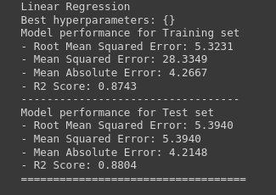
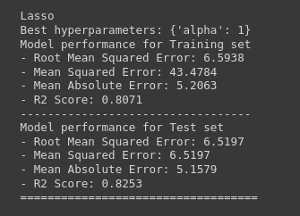
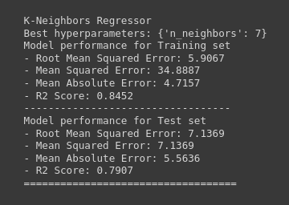
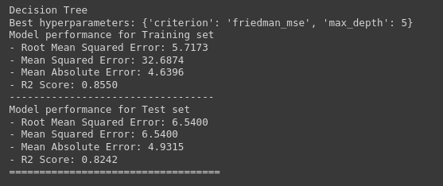
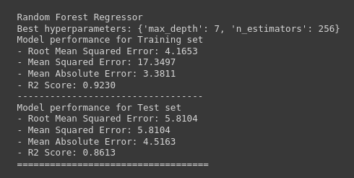
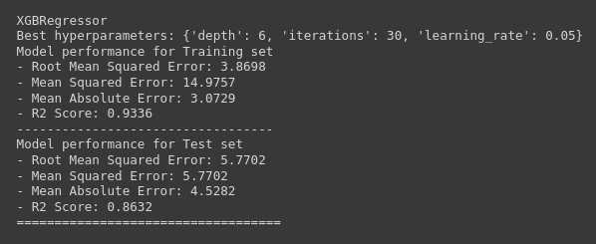
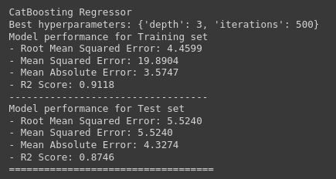
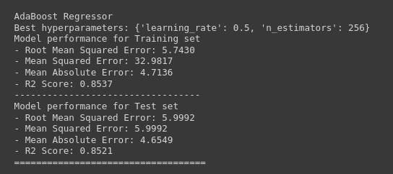
If we choose Linear regression as the final model because that model will get a training set r2 score is 87.42 and a testing set r2 score is 88.03.

Model Selection
This is used to select the best model of all of the regression algorithms.
In linear regression, we got 88.03 curacy in all of the regression models that’s why we choose model.
pd.DataFrame(list(zip(model_list, r2_list)), columns=['Model Name', 'R2_Score']).sort_values(by=["R2_Score"],ascending=False)
Accuracy of the model is 88.03%
plt.scatter(y_test,y_pred)
plt.xlabel('Actual')
plt.ylabel('Predicted')
plt.show()
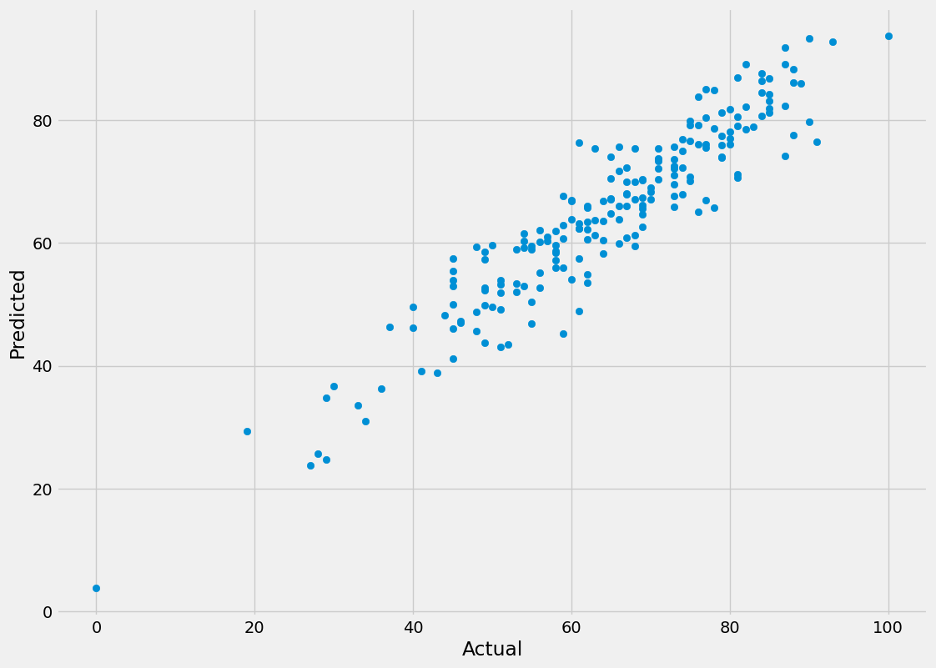
sns.regplot(x=y_test,y=y_pred,ci=None,color ='red')
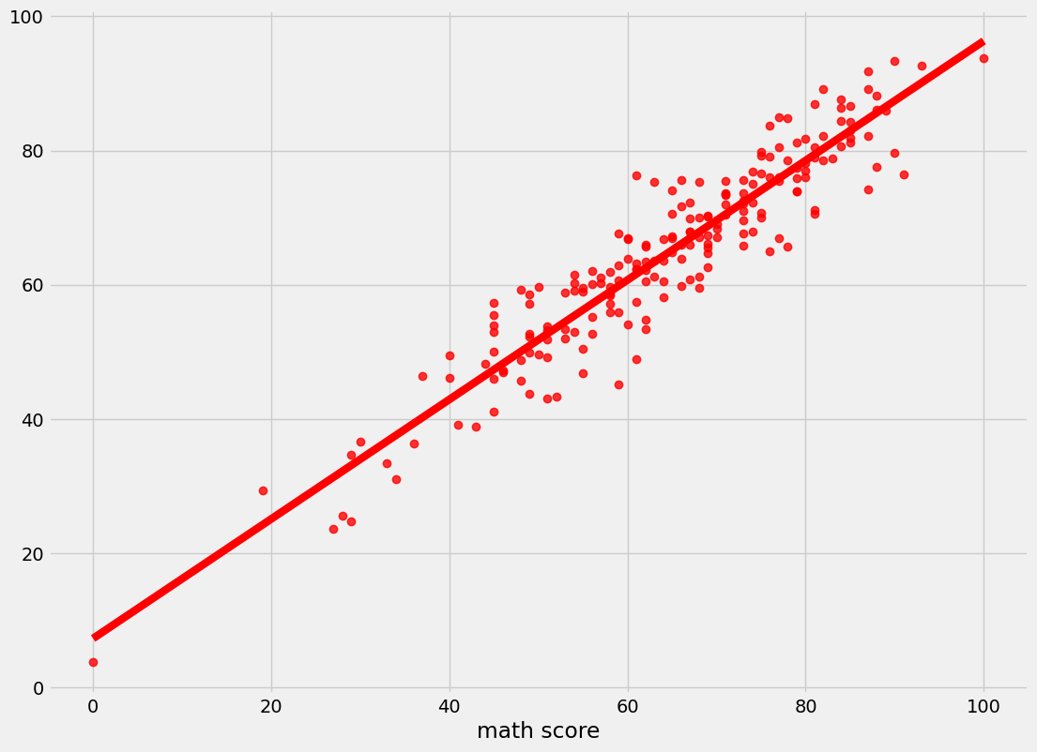

Difference Between Actual and Predicted Values
pred_df=pd.DataFrame({'Actual Value':y_test,'Predicted Value':y_pred,'Difference':y_test-y_pred})
pred_df
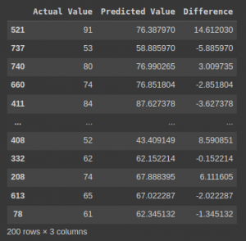

Convert the Model to Pickle File
# loading libraryimport pickle# create an iterator object with write permission - model.pklwith open('model_pkl', 'wb') as files:
pickle.dump(model, files)
# load saved modelwith open('model_pkl' , 'rb') as f:
lr = pickle.load(f)

Conclusion
This brings us to an end to the student’s performance prediction. Let us review our work. First, we started by defining our problem statement, looking into the algorithms we were going to use and the regression implementation pipeline. Then we moved on to practically implementing the identification and regression algorithms like Linear Regression, Lasso, K-Neighbors Regressor, Decision Tree, Random Forest Regressor, XGBRegressor, CatBoosting Regressor, and AdaBoost Regressor. Moving forward, we compared the performances of these models. Lastly, we built a Linear regression model that proved that it works best for student performance prediction problems.
The key takeaways from this student performance prediction are:
- Identification of student performance prediction is important for many institutions.
- Linear regression gives better accuracy compared to other regression problems.
- Linear regression is the best fit for the problem
- Linear regression provides an accuracy of 88%, giving out the most accurate results.
I hope you like my article on “Student performance analysis and prediction.”

