**Gesture Recognition Case Study Write Up**

**Group:**

1. **Sandhya Rajagopalan (Group Facilitator)**
2. **Arasan P M**

**Observations:**

* **Choosing the appropriate Batch size is important to help the model learn in this case 40 seems to be performing well**
* **Decreasing the image size is helping to reduce the number of Parameters**
* **Changing the Kernel size is helping capture the features better and improve accuracy**
* **Changing the image index slightly also helps reduce the number of parameters**
* **Lesser the parameters faster the model is able to train**
* **Batch normalization did not help this model as the depth is less**
* **Introducing Dropouts appropriately is helping to reduce overfitting and generalize the model**
* **Using Transfer Learning might further help this model**
* **Final Model has an approx. Train Accuracy of 85 to 87% and Validating Accuracy of 85% to 86%**
* **Augmentation might cause issues as Gestures are very directional**

|  |  |  |  |  |
| --- | --- | --- | --- | --- |
| **Experiment Number** | **Model** | **Parameters** | **Result** | **Decision + Explanation** |
| **1** | **Conv3D** |  | **ResourceExhaustedError** | **Batch Size 100 with Batch Normalization** |
| **2** | **Conv3D** |  | **ResourceExhaustedError** | **Reduced Batch Size from 100 to 90** |
| **3** | **Conv3D** | **Frame start = 0**  **Frame end = 30**  **Step = 2**  **Total Frames = 15**  **Image Size = 100*100**  **Params = 13,556,261** | **Training Accuracy = 27%**  **Validation Accuracy = 35%** | **Reduced Batch Size to 70 to avoid error** |
| **4** | **Conv3D** | **Frame start = 0**  **Frame end = 30**  **Step = 2**  **Image Size = 100*100**  **Params = 22,512,869** | **Training Accuracy = 38%**  **Validation Accuracy = 60%** | **Removed Batch Normalization as the model depth is less** |
| **5** | **Conv3D** | **Frame start = 0**  **Frame end = 30**  **Step = 1**  **Totals Frames = 30**  **Image Size = 100*100** | **ResourceExhaustedError** | **Increased images to 30 by making step size to 1 to improve accuracy** |
| **6** | **Conv3D** | **Frame start = 0**  **Frame end = 30**  **Step = 1**  **Totals Frames = 30**  **Image Size = 100*100** | **ResourceExhaustedError** | **Decreased batch size to 50 to avoid resource error** |
| **7** | **Conv3D** | **Frame start = 0**  **Frame end = 30**  **Step = 1**  **Total Frames = 30**  **Image Size = 100*100**  **Params = 44,664,037** | **Training Accuracy = 41%**  **Validation Accuracy = 38%** | **Decreased batch size to 45 again to avoid resource exhausted error** |
| **8** | **Conv3D** | **Frame start = 0**  **Frame end = 30**  **Step = 1**  **Total Frames = 30**  **Image Size = 100*100**  **Params = 44,664,037** | **Training Accuracy = 58%**  **Validation Accuracy = 59%** | **Decreased batch size to 40 try and increase accuracy** |
| **9** | **Conv3D** | **Frame start = 0**  **Frame end = 30**  **Step = 1**  **Total Frames=30**  **Image Size = 100*100**  **Params = 44,664,037** | **Training Accuracy = 71%**  **Validation Accuracy = 65%** | **Changed epoch to 15 from 10 to try increase the accuracy** |
| **10** | **Conv3D** | **Frame start = 4**  **Frame end = 30**  **Step = 1**  **Frames = 26**  **Image Size = 100*100**  **Params = 33,588,453** | **Training Accuracy = 78%**  **Validation Accuracy = 60% (Approx)** | **Changed Image index Range from 4-30 (26 frames). Reduced Batch Size to 38 and Increased Epoch to 20 to reduce parameters** |
| **11** | **Conv3D** | **Frame start = 2**  **Frame end = 30**  **Step = 1**  **Frames = 28**  **Image Size = 90*90**  **Params = 32,081,125** | **Training Accuracy = 71%**  **Validation Accuracy = 70%** | **Increased Batch size back to 40 and Increased Frames to 28**  **Decreased no of Epoch 15**  **Reduce Image size 90*90 to reduce Params** |
| **12** | **Conv3D** | **Frame start = 2**  **Frame end = 30**  **Step = 1**  **Frames = 28**  **Image Size = 90*90**  **Params = 32,081,125** | **Training Accuracy = 21%**  **Validation Accuracy = 15%** | **Increased Learning Rate to 0.005 to check if Accuracy would increase**  **Increased no of epochs to 20** |
| **13** | **Conv3D** | **Frame start = 2**  **Frame end = 30**  **Step = 1**  **Frames = 28**  **Image Size = 90*90**  **Params = 32,081,125** | **Training Accuracy = 81%**  **Validation Accuracy = 45%** | **Decreased Learning Rate to 0.002 as accuracy fluctuated wildly**  **Decreased no of epochs to 15** |
| **14** | **Conv3D** | **Frame start = 2**  **Frame end = 30**  **Step = 1**  **Frames = 28**  **Image Size = 70*70**  **Params = 21,516,037** | **Training Accuracy = 80%**  **Validation Accuracy = 78%** | **Reduced Kernel size from 4 to 3 to increase feature capture. Decreased back to default Learning Rate 0.001. Reduced Img size 70*70 to reduce Params**  **And Batch size at 40** |
| **15** | **Conv3D** | **Frame start = 2**  **Frame end = 30**  **Step = 1**  **Frames = 28**  **Image Size = 70*70**  **Params = 21,516,037** | **Training Accuracy = 91%**  **Validation Accuracy = 80% (Approx)** | **Increased no of Epoch 20 to see the complete accuracy** |
| **16** | **Conv3D** | **Frame start = 2**  **Frame end = 30**  **Step = 1**  **Frames = 28**  **Image Size = 70*70**  **Params = 2,379,525** | **Training Accuracy = 91%**  **Validation Accuracy = 82% (Approx)** | **Changed Max pooling pool size to 3 from 2 for first two max pooling layers to retain better level of information** |
| **17** | **Conv3D** | **Frame start = 2**  **Frame end = 30**  **Step = 1**  **Frames = 28**  **Image Size = 70*70**  **Params = 2,338,789** | **Training Accuracy = 92%**  **Validation Accuracy = 82% (Approx)** | **Changed Kernel of two Conv3d Layers to 2 from 3 to capture better Higher-level features**  **Increased Epoch to 25** |
| **18** | **Conv3D** | **Frame start = 2**  **Frame end = 30**  **Step = 1**  **Frames = 28**  **Image Size = 70*70**  **Params = 2,338,789** | **Training Accuracy = 88%**  **Validation Accuracy = 85% (Approx)** | **Added Dropout of 0.5 after last max pooling layer to help with Overfitting.**  **Epoch remains at 25** |
| **19** | **Conv3D** | **Frame start = 2**  **Frame end = 30**  **Step = 1**  **Frames = 28**  **Image Size = 70*70**  **Params = 2,338,789** | **Best Training Accuracy = 87%**  **Best Validation Accuracy = 86% (Approx)**  **Final Training Accuracy = 85.4%**  **Final Validation Accuracy = 85%** | **Added Dropout of 0.1 after first two max pooling layers to help with overfitting and generalize the model.**  **Epoch remains at 25.** |

**Loss and Accuracy Plots for the different Models:**

**Model 1:**

Batch Size 100 throws Resource Error

**Model 2:**

Batch Size 90 throws Resource Error

**Model 3:** Batch Size 70, img100*100 and frames 15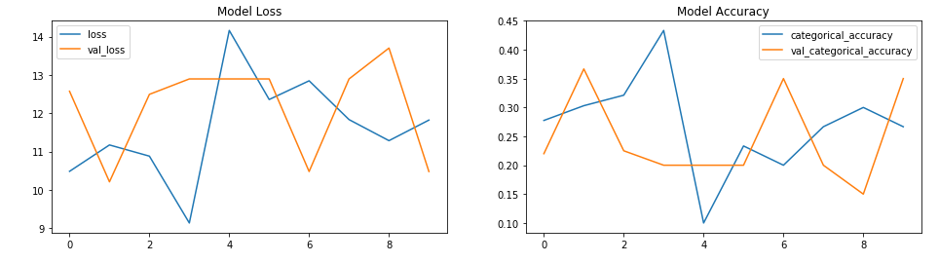

**Model 4**: Batch Size 70, img100*100 and frames 15 (Removed Batch Normalization)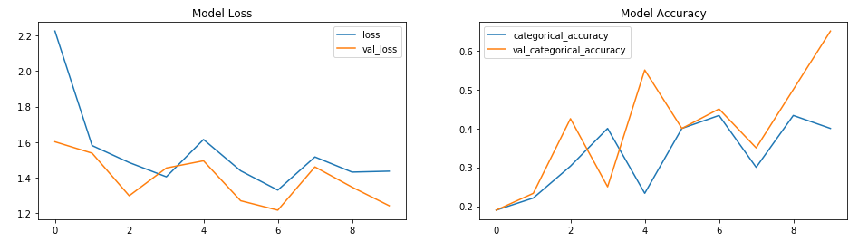

**Model 5**: Increased images to 30 by making step size to 1 and Encountered Resource error

**Model 6**: Decreased batch size to 50 and Encountered Resource Error

**Model 7**: Decreased batch size to 45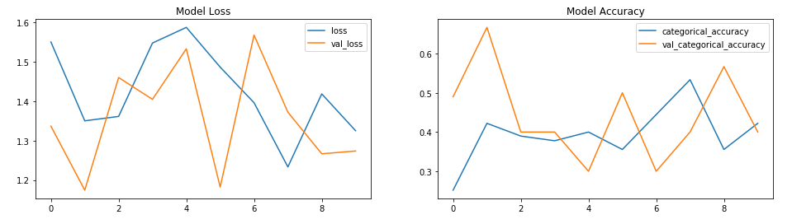**Model 8**: Changed Batch Size to 40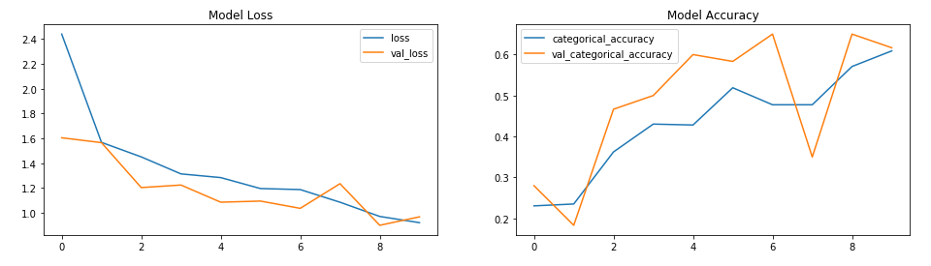

**Model 9**: Changed epoch to 15

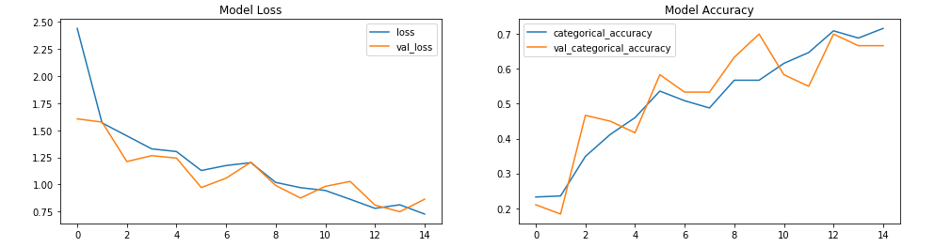

**Model 10**: Changed Image idx Range from 4-30 (26 frames) and Batch Size to 38 and Epoch to 20

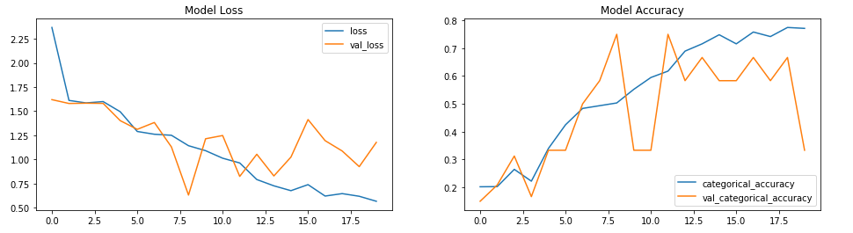

**Model 11**: Batch size 40; Frames 28 (2-30); Epoch 15; img 90*90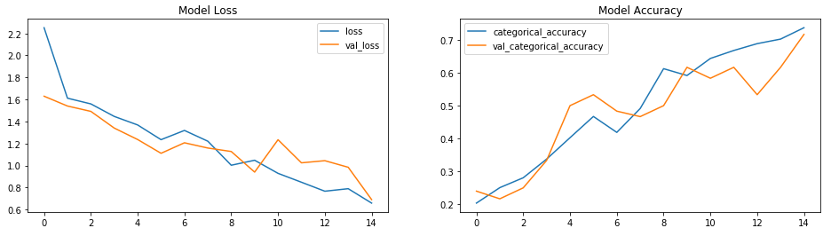

**Model 12**: Increased LR:0.005 and epoch to 20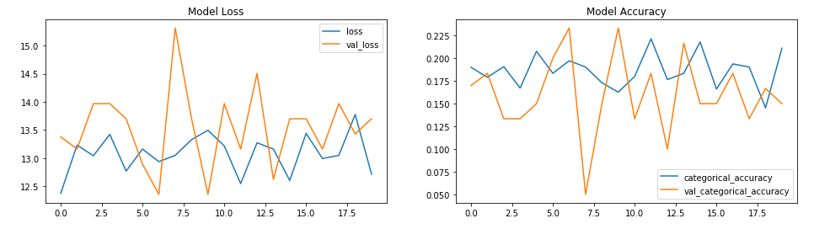

**Model 13**: Decreased LR to 0.002 from 0.005 and Decreased epoch to 15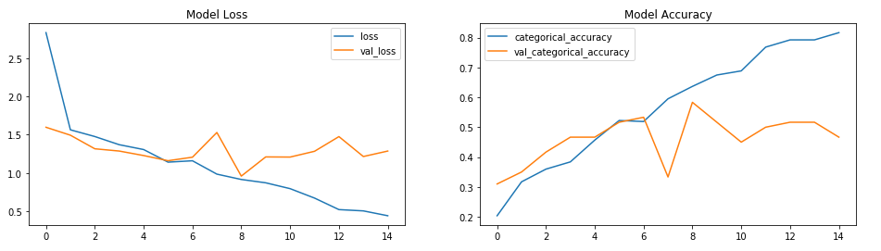

**Model 14**: Changed Kernel size from 4 to 3 for first two convolution layers; Changed LR back to default 0.001; Reduced Img 70*70; Batch 40; epoch = 15

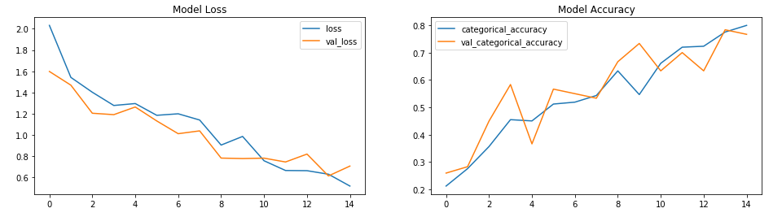

**Model 15**: Changed Epoch 20

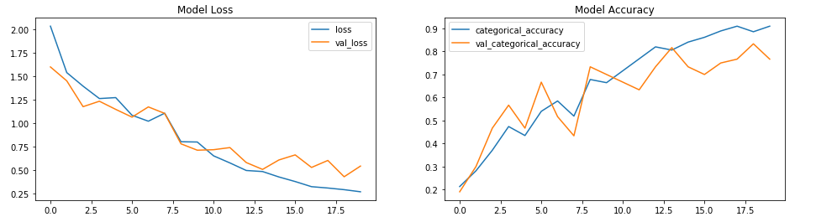

**Model 16**: Changed Max pooling pool size to 3 from 2 for first two max pooling layers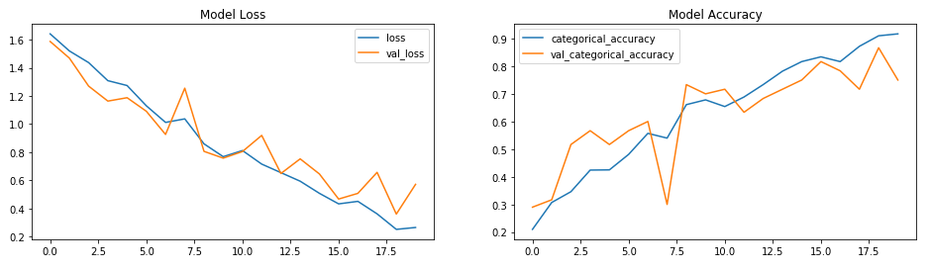

**Model 17**: Changed Kernel of first two convolution layers to 2 from 3 and Increased Epoch to 25

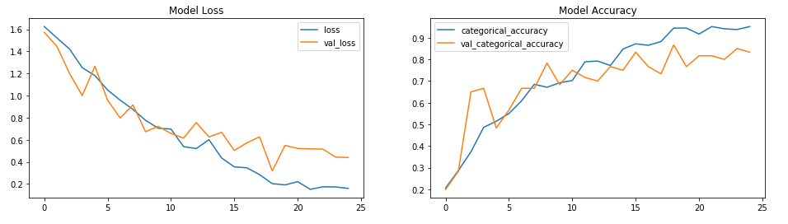

**Model 18**: Added Dropout of 0.5 for the third max pooling layer

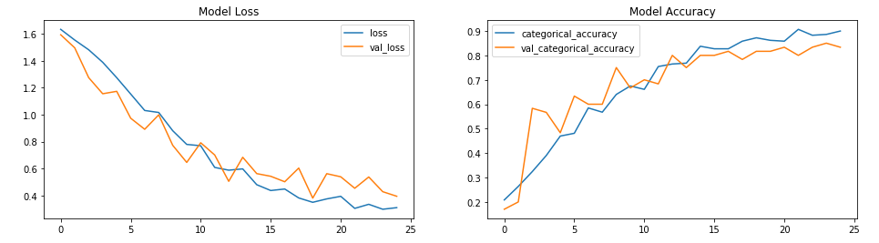

**Model 19**: Added Dropout of 0.1 for the first and second max pooling layer

