CENG 421/ELEC 536 Assignment 2

Posted: February 15 2011.  Due: March 4 2011 4:00pm | Aras Balali Moghaddam

This assignment consists of several steps. The main goal is to familiarize yourself with
thresholding algorithms and morphological operations discussed in class and in Chapter 6 of
your textbook.

1. Foreground Segmentation:

Note: For this section, you will need the files “stuff.pgm” and “stufmin1.pgm”.
1a. Write a program which takes as input two grayscale images: The first of a scene containing a foreground object, the second of the same scene with the foreground object removed. Your program must isolate the missing object using an image differencing or background subtraction method. The output of the program will be a binary image in which background pixels are set to 0, and foreground pixels are set to 1.

I perform this to separate the eliminated object from the rest of the scene:

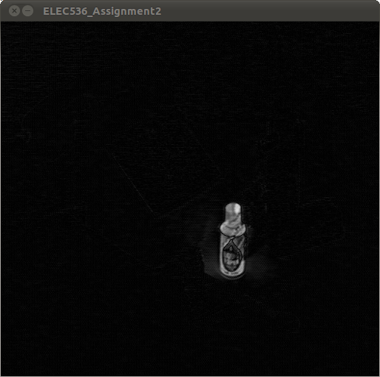
Here is the result image before thresholding. There is still some noise.

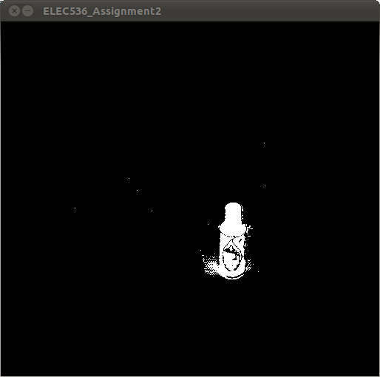
1b. Write a program to automatically threshold the foreground object from the background using any method discussed in class (indicate in your write up which method you used). The program will take as input 2 greyscale images as described in 1a. Your program must not use a manually selected threshold. The output of the program will be a binary image in which background pixels are set to 0, and foreground pixels are set to 1. (Use of the MatLab function “imthresh” is not allowed. You must write your own function.)

Question 1 part b: Automatic threshold selection
Automatic threshold selection ...
1 - Previous T: [100] Next T: [66]
2 - Previous T: [66] Next T: [57]
3 - Previous T: [57] Next T: [55]
4 - Previous T: [55] Next T: [55]
Selected threshold: [[ 55 ]]
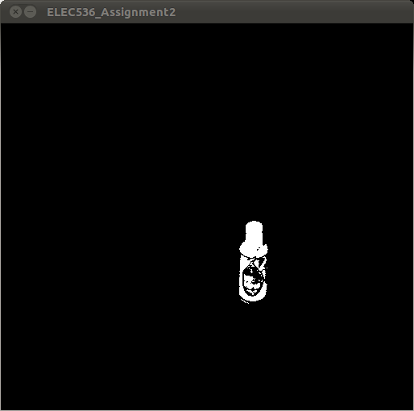
Automatic thresholding

1c. Write a program to perform noise removal on an input image using a median filter. The program must be able to accept either grayscale or binary images as input, and the output image will be of the same format as the input image. Select the image from 1a or 1b that gave you the best result, and use your program to perform median filtering on that image. (Use of the MatLab functions “imfilter” and “medfilt2” are not allowed. You must write your own function to perform the median filtering of the image.)

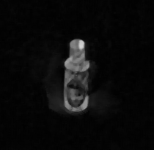 |  | 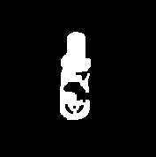

2. Connected Components:

2a. Write a program to perform a connected component labeling of the binary image produced in 1c. The output of your labeling should follow the same format as the MatLab bwlabel() function (see MatLab help files). You may define your connected components using either 4-connected or 8-connected regions, just make sure to state which you use in your written report. (Use of the MatLab function “bwlabel” is not allowed. You must write your own function for connected component labeling.)

I have not finished implementing this algorithm yet. So I used OpenCV equivalent of bwlabel which are findContour() and drawContour() functions to implement this part and move forward.
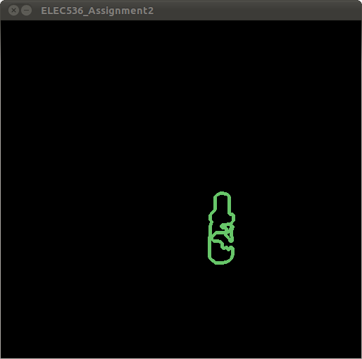

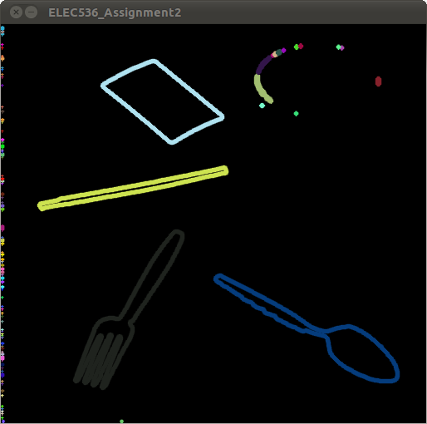

2b. Identify and display (using colour) the connected component corresponding to the object of interest. Any connected components not belonging to the object of interest (ie: noise) should remain white. Use this connected component as a mask to display the original grayscale object. Your output image should display the object in grayscale as determined by the mask, while the rest of the image remains black (ie: Everything but the object should be removed from the image).

3. Measurement:

Using the connected component object labeling computed in 2a and the MatLab regionprops() function, write programs to do the following:

3a. Calculate the area of the object of interest (in pixels).

3b. Calculate the centroid of the object of interest. In addition, display the object
with the centroid indicated by superimposing ‘cross hairs’ over the image.

3c. Calculate the orientation (in degrees) of the object of interest from the x-axis.
Display the major axis by superimposing a line over the object image.

Note: For 3.b and 3.c, it is enough to superimpose the cross hairs or line on the binary
connected component image of the object. You do not need to display the grayscale
image of the object.

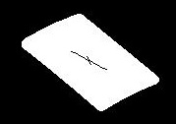

Example:

In this image, the cross hair position indicates the centroid location, while the long edge of the cross hair indicates the major axis of the object.

4. General Thresholding:

Using the image “things.pgm”, test the algorithms that you designed in the previous sections on it.

Since you have only one image to work with, you cannot test the image differencing algorithm from 1a. You also cannot use a comparison of two images to determine an automatic threshold as in 1b. Instead, modify your 1b code to accept a single image as input, and use automatic thresholding directly on that image to look for bright objects.

Perform the connected component labeling from Part 2, and calculate the measurements from part 3 on each of the detected objects.

Discuss how well your code performs at detecting the various objects in the image. One object will be particularly difficult to find, do not worry if you are not able to detect it. Comment on how you might go about detecting it.

Optional:

For a little additional challenge (and a few bonus marks!), try to segment the objects in the images “testimage.pgm” and “testimagemin1.pgm”. You may notice that the images are not perfectly aligned. Does this have any effect on your results? Are you able to clean up any noise using the function you wrote in 1.c? If not, how might you obtain a cleaner result (ie: what other algorithms discussed in class might prove useful)?

Guide for Submission:

Assignments are to be submitted by e-mail by the required date & time. Attach your
assignment document to the e-mail (word or pdf), and copies of all MatLab code (mfiles).
Your document should include any written answers as well as printed results from
your algorithms (data, images, etc).

Please ensure that your code is well commented and easy to read and follow. The marker
should be able to run your code to reproduce any output data with a minimal amount of
user input.

You may wish to write a short “readme” file to include with your code, giving short
instructions on how to run it, including any necessary function parameters. Alternatively,
you may write a separate script file which executes each problem’s code and displays the
results.

