Case 1: Sales Performance Analysis
Company Background
TechSupply Co. is a regional distributor that sells electronics, office supplies, and office furniture to both retail and business customers. Management wants to better understand sales trends, customer purchasing behavior, and regional performance to improve future sales strategies.
You have been hired as a junior data analyst to explore the sales dataset and provide insights. Your task is to use Excel filtering and sorting tools to answer business questions and provide recommendations.
Dataset: use the techsupply_dataset.xlsx
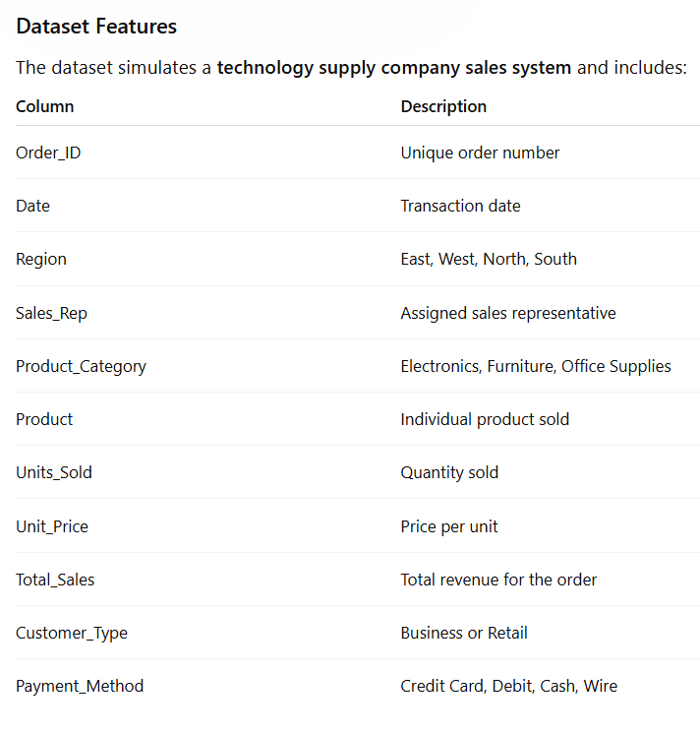

Complete the following 5 tasks.
REGIONAL PERFORMANCE ANALYSIS
Task 1: Use filters to explore sales by region.
- Filter by Region = East
- Sort Total_Sales from Largest to Smallest
Questions:
- What is the largest sale in the East region?
The largest sale in the East was $52,950.
- Which product category appears most frequently?
Electronics appears the most in the East, with 33 orders.
- Which sales representative appears most often?
Brown and Johnson are tied. They each have 13 East orders.
CUSTOMER BEHAVIOR ANALYSIS
Task 2: Filter by
- Customer_Type = Business
Questions
- Which product category do business customers purchase most often?
Business customers bought Office Supplies the most, with 60 orders.
- What is the largest business transaction?
The largest business sale was $63,646.20.
- Which sales rep handles the most business orders?
Brown and Garcia are tied with 25 business orders each.
PRODUCT PERFORMANCE
Task 3: Use filters to analyze Product_Category.
Analyze each category separately:
- Electronics
- Furniture
- Office Supplies
Questions
- Which category appears to generate the highest total sales?
Furniture made the most money, with $1,290,860.65 in sales.
- Which specific product appears most frequently?
Filing Cabinet, Notebooks, and Printer Paper are tied at 26 orders each.
- Which category tends to have the largest individual transactions?
Furniture has the highest average sale. The biggest single sale was Electronics.
PAYMENT PATTERN ANALYSIS
Task 4: Filter by Payment_Method
Analyze:
- Credit Card
- Debit
- Cash
- Wire
Questions
- Which payment method is used most frequently?
Credit Card was used the most, with 88 orders.
- Do business customers prefer a specific payment type?
Yes. Debit was used the most by business customers, with 48 orders.
- Which payment type is associated with larger purchases?
Wire payments had the highest average sale, about $10,812.79.
TOP SALES REPRESENTATIVES
Task 5: Sort by:
- Sales_Rep
- Total_Sales(Largset > Smallest)
Questions
- Which sales rep appears to handle high-value transactions?
Garcia handled the biggest single sale at $75,929.88. Lopez made the most sales money overall.
- Which rep appears most frequently in the dataset?
Brown appears the most, with 45 orders.
- Which region do they appear to sell in most often?
Brown made the most orders in the West, with 15.
ANALYST RECOMMENDATION
Imagine you are presenting your findings to management.
Answer the following:
- Which region appears to be the strongest market?
East had the highest sales, with $582,612.36.
- Which product category should the company promote more?
I would promote Furniture because it made the most sales money.
- Are business customers or retail customers more valuable?
Retail made a little more money from sales, but Business placed more orders.
- What two recommendations would you give the sales manager?
I would focus on the East and South regions. I would also promote Furniture more.

Bonus
Build
- Bar Chart – Sales by Product Category
- Pie Chart – Customer Type Distribution
- Column Chart – Sales by Region
What story does the data tell?
Furniture made the most money, and East had the strongest sales. Retail brought in slightly more money than Business.

