Improving Weak Prompts

1. Explain Regression

Improved Prompt: I am a beginner learning data analytics. Can you explain linear regression in simple terms, give me a real-world example, and explain how it can help predict future values? Avoid complicated mathematical terms.
Why My Prompt Is Stronger: My prompt is better because I told AI that I am a beginner and asked it to use simple words. I also asked for a real-life example to help me understand it better
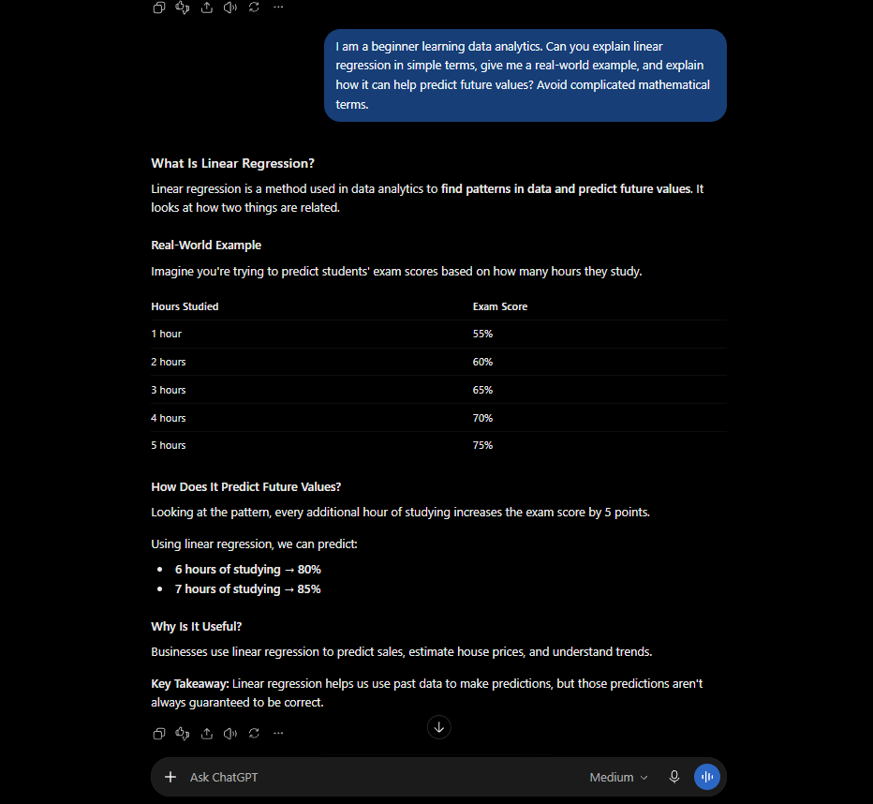

2. Help Me Understand SQL
Weak Prompt: Help me understand SQL.
Improved Prompt: I am new to SQL and learning it for data analytics. Explain what SQL is used for and show me three beginner examples using SELECT, WHERE, and ORDER BY. Explain what each query does step by step.
Why My Prompt Is Stronger: My prompt is better because I told AI exactly what I wanted to learn about SQL instead of asking a general question. I also asked for examples and simple steps to understand it better.
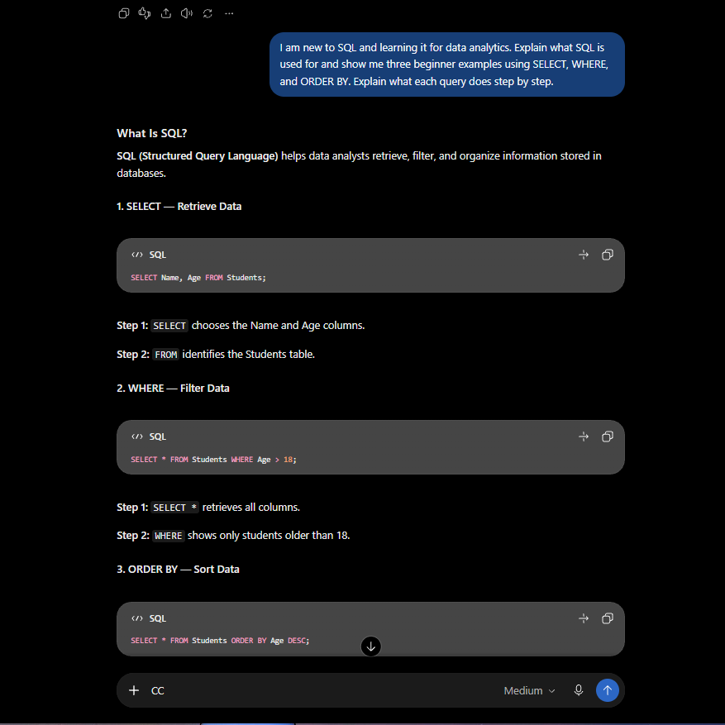

3. Create a Dataset
Weak Prompt: Create a dataset.
Improved Prompt: Create a sample dataset for a small online store with 10 rows and four columns: Product Name, Price, Quantity Sold, and Customer Rating. Prices should range from $10 to $200, quantities from 1 to 100, and ratings from 1.0 to 5.0. Format the data as a table so I can copy it into Excel.
Why My Prompt Is Stronger: My prompt is better because I gave AI clear instructions about how I wanted my dataset, like how many rows and columns I needed. I also told it to make a table so I could easily use it in Excel.
