LHRFvsLHRF

Average x estimation error = 8.524


Average y estimation error = 9.193


Average s estimation error = 7.014


NLHRFvsNLHRF

Average x estimation error = 22.252


Average y estimation error = 23.614


Average s estimation error = 13.075


LHRFvsNLHRF

Average x estimation error = 64.373


Average y estimation error = 63.545
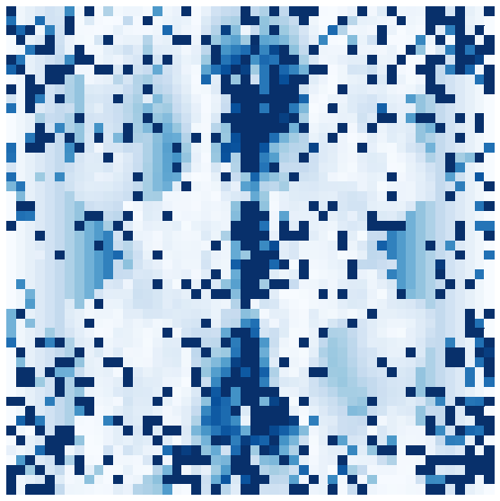

Average s estimation error = 172.182


NLHRFvsLHRF

Average x estimation error = 158.826


Average y estimation error = 156.746


Average s estimation error = 75.578
