Salt ponds with no inundation: ADCIRC water levels at the questioned locations
RICHAMP forecast gfs_2026-09-24-12, mesh ricv1_noriv_nopump
Arash Rafiee
25 September 2026

1. Jon’s question
I noticed in the most recent run that there are salt ponds/coastal waterbodies that do not show any flooding despite adjacent bodies of water having some.
Specifically: Flooding appears in all salt ponds except Ninigret, Green Hill, & Potter Ponds. I wonder if the Charlestown breachway isn’t being adequately resolved in the mesh? (Plus the Succotash Rd bridge connecting Potter Pond to Pt. Judith Pond)
There is also an Ocean Ave culvert to “Goose Neck Cove” in Newport that doesn’t seem to connect, and a culvert under Veterans Memorial Parkway a little pond off of the old golf club in East Prov (next to Watchemoket Cove).

2. Isaac’s comment
The dashboard displays water depth above ground (inundation), calculated using the post-processing code Chris and Peter developed. The ADCIRC output provides the total water surface elevation referenced to NAVD88. The ground elevation data used in ADCIRC and the post-processing are consistent but not identical because of differences in spatial resolution. We need to look at the ADCIRC water elevation output at these locations. Arash, could you make these plots?

3. What was done
The ADCIRC water surface elevation (zeta, metres NAVD88) was read directly from the full-domain fort.63.nc of the 24 September 2026 12Z GFS forecast (forecast_base run, 20-minute output, 24 Sep 12:20 to 29 Sep 12:00 UTC). For each location a point was placed inside the pond, at its inlet, and in the adjacent open water, and the nearest subtidal mesh node (depth below NAVD88) was sampled. A second pass computed the peak zeta over the whole run at every node, to draw a map of how far the tide reaches into each area.
Script: tools/pond_timeseries.py in the richamp-support-floodwater repository, points in tools/pond_points.json. Outputs: pond_zeta.csv, pond_nodes.json, and the figures below.

4. Answer in one line
ADCIRC never raises the water in these ponds. They sit flat near +0.1 m NAVD88 for the whole forecast while the tide outside swings from about -0.5 to +1.0 m. The dashboard is faithful to the model. The ponds are disconnected in the mesh.

5. Summary of the numbers
Location | Outside: max zeta (m) | Inside: range (m) | Inside behaviour
Ninigret Pond | 1.00 (Block Island Sound) | 0.00 to 0.07 | flat
Charlestown Breachway channel, inside jetties | 1.00 | -0.05 to 0.07 | flat, wet all run
Green Hill Pond | 1.00 | -0.12 to 0.16 | flat, dries 22% of the time
Potter Pond | 0.94 (Point Judith Pond) | -0.08 to 0.06 | flat, slow drift down
Potter Pond inlet channel | 0.92 (Succotash Rd marsh) | -0.08 to 0.06 | flat
Goose Neck Cove | 1.01 (Atlantic off Ocean Ave) | 0.05 to 0.08 | flat
Pond by old golf club | 1.24 (Watchemoket Cove) | 0.08 to 0.10 | flat, creeping up
Point Judith Pond is the control case. It follows the Harbor of Refuge almost one to one, with a small lag and damping. That is what a working breachway looks like in this mesh.

6. Ninigret Pond and Green Hill Pond
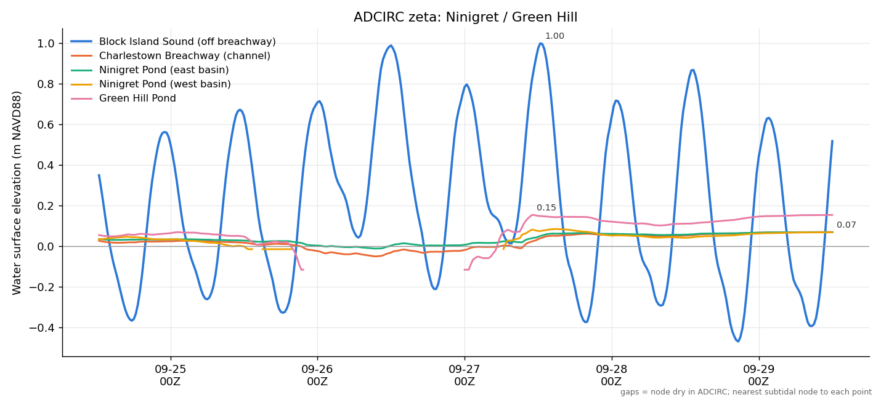
Water surface elevation inside and outside Ninigret and Green Hill Ponds.
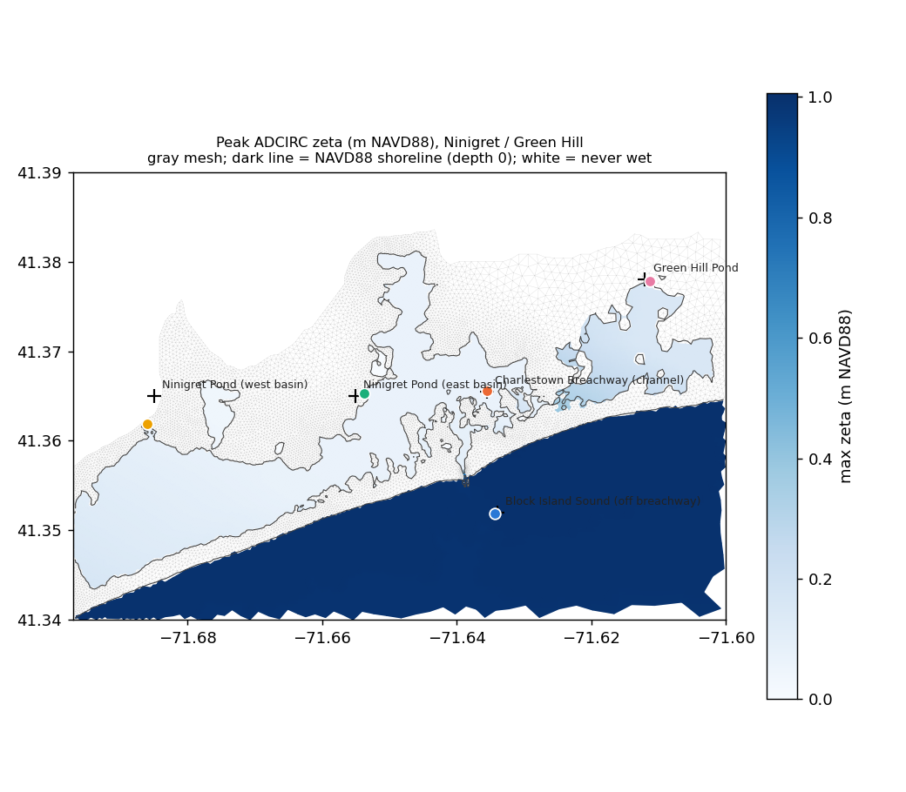
Peak zeta over the run around the Charlestown Breachway. Dark blue is open water reaching about 1 m; pale is water that never rises above 0.1 m; white is never wet. The dark line is the NAVD88 shoreline in the mesh.
- The dark tongue in the map is the tide entering between the breachway jetties. It stops about 200 m in, near 41.357 N. Everything north of that never exceeds 0.07 m.
- The channel node sampled inside the jetties (depth 0.83 m) is wet for the whole run but its level does not move. The mesh contains the channel; something between the jetties and that node blocks the flow, most likely a row of nodes above datum or a boundary string across the channel. That is a fort.14 question.
- Green Hill’s small swings and drying are wind setup inside a closed basin, not exchange with the ocean. The sampled node is only 0.12 m deep, so a few centimetres of setup exposes it.
- The two Ninigret points snapped 113 m and 355 m from the requested spots because the nearest nodes were above datum. Much of the pond interior is land in the mesh.

7. Potter Pond and Point Judith Pond
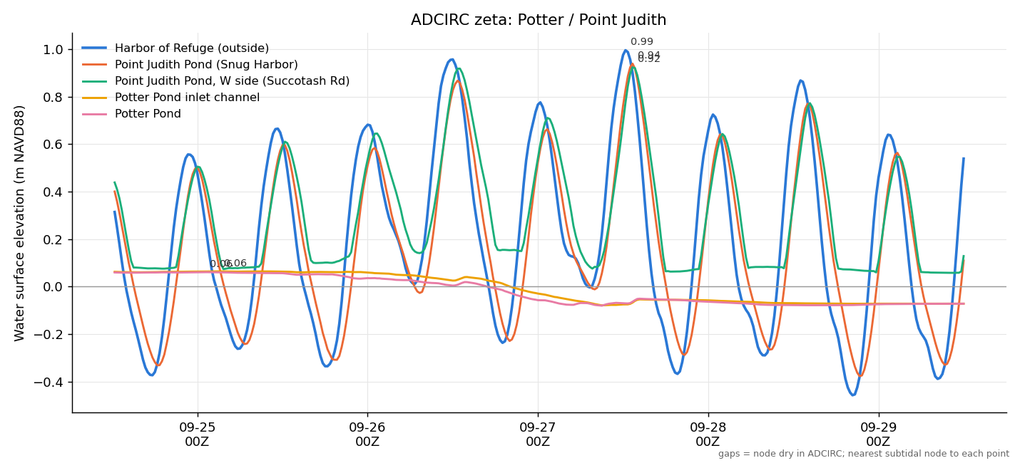
Water surface elevation in Potter Pond, Point Judith Pond and the Harbor of Refuge.
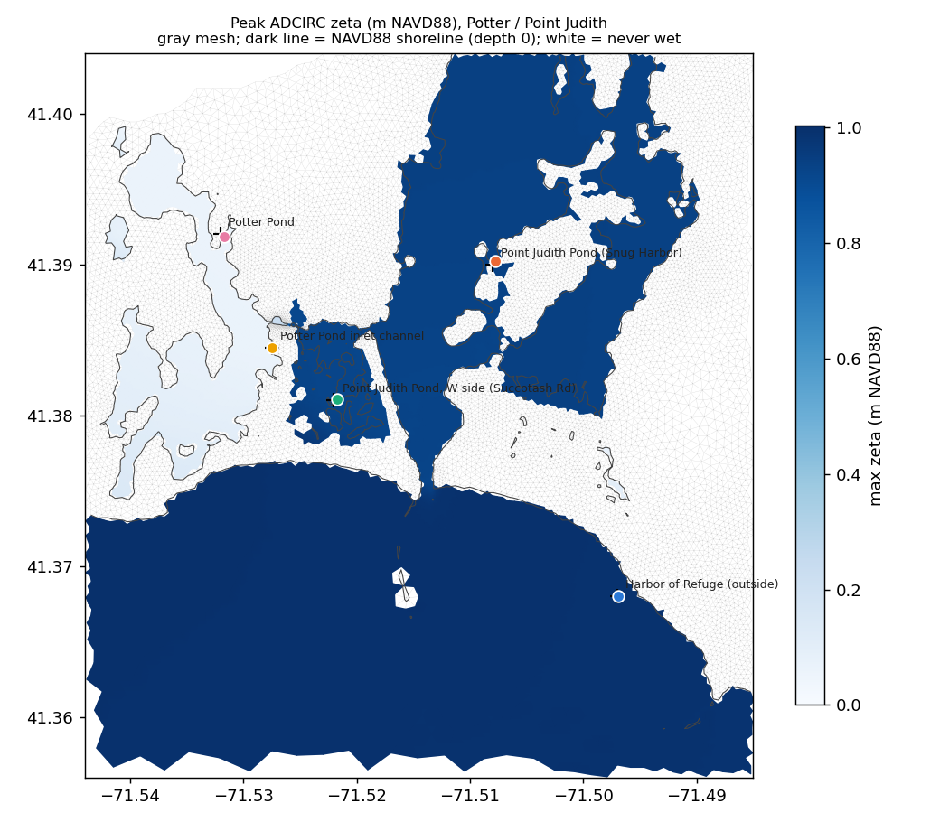
Peak zeta around Point Judith Pond and Potter Pond.
- Point Judith Pond (orange) tracks the Harbor of Refuge (blue). The Succotash Road marsh pocket (green) fills on every high tide and holds at 0.06 m between tides, which is what a perched marsh does. Both are fine.
- Potter Pond (pink) and its inlet channel (yellow) are identical and flat, then drift from +0.06 m down to -0.07 m over five days. The pond is closed and slowly leaking or settling. The tide does not reach it.
- The map shows Potter Pond as a pale closed basin west of the bright Point Judith Pond, with the inlet channel node at the edge and never moving. Same diagnosis as the breachway: a sill in the mesh where the Succotash Road bridge channel should be.

8. Goose Neck Cove, Newport
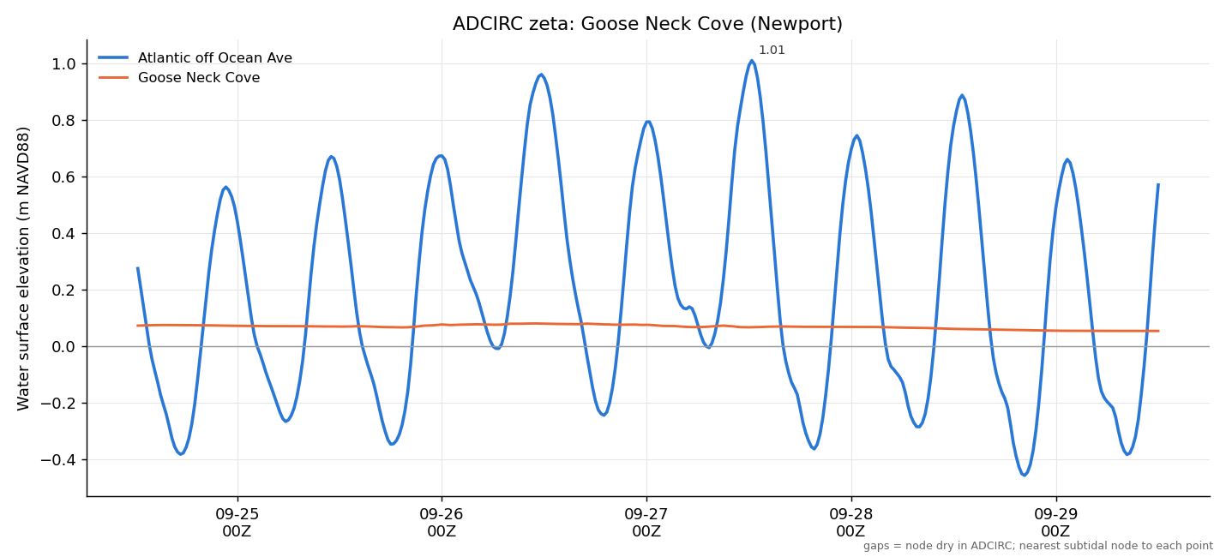
Water surface elevation in Goose Neck Cove and the Atlantic off Ocean Ave.
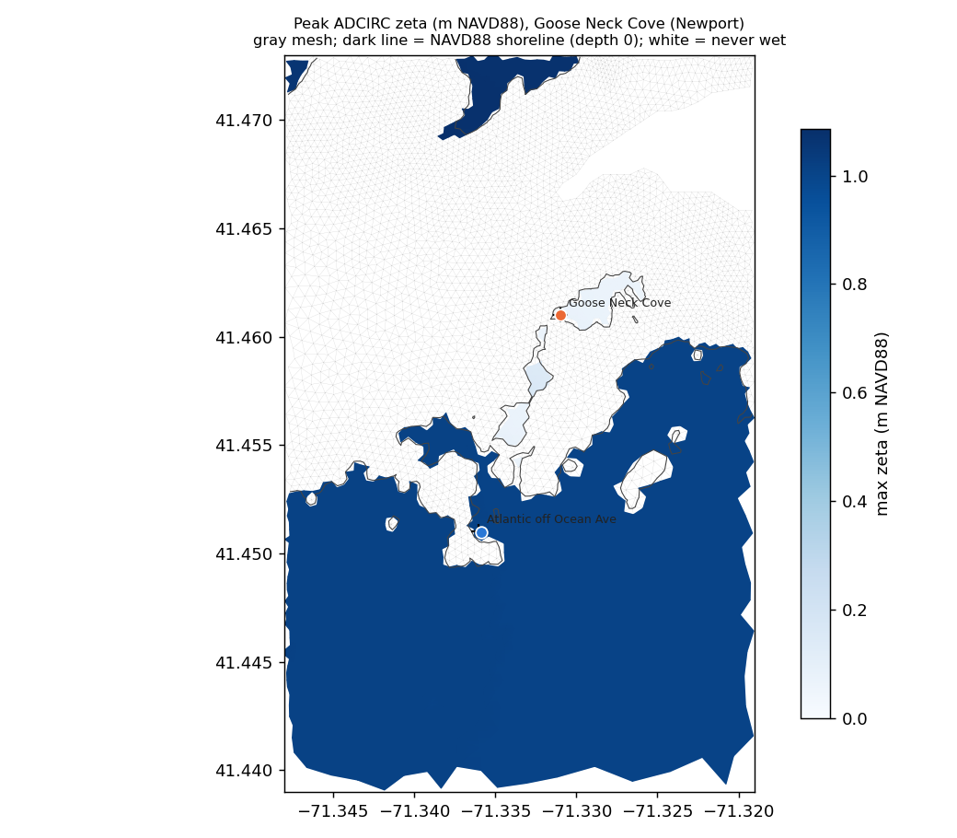
Peak zeta around Goose Neck Cove.
- The cove is a pale isolated pocket at 41.461 N with a thin chain of pale elements running south toward Ocean Ave and no wet path to the ocean.
- Its level is 0.05 to 0.08 m and dead flat: the initial water level with no exchange.
- A culvert under Ocean Ave is a sub-grid feature. ADCIRC only represents it if the mesh has an internal barrier boundary with a pipe, and this mesh does not.

9. Pond by the old golf club, East Providence
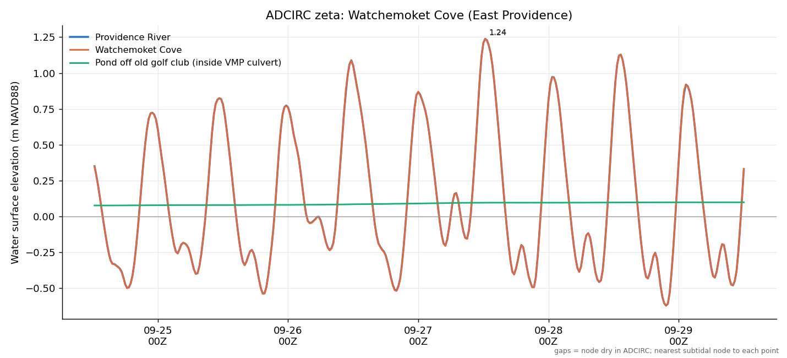
Water surface elevation in the Providence River, Watchemoket Cove and the pond inside the Veterans Memorial Parkway culvert.
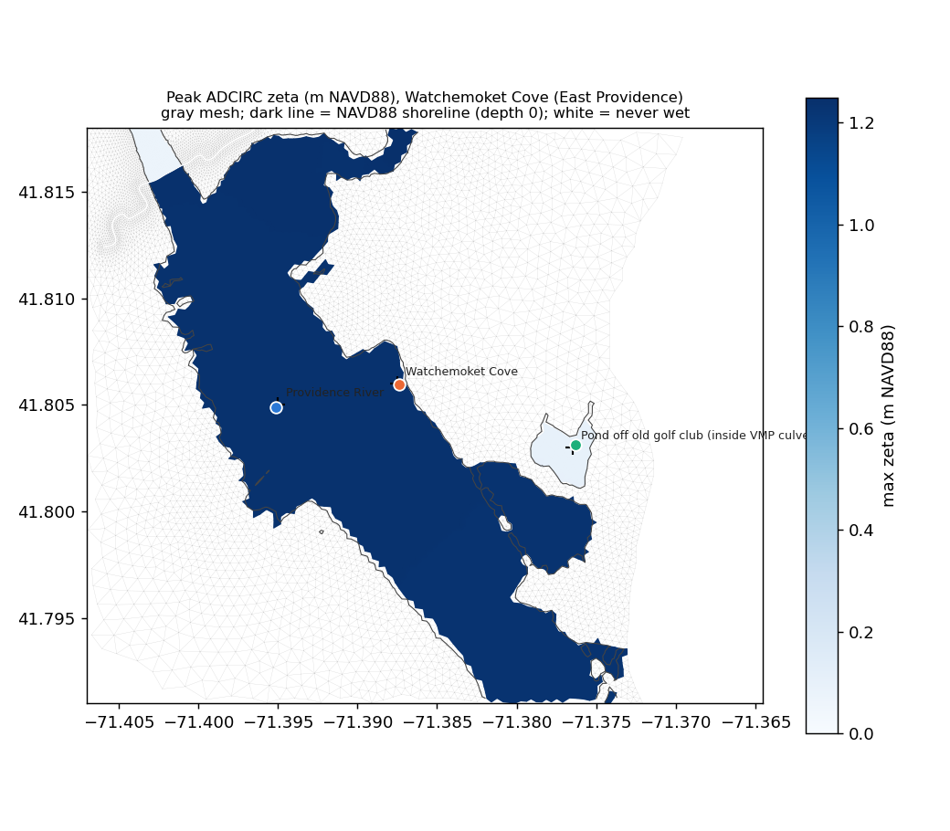
Peak zeta around Watchemoket Cove.
- Providence River and Watchemoket Cove are the same curve, so the cove is open water in the mesh.
- The pond (green) is 0.08 to 0.10 m, flat, with a very slow rise, and the map shows it as a closed pale basin with no channel to the cove. Same situation as Goose Neck Cove: the Veterans Memorial Parkway culvert is not in the mesh.

10. What this rules in and out
- Not post-processing. A ground-elevation resolution mismatch would show up as an offset between ADCIRC zeta and the dashboard depth. Here ADCIRC itself has no surge in the ponds, so there is nothing for the post-processing to convert.
- Not a wetting threshold. The pond interiors are wet (depth below datum) and stay wet. They simply do not move.
- It is mesh connectivity. Two blocked channels (Charlestown Breachway, Potter Pond inlet at Succotash Road) and two missing culverts (Ocean Ave, Veterans Memorial Parkway).

11. If the team wants to fix it
- Open the fort.14 for ricv1_noriv_nopump and walk the node elevations along the Charlestown Breachway from the jetties to the pond, and along the Potter Pond channel at Succotash Road. Find the nodes above datum or the boundary string that closes them and lower them to the surveyed channel depth.
- For Goose Neck Cove and the East Providence pond, add internal barrier boundaries with culvert pipes, or accept that these will not flood in the model.
- Rerun and check with bash tools/pond_timeseries.sh /path/to/new/fort.63.nc. Success looks like the Point Judith Pond curve: the pond tracks the outside water with lag and damping.

12. Caveats
- Points were placed by eye and snapped to the nearest subtidal node within 400 m (150 m for the Potter inlet). Node distances and depths are recorded in pond_nodes.json.
- The peak-zeta maps use the maximum over the run, so a node that wets once at 0.07 m looks the same as one always at 0.07 m. The time series disambiguate.
- This is one GFS run with ordinary tides and no storm. A surge large enough to overtop the barrier beach would flood the ponds by overwash regardless of the inlets, so this finding is about tidal and moderate-event connectivity.

