SPECIFIC REQUIREMENTS

A. External Interface Requirements
A.1 User Interfaces
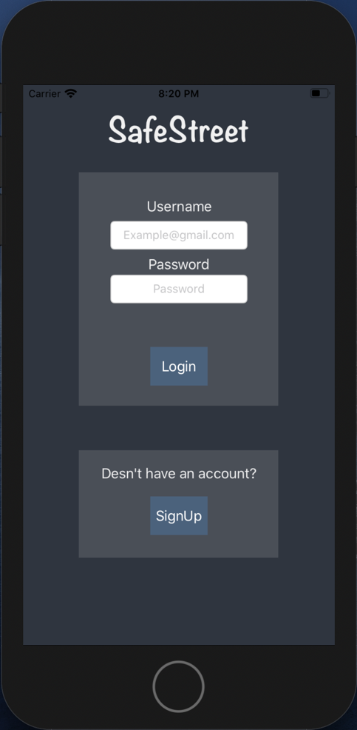
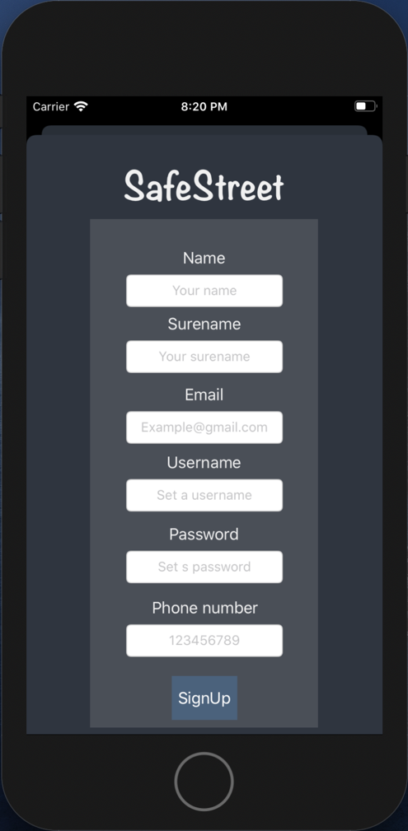
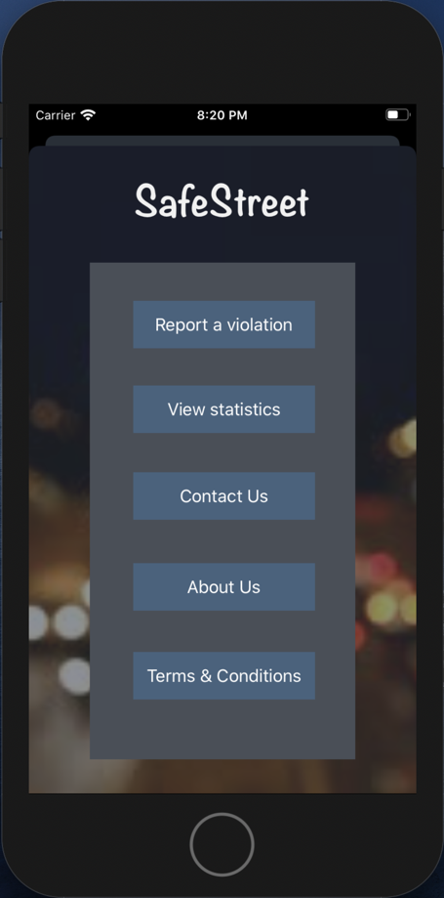
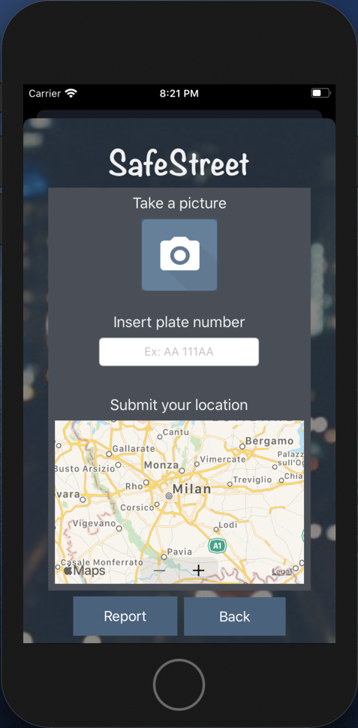

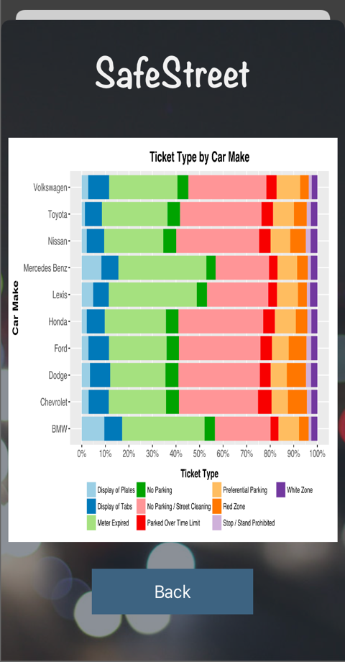

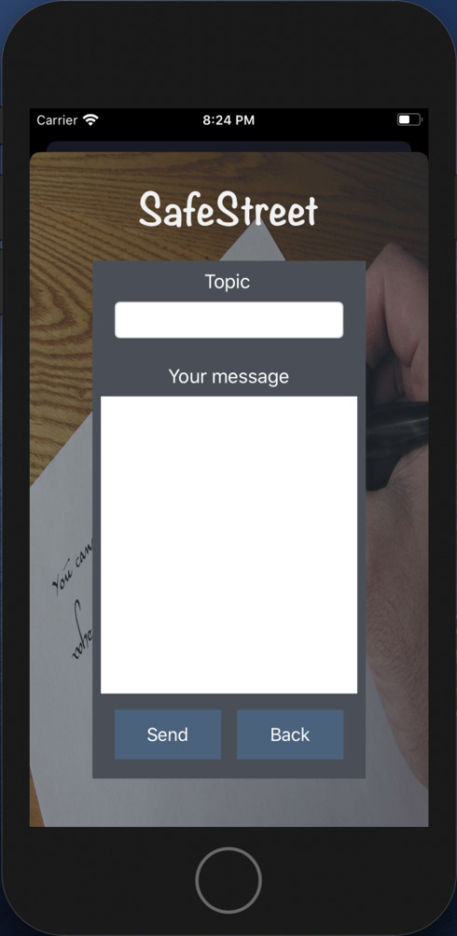
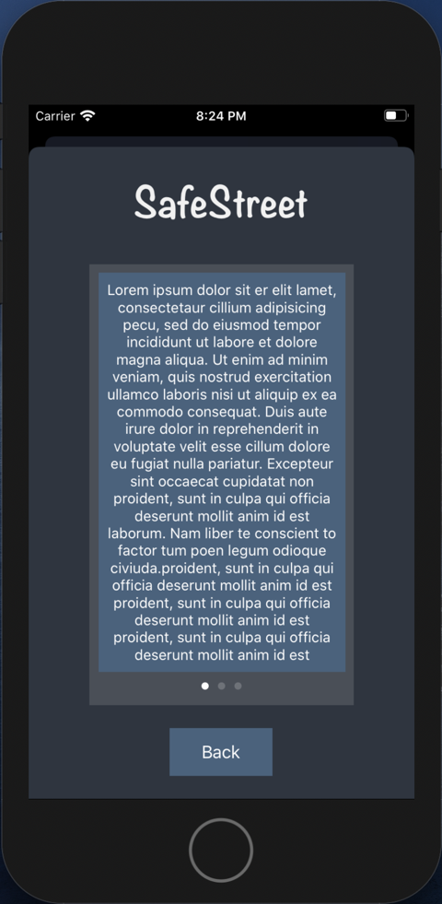

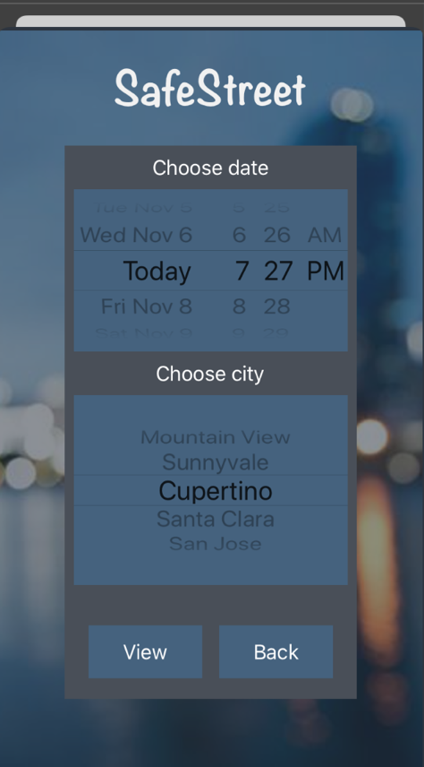
A.2 Hardware Interfaces
It is just a recommendation for other versions of the software. Municipality should assign each car an RFIDs which is located inside the car behind the front window. Regarding this, the reporter has to scan the RFID code and attach it to the report. So that the municipality can check if the number of the car is matched with the rfid code or not and find out the validation of the report.

A.3 Software Interfaces
This application does not need a software interface.
A.4 Communication Interfaces
For communication the application uses internet connection.
B. Functional Requirements
B.1 Goals and requirements
B.2 Usecase Diagrams
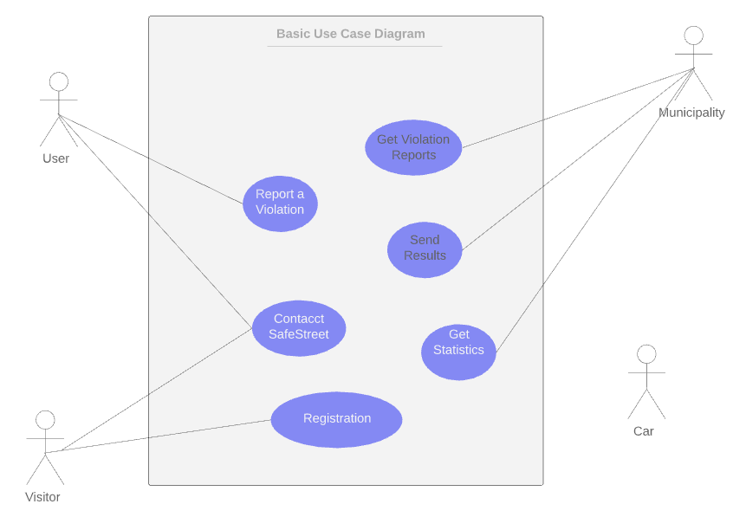

Use Case Scenarios:

Scenario one: Registration
jack is a public transport bus driver. It has occurred a lot when he arrives at a bus station, finds a car parked in that bus station. He has heard about SafeStreet and decides to take advantage of this app to notify authorities about drivers who are not law obedient, so he signs up for the app. While he stops at bus station and waiting for passengers to board, he carelessly takes a picture of a car that parked in that bus station. Since the picture doesn’t fulfill the required conditions of what app has specified, jack’s report is denied.

Name | Registration
Goals
Actors | Visitor
Input Conditions | There are no entry conditions
Event Flow | 1.The Visitor on the home page clicks on the “Sign UP” button to start the registration process.  2.The Visitor fills all the mandatory fields and provides his/her payment information.  3.The Visitor clicks on the “Confirm” button.  4.The system saves the data.  5.The system sends an SMS to the new User with the password.
Output  Conditions | The Visitor successfully ends the registration process and become a new User. From now on he/she can log in to the application providing his/her credentials and start using SafeStreet.
Exceptions | 1.The Visitor is already a User.  2.The Visitor inserts not valid information in one or more mandatory fields.  3.The Visitor chooses a username that has already been taken by another user.  4.The Visitor chooses an email that has been associated with another user.  All exceptions are handled notifying the issue to the Visitor and taking back the Event Flow to the point 2.

Scenario two: Report a vilation
Alex is a handicap driver. It’s crucial for him to be able to park his car in handicap parking slots since he has to go to his office by his car every day. Unfortunately, most of the time there are careless drivers who doesn’t respect this matter and park their car in those parking slots. So, Alex decides to exploit SafeStreet application do notify authorities about those rough drivers. One day he faces this situation so after Singin he takes a picture of situation along with that car’s plate and successfully reports this minor offence.

Name | Report a Violation
Goals
Actors | User, Municipality, Car
Input Conditions | The User is already on the home page.
Event Flow | 1.The User inserts Login information in the SafeStreer.  2.The User clicks on the “Log In” button in order to access.  3.The User fills all the mandatory fields and take a picture of the violation.  4.The User clicks on the “Confirm” button.  5.The system saves the data.  6. The system processes the data and extracts the properties of the car.  7. The system makes a report.  8.The system sends the report to the Traffic Police.
Output  Conditions | The User is successfully redirected to the Home Page.
Exceptions | 1. The User inserts a not valid username.  2. The User inserts a not valid password.  All exceptions are handled notifying the issue to the Visitor and taking back the Event Flow to the point 2.

Scenario three: Provide API
Sofia is a traffic control operator in municipality of Milan, and she has been tasked to detect streets with highest violation of double-parking cars where it’s prohibited so that municipality can plan to place elevator car parking to address the issue. She has heard about SafeStreet application which can indicate such streets by the help of users who report such violations such as double-parking. So, she signs a contract with SafeStreet corporation to receive such information by the help of an API which SafeStreet provides.

Name | Provide API
Goals
Actors | Third-Parties
Input  Conditions | There are no entry conditions
Event Flow | 1.The Visitor on the home page clicks on the “Contact Us” button to start  2.The Visitor can see the contact information of the SafeStreet Owners.  3.The Visitor clicks on the “Back” button to redirect to the home page.
Output  Conditions | No output.
Exceptions | No expectation.

Scenario four: Notify Municipality and Get ticket info
Due to a contract signed by SafeStreet corporation and municipality of Milan, SafeStreet is now responsible to provide municipality with reported traffic violations collected by its users and in return municipality is responsible to provide Safestreet with the tickets they issued for rough divers. People at SafeStreet plan to retrieve these thickest so that they can indicates how many of those violations reported by its users resulted in issuing thickets by municipality so that they can underline reliability of their user’s reports and further planning to improve the overall performance of SafeStreet application.

Name | Notify Municipality and Get ticket info
Goals
Actors | Municipality
Input  Conditions | 1.Municipality have received data from SafeStreet  2.Municipulity considered the data and had a reaction on each record
Event Flow | 1.The Municipality sends new data to SafeStreet  2.SafeStreet saves the data.  3.SafeStreet mine the data and update the statistics  4.Visitors and Users can see the updated statistics
Output Conditions | The data from municipality saves in the Safestreer Database.
Exceptions | 1. The process of receiving data fails,  In this case the received data is deleted and the Municipality redirects to line 1 of event flow.

B.3 Sequence Diagrams
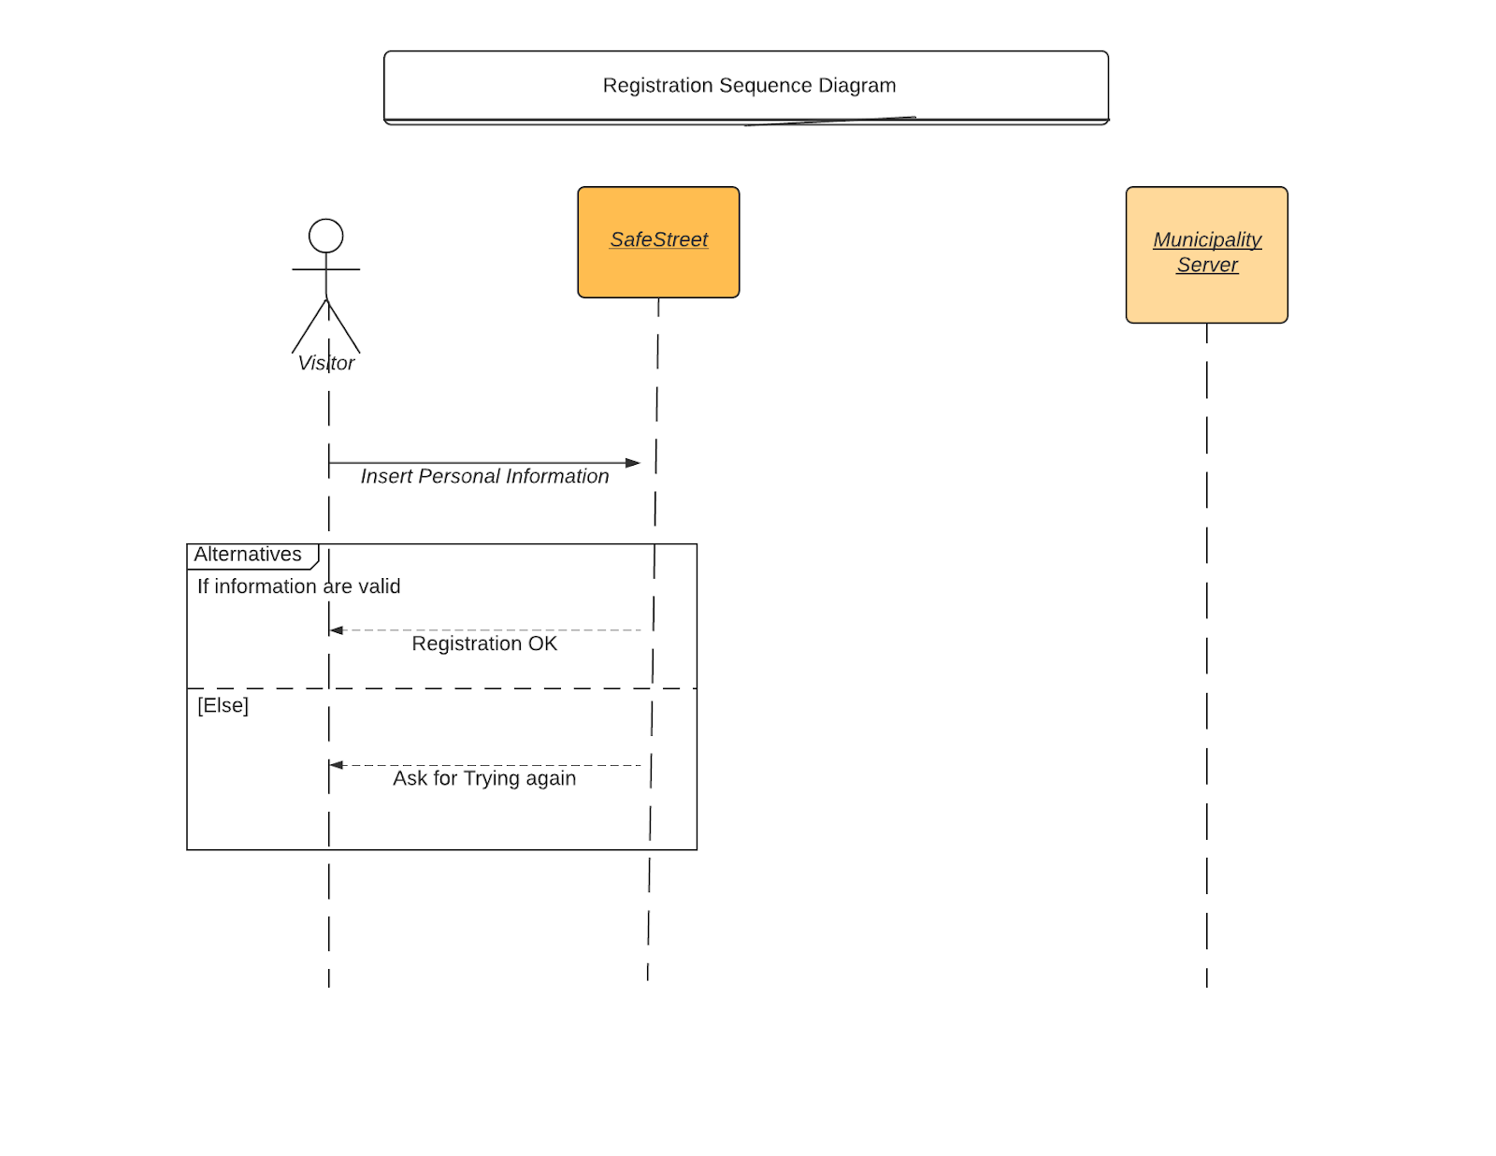
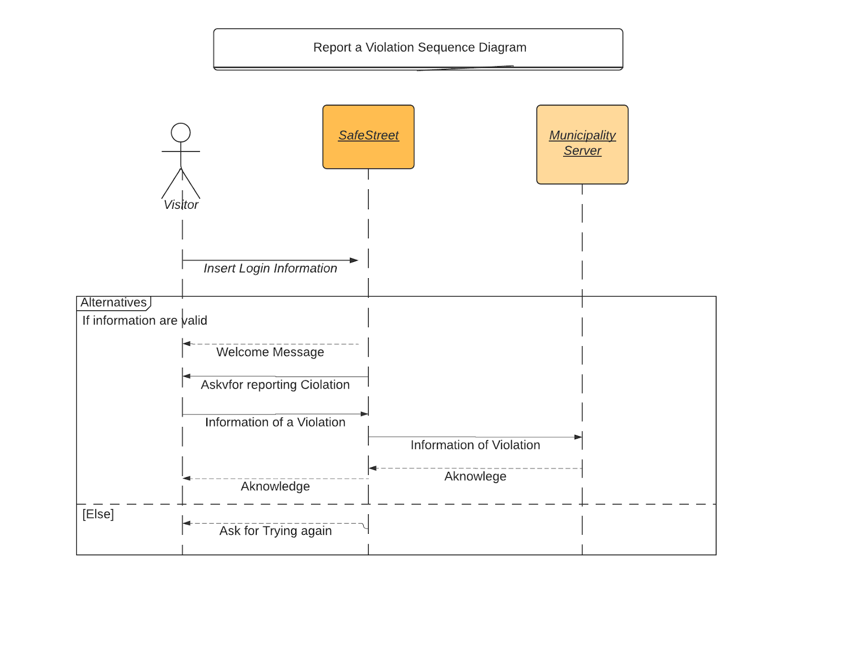
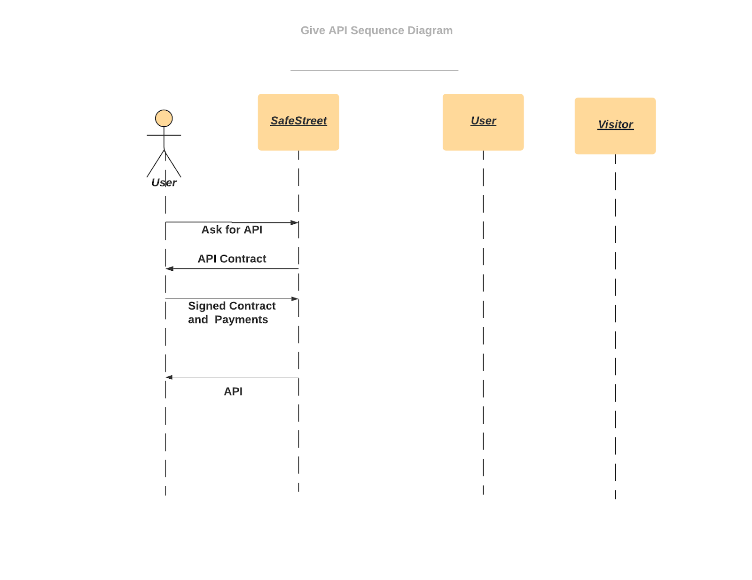
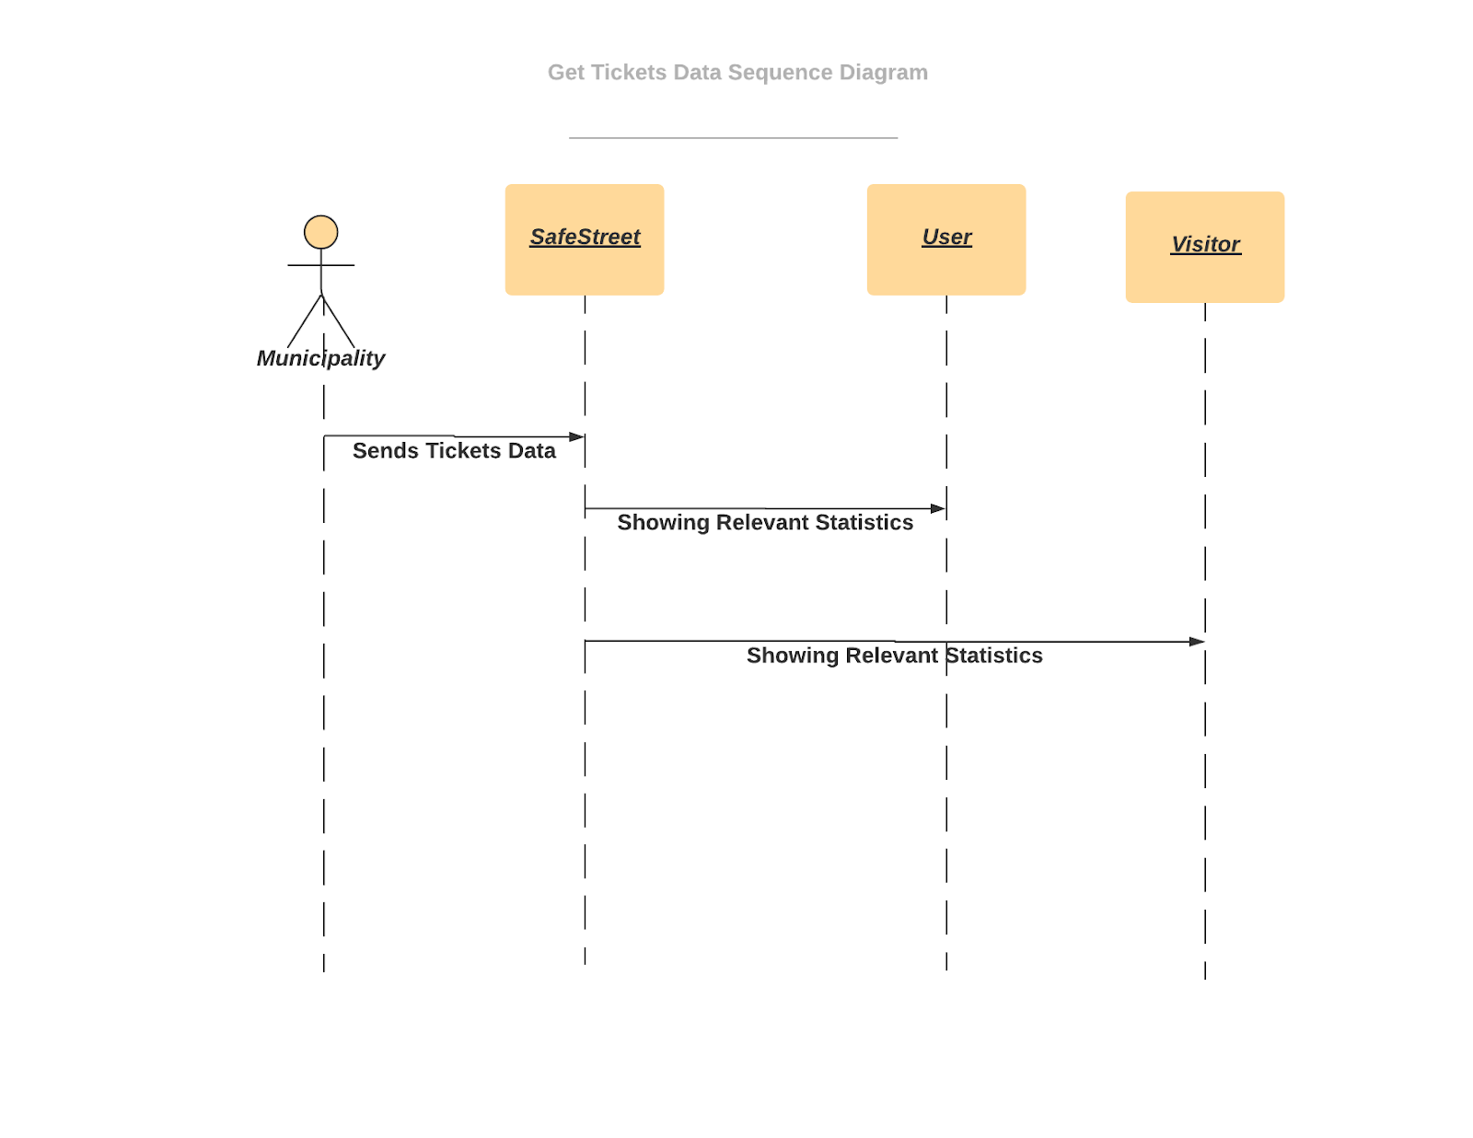
C. Performance Requirements
This application deals with sensitive information and the municipality may charge people by the reports of the application. It has to consider especial methods for preventing people to report not valid violations. Therefore, we allocate a number to each person. This number changes according to the reaction of the municipality to the reports of that account. To explain more, if the municipality decide the report from user x is valid the number for the user x increase. As a result, we rank the reports based on this numbers when we are sending the reports to the municipality.

D. Design Constraints
D.1 Standards compliance
D.2 Hardware limitations
This application does not need cutting-edge hardware technologies. The only requirement is having a smartphone.
  - Android or iPhone OS for smartphones.
  - GPS service.
  - 3G/4G connection.
  - Camera

D.3 Any other constraint
There are no any other constraints for the application.

E. Software System Attributes
E.1 Reliability
The application provides a reliable service, as it limits the users to take a picture of the violation at the moment and does not let them to upload pictures from the past so that we are sure the pictures are from the moment and not edited. All the data are sent to the municipality without any additional manipulation so that they can trust the records.
E.2 Availability
The availability of the application depends on the device state, whenever it connects to the internet, the reports which are saved on the device are sending to the SafeStreet servers and save in a buffer. Each night on 12am the buffer is sent to the server of the municipality. Since communicating data using this application is not a real time service, we do not need a high tech server just need enough space for saving records and also not the pictures.
E.3 Security
The systems use hash functions to store user’s data. In addition, in the reports to the municipality the personal information of the users is not sent.
E.4 Maintainability
The application will be implemented and designed with a complete documentary which makes it easier to maintain and understand the application for the future. Additionally, the user interface designed simply so that every user and third parties in the near future will figure out the usage. Furthermore, as the system sends all the data of the day to the municipalities, not much data will be loss in case the system breaks down. Also, the system takes backups each night so the statistics will be safe again.
E.5 Portability
The application will be able to run on Android or iPhone systems. SafeStreet wants to focus on both, because this application must be available for all the people in the citizens.

