**INSTITUTE OF COMPUTER SCIENCE AND DIGITAL INNOVATION**

Course Codes : CC 216/BIC2134 (May 2023)

Course Names : Operating System

Lecturer : Assoc. Prof. Dr. Ismail Ahmed Al-Qasem Al-Hadi

**Group Assignment**

|  |  |
| --- | --- |
| **Student Name** | **Student ID** |
| YUYE | 1001957154 |
| abdulrahman kamyabi | 1002267477 |
| Tai Meng | 1002162261 |
| Arash Karimpourghannadi | 1002057456 |

|  |  |  |
| --- | --- | --- |
| NO. | content | Page |
| 1. | Introduction | 2 |
| 2. | Problems in the existing operating system | 2 |
| 3. | Propose a new operating system | 4 |
| 4. | Features of the new operating system. | 5 |
| 5. | Discuss details on the suggested solutions for the challenges that you  highlight in this report. | 7 |
| 6. | Conclusion | 12 |
| 7. | Reference | 13 |

**1.0 Introduction**

As directed by our IT company, the purpose of this report is to present a comprehensive proposal for a new operating system that will address the problems encountered with the various versions of current personal computer operating systems. The primary goal of the proposal is to develop an efficient, user-friendly and secure operating system that will significantly enhance the overall user experience. This report will focus on identifying the problems associated with existing operating systems, proposing new and innovative solutions, discussing the features and improvements of the new operating system, and addressing the challenges associated with interfaces and storage devices.

1. **Problem in the existing operating system**

Existing personal computer operating systems suffer from a range of common problems that may vary from version to version. These issues have been identified as major pain points for users and include

a) Performance: A major problem is the low performance of many existing operating systems. Users often experience slow startup, application lag, and overall slow system responsiveness. These problems can be attributed to insufficient resource allocation, poor memory management, and inefficient task scheduling algorithms.

b) Security: Security vulnerabilities pose a major threat to existing operating systems. The prevalence of malware, viruses, and hacking attacks requires frequent security updates and patches to effectively mitigate these risks. Strengthening the security infrastructure is essential to protect user data and maintain system integrity.

c) Compatibility: Compatibility issues arise when trying to run older software or hardware on newer operating systems. Lack of backward compatibility can inconvenience users who rely on legacy applications and require extra effort to ensure smooth operation.

d) User Interface (UI): The user interface is an important aspect of any operating system, but the user interface design of some existing systems is not sufficiently intuitive and sophisticated. Users often experience difficulties in navigating the system and understanding its functionality. A visually appealing, user-friendly and intuitive user interface is essential to increase productivity and user satisfaction.

The security of our devices is important in the scientific and technical era that we are living in now, and most of the people make transmission through online and private information that is saved in their personal devices. Although there are many security measure that can help with prevention or minimize the unauthorize access, criminal acts, threat or cyber attack, as the improvement of technologies, their attack will also improve to make destruction, which the security vulnerabilities will have opportunity to occur in the future, that makes the security measures important and need to keep up with the trends of attacks in order to prevent the new attacks before it cause damage to our society. In the research of Chalmers University of Technology, they have shown that the vulnerabilities of security will probably always exist although there are security measure to prevent the problem that create the weakness of our devices, but can not totally reduce and eliminate all of them (Lindskog, S., 2000), therefore, we will discuss some security issue that we had facing in the common operating system.

In Windows system, Microsoft have state and mention that if any of the attacks success, the attacker can gain the access of the user, which there are one vulnerability of server message block which is a network protocol that is use for transmission and communication through network, and there are a DOS vulnerability in server message block which can let the device easily to be damage if the attacker use any denial of service on a target devices, it can make the device unresponsive, it crash the whole system and devices (CalCom., 2023). In 2023, the Nokoyawa ransomware attacker targeted the CLFS which is the Common Log File System from last year and attacked this year, and they have targeted various industries (Gatlan, S., 2023).

The second case  is the high-severity vulnerability in Linux, which this vulnerability appear on the Linux kernel version 5.8 in 2020 even though it is fixed in the version of 5.16.11, 5.15.25 and 5.10.102, it appear another vulnerability in 2022 call “Dirty Pipe”, this attack arises from the presence of an uninitialized variable which  allow attackers to overwrite any file information cached in memory even though the file has restriction on any action to the file (Goodin, D., 2022).

Third cases are the macOS, which have vulnerabilities that allow hackers to write arbitrary code on kernel privileges on personal devices which is a kernel problem and also allow attackers to write malicious web content that can cause execution of the arbitrary code ( Mashable SEA.*, 2023* ). There are another vulnerability call “Migraine” this allow the hackers have access to pass the SIP, which the system integrity protection are the security feature that is use in the macOS to protect the system file and prevent unauthorized modification, thus put a huge risk on the security of the user devices that can let the attacker to steal any information from the user (Microsoft Security Blog. 2023).

The security vulnerability can also be cause by the configuration complexity, configuration complexity can happen in the integration between software and hardware, the goal between both component is to make them work smoothly, but it take time to make it happen and is easy to produce error, thus produce a weak or default configuration which normally happen in the complex system that can raise security issues which can lead to the weak on passwords or encryption setting, and thus allow attacker easy to gain access and modify the data that store in the computer or even damage the device (Codecademy.2023).

The developer will need to be cautious on the requirement and the adjustment on both software and hardware, otherwise it can cause performance degradation as the software and hardware are components that are important for the performance and also can influence the compatibility issue that can be caused by the insufficient integration of the software application and hardware components.

1. **Propose a new operating system**

The proposed operating system aims to overcome the above challenges and revolutionize the personal computing experience. The new OS will implement the following key features and improvements:

a) Performance Optimization: The new OS will prioritize efficient resource allocation, robust memory management techniques, and optimized task scheduling algorithms. These improvements will dramatically reduce boot times, improve application responsiveness, and ensure an overall increase in system performance.

b) Enhanced Security: The new OS places a high priority on security and will integrate advanced security measures. These include built-in anti-virus software with real-time threat detection, a secure boot mechanism, and advanced encryption technology. Regular security updates will be seamlessly provided to guard against emerging threats.

c) Broad compatibility: The new OS will emphasize backward compatibility to provide a smooth transition for users. Compatibility layers and virtualization technologies will be leveraged to ensure seamless execution of legacy applications and hardware components without additional configuration or compatibility patches.

d) Intuitive User Interface: The user interface will be carefully designed to be visually appealing, intuitive and user-friendly. With modern design principles, customizable layouts and simplified navigation, the new operating system will provide an intuitive and engaging user experience. Novice users will find it easy to navigate, while advanced users will appreciate the efficiency and flexibility it offers.

To improve the security vulnerability, the new operating system will propose a system that focuses on the configuration, secure software distribution and error prevention. Configuration is important and needs to be well managed as it is related to the performance of the computer and its function, which means this is important to an operating system as it is a component that allows the software and hardware to work together in a low risk stage.                       Most of the attacks these days are from the network so it can also prevent unauthorized access to modified or write code during distribution by implementing secure mechanisms, and a security measure is the essential component that must be in a system .                         The error prevention can be used to limit the security issue to happen when any error occurs in the system or by users interaction with the system, and allow the system to produce an immediate solution to solve this error that can block the opportunity for an attacker to sneak into the system from the bug.

1. **Features of the new operating system.**

In order to address interface and storage challenges, especially those related to SSDs and HDDs, the following solutions are recommended:

a) Interface Challenges: The new OS will include robust device drivers that provide seamless support for a variety of interfaces. This includes support for SATA (Serial ATA) and NVMe (Non-Volatile Memory Express) for SSDs and SATA for HDDs. Comprehensive driver support will ensure optimal performance and compatibility across different storage devices.

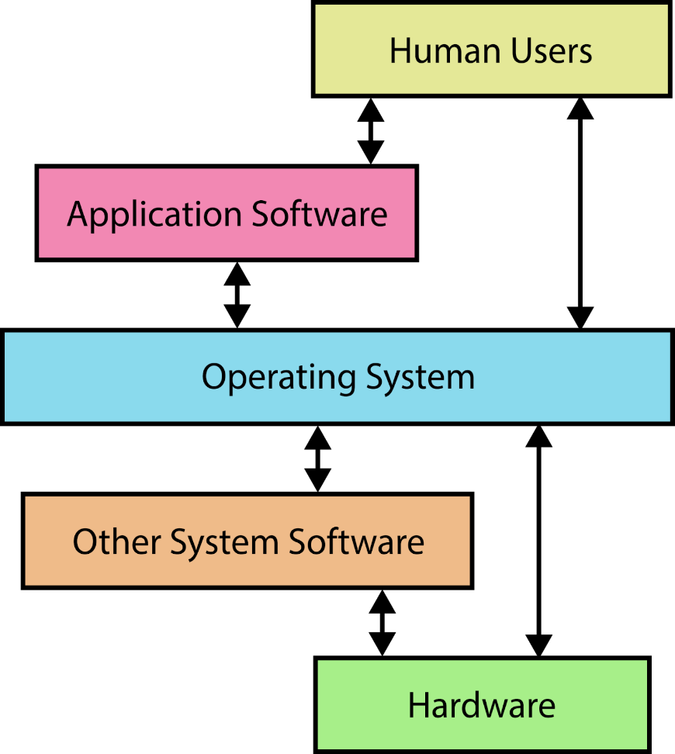

b) Kernel-Level Challenges: To overcome the challenges associated with SSDs and HDDs at the kernel level, the new operating system will employ advanced algorithms for efficient data management, wear leveling, and garbage collection. These techniques will maximize the life of SSDs by evenly distributing write operations among memory cells and optimizing data storage. In addition, the new operating system will implement strategies to minimize performance differences between SSDs and HDDs to ensure optimal SSD performance.

**Cross Platform Integration**

Cross platform integration is the ability that allow seamless communication between software application run on different operating system which user can be freely to work on the operating system without any integration problem, and user can share data in any form and does not need to worry the layout the original data information being change due to the section when they transform to other system, the data will be keep and share or transmit to other system as the same in the previous system and incorporate without any disruption functionality.

**Error Prevention**

Error prevention can encounter various errors that commonly happen in the operating system and provide solutions when the error occurs.This also improves the security of the operating system by limiting the error that can cause bugs and prevent performance degradation so users can have better experience on our operating system. This can also prevent the error caused by hardware failure, software problems and also human errors, and also increase security, so users can apply our system and limit serious damage on their devices.

**Hardware Failure Detection**

Hardware failure detection can forecast and provide information to inform users on the situation on the hardware so the user can understand and be aware of the failure of hardware. This feature is create to proactive the maintenance of users device which can notify the user before any attack that can happen when the attacker have opportunity during the period of hardware downtime, and it can help user to save any expensive emergency repairs.

**Secure Software Distribution**

Secure software distribution is the process that put the software in a safe and secure environment for the user so it protects the user’s confidential information and prevents any chance for an attacker to sneak in the system for any criminal act or malicious action. User can use the system with peaceful mind as the system will provide complete and proper verification, and the compliance and licensing of the software in order to prevent unauthorized usage

1. **Solutions for the challenges that highlight in this report.**

There are a number of key challenges that you may face when comparing SSD (Solid State Drive) and HDD (Hard Disk Drive) hard drives. Here are some suggestions to help you address these challenges:

Speed and performance:

SSDs offer significant speed and performance advantages over HDDs. They are much faster in terms of data transfer rates and access times.

Recommendation: Take advantage of the speed of SSDs and use them as the primary drive for storing your operating system, frequently used software and critical files. This will ensure faster boot times and faster performance.

Cost:

SSDs tend to be more expensive than HDDs, especially at higher storage capacities.

Recommendation: Consider the cost-effectiveness of storage options based on your specific needs. You can use SSDs for applications that require high performance, while using HDDs for bulk storage of infrequently accessed files.

Storage capacity:

HDDs typically provide more storage capacity at a lower cost per GB than SSDs.

Recommendation: Carefully determine your storage requirements and budget. If you need a lot of storage space, consider using a combination of SSDs and HDDs. Use SSDs for frequently accessed data and HDDs for large files, such as videos or backups.

Durability and longevity:

SSDs have a limited number of write cycles, which means they can wear out over time, especially when used for large write operations.

Recommendation: Regardless of the type of hard drive you use, make sure you back up important data regularly SSDs are generally reliable for everyday use, but use manufacturer-provided tools or third-party software to keep an eye on their operation.

Power efficiency:

SSDs are more energy efficient than HDDs, which is great for laptops and portable devices.

Recommendation: If you use a laptop or any battery-powered device, using an SSD can help extend battery life. This can extend usage time and improve overall efficiency.

Keep in mind that the choice between an SSD and an HDD depends on your specific needs and budget. Both types of drives have their benefits and challenges, so knowing your requirements and balancing them with the available options is key to making the right decision.

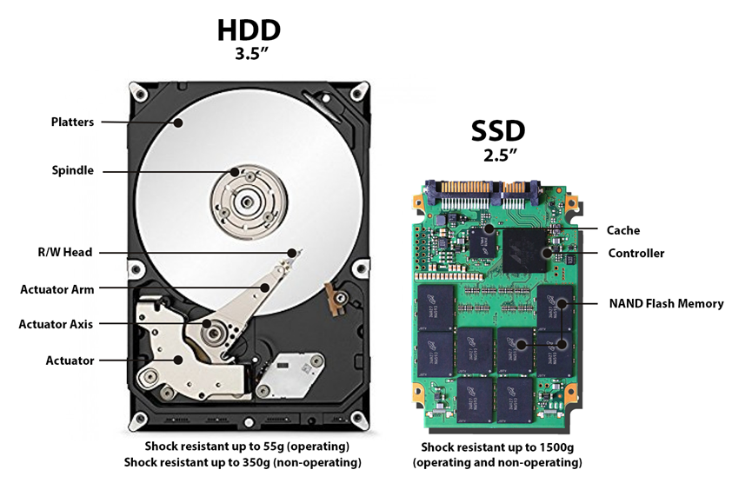

the solution that our system provides to solve and prevent the security vulnerability that can be caused by the integration between software application and hardware component. The features of the operating system that we propose can contribute to several matters.

Reliability of the system can be contributed by the error prevention as it ensures the system can be operated consistently and to prevent any unexpected behavior or failure, and it also provides an error free environment that gives users a smooth experience and increases security.

The platform integration will ensure that the integration is smooth and make sure of the compatibility of the system which enhances the interoperability of our system to allow users to work on different platforms, this increases the efficiency of the system.

the most important part is that our operating system provide maintenance and security for the software and hardware, so it can limited and prevent any security vulnerability cause by the configuration complexity so there will be such issue as the insufficient integration of hardware and software as we will detect whether the hardware are suitable for integration and also the software deployment are safe and trustworthy for incorporation.

The difficulties that different CPU, main memory, and cache skills face are many and can change according to architecture, market demands, and technical improvements. I can give you a broad summary of the difficulties related to each component, though.

1. CPU (Central Processing Unit): Performance: Improving CPU performance in order to meet the increasing requirements of modern programmes and computational tasks is one of the main problems for CPUs. Improving clock rates, adding cores, boosting instruction pipelining, and optimizing instruction set architectures are all part of this.

   - Power usage: As CPU power increases, power usage management becomes more important. Reduced power usage aids in the prevention of overheating, increases the battery life of mobile devices, and lowers data Centre energy expenses.

- Heat dissipation: High-performance CPUs produce a lot of heat, requiring effective cooling systems to avoid thermal throttling and guarantee stable performance.

   - In parallel processing: To benefit from multi-threaded applications, CPUs must enable parallel processing. The issues of improving parallel execution include job scheduling, load balancing, and minimizing synchronization overhead

. RAM, or main memoryز

   - Capacity: More memory is needed because to the complexity of programmes and the necessity to manage huge amounts of data. RAM pricing and capacity optimisation is a continuing concern.

   - Access speed: To meet the performance requirements of contemporary applications, memory latency must be decreased and data transfer rates must be increased. Memory technology developments like DDR5 are aimed at overcoming this difficulty.

   - electricity consumption: RAM modules use electricity, and it might be difficult to control this without sacrificing performance, especially in mobile devices with small batteries.

   - Error detection and correction: Data corruption can result from memory defects, such as single-bit or multi-bit mistakes. Data integrity is improved by implementing strong error detection and correction techniques in memory modules

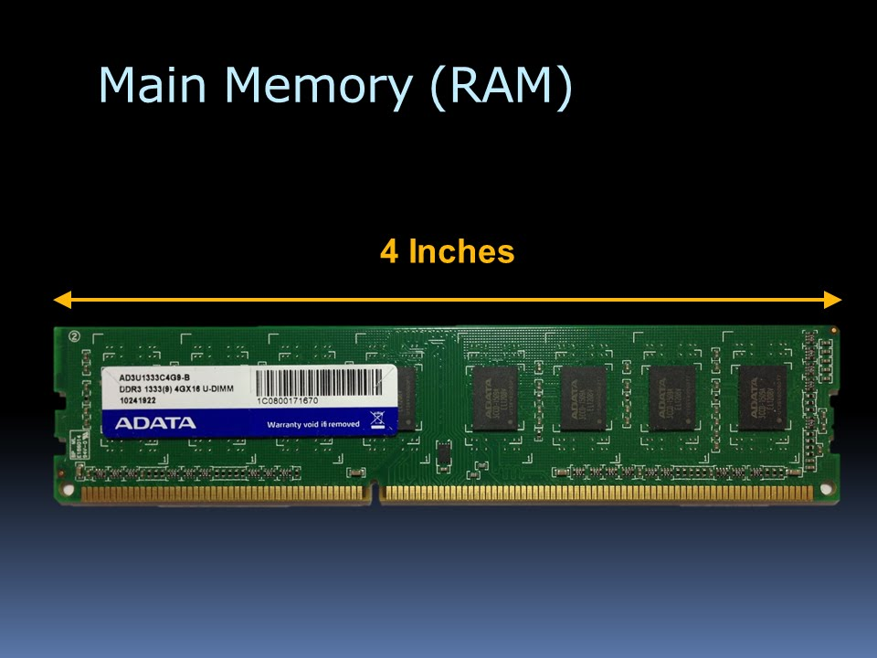

3. Cache Memory: Size and Hierarchy: Cache memories have been organised in many layers (L1, L2, L3) with variable sizes and access rates. It is difficult to find a balance between cost, performance, and power consumption without knowing the ideal cache size, structure, and replacement procedures.

   - Cache coherence: To preserve data consistency in multi-core systems, it is essential to maintain cache coherence across various caches. To reduce communication cost and ensure accuracy, efficient cache coherence protocols like MESI or MOESI must be developed.

   - Data locality: It might be difficult to use physical and temporal data translation to the greatest extent possible. To reduce cache misses and boost overall performance, efficient algorithms and data structures are necessary.

Cache pollution can be caused by incorrect data placement or severe cache thrashing, which lowers the efficacy of the cache. Techniques for efficient cache management are required to address this issue.

Cache pollution can be caused by incorrect data placement or severe cache thrashing, which lowers the efficacy of the cache. Techniques for efficient cache management are required to address this issue

**Problems with Windows’s CPU Scheduling**

In server environments efficient utilization of system resources becomes crucial. This is a problem in the IT company as they use the Windows operating system which is not fit for a server environment. The reason for this inefficiency is because, while Windows CPU scheduling is not inherently unfit for server environments, there are better ways to handle CPU scheduling to make the operating system much more suitable for such scenarios.

**Solution: Dynamic Priority System**

We propose using the dynamic priority system used in Linux systems for the new operating systems as it offers several advantages over Windows for a network environment. Here are some of the reasons why Linux's dynamic priority system is better suited for a networking environment:

1. Fairness in Resource Allocation: Linux's dynamic priority system, particularly the Completely Fair Scheduler (CFS), prioritizes fairness in resource allocation. It ensures that all network-related processes receive an equitable share of CPU resources, preventing any single process from dominating the CPU and causing performance degradation for other network processes. This fairness helps maintain consistent network performance and responsiveness.
2. Real-Time Capabilities: Providing real-time scheduling classes, such as the Real-Time Scheduler (RT), offer deterministic execution for time-critical network tasks. Real-time scheduling ensures that critical network processes meet strict timing requirements, minimizing delays and providing predictable behavior. This is crucial for applications that demand low-latency communication, such as real-time video streaming, online gaming, or high-frequency trading.
3. Customizability for Network Optimization: Dynamic priority systems allow for extensive customization and tuning options, enabling administrators to optimize CPU scheduling for specific network workloads. By fine-tuning parameters and selecting appropriate scheduling classes, it provides the flexibility to prioritize network-related processes based on their importance and specific requirements. This customization empowers administrators to tailor the system to their network's unique demands.

Overall, dynamic priority systems excel in network environments due to their fairness in resource allocation, support for real-time requirements, customizability, extensive protocol support, community-driven development, and proven stability.

1. **Conclusion**

In summary, as an IT professional working in Kuala Lumpur, I was tasked with developing a new operating system for personal computers. The goal was to solve the problems in the existing operating systems for different versions of personal computers. I had one month to come up with a new operating system to overcome these problems.

To accomplish this task, I identified a number of challenges that needed to be addressed. First, there are integration challenges between the different features of software applications and hardware components of different computer versions. This made it difficult to ensure seamless compatibility and optimal performance.

Second, challenges arose due to changes in CPU capacity, main memory, and cache. New operating systems should manage and utilize these resources efficiently, optimizing their performance and ensuring effective allocation of computing power.

In addition, challenges related to memory management need to be addressed. The operating system must overcome barriers that prevent accurate and efficient communication between different types of memory and other hardware components to ensure smooth data transfer and processing.

Existing CPU scheduling mechanisms pose another challenge that needs attention. The proposed operating system should be improved to increase scheduling efficiency, prioritize tasks effectively and maximize overall system performance.

Finally, the challenges posed by solid state drives (SSDs) and hard disk drives (HDDs) need to be considered. Operating systems should address the different characteristics and access patterns of these storage devices to optimize data storage, retrieval, and overall system responsiveness.

When proposing a new operating system, solutions to these challenges should be provided. The new system should provide seamless integration between software applications and hardware components, efficient resource management, effective memory handling, improved CPU scheduling mechanisms, and optimized support for SSD and HDD storage devices.

By addressing these interface and kernel-level challenges, the proposed operating system aims to enhance user experience, improve performance, and ensure compatibility between different PC versions. Details of the functionality of the new operating system and recommended solutions to the highlighted challenges will be discussed in the proposal report.

1. **Reference**

Observations on Operating System Security Vulnerabilities. Lindskog, S. (2000).*Licentiate thesis, Chalmers University of Technology, Göteborg, Sweden*. <https://citeseerx.ist.psu.edu/document?repid=rep1&type=pdf&doi=d7b672ef1f01222052bcd492b4a1b00564be3e96>

*Windows 10 most critical vulnerabilities in 2022*. CalCom. (2023, May 10). <https://www.calcomsoftware.com/windows-10-most-critical-vulnerabilities-in-2022/#_Toc118232020>

Gatlan, S. (2023, April 12). *Windows zero-day vulnerability exploited in ransomware attacks*. BleepingComputer. <https://www.bleepingcomputer.com/news/security/windows-zero-day-vulnerability-exploited-in-ransomware-attacks/>

Goodin, D. (2022, March 8). *Linux has been bitten by its most high-severity vulnerability in years*. Ars Technica. <https://arstechnica.com/information-technology/2022/03/linux-has-been-bitten-by-its-most-high-severity-vulnerability-in-years/>

*Apple’s IOS and macos have a nasty vulnerability, so update now*. (2023, February 14). Mashable SEA. <https://sea.mashable.com/tech/22564/apples-ios-and-macos-have-a-nasty-vulnerability-so-update-now>

*New macos vulnerability, migraine, could bypass system integrity protection*. Microsoft Security Blog. (2023, May 30). <https://www.microsoft.com/en-us/security/blog/2023/05/30/new-macos-vulnerability-migraine-could-bypass-system-integrity-protection/>

Codecademy. (2023.January 14.). *Weak configurations*. Codecademy.  <https://www.codecademy.com/article/weak-configurations>

[**www.intel.com**](http://www.intel.com/)

[**AMD ׀ together we advance_AI**](https://www.amd.com/en.html)

[**Tom's Hardware: For The Hardcore PC Enthusiast (tomshardware.com)**](https://www.tomshardware.com/)

[**AnandTech: Hardware News and Tech Reviews Since 1997**](https://www.anandtech.com/)

S. Moulton, "Solid State Drives Destroy Forensics & Data Recovery Jobs," Las Vegas, 2011.

G. B. Bell and R. Boddington, "Solid State Drives: The Beginning Of The End For Current Practice In Digital Forensic Recovery?," The Journal of digital forensics, Security and Law, pp. Volume 5, Number 3, 2010.

WIRED, "WIRED," 01 03 2014. [Online]. Available: http://www.wired.com/2014/01/tech-time-warp-ibm-ramac/. [Accessed 09 02 2015].

C. Mellor, "The Register," 03 05 2013. [Online]. Available: http://www.theregister.co.uk/2013/05/09/ihs_on_pc_hdd_ssd_units/. [Accessed 10 02 2015].

E. Casey, Digital Evidence and Computer Crime Third Edition, Watham, San Diego, London: Academic Press, 2011.

W. Miller, "Understanding the Differences Between NAND Flash and NOR Flash Memory and Key Future Trends," [Online]. Available: http://www.em.avnet.com/en-us/design/technical-rticles/Pages/Articles/ Understanding-the-Differences-Between-NAND-Flash-and-NOR-FlashMemory-and-Key-Future-Trends.aspx. [Accessed 13 02 2015].

J.-J. Maleval, "storagenewsletter.com," 14 06 2011. [Online]. Available: http://www.storagenewsletter.com/rubriques/solid-state-ssd-flash-key/ 91-ssd-manufacturers-in-the-world-document/. [Accessed 11 05 2015].

K. Vättö, "anandtech.com," 29 05 2014. [Online]. Available: http://www.anandtech.com/show/8073/seagate-acquires-sandforcefrom-avagolsi. [Accessed 11 05 2015].

Slidesharecdn, "slidesharecdn.com," 2014. [Online]. Available: http://image.slidesharecdn.com/flashmemorysummit-itbrandpulseenterprisessd-whoisadoptingthemandwhy-150221192132-conversiongate01/95/enterprise-ssd-who-is-adopting-them-and-why-38- 638.jpg?cb=1424568237. [Accessed 11 05 2015].

Seagate, "seagate.com" n.a.. [Online]. Available: http://www.seagate.com /ca/en/tech-insights/duraclass-technology-master-ti/. [Accessed 11 05 2015].