Isolated DC-DC Power Converter For HV Battery Pack Application

Input Voltage Range :85 - 600 V_{DC}
Output Voltage : 24 V_{DC}
Output Current : 1.25A
Isolation Voltage : 2kV
Power : 30W
Efficiency : η > %80
Protection Function:
- Transient voltage protection
- Reverse voltage protection
- Under voltage protection
- Over voltage protection
- Output over current protection
- Temperature protection

Dimensions: (W) 50mm * (L) 87mm * (H) 25mm
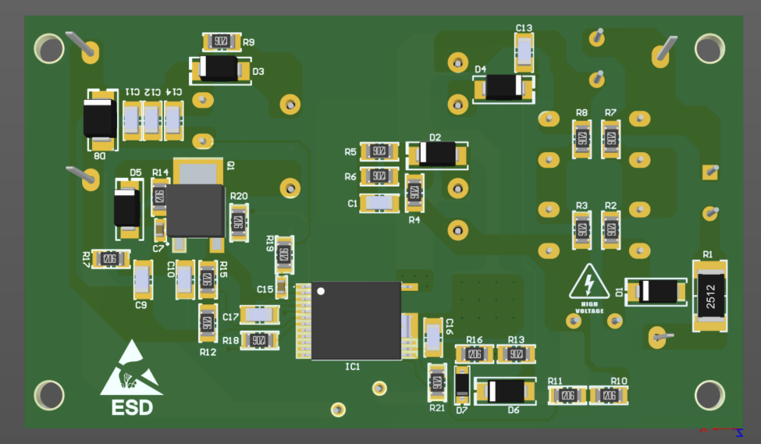Figure 1: Bottom side view of pcb
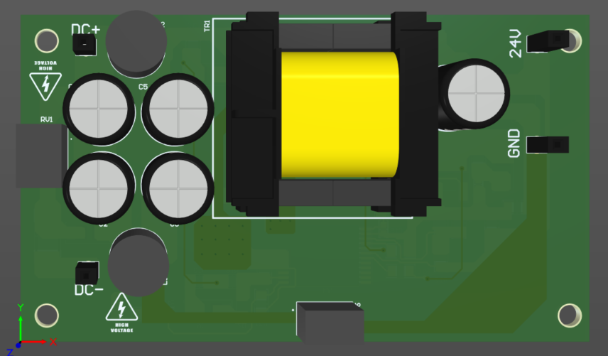Figure 2: Top side view of pcb

