Arash Mousavi
CSCI-C310
Prof. Hong Liu
10/03/2026

Project 2: Binary Search Trees
Objective
The objective of this project was to implement a Binary Search Tree (BST) in Python and evaluate its behavior under the different input conditions. The implementation supported insertion, deletion, search, in-order traversal, pre-order traversal, post-order traversal, and tree-height calculation. Testing is actually divided into functional verification with 64 unique random integers and comparative testing with random and ascending data sets of 64, 128, and 256 integers.
The BST used the standard ordering rule: values smaller than a node were placed in its left subtree and values larger than the node were placed in its right subtree.
Task 2 – BST Operations and Function Testing
A set of 64 unique random integers in the range [1, 128] was inserted into a fresh BST. The resulting tree had a height of 10. The first, middle, and last values from the generated list were then searched, followed by all three required traversal methods and deletion tests.
Seach value | Found
29 | True
58 | True
108 | True

The tree height remained 10 after all three deletions. This does not indicate a deletion failure. Tree height changes only when a deletion shortens a deepest root-to-leaf path, and none of these deletions removed the path that determined the maximum height.

Task 3 – Testing with Different Data Sets
Fresh BST instances were built for six data sets. Three used unique random integers, and three used ascending sequences to create the worst-case insertion order. For each data set, the program printed the in-order traversal and measured the resulting tree height.
Dataset type | Nodes | Observed height | Structural Behavior
Random | 64 | 11 | Irregular but relatively compact
Random | 128 | 17 | Irregular but much shorter than worst case
Random | 256 | 17 | Irregular; height did not increase in this sample
Ascending worst case | 64 | 63 | Completely right-skewed
Ascending worst case | 128 | 127 | Completely right-skewed
Ascending worst case | 256 | 255 | Completely right-skewed

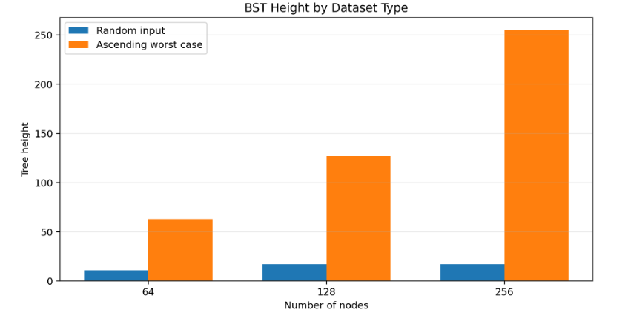

Comparative Analysis and Discussion
Random Input
The random input sets produced tree heights of 11, 17, and 17 for 64, 128, and 256 nodes. These trees were not guaranteed to be balanced, since the implementation is an ordinary BST rather than an AVL tree, however the random insertion order distributed values across both left and right subtrees. As a result, the measured heights were far smaller than the number of stored nodes.
The 128-node and 256-node random trees both had height 17. This is a legit and valid result: tree height depends on the exact insertion order, therefore increasing the number of nodes does not force the height to increase in every individual random sample.
Ascending Worst-Case Input
Ascending input produced heights of 63, 127, and 255 for 64, 128, and 256 nodes. These values equal n - 1, which is the maximum possible height under the project's height convention. Because every new value was larger than the previous value, each node was inserted as the right child of the preceding node. The resulting BST therefore became a right-skewed structure similar to a linked list.
The Effect on Operation Cost
BST insertion, search, and deletion follow a path through the tree, so their running time is proportional to tree height, O(h). For compact trees, h is much smaller than n and operations need relatively few comparisons. In the worst-case ascending trees, h = n - 1, so these operations can require O(n) time. Thus, the experiment shows why insertion order has a major effect on the practical efficiency of an unbalanced BST.
Nodes | Minimum possible height* | Random height | Worst-case height | Worst/random height ratio
64 | 6 | 11 | 63 | 5.7x
128 | 7 | 17 | 127 | 7.5x
256 | 8 | 17 | 255 | 15.0x

I think the gap gets especially clear at 256 nodes: the random tree had height 17, while the ascending tree had height 255. So, the worst-case tree was 15 times deeper in terms of measured height. This large structural difference explains why an unbalanced BST can lose the efficiency normally associated with the tree-based searching.

Conclusion
The BinarySearchTree implementation successfully completed insertion, search, deletion, traversal, and height operations. The Task 2 in-order traversal confirmed correct BST ordering, all required search operations succeeded, and all requested deletions preserved a valid sorted traversal.
The comparative tests demonstrated that BST shape is very dependent on insertion order. Randomly ordered data produced much shorter trees, while ascending data produced the maximum possible height of n - 1. Since the primary BST operations run in O(h) time, the results show the practical difference between a reasonably compact BST and a worst-case skewed BST. I think this also explains the motivation for the self-balancing structures such as AVL trees, which prevent the tree height from growing linearly.

Screenshots of the Output
