Arash Mousavi
CSCI-C310
09/21/2026
Project Report

Objective
The goal of this project is to implement and test five sorting algorithms: Insertion Sort, Selection Sort, Bubble Sort, Merge Sort, and Quick Sort. The project also assesses and evaluates how runtime changes as the input size grows and compares the observed behavior with the algorithms' expected Big-O time complexity.
Method
All tests were executed on Indiana University's BigRed200 computing environment. The random integer datasets were generated with values from 0 through 2,147,483,647. Also, data generation, printing, and other setup work were excluded from the sorting timer.
- Correctness testing used two different randomly generated lists containing 10 integers each. All of the five algorithms were applied independently to copies of the same original list.
- Performance testing used dataset sizes of 1,000; 10,000; 100,000; 1,000,000; and 10,000,000 integers.
- Each algorithm-dataset combination was executed five times using a newly generated random dataset for every run.
- For each of the completed dataset size, the slowest of the five measured sorting times was removed and the remaining four times were averaged.
- Any individual sorting run exceeding 20 minutes was terminated and recorded as more than 20 min. Larger dataset sizes for that algorithm were not attempted after the cutoff.
Test | Original List | Sorted Result
Test 1 | [8, 49, 70, 94, 14, 12, 10, 42, 19, 25] | [8, 10, 12, 14, 19, 25, 42, 49, 70, 94]
Test 2 | [74, 78, 55, 94, 37, 19, 43, 60, 31, 0] | [0, 19, 31, 37, 43, 55, 60, 74, 78, 94]
Table 1. Correctness tests. Each sorting algorithm produced the same sorted result.

Performance Results
The table 2 summarizes the final average sorting times after removing the slowest run from each set of five trials. The values marked > 20 min exceeded the project cutoff during the first run at that dataset size. The “Not tested” indicates that the larger dataset was skipped after the cutoff had already been reached.
Dataset Size | Insertion | Selection | Bubble | Merge | Quick
1,000 | 0.025526 s | 0.032604 s | 0.060460 s | 0.001602 s | 0.001154 s
10,000 | 2.796529 s | 3.318370 s | 7.358313 s | 0.022215 s | 0.015344 s
100,000 | 301.085741 s | 346.954693 s | 766.284112 s | 0.272066 s | 0.225554 s
1,000,000 | > 20 min | > 20 min | > 20 min | 3.277573 s | 2.783986 s
10,000,000 | Not tested after cutoff | Not tested after cutoff | Not tested after cutoff | 44.982232 s | 37.828925 s
Table 2. Average sorting runtime by algorithm and dataset size.
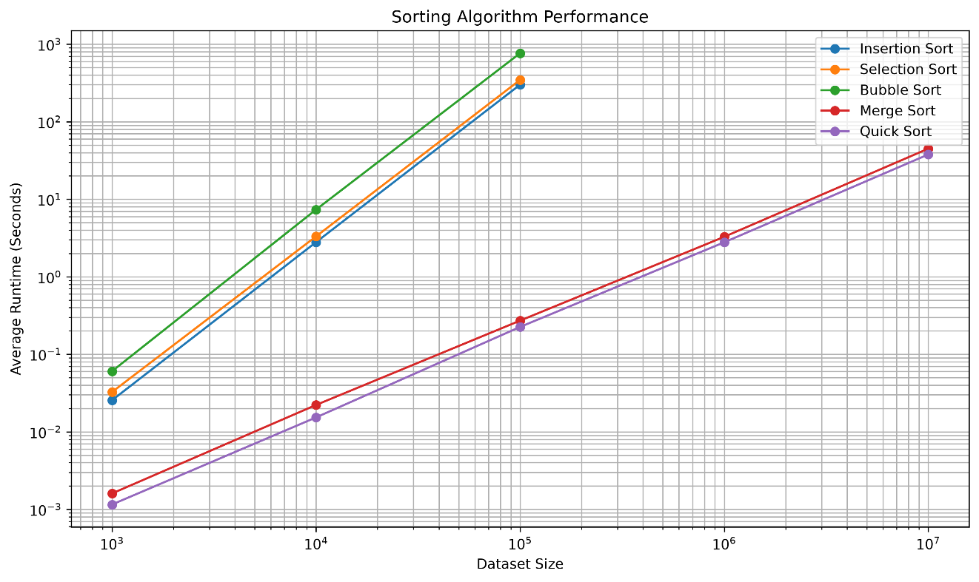
Figure 1.The Average runtime versus dataset size on logarithmic x- and y-axes. Missing points for the three quadratic algorithms reflect the 20-minute cutoff.

Analysis and Interpretation
Insertion Sort, Selection Sort, and Bubble Sort showed the steepest runtime growth. When the dataset increased by a factor of 10 from 10,000 to 100,000 elements, their runtimes increased by approximately 108x, 105x, and 104x, respectively. I think this behavior matches the expected quadratic growth of O(n²), that multiplying n by 10 can increase work by about 100x. All three algorithms exceeded the 20-minute cutoff at 1,000,000 elements.
Among these three algorithms, Bubble Sort was the slowest in the measured random-data tests. At 100,000 elements, Bubble Sort averaged 766.284112 seconds, compared with 346.954693 seconds for Selection Sort and 301.085741 seconds for Insertion Sort. Although all three share O(n²) average- and worst-case growth, implementation details and data movement cause their actual runtimes to differ.
I think the Merge Sort and Quick Sort scaled far more effectively. Their runtime increased by roughly 12x to 15x for each 10x increase in dataset size, which is consistent with O(n log n) growth over the tested range. Both algorithms completed the full 10,000,000-element dataset comfortably within the 20-minute limit.
Quick Sort was the faster of the two in every completed comparison in this experiment. At 10,000,000 elements, Quick Sort averaged 37.828925 seconds, while Merge Sort averaged 44.982232 seconds. This is an empirical result for these random datasets and this implementation; it does not mean that the Quick Sort is universally faster in every input distribution or implementation.
Algorithm | Best Case | Average Case | Worst Case
Insertion Sort | O(n) | O(n²) | O(n²)
Selection Sort | O(n²) | O(n²) | O(n²)
Bubble Sort* | O(n) | O(n²) | O(n²)
Merge Sort | O(n log n) | O(n log n) | O(n log n)
Quick Sort | O(n log n) | O(n log n) | O(n²)
Table 3. Theoretical time complexities. *The Bubble Sort implementation uses an early-exit flag, giving O(n) the best-case behavior on already sorted input.
The measurements actually reinforce the practical importance of the asymptotic complexity. At 100,000 elements, Quick Sort completed in 0.225554 seconds while the Bubble Sort needed 766.284112 seconds. The performance gap becomes enormous as n increases since the O(n²) growth dominates O(n log n), even when both algorithms are implemented correctly.

Conclusion
The experiment showed a robust relationship between theoretical time complexity and measured runtime. All of the five algorithms correctly sorted the test inputs, but their scalability differed dramatically. Insertion Sort, Selection Sort, and Bubble Sort were practical for small inputs but became prohibitively slow as the dataset grew, reaching the 20-minute cutoff at 1,000,000 elements. Merge Sort and Quick Sort handled much larger datasets efficiently and successfully completed 10,000,000 elements in less than one minute on the test system.
For large random datasets in this experiment, Quick Sort produced the lowest measured average runtime, followed closely by Merge Sort. The results also indicate that why O(n log n) algorithms are generally preferred over O(n²) algorithms when input size can become large. They also illustrate that Big-O notation describes growth rather than exact elapsed time: the algorithms with the same asymptotic class can still have noticeably different measured runtimes because of the constants, memory access patterns, swaps, and implementation details.

