LOW PRESSURE FEEDER (REV.16 03/11/2016 B.L.Guy)

RECEIVING INSPECTION REPORT

JOB#:50851653 DATE: 9-22-16 INSPECTOR: 000136/107021

SIZE: #7 CUSTOMER: Resolute : Thunder Bay

S.H.#: 1233 KAMYR#: MYRENS#:

GENERAL RECEIVING INFORMATION:

FEEDER SKID: no COMMENTS: N/A Feeder Settings @ Shipment

HANDWHEEL: yes COMMENTS: ok Cold Travel-

HANDWHEEL KEY: yes COMMENTS: ok Rotor Setting-

SCALE: yes COMMENTS: set at 32mm

SCALE POINTER: yes COMMENTS: ok

FEET: no COMMENTS: N/A

COUPLING: no COMMENTS: N/A

FLINGERS: no COMMENTS: N/A

LANTERN RINGS: yes COMMENTS: worn

EXHAUST COVER: no COMMENTS: N/A

STEAM MANIFOLD:no COMMENTS: N/A

LIFTING PLATES: no COMMENTS: N/A

REDUCER SUPPORT: no COMMENTS: N/A

GENERAL REMARKS: N/A

HARDWARE INSPECTION LIST

T.S. HEAD: Replace # & SIZE: 13ea 1 1/4-12 x 3 3/8''/ 5ea 1 1/4-12 x 3''
BEARING COVER: Replace # & SIZE: 8ea 3/4-10 x 1 3/4

D.S. HEAD: Replace # & SIZE: 16ea 1 1/4-12 x 3 3/8''
BEARING COVER: Replace # & SIZE: 8ea 1/2-13 x 1 1/2''

SPIDER: Replace # & SIZE: 12ea 3/4-10 x 1 3/4''

HANDWHEEL HOLDER: no # & SIZE: N/A

PACKBOX: Replace # & SIZE: 8ea 3/4-10 x 4 1/4'' studs, nuts & washers

PACKING GLAND: Replace # & SIZE: 4ea 1/2-13 x 3 3/8'' stainless SHCS

EXHAUST COVER: N/A # & SIZE: N/A

LOW PRESSURE FEEDER REBUILD REPORT

JOB#: 50851653 DATE: 9-22-16 INSPECTOR: 9-22-16

SIZE: #7 CUSTOMER: Resolute : Thunder Bay

S.H.#: 1233 KAMYR#: MYRENS#: 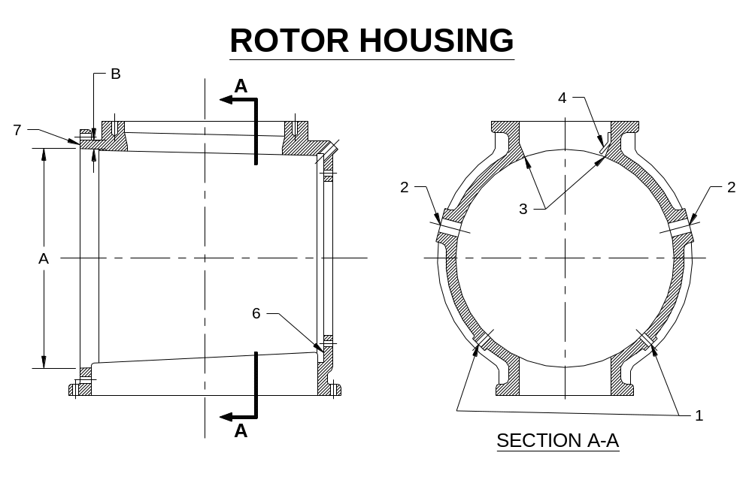

A) BORE SIZE AS RECEIVED:46.207 ACTUAL FINISHED DIAMETER:
CONDITION OF BORE:poor - worn - see pics

B) HOUSING WALL THICKNESS AS RECEIVED:1 3/8 - 1 9/16

1) POCKET PURGE: 1ea CONDITION:ok

2) EXHAUST PORTS: repair CONDITION: moderate erosion

3) SHEAR EDGE OVERLAY: Required POCKET TAPER: 1 1/2'' in use/ 1/4'' opposite CONDITION: wear

4) DOCTOR BLADE: Replace CONDITION: dings/ minor damage

5) FEEDER ROTATION(FROM D.S.): CCW RUN IN BOTH DIRECTIONS? noo

6) DRIVE SIDE GASKET FACE: ok CONDITION: ok

7) ADJUSTING SIDE GASKET FACE: ok CONDITION: ok

8) VISIBLE CRACKS: no CONDITION: N/A

9) TAPPED HOLES: repair NUMBER & SIZE:4ea 1 1/8-7 @ bottom/ 1ea 1 1/8-7 @ top/ 2ea 1 1/4-12 @ T.S./ 1ea steel drain cap - see pics

GENERAL REMARKS: repair 1ea adjusting block @ T.S./ remove bolt @ adjusting & drive side/ repair skin @ bottom - see pics

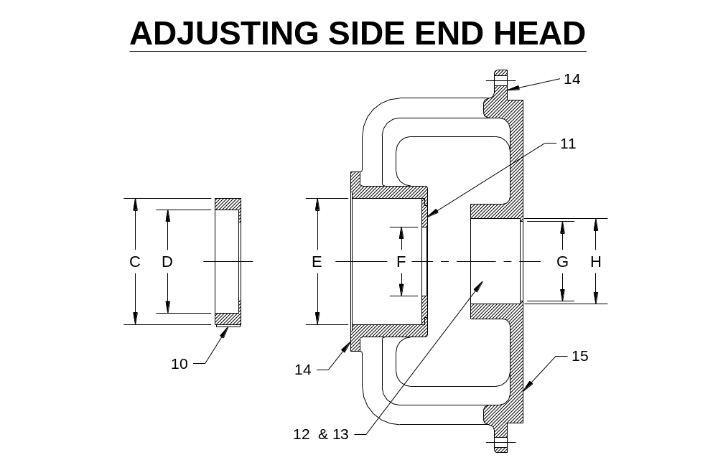
AS RECEIVED CONDITION AFTER REPAIR
C) SLIDING MEMBER O.D.: “0” OUTBOARD:16.863 INBOARD:16.863 dings/ minor erosion
45 16.863 16.863
90 16.863 16.863
135 DEG’S 16.863 16.863
D) SLIDING MEMBER I.D: “0” OUTBOARD:14.173 INBOARD:14.173 minor erosion
45 14.173 14.173
90 14.173 14.173
135 DEG’S 14.173 14.173

E) BEARING HOUSING BORE: “0” OUTBOARD:16.868 INBOARD:16.865 minor to moderate erosion
45 16.868 16.865
90 16.869 16.866
135 DEG’S 16.869 16.866

F) SEAL BORE: “0” 9.255 heavy dings
90 DEG’S 9.253

G) WEAR RING I.D.: “0” 9.956 dings/ minor erosion
90 DEG’S 9.949

BORE SIZE IF RING REMOVED “0” N/A N/A
90 DEG’S N/A
STOP/STEP THICKNESS (Measure 4 places and average) : wear ring installed

H) PACKBOX BORE: “0” OUTBOARD:11.375 INBOARD:11.375 dings/ minor erosion
90 DEG’S 11.374 11.375
10) KEY/KEYWAY: Installed CONDITION: ok

11) SEAL ADAPTER PLATE: yes CONDITION: ok

12) PACKING GLAND: A MAT’L: steel COMMENTS: severe erosion
GLAND HARDWARE: Replace DESCRIPTION: See Print
PACKING GLAND:OUTSIDE DIAMETER: 11.319 AT 90 DEG’S:11.310 COMMENTS: severe erosion
INSIDE BORE: DIAMETER: 10.332 AT 90 DEG’S:10.309 COMMENTS: severe erosion
13) LANTERN RINGS: replace MATERIAL: stainless COMMENTS: bore worn
13a) WATER HOLE: repair SIZE & CONDITION: 2ea 3/8 NPT holes eroded

14) GASKET FACES: repair CONDITION:moderate erosion - see pics

15) BACKSIDE OF HEAD: ok CONDITION: 100% stainless overlayed

16) WEAR RING ADAPTER PLATE:N/A CONDITION: N/A

17) TAPPED HOLES: repair NUMBER & SIZE:1ea 1 1/4-7 @ jack bolt

18) CLEAN-OUT PORTS: N/A COMMENTS: N/A

GENERAL REMARKS: 1ea purge hole - ok/ moderate erosion @ bolt flange & bottom quad - see pics

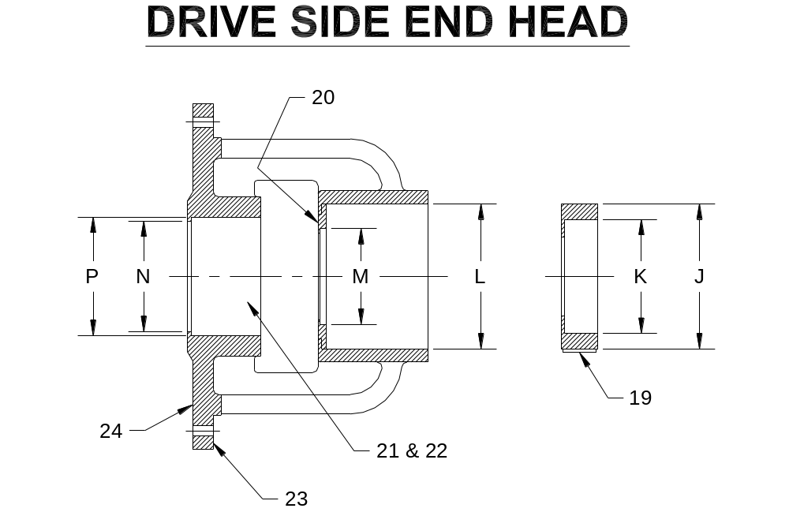

AS RECEIVED CONDITION AFTER REPAIR
J) SLIDING MEMBER O.D.: “0” OUTBOARD:13.985 INBOARD:13.984 dings/ moderate erosion
45 13.988 13.989
90 13.986 13.987
135 DEG’S 13.984 13.984
K) SLIDING MEMBER I.D: “0” OUTBOARD:11.816 INBOARD:11.816 moderate erosion
45 11.818 11.818
90 11.816 11.816
135 DEG’S 11.814 11.814

L) BEARING HOUSING BORE: “0” OUTBOARD:13.993 INBOARD:13.993 dings/ minor erosion
45 13.993 13.993
90 13.993 13.993
135 DEG’S 13.992 13.992

M) SEAL BORE: “0” 9.254 dings/ minor erosion
90 DEG’S 9.254

N) WEAR RING I.D.: “0” 9.960 dings/ minor erosion
90 DEG’S 9.951

BORE SIZE IF RING REMOVED “0” N/A N/A
90 DEG’S N/A
STOP/STEP THICKNESS (Measure 4 places and average) : wear ring installed

P) PACKBOX BORE: “0” OUTBOARD:11.371 INBOARD:11.375 gouges/ minor erosion
90 DEG’S 11.373 11.376

19) KEY/KEYWAY:Installed CONDITION: ok

20) SEAL ADAPTER PLATE:yes CONDITION: ok
21) PACKING GLANDS:B MAT’L:steel COMMENTS: severe erosion
GLAND HARDWARE Replace DESCRIPTION: See Print
PACKING GLAND:OUTSIDE DIAMETER: 11.284 AT 90 DEG’S:11.275 COMMENTS: severe erosion
INSIDE BORE: DIAMETER: 10.273 AT 90 DEG’S:10.305 COMMENTS: severe erosion

22) LANTERN RINGS:replace MATERIAL:stainless COMMENTS: bore worn

22a) WATER HOLE:repair SIZE & CONDITION: 2ea 3/8 NPT holes eroded

23) GASKET FACE:ok CONDITION:ok

24) BACKSIDE OF HEAD:ok CONDITION: 100% stainless overlayed

25) WEAR RING ADAPTER PLATE:N/A CONDITION: N/A

26) TAPPED HOLES:repair NUMBER & SIZE:4ea @ pack box

27) CLEAN-OUT PORTS:N/A COMMENTS: N/A

GENERAL REMARKS: 1ea purge hole - ok/ moderate erosion @ bottom quad - see pics

PACK-RYT INFORMATION Form

TENDING SIDE END HEAD:

PACK BOX BORE: See Print

PACKBOX BORE LENGTH: 6'' with wear ring

WATER HOLE DIAMETER: 1ea 3/4''/ 1ea 5/8''

WATER HOLE LOCATION: 2 5/8''
(FROM TOP OF WEAR RING TO C/L OF HOLE)

WEAR SLEEVE DIAMETER: See Print

DRIVE SIDE END HEAD:

PACK BOX BORE: See Print

PACKBOX BORE LENGTH: 6'' with wear ring

WATER HOLE DIAMETER: 5/8''

WATER HOLE LOCATION: 2 5/8''
(FROM TOP OF WEAR RING TO C/L OF HOLE)

WEAR SLEEVE DIAMETER: See Print

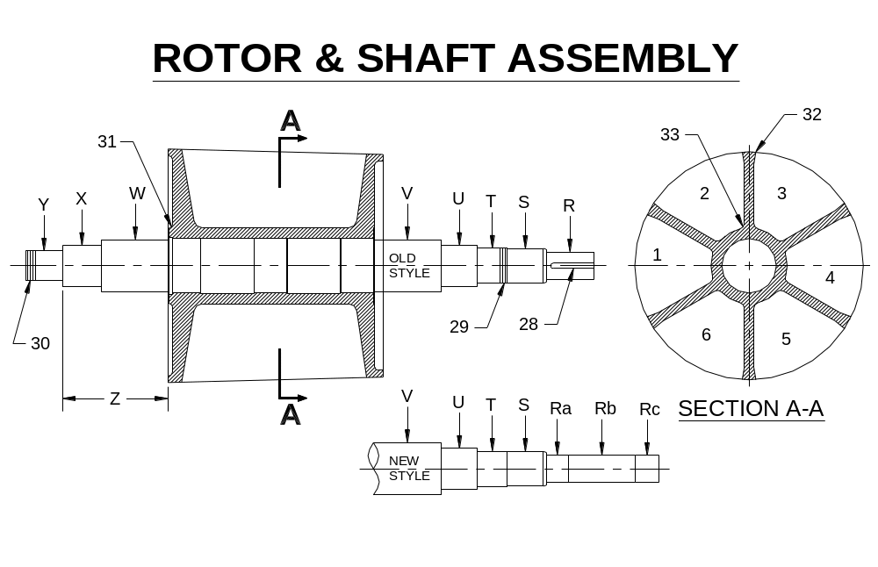
ROTOR CAST ?:
FABRICATED ?: xxx
AS RECEIVED CONDITION AFTER REPAIR
R) DRIVE FIT DIAMETER: “0” OUTBOARD:5.748 INBOARD:5.740 radial grooves/ dings/ tapered
90 DEG’S: 5.748 5.743

Ra) INBOARD DRIVE FIT DIAMETER: “0” OUTBOARD:N/A INBOARD:N/A N/A
90 DEG’S: N/A N/A

Rb) CLEARANCE DRIVE FIT DIAMETER: “0” OUTBOARD:N/A INBOARD:N/A N/A
90 DEG’S: N/A N/A

Rc) OUTBOARD DRIVE FIT DIAMETER: “0” OUTBOARD:N/A INBOARD:N/A N/A
90 DEG’S: N/A N/A

S) OUTBOARD SEAL FIT DIAMETER: “0” OUTBOARD:6.364 INBOARD:6.366 radial scoring
45 6.364 6.366
90 6.365 6.366
135 DEG’S: 6.365 6.366

T) D.S. BEARING FIT DIAMETER: “0” OUTBOARD:6.433 INBOARD:6.433 metalized/ scoring
45 6.433 6.433
90 6.433 6.433
135 DEG’S: 6.433 6.433

U) INBOARD SEAL FIT DIAMETER: “0” OUTBOARD:7.491 INBOARD:7.488 80% severe erosion
45 7.491 7.496
90 7.491 7.496
135 DEG’S: 7.491 7.491

V) D.S. WEAR SLEEVE DIAMETER: “0” OUTBOARD:Removed INBOARD:N/A N/A
90 DEG’S N/A N/A

W) T.S. WEAR SLEEVE DIAMETER: “0” OUTBOARD:Removed INBOARD:N/A N/A
90 DEG’S N/A N/A

X) T.S. SEAL FIT DIAMETER: “0” OUTBOARD:7.498 INBOARD:7.493 minor erosion
45 7.498 7.494
90 7.498 7.493
135 DEG’S: 7.498 7.495

AS RECEIVED CONDITION AFTER REPAIR
Y) T.S. BEARING FIT DIAMETER: “0” OUTBOARD:5.932 INBOARD:5.932 dings/ scoring/ minor erosion
45 5.932 5.932
90 5.932 5.932
135 DEG’S: 5.932 5.932

Z) BEARING SHOULDER TO FACE: 18 1/8'' ok

28) KEYWAY: 1 1/2'' x 1/2'' x 9''

29) D.S. THREADS: N/A N/A

30) T.S. THREADS: 2ea 3/4-10 @ end of shaft - ok

31) CRACKS AROUND HUB?: no DESCRIPTION: severe erosion

32) BAR CRACKS?: yes DESCRIPTION: see pics

33) POCKET CORNER CRACKS?:see dye check DESCRIPTION: see dye check

NOTE: SEE ATTATCHED N.D.T. REPORT(S) FOR ROTOR/SHAFT.

GENERAL REMARKS: both end faces damaged/ hub severely eroded on both sides/ has NPT air inserts on T.S./ has 2ea severely eroded nuts welded on end - see pics

MISCELLANEOUS COMPONENTS

34) SPIDER: yes COMMENTS: ok

35) SPINDLE: yes COMMENTS: ok
THREADS: ok COMMENTS: die goes - sloppy
HARDWARE: Replace COMMENTS: 4ea 3/4-10 x 1 1/4 nyloc

36) BRASS NUT: yes COMMENTS: ok
HANDWHEEL FIT: 2.996 COMMENTS: ok
KEYWAY: SIZE: 1/2'' x 1/4'' x 2 3/4'' COMMENTS: ding - ok
FIT WITH SPINDLE- AXIALLY: .002 RADIALLY: .007

37) BRASS WASHER: replace COMMENTS: damaged

38) HANDWHEEL: yes COMMENTS:ok
HANDWHEEL BORE: 3.007 COMMENTS: minor erosion
HANDWHEEL KEYWAY: 1/2'' x 1/4'' through COMMENTS: ok
HANDWHEEL KEY: 1/2'' x 1/2'' x 2 11/16 COMMENTS: ok

39) 3”NUT & SHROUD: yes COMMENTS: ok

40) HANDWHEEL HOLDER: no COMMENTS: N/A

41) T.S. BEARING COVER: yes COMMENTS: ok

42) D.S. BEARING COVER: yes COMMENTS: ok

42a) SEAL BORE SIZE:7.379/.380 SIZE AFTER REPAIR:

42b) GREASE TUBE SEAL C’BORE SIZE: .877 COMMENTS: ok

43) EXHAUST COVER PLATE: not received COMMENTS: N/A

44) STEAM PURGE MANIFOLD: not received COMMENTS: N/A

45) D.S. BEARING NUT: Replace COMMENTS: N/A

46) T.S. BEARING NUT: Replace COMMENTS: N/A

47) LOCK TAB WASHER: Replace COMMENTS: N/A

48) ADAPTER SLEEVE: Replace COMMENTS: N/A

49) LOCKPLATE: gouges COMMENTS: see pics

50) BEARING SHOULDER RINGS: replace COMMENTS: 2ea - bent/damaged

51) DRIVE APPARATUS: not received CONDITION: N/A
BORE: N/A COMMENTS: N/A
KEYWAY: N/A COMMENTS: N/A
KEY: N/A COMMENTS: N/A
PILOT: N/A COMMENTS: N/A
TAPPED HOLES: N/A NUMBER & SIZE:N/A

GENERAL REMARKS: N/A

SHAFT MOUNTED REDUCER MOUNT

List any defects. Take pictures.

Erosion to weldments: not received

Structurally sound ? : N/A Bent Parts ? : N/A

Erosion to mounting surfaces ? : N/A

Bolt hole damage ? : N/A

Liquid Penetrant Inspection Form

JOB#: 50851653 DATE: 9-22-16 INSPECTOR: 000136/107021

SIZE: #7 CUSTOMER & LOCATION: Resolute : Thunder Bay S.H.#: 1233

SPECIFICATIONS: ASME Sec VIII COMPONENT: Rotor/ Shaft/ Coupling

SOLVENT VISIBLE: WATER WASHABLE: XXX

RESULTS:

INSPECTOR CLOCK NUMBER: 1029

ACCEPTED: REJECTED: REMARKS:Rotor - bar cracks/ pin holes in pockets

ACCEPTED: REJECTED: REMARKS:Shaft - sleeve/ eroded @ hub

ACCEPTED: REJECTED: REMARKS:Coupling - not received

ACCEPTED: REJECTED: REMARKS:

ACCEPTED: REJECTED: REMARKS:

ACCEPTED: REJECTED: REMARKS:

ACCEPTED: REJECTED: REMARKS:

ACCEPTED: REJECTED: REMARKS:

ACCEPTED: REJECTED: REMARKS:

ACCEPTED: REJECTED: REMARKS:

ACCEPTED: REJECTED: REMARKS:

ACCEPTED: REJECTED: REMARKS:

ACCEPTED: REJECTED: REMARKS:

GENERAL COMMENTS: N/A

BRINELL HARDNESS TEST REPORT
JOB#: 50851653 DATE: 9-22-16 INSPECTOR: 000136/107021 S.H.#: 1233

SIZE: #7 CUSTOMER: Resolute Thunder Bay

SPECIFY PART Housing

( A or 1,T/S,D/S, etc. for numbering all blanks,mark part(s) to correspond with ROW(S) )
T/S)- Mid)- D/S)- )-

551)- 578)- 553)- )-

566)- 562)- 556)- )-

552)- 546)- 568)- )-

559)- 534)- 561)- )-

565)- 530)- 565)- )-

Avg-)- 559 Avg-)-550 Avg-)-561 )-

)- )- )- )-

Over)- All Avg)-557 )- )-

)- )- )- )-

)- )- )- )-

)- )- )- )-

)- )- )- )-

)- )- )- )-

)- )- )- )-

)- )- )- )-

)- )- )- )-

)- )- )- )-

)- )- )- )-

)- )- )- )-

GENERAL REMARKS:N/A

BRINELL HARDNESS TEST REPORT
JOB#: 50851653 DATE: 9-22-16 INSPECTOR: 000136/107021 S.H.#: 1233

SIZE: #7 CUSTOMER: Resolute Thunder Bay

SPECIFY PART Rotor

( A or 1,T/S,D/S, etc. for numbering all blanks,mark part(s) to correspond with ROW(S) )
T/S)- Mid)- D/S)- )-

497)- 443)- 451)- )-

453)- 413)- 449)- )-

441)- 407)- 490)- )-

432)- 446)- 477)- )-

515)- 412)- 504)- )-

Avg-)- 468 Avg-)-424 Avg-)-474 )-

)- )- )- )-

Over)- All Avg - )-455 )- )-

)- )- )- )-

)- )- )- )-

)- )- )- )-

)- )- )- )-

)- )- )- )-

)- )- )- )-

)- )- )- )-

)- )- )- )-

)- )- )- )-

)- )- )- )-

)- )- )- )-

GENERAL REMARKS:N/A

Component Scrap Request

JOB#: 50851653 DATE: 9-22-16 INSPECTOR: 000136/107021

SIZE: #7 CUSTOMER & LOCATION: Resolute Thunder Bay S.H.#: 1233

INSPECTOR CLOCK NUMBER: 000136/107021

Items scrapped :

:scale REMARKS:Per R .Campball

:packing glands REMARKS:Per R .Campball

: REMARKS:

: REMARKS:

: REMARKS:

: REMARKS:

: REMARKS:

: REMARKS:

: REMARKS:

: REMARKS:

: REMARKS:

: REMARKS:

GENERAL COMMENTS:

