Professional Self-Assessment

I have learned a wide variety of skills through the completion of my coursework at SNHU while maintaining a 4.0 GPA. The outcome of the SNHU program is a full-stack development skill-set. Besides the work done at SNHU, I already had a great deal of CS knowledge and skills, and I continued to work on these outside of my coursework. The number of concepts and skills learned at SNHU is quite impressive and is elaborated below.

At SNHU, I was introduced to programming languages; in particular, Java and Python. I completed a course introducing each of those languages. After, I took subsequent courses that revisited these languages allowing me to gain an understanding of a wide variety of tools and other concepts. For example, one course focused on software testing and the application of it using Junit in Java. Another course focused on mobile development, namely Android development, where I developed an Android application with Java in Android Studio. In this course, security of the mobile app was considered. Another course focused on MongoDB NoSQL databases and creating a REST service with Python. So, through the practice of these languages and learning related tools, I fortified various core CS skills such as software engineering, databases, and security.

While at SNHU, I also gained experience with skills I already had such as data structures and algorithms and C++ programming. In particular, I completed rather complex work with OpenGL graphics programming C++ at SNHU. Additionally, one course focused on secure coding and applied this knowledge through work in C/C++. Algorithms and data structures work permeated most of the courses at SNHU. However, outside of my coursework, I relentlessly worked on algorithms and data structures for countless hours, I continue to do so.

Other skills required as a software engineer were also practiced such as collaborating in a team environment, documentation, and communicating to stakeholders. Multiple courses had focused on these concepts. One course focused on collaborating in a Git version control repository. Multiple courses required substantial work simulating communication with stakeholders. One course entirely focused on this through understanding the requirements of a business in a scenario. A data mining course also focused on this as I analyzed a set of data and recommended actions for a business.

The creation of the ePortfolio and the enhancements of artifacts showcased within, as part of my final course at SNHU, served as a review and solidification of skills I learned at SNHU and on my own. Some concepts I still did not have a strong enough grasp on, but the work done here gave me clarity on these. Review is where the skills truly become viable. The work here covered full-stack development skills. The portfolio showcases an ability to succeed as a software engineer in a variety of areas.
The impressive variety of skills illustrated here make it clear that I have ability and knowledge requirements of a successful software engineer. Besides the work at SNHU, I already had years of prior development experience and coursework at the community college level. Also, while obtaining my education at SNHU, I continued to learn and practice skills on my own time and complete internships. Through the my own work and the completion of the SNHU CS program I've become a well-rounded software engineer. I already have succeeded in the industry and I am ready to continue being a valuable software engineer in many possible areas of the industry.

Portfolio Introduction

The work in my portfolio primarily covers three core computer science topics: software engineering and design, data structures and algorithms, and databases. One artifact for each topic was enhanced. Through these enhancement a full-stack development ability is illustrated. Other topics were also displayed through these enhancements for example security, game development, Unity engine, and advanced C++ skill. The enhancements are described below and again in the form of individual narratives accompanying each enhancement development.

Software engineering and design is illustrated by an enhancement of an application I developed on my own time. The application is a 3D chess game made with the Unity engine and C#. The enhancement adds a new game mode. There was much thought and planning put into this design; the outcome was very clean. The clean design of the game allowed this new game mode to be added with little effort.

Data structures and algorithms is illustrated by an enhancement made to a Prim's algorithm implementation and the containing graph class I had wrote in C++ on my own time in 2017. The graph class was modified to be a template class. Prim's algorithm finds a spanning tree of a graph with a minimum edge weight sum. A much cleaner implementation was written avoiding the previous use of an additional self-implemented, unusual data structure.

Databases is illustrated by an enhancement made to a MongoDB/Python REST service made for a SNHU course. An HTML/JS interface to the REST service was created. This gave a user in the browser access to a MongoDB database via CRUD functionality conveniently in the browser. The interface abstracts away some of the syntax of manipulating the database by just requiring input of required parts of the queries inside textboxes.

The enhancements can be found hosted on Github:
https://arasouli91.github.io/

More examples of my work can be found on a previously created portfolio here:
https://www.portfoliogen.com/arasouli/

Narratives of each enhancement are found below. Each narrative has an additional paragraph discussing changes made for the final publication.

Milestone 2: Software Engineering and Design Enhancement Narrative
The artifact I've chosen is a 3D chess game developed with the Unity engine using C#. It is titled OmniChess. The board size can be specified by the user. It was created in the fall of 2018. It took two weeks to develop. The week before I had spent learning C#. Then, I began using Unity and made this game. At the time I created this game, I had spent a great deal of time learning design patterns. One motivation for creating this game was to apply principles of software design. Thus, the game has been designed very well.
I chose this artifact because it was one of my significant projects, but also because it was very easy to work with. This is unlike my main project which is very difficult to add new features to. Adding a feature to software seemed very appropriate for the software engineering requirement. The game was improved with an additional gamemode. The gamemode uses randomly selected chess pieces, but still uses a single King in the back row. An extra screen was added to the UI menu to choose the gamemode. As prescribed by the code review, I did some clean up in the relative code and the code above it.
To avoid including the entire Unity project, I've only included the two relative files and an image of the change in the UI made in the Unity editor. Only line 59 changed in IP_UI_System.cs. Most of the work was done in Board.cs. The initial enhancement involved clean up like switching to named constants, improving comments and formatting. Also, the nested for loop piece placement algorithm was duplicated and modified to make the placement random. For the final publication, I refactored that code and did more of the similar code clean up. A significant amount of duplicate logic was removed from the board setup logic across each gamemode resulting in multiple methods. The board setup logic now looks like a very simple nested for loop that takes care of both gamemodes. Ultimately, the code is much cleaner because a great deal of refactoring and other code cleanup occured.
This work has illustrated the course objective I planned for, CS-499-04, and the concepts I planned for. As mentioned, I added to the GUI and worked with C# code in the Unity engine, these were the concepts I planned to use.
Through this enhancement, I learned the Unity API for random number generation and honed my troubleshooting skills. It took me awhile to get my head back into my code and using the Unity editor. I made some minor mistakes while coding and fixed them as I tried to play the game. The only one that caused me some real frustration was I misread the description of the Random.Range() method, so my range was incorrect. It is very easy to add functionality to this game because of my clean design and the convenience of both C# and Unity. After I ironed out some errors in my changes the new game mode seems to work fine.

Milestone 3: Algorithms and Data Structures Enhancement Narrative
The artifact I've chosen is an implementation of an undirected, weighted Graph data structure in C++ which contains an implementation of Prim's minimum spanning tree algorithm. I originally wrote the Graph code in 2016 and Prim's algorithm was probably written in 2017.
I chose this artifact because it seemed like a reasonable choice for this category. I was considering enhancing a major project of mine, but any significant enhancement concerning algorithms and data structures in that code would have been too big of an endeavor. I was looking through my algorithms and data structures projects when I found a note I left in my Graph class. It said to redesign Prim's algorithm with a cleaner approach. There were also some notes regarding my thoughts on making the class compatible with Edges of char type vertices. That gave me the idea to make the class templated. The enhancement demonstrates my abilities with algorithms and data structures as I am rewriting an algorithm and improving a data structure to be more advanced.

The graph class was redesigned to be templated. The changes of the redesign permeated throughout the code including Prim's algorithm. The first iteration of work on this templated the graph vertices. The class and algorithm was tested with int and char types. I assumed should work with any type that implements the < operator. This is necessary for the nested STL maps, the underlying data structures which hold the data, to be able to order the values. Below are screenshots of successful runs with int and char types. The run with char is the same graph representation but with vertices A-F instead of 0-5. The input is in the form of v, w, weight.
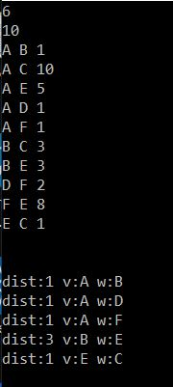
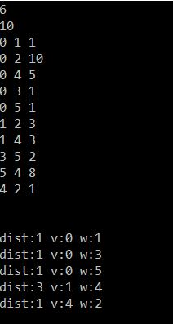
Prim's algorithm was rewritten with a cleaner approach. If we don't consider the necessary changes made due to redesigning the Graph class, the new approach is much more reasonable for me to implement during an interview. However, there is still one big piece of syntax that makes the algorithm look complex and I might not remember how to type up correctly during an interview. That is the declaration of the priority queue of pairs of int and Edge sorted in ascending order. The structure is complicated and to specify the ordering is verbose.
With the final publication, I decided to test the graph with a user-defined type and to make the edge weight templated as well. I realized that it wasn't just going to work with user-defined types that overloaded < operator. The types also needed a hash function, == operator, and a copy constructor. Templated edge weight is also complicated. It needs to behave numerically to an extent. If it was getting the sum of the edge weight it would need even more numerical behavior, but it isn't doing that so it can get by with partial numerical behavior. This means it needs a constructor that takes int and initializes to some conceptual minimum value. The user-defined edge weight also needs to overload the < and = operators, and needs a copy constructor. I could have just specified builtin numerical types to keep this simple, but this was more interesting. The code all looks very complicated now, but without all the template code there is still a easy-to-follow implementation of Prim's algorithm.

Below, tests of the new changes are shown. The implementation of the user-defined class and weight types can be found in main.cpp. The first test used a char as weight, the second used a user-defined weight type. The weight type holds a string, but the compares their “numerical” value by summing the ASCII values of the chars and multiplies by two when encountering an 'x'. The weight could have just used string comparison, but this was more interesting. The both sets of test cases result in the same edges being selected as the weights have the same relative rank within each respective set of weights.

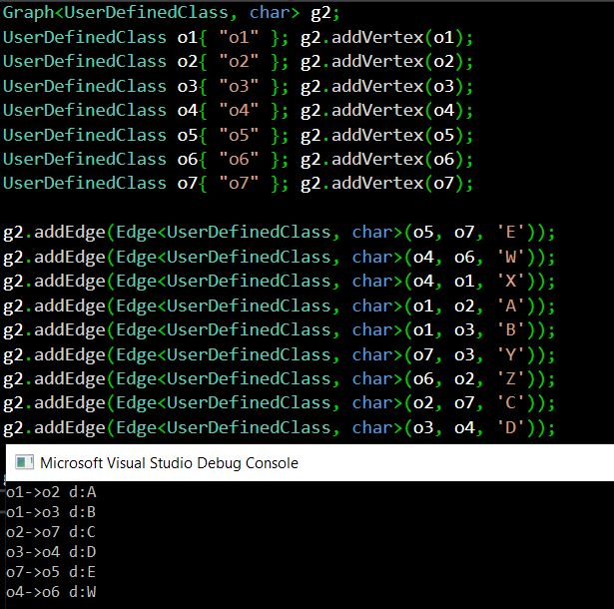

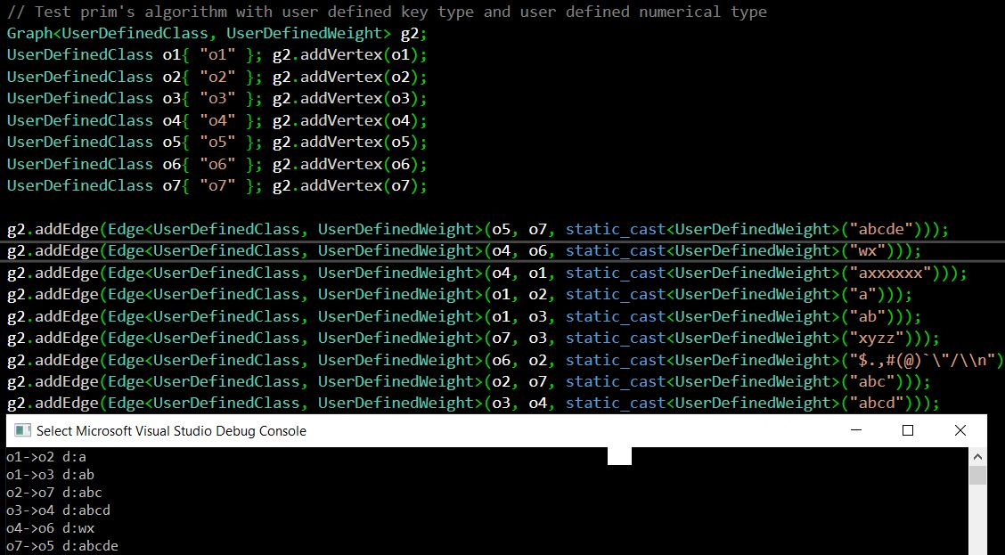

Although I was mostly working with familiar concepts, there was significant review and deepening of understanding. I had not worked with implementing C++ template class or functions and not with this graph class for two years some of the reviewing felt like learning. For example, I was stuck for a while because I forgot that template classes must have all their function definitions in the header file. Furthermore, I had not previously fully realized what it would take to switch the class and algorithm to using templates and now I know. However, there was considerable learning of C++ template insights as I did some complicated work with them. Although, I knew I could do this, I had not spent enough time thinking about what it required, or at least I had not recently done so. For example, I did not anticipate that I would need to change the underlying structure of the graph to be a map of maps, but I remember that is something I had done elsewhere in the past. While writing the Prim's algorithm code, I kept making mistakes based on the wrong assumptions, this made me realize I did not ever have a clear enough understanding of Prim's algorithm, even though I had implemented it multiple times in the past. In the past, I used techniques that were less optimal and required less thinking. With this current implementation, I spent much more time considering the complexity and trying to come up with a cleaner and optimal solution.
This work has illustrated the course objective I planned for, CS-499-03, and the concepts I planned for. The Graph class is a data structure and Prim's algorithm is a challenging algorithm, so by doing significant work with this code I've displayed a keen understanding of these concepts. Writing template classes is an advanced topic of C++, which was especially challenging given that the underlying adjacency list was a complicated map of maps. Thus, my success with these changes displayed advanced C++ knowledge.

Milestone 4: Database Enhancement Narrative
The artifact I've chosen is a MongoDB REST web service implemented in Python. I originally developed this as classwork for CS-340 at SNHU earlier in 2019. It implements basic CRUD functionality. Previously, it had only been tested on a shell in the browser designated for the class using the curl command.
This artifact was a great choice for the category because it was SNHU classwork and the improvement of providing a Javascript/HTML interface for MongoDB was suggested in the final project guidelines document. All of the work in Python involved database skills which are an integral part of software development. However, the work in Javascript also required an understanding of MongoDB documents. The work demonstrated full-stack software development abilities. Javascript/HTML comprised a frontend and the python web service and MongoDB database comprised a backend.
The main improvement to the artifact was adding a Javascript/HTML interface to the MongoDB/Python webservice. However, a lot of changes were made along the way to make it work and to improve the preexisting code. Also, the important security measure of sanitizing inputs was added. The sanitization occurs in the Python code at the backend. The frontend interface allows a user to conveniently access the CRUD functionality provided by the web service. In the preexisting code, more descriptive names were given, more error checking was added, and comments were added as there weren't any before. There were some bugs resolved as well, which I am not sure how they existed before because I had all this code working and documented that with images. Some code was changed because I wasn't using curl from shell anymore, instead using the Javascript fetch API. I revised the error codes to ensure they make sense. Lastly, I finished writing and improved the test code.
For the final publication, I made added placeholder text to all the input textboxes in the HTML that gives the syntax required for the input. I also included detailed instructions of how to get this project running. This includes installing the required components, setting up the database, running the webservice and viewing the site on localhost.
I met the specified course outcome, CS-499-05, as it related to security. This was met by sanitizing the user input before it was used to work with the database.
As with the other enhancements, this was also mostly review. However, many concepts here I did not have a strong enough grasp on in the beginning so it felt more like learning. That applies to almost everything used here, Python, Javascript, and MongoDB, but the HTML work was simple enough. I experienced various challenges that caused me to spend a great deal of time on this enhancement. At first, I spent some time trying to figure out how to host this on the web. I settled on doing it on the localhost. Also, I spent a while trying to figure out how to start the server because I forgot. I was trying to use Python's SimpleHTTPServer, but all I needed to do was run the webServices.py file. I am currently traveling out of the country and the internet is very slow, so it is a big impediment to looking for answers online. Besides the fact, I often have trouble finding the simple answers I am looking for. I spent a while trying to get the async/await and fetch code to work. Just copying the example from Mozilla documentation wasn't going to work in my code. So, I spent a lot of time reading online, but ultimately it just took me examining the code better and rearranging. As previously mentioned, there were preexisting issues that were very strange to have existed, this caused me a lot of trouble and confusing errors. And, issues in the Python code were introduced by using Javascript's fetch API as opposed to the curl tool. Also, as usual, I spent a lot of time dealing with the mistakes I made while writing the new code in Javascript/HTML. In the end, I feel much more comfortable with concepts like REST services, async/await, and fetch API. Also, I feel reviewed on everything else.

